台北市松山高中九十四學年度第二學期高一英文科第二次期中考
(第1-65題請在電腦卡上作答)
Live ABC (April 2006)
I. Listening Comprehension : 15%
Part A: Picture Match : 3% (請選出符合文意的圖片)
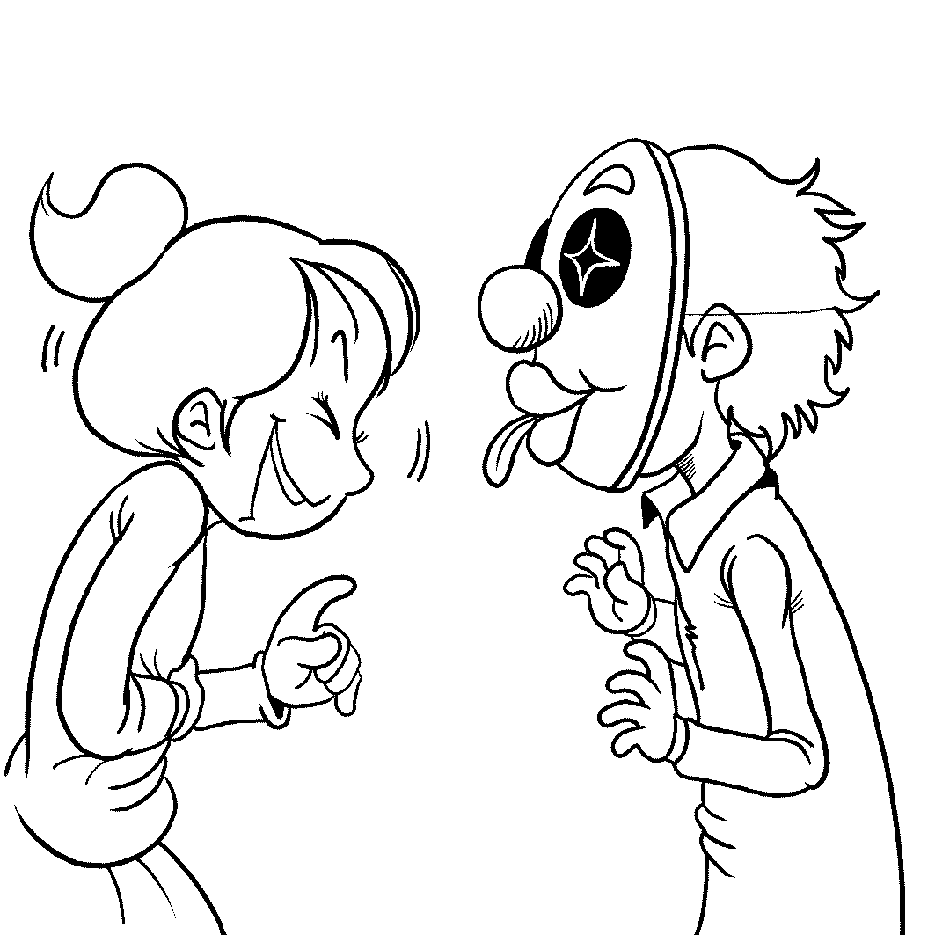( A ) 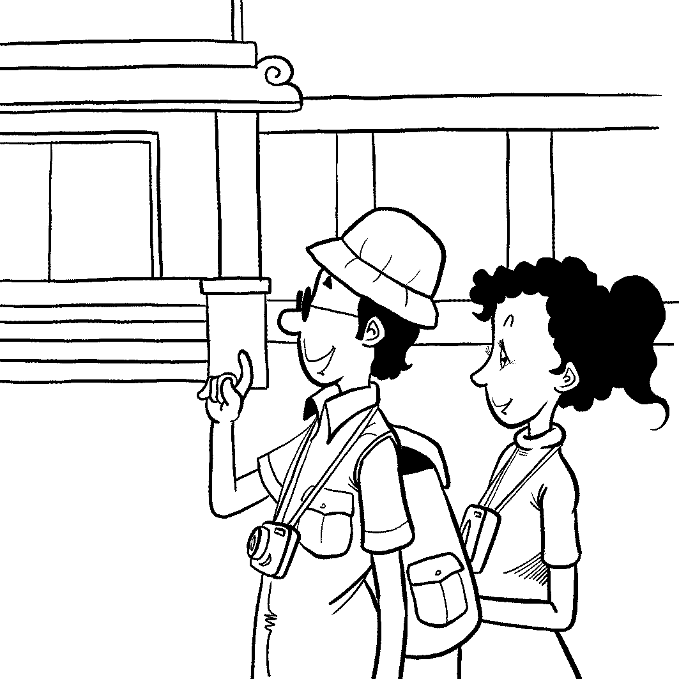( B ) 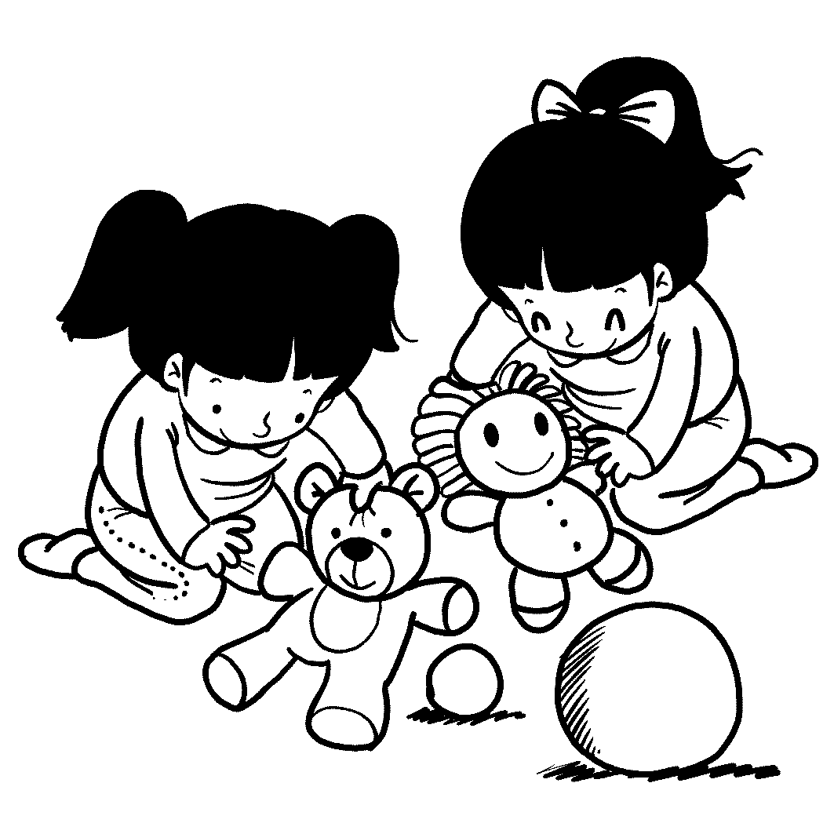( C )
Part B: Best Response Questions 5%
4. (A) I agree. She has a very soft voice.
(B) I know. She has an amazing body.
(C) Really? She doesn’t seem like a nice person to me.
(D) Yeah, she always has creative ideas and a lot of energy.
5. (A) I think you should take the job. It sounds like a good offer.
(B) I have three years of experience in this field.
(C) Oh, I don’t have a job. I’m still looking for one.
(D) I didn’t get him the job. Someone else did.
6. (A) Oh. I didn’t know she was your teacher.
(B) Well, best friends can sometimes make us mad.
(C) Why didn’t she write it herself?
(D) That’s awful. Does she often make you laugh?
7. (A) Yes. I can give you some money and I’d like to help out.
(B) Sure. I’ll ask my friends.
(C) I’m sorry. I don’t know any homeless people.
(D) OK. What are you selling?
8. (A) Really? Doesn’t that make it oily?
(B) He must go fishing a lot.
(C) Oh! I can’t eat spicy foods.
(D) It’s hard to get fresh cheeses around here.
Part C: Conversation Questions : 4%
9. (A) Constantly improving.
(B) Not improving at all.
(C) Sometimes good, sometimes bad.
(D) In need of improvement.
10. (A) Feed the animals.
(B) Talk to the animals.
(C) Touch the animals.
(D) Throw things at the animals.
11. (A) It is very bright.
(B) It is dark.
(C) It is very noisy.
(D) It is too crowded.
12. (A) Culture.
(B) He is not sure.
(C) Having so many places to play in.
(D) The weather.
Part D. Short Talk Questions 3%
13. (A) Contain rice.
(B) Balance the elements of nature.
(C) Be stirred up.
(D) Be many different colors.
14. (A) Rice.
(B) Hot stones.
(C) Kimchi.
(D) Green vegetables.
15. (A) It is very spicy.
(B) The Chinese Emperor made it popular.
(C) It is cooked in a stone pot.
(D) People believe it is healthy.

II. Word & Phrases Matching: 15%
16. The scandal _____ many government officials; yet, Mr. Chen insists that he has nothing to do with it.
- involves (B) removes (C) combines (D) contributes
17. A: I need to bend your ear about something.
B: What?
A: I _____ Jolin riding in her blue car last night.
B: Wow! Cool!
(A) responded (B) served (C) spotted (D) required
18. You should know what Eric said is simply _____; he flattered you just to get what he wants.
(A) outfit (B) nonsense (C) slang (D) technique
19. The Chinese test in the college entrance exam this year caused severe _____ because there were questions about “Martian Language” such as “3Q” and “Orz.”
(A) communication (B) companion (C) despair (D) criticism
20. I’m in love with _____ food; my dream is to take a trip to Paris and dine in its finest restaurants.
(A) formal (B) gourmet (C) normal (D) holy
21. To win the championship, you have to _____ all your competitors.
(A) remove (B) exchange (C) squeeze (D) defeat
22. Round, flat faces, large eyes, and clumsiness are traits of cuteness – all _____ with babies.
(A) associated (B) bargained (C) required (D) buried
23. For visitors coming from Mainland China, no visit to Taiwan could be _____ without going to Sun Moon Lake.
(A) extreme (B) cunning (C) complete (D) dim
24. For people in Taiwan, it is a great honor that Ang Lee’s movie Brokeback Mountain _____ the awards at Golden Globes and Oscar.
(A) swept (B) dumped (C) opted (D) faded
25. My sister’s dream is to be an astronaut riding in the space shuttle to _____ the unknown part of the outer space.
(A) recommend (B) sponsor (C) rotate (D) explore

(A) turned . . . down | (B) behind the scenes | (C) put . . . down
(D) is made up of | (E) is wired to | (AB) for the purpose of
(AC) in terms of | (AD) put…aside | (AE) is adapted from
26. Amy doesn’t have much confidence. When she was still a child, her parents often _______ her ________ though she was not to blame.
- Kenting is a wonderful place for a vacation _________ reliable weather.
- Many bloggers set up blogs _________ sharing their lives and thoughts.
- I can’t believe that Peggy ________ Adam ________ when he asked her out. If I were Peggy, I would never refuse his invitation.
- This new movie, which ___________ a famous science fiction, attracts its audience with strange realities and fantasies.

Textbook ( Book Two L5,6,7,9 )
III. Cloze Test : 24%
(A)
We do not know when people first began to use salt, but we do know that it __31__ in many different ways throughout history. Historical records show, for example, that people __32__ more than 3000 years ago ate salted fish. __33__, salt was used to keep the bodies from decaying in ancient Egypt. In the past, salt was __34__ an important item on the dining table __34__ it had to be placed in front of the king when he sat to eat. Important guests at the king’s table __35__ near the salt. In the Roman Empire, Roman guards were placed along the road on which salt was carried from the salt mines to Rome to protect against salt thieves. Besides, any guard who fell asleep while on duty was said to be “not worth his salt”. __36__, he was punished by receiving less salt on the next payday. Today, the term “not worth his salt” is still used to refer to a person who is not __37__ his job.
31. (A) has used (B) has been using (C) has been used (D) is used
32. (A) who live (B) living (C) who living (D) lived
33. (A) As a result (B) In other words (C) In addition (D) However
34. (A) such…that (B) indeed…but (C) not…until (D) so…that
35. (A) were sat (B) seated (C) sitting down (D) were seated
36. (A) For instance (B) As a consequence (C) To sum up (D) In truth
37. (A) patient with (B) responsible for (C) respectful to (D) aware of
(B)
When we meet a foreigner, we feel like talking to him or her. __38__, we are not certain about the topics we can talk about. Most of us already know that we can not ask such personal things __39__ how much money he or she makes, or how much something costs. Well, here is a tip: to talk about topics__40__ that we have in common. As we get to know a person better, we can begin to talk about more personal topics. In the meantime, we need to have some __41__ of other cultures since there are differences from culture to culture. These differences can __42__ people to emphasize the importance of one thing and to neglect another. For example, Americans often wish __43__ individuals rather than as members of a larger unit, their family. They consider their family life a private matter. This is also true in Germany. In Brazil, soccer is the one topic that can __44__ friends __44__ enemies. Therefore, we have to avoid this topic completely. Learning about a foreign culture as well as being sensitive to the cultural differences is part of learning a language. When you know better about what other people consider important in their own lives, you may find you have __45__ to talk about.
38. (A) Also (B) However (C) Thus (D) Therefore
39. (A) like (B) about (C) as (D) that
40. (A) we are sure (B) we think of (C) we consider it to be (D) we aware
41. (A) knowledge (B) reflection (C) inspiration (D) imagination
42. (A) make (B) let (C) cause (D) have
43. (A) to regard as (B) to be thought as (C) to refer to as (D) to be viewed as
44. (A) change…into (B) turn…to (C) supply…with (D) bring… to
45. (A) plenty of (B) a lot of (C) a large number (D) a great deal
(C)
Helping wildlife has become a global concern today. Let’s __46__ the panda as an example. The reason why there are so few living in the wild today is __47__ people cut down the bamboo forests where pandas live to make more living room for themselves. But __48__ not only the panda that is endangered. Right here in Taiwan, the Formosan black bears are also __49__ extinction. They can only be seen in a few high-mountain areas __50__ an increase in human population. In fact, the government and people __51__ should share the responsibility for helping wildlife. What can we do then? Well, as long as we __52__ the following advice, we will certainly make the world safer for them. If we find an animal that is hurt, call an expert to come and treat its wounds __53__ touching it. If we see a baby animal without its mother, we shouldn’t pick it up and take it home. __54__ we can do is leave it alone if it looks healthy. Then we can go back to check on it the next day to see how it is. In short, before we rush out to feed and take care of the animals, we’d better make sure these creatures really need our help.
46. (A) set (B) take (C) make (D) have
47. (A) because (B) how (C) when (D) that
48. (A) this is (B) that is (C) it is (D) which is
49. (A) in danger of (B) in place of (C) in honor of (D) in favor of
50. (A) according to (B) due to (C) regardless of (D) in spite of
51. (A) like (B) alike (C) likely (D) the same
52. (A) stand for (B) come across (C) pay attention to (D) straighten up
53. (A) rather than (B) instead of (C) by means of (D) in addition to
54. (A) That (B) How (C) Even (D) What
IV. Matching: 6% (答案選項不重複)
55. I am not used to (A) and ended up penniless.
56. Australians talk about everything, (B) to lie to the teacher.
57. Ken was addicted to gambling (C) that we have no idea where to put it.
58. The little boy was caught (D) being praised in front of others.
59. If you concentrate in class, (E) chances are you’ll get better grades. 60. Mary’s mother tried hard to prevent her (AB) including politics.
(AC) take a taxi home late in the night.
(AD) to deal with the whole situation. (AE) from marrying that poor old man.
(BC) and she is crazy about pop music.
(BD) stealing money from his mother’s
purse.

V. Reading :10%
(A)
The naming of a child is a momentous decision for any family. Some parents seem to choose based simply on personal preference. In other families, grandparents or professional name-makers come up with a child’s name. How did our parents decide which method to use? In the end, it seems to depend on the culture we were born in.
In many European cultures, names are typically chosen by parents and may be based on relatives or ancestors within a particular family. For example, in Italy, children are traditionally named after their grandparents. In some Asian countries, the child’s grandfather or a fortune-teller chooses the name. And the child’s name is chosen to influence the child’s character. For example, names may be based on a connection to certain elements in nature, like fire, water, earth, wood, or metal. Or the name might include written character meaning beauty, strength, or kindness.
A child’s name is the first gift in life. Whether it is chosen according to preference or dictated by tradition, the name reflects something about a child’s culture. For that reason, all names should be treasured and respected.
61. What is the main idea of this reading?
- Choosing names in Italian culture.
- Some old traditions in choosing names.
- How Asian people name their children.
- How names reflect a person’s culture.
62. In China, what should names relate to?
- A child’s ancestors.
- A child’s birth date.
- A child’s birth elements.
- The parents’ personal preference.
(B)
Alaska is disappearing slowly but surely. One reason for Alaska’s gradual disappearance is the melting of its glaciers. And this, according to one geologist at the US Geological Survey, seems mainly because of the increase in global temperatures.
Another problem contributing to Alaska’s gradual disappearance is its thawing permafrost. Much of the land in Alaska was permanently frozen, or frozen for most of the year. Now, the thawing permafrost is causing a number of problems on land. Roads and utility poles are collapsing. For villages on small low islands, one terrible storm could wipe out the entire community.
The melting permafrost and increasing temperatures are also having a negative influence on Alaska’s forests. As the permafrost under the forests melts, insects that normally don’t appear until the warmer seasons are appearing sooner. Those insects increase in numbers, damaging as many trees in one year as they previously damaged in two. At this rate, Alaska’s forests won’t survive the turn of the century.
Some scientists believe that human activity is linked to a global increase in weather temperatures. Whether the rising temperatures are caused by human activity or natural changes, the fact remains that Alaska is warming. Horribly, this could be a preview of what will happen to the rest of the world in the next century.
63. What is the reading mainly about?
- Global warming is affecting Alaska.
- Alaska’s forests are disappearing.
- Alaska’s glaciers are melting away.
- People who live in Alaska must move to other places.
64. Which is NOT true about permafrost?
- It is causing problems on land.
- When it melts, it makes some insects increase in numbers.
- It has nothing to do with the global warming.
- It may be frozen all year.
65. How could the events in Alaska be a preview for the rest of the world?
(A) They show ice is necessary to the Earth.
(B) They show forests are important for ecology.
(C) They show global warming has little influence on the Earth.
(D) They show global warming could affect us negatively.

＊以下部份請作答於答案紙上＊

VI. Vocabulary: 18%
- It is very important to have a b______ed diet if you want to stay healthy.
- Janice watches TV news every day so that she can keep up with c______t events.
- Sandy spends a large a______t of money on fancy clothes every month. That’s why she has difficulty saving money.
- Whenever I successfully do something, I feel a sense of a______t.
- After the serious earthquake, people in that area are in u______t need of food and medication.
- The plane disappeared near Penghu after it lost its radio c______t with the tower.
- Many fish die from water p ______n because some factories pour poisonous waste into the rivers.
- Children should be taught to f______h the toilet after using it.
- I’d like to make a s_______n -- we may go to the movies to relax ourselves after the mid-term exam.
- The young woman is very r______s. She goes to church every Sunday morning.
- Salt and spices were used to p______e meat in ancient times.
- It is a w______r that he remained alive after dropping from the cliff.
- Tom put a lot of e______s on doing well in sports, but hardly focused on his academic performance in school.
- The new government declared that the diplomatic p______y will be on the same way in dealing with the international situation.
- He was f______ned by the horror movie and never wanted to see any again.
- He is just a distant r______e of mine. One of his aunts is the daughter-in-law of my cousin.
- Machines were invented and the first factories were established in the i______l revolution in the 18th century.
18. Amy’s t______t for the new school year is to pass all the tests with high scores.

VII. Translation: 12%
- 在這個會議中，任何議題都可以開放討論，但千萬別驟下定論。
In this meeting, any issue is 1 , but never j 2 .
- 因為他沒有採取步驟解決所有問題，所以註定最後要失敗。
He was d 3 fail in the end since he didn’t 4 solve all the problems.
- 不論這個競賽有多困難，你們應該要一起合作，並且公平競爭。
5 this contest will be, you are 6 stick together and 7 .
- 事實上，我摯愛的朋友們一直在我生命中扮演著一個重要的角色。
U 8 , my beloved friends always 9 in my life.
- 在我看來，他寧可私底下談論這個話題，也不願公開地談論。
I 10 , he p 11 talk about this topic in private 12 in public.

台北市松山高中九十四學年度第二學期高一英文科第二次期中考答案
I.- V. 70%
1. | C | B | A | D | A |  |  | 6. | B | A | C | A | C
11. | B | D | B | C | D |  |  | 16. | A | C | B | D | B
21. | D | A | C | A | D |  |  | 26. | C | AC | AB | A | AE
31. | C | B | C | A | D |  |  | 36. | B | B | B | C | A
41. | A | C | D | A | D |  |  | 46. | B | D | C | A | B
51. | B | C | B | D | D |  |  | 56. | AB | A | BD | E | AE
61. | D | C | A | C | D
VI. Vocabulary: 18%
1.  balanced | 2.  current | 3.  amount | 4.  achievement
5.  urgent | 6.  contact | 7.  pollution | 8.  flush
9.  suggestion | 10.  religious | 11.  preserve | 12.  wonder
13.  efforts | 14.  policy | 15.  frightened | 16.  relative
17.  industrial | 18.  target

VII. Translation: 12%
1.  open to discussion | 2.  jump to a conclusion
3.  doomed to | 4.  take steps to
5.  No matter how difficult/hard | 6.  are supposed
7.  play fair | 8.  Under the skin
9.  play an important role/part | 10.  In my opinion
11.  prefers to | 12.  rather than

