台北市立松山高中九十四學年度第二學期高一英文科期末考
(試題1—65請在電腦卡上作答)
第一部份: Live ABC (May Unit11—July Unit12)
I. Reading Comprehension: 15%
Part A. Picture Match:
Choose the best one to fit the meaning of the sentence you hear.
1. _________ 2. _________ 3. _________
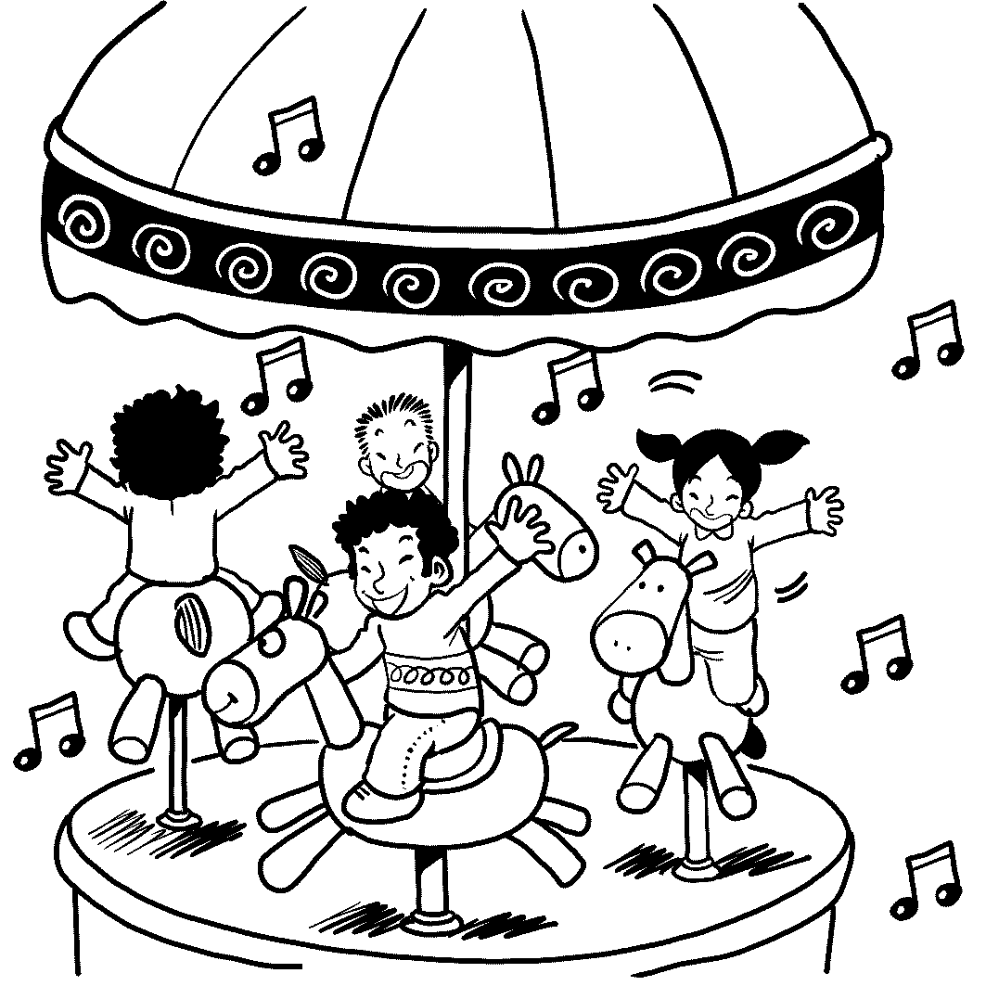( A ) 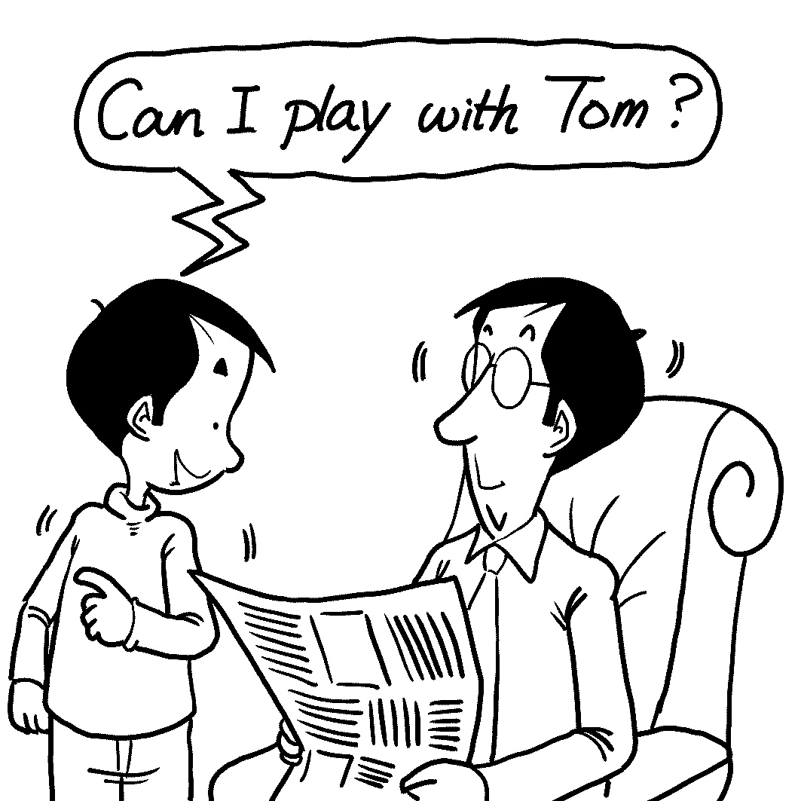( B ) 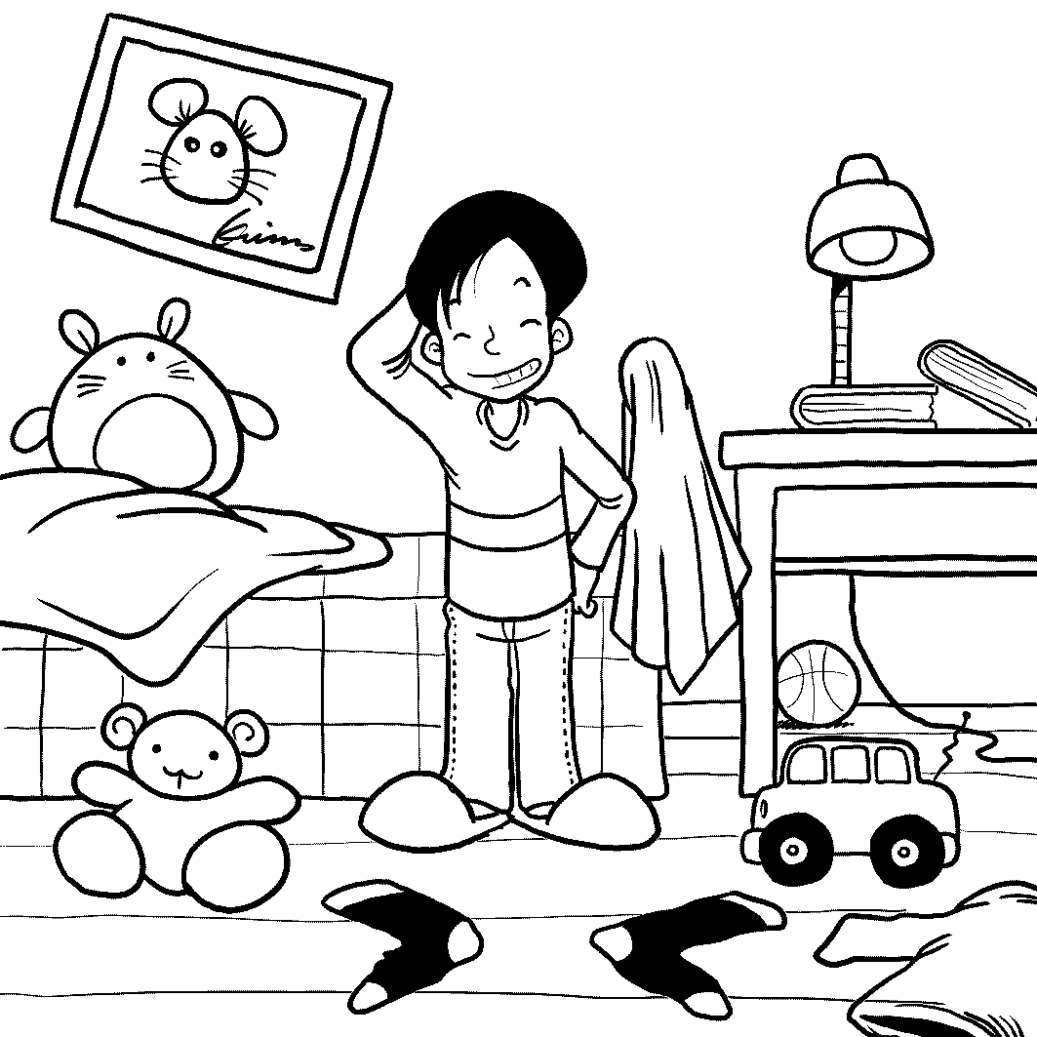 ( C )

Part B. Best Response Questions:
Listen to the statement or question and choose the best response.
4. (A) I think food without chemicals is expensive anywhere.
(B) Sure they are. It costs a lot to bring them here.
(C) No it's not! There are many inexpensive vegetarian options here.
(D) Well, maybe you should eat at home more often.
5. (A) I heard it was because the building’s roof had a hole in it.
(B) I guess so! That was one of the worst rain storms this year.
(C) Right. The band missed their plane, and couldn’t get to the theater.
(D) That’s too bad. I love going to that theater. It is so old and beautiful.
6. (A) Yes. He told me he lived in the hospital most of his life.
(B) I know. Actually, I met his last wife.
(C) I heard that, but I think he leads an honest life now.
(D) Actually, most of friends have worked for the government.
7. (A) Really? Is he certain about that?
(B) That’s fine, as long as he’s there on time.
(C) Tell him not to get too excited.
(D) Why is he unsure whether he will be late or not?
8. (A) I hate it when people talk during the movie.
(B) Really? Was the movie that sad?
(C) I always scream during scary movies too.
(D) You’re supposed to turn your cell phone off.

Part C. Conversation Questions:
Listen to each conversation and answer the question.
9. (A) She already paid the bill.
(B) She wants to wait a while before paying the bill.
(C) She wants to pay for the man’s meal.
. (D) She wants him to pay the bill.
10. (A) Sit on a lovely beach.
(B) Go on a relaxing cruise.
(C) White water raft or go mountain climbing.
(D) Stay at a really expensive resort.
11. (A) Stopped the man and woman from calling out.
(B) Stopped the man and woman from seeing out.
(C) Stopped the man and woman from getting out.
(D) Stopped the man and woman from finding out.
12. (A) It’s the date when he got married to his wife.
(B) It’s his wife’s birthday.
(C) It’s Valentine’s Day.
(D) He is going to ask Jill to marry him.

Part D. Short Talk Questions:
Listen to the following paragraphs and answer the questions.
13. (A) National languages.
(B) People coming from different countries.
(C) Capital cities.
(D) Common passions.
14. (A) The buildings and the food.
(B) The breezes and flavors of the city.
(C) The buildings and the feel of the city.
(D) The music and its rhythms.
15. (A) They come from the same parts of the world.
(B) They eat European food.
(C) They love eating.
(D) They come from Paris.
II. Vocabulary: 10%
16. The _______ is trying his best to look into the murder with the policemen.
(A) technician (B) detective (C) terrorist (D) supervisor
- As a teenager, you should ask your parents for _______ to take a two-day
trip with your classmates.
(A) permission (B) receipt (C) adventure (D) promise
- Some tourists from foreign countries enjoy strolling around the night
market in Taiwan because of the hot and noisy ______.
(A) competition (B) atmosphere (C) revolution (D) mess
- As we know, the Building 101 is the most distinctive ______ in Taipei; you
can see it from a distance.
(A) residence (B) device (C) landmark (D) plaza
- There are many ______ of keeping early hours every day.
(A) glories (B) points (C) doubts (D) benefits
- Many people are still ______ that the suspect is innocent.
(A) conserved (B) analyzed (C) convinced (D) disgusted
22. The ancient castle is the cultural and ____ treasure to humans.
(A) artistic (B) awful (C) original (D) rough
23. Almost all the people around say that Mary really _____ her twin sister.
(A) resembles (B) constructs (C) represents (D) unwrap
24. It was really a ______ news that our favorite player won the championship.
(A) fashionable (B) essential (C) fabulous (D) complex
25. All the people attended the general’s ______ in black clothes, mourning for his death with tears in their eyes.
(A) ceremony (B) funeral (C) anniversary (D) performance

III. Idiom matching: 5% (Pease choose the best one.)
(A) might as well | (B) catch on to | (C) get over
(D) live up to | (AB) cut down on | (AC) put someone out
(AD) catch up with | (BC) on hand | (BD) am set to
26. The legislators passed a proposal to _____ the budget in many aspects.
27. John ran as fast as he could to _____ the opponents ahead of him.
28. Everyone _____ stood up to applaud for his excellent performance.
29. Our hiking is put off because it is going to rain soon; I _____ go home to take a rest.
30. Tom is studying hard to _____ his parents’ expectations.
第二部分: Textbook(L2,5,7,9 單字片語+ L10---L12)
IV. Cloze 25%
A.
For hundreds of years, the Bermuda Triangle has been __31__ one of the most famous mysterious areas in the world. The reason is that many ships or planes disappeared there without a trace, so __32__ the rescue planes sent out to search them. Since no survivors ever came back to give a detailed description of what it is like there, people can only make guesses. Some infer that the disappearance of those ships or planes may __33__ strange magnet forces in that area which __34__ the radar systems of those ships or planes. __35__ say it is not surprising that so many accidents __36__ occur there, for it is one of the most heavily traveled areas of ocean in the world.
Besides this mysterious area, there are some mysterious creatures having a strong hold on our imagination. One of them is called the Yeti. He is said __37__ in the high areas of the Himalayan mountains of Nepal. Mountaineers reported __38__ huge footprints on the upper slopes of the mountain and the local people guessed they __39__ by certain huge hairy creature they sometimes saw from a distance. But so far, no further evidence has been found. The story of Yeti is similar to __40__. One interesting thing is that Bigfoot seemed so shy that it would immediately run away when __41__. Unlike other legends, a photographer did leave us the evidence of the existence of Bigfoot when he filmed a tall, hairy, ape-like creature moving away into the trees in 1967.
31. (A) looked upon (B) thought of (C) viewed as (D) referred as
32. (A) are (B) were (C) do (D) did
33. (A) because (B) because of (C) due to (D) be due to
34. (A) strike down (B) fix up (C) interfere with (D) come across
35. (A) Other (B) The others (C) Another (D) Some
36. (A) may (B) should (C) would (D) can
37. (A) that lives (B) that has lived (C) to live (D) to have lived
38. (A) to find (B) finding (C) to look for (D) looking for
39. (A) might leave (B) might have left (C) might be left (D) might have been left
40. (A) Bigfoot (B) it of Bigfoot (C) that of Bigfoot (D) this of Bigfoot
41. (A) spotting (B) spotted (C) it spotted (D) it spotting
B.
When I was 21 years old, a wise man gave me the advice __42__ one may give away everything else, including money, __43__ one’s heart. He told me that once the heart is given away, what one will get in return will be __44__ sighs and regret. However, because I was too young and innocent then, I __45__ his advice. I soon had a crush on one of my classmates, who was handsome and athletic, but he turned me down. Not until then did I realize the importance of keeping one’s fancy free. By the time I was 22, the bitter experience of falling out of love __46__ me a lot. If time could go back, I wish I might have taken the advice from that wise man at 21.
42. (A) which (B) what (C) that (D) of which
43. (A) in addition to (B) besides (C) but (D) despite
44. (A) a plenty (B) plenty of (C) a great deal (D) a great deal of
45. (A) asked for (B) followed (C) acted on (D) turned a deaf ear to
46. (A) matured (B) had matured (C) has matured (D) had been matured
C.
Advanced modern technology ___47___ people to enjoy an improved living quality and give people more confidence to explore into many unknown possibilities. Take GM foods for example. They are particularly created to the __48__ of growers, businessmen and starving people. Growers believe that GM crops are easier and cheaper to grow. __49__ poor growing conditions, the special characteristics of the GM crops can make them grow faster and bigger, and thus costs are reduced. Businessmen hold that since GM foods can last longer and appear more beautiful, __50__ more customers in the supermarket will __51__ them without thinking twice. __52__, the increased crop yields will benefit those who suffer from the shortage of food in underdeveloped countries. However, there is a __53__ as well as a __53__ side to growing GM crops. Many critics point out the fact that the chemical substances which exist in GM crops may upset the balance of nature. Besides, __54__ the studies show no immediate harm, no one can be sure of whether we will be ____55____ in the future by what we create today.
47. (A) makes (B) lets (C) enables (D) has
48. (A) concern (B) achievement (C) opinion (D) advantage
49. (A) Instead of (B) Because (C) Despite (D) Besides
50. (A) as soon as (B) chances are (C) time will tell (D) for instance
51. (A) come into contact with (B) be taken from
(C) reach for (D) be related to
52. (A) As a result (B) Instead (C) However (D) Furthermore
53. (A) positive/negative (B) negative/positive
(C) positively/negatively (D) negatively/positively
54. (A) according to (B) despite (C) even if (D) due to
55. (A) ended up (B) met our fate (C) fixed up (D) struck down

V. Matching 5%
- There are many mysteries in the world A. remain unsolved today.
- Whether GM foods are good or bad, B. that study abroad after graduation.
- Some students are likely C. he decided to give up the plan.
59. A series of pouring rain hit Taiwan, D. that scientists today still can’t explain.
60. Despite all the difficulties, E. to give up trying anything after they
have faced repeated failures.
AB. caused a huge loss of money and property.
AC. is a question no one can answer for sure now.
AD. they climbed up to the mountain.
AE. only time will tell.
BC. leaving many farms and villages flooded.

VI. Reading Comprehension: 10%
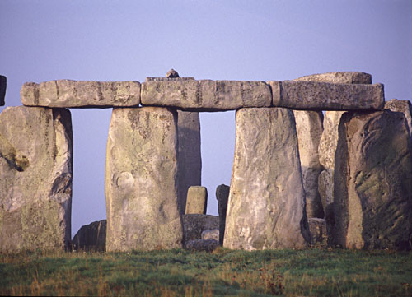 Stonehenge, the ancient monument of huge stones solitarily standing on the Salisbury Plain in Wiltshire, England has caught imaginations for centuries. Stonehenge is filled with mystery. No one knows exactly who built it, or how, or why, but theories are plentiful.
Speculation on the reason it was built range from human sacrifice to astronomy. Investigations over the last 100 years have revealed that Stonehenge was built in several stages from 2800 - 1800 BC. It seems to have been designed to allow for observation of astronomical phenomena - summer and winter solstices, eclipses, and more.
The stones have been called everything from a burial ground to a giant astronomical calculator. Up to date, an equally wide variety of people have been attracted to Stonehenge for centuries: archaeologists, artists, tourists, even modern-day druids and their rituals. Stonehenge has become England's top tourist attraction, with roughly 700,000 visitors per year. The current visitor experience is not as powerful as it could be, because the stones have been blocked off in an attempt to protect them from visitors. However, plans are underway to better balance preservation and use, and to combine free movement through the site with a new visitor's center farther away.
Questions:
61. According to the investigations, how long has Stonehenge existed?
(A) No one knows that.
(B) About 2800 years
(C) For 4000 years around
(D) At 1800 BC
62. In what country is Stonehenge located?
(A) America
(B) Cambodia
(C) Costa Rica
(D) England
63. For what purpose was Stonehenge likely designed?
(A) For the sightseeing of the royal people
(B) To worship some gods
(C) For the observation of the Sun and the Moon
(D) To capture the imagination of people
64. Nowadays, why do people go there mostly?
(A) Some modern druids still go there to hold sacred rituals.
(B) People traveling in the country take it as the most touring spot.
(C) Archaeologists go there for investigating ancient mysteries there.
(D) Artists work hard to regain its power as before.
65. Why have the stones been blocked off?
(A) To preserve the stones from being ruined by tourists
(B) To stop the magic power from the stones
(C) To combine its practical use and its economical effect
(D) To set up a center to value their treasures and usages
***以下部份請作答於答案紙上***

VII. Vocabulary: 20%
- With the higher death rate and lower birth rate, the p_____n of Taiwan is decreasing .
- In order to keep track of what’s happening on campus, our school e_____ps each floor with a video camera.
- For the Chinese people, there is a cultural p_____ce for boy babies, who are supposed to continue the family traditions.
- People living in the mountains are often warned to take p_____ve measures against the mudslide disaster.
- With the help of computers, people now can a_____b a large quantity of information easily and quickly.
- The intense Java earthquake in Indonesia has led to the serious d_____n of life and property.
- There was little hope left for the patient, for the cancer had s_____d to his liver and lung.
- Women tend to be s_____ve about their age or weight, so try not to make a joke of it.
- Pandas could become e______t in the wild because their habitats are invaded by human beings and they are forced into the higher mountains isolated .
- Children are always seeking the a_____l from their parents while teenagers are from their peers.
- Although Lian-i now can’t move around without the wheelchairs, her determination to stand again d_____es our respect and admiration.
- Cake basically c_____ts of flour, sugar, egg, and some other ingredients.
- Being out of work for years didn’t stop Ang Lee from f______ling his dream to be a movie director.
- The Chicken Soup series always offer me a lot of r_____ns on my attitude toward life.
- In the army, there is a lot of e_______s on following the rules. Soldiers are always reminded of the importance of obedience.
- The ancient Egyptians used many ways to p______e dead bodies from decay.
- Mother Teresa was awarded the Nobel Prize for her c______n to the helpless and the dying.
- Because of the heavy rain and strong wind caused by the typhoon, the airport was t______ily closed.
- Nobody is taking care of the garden. It is turning into a w_____s.
- How tall one will grow may be partly determined by the g_____es one gets from his or her parents.

VII. Translation: 10% (每格不只一字)
- 你可能已經注意到校園裏打領帶的學生人數正在增加當中。
You _____1_____ that the number of students who wear a necktie is ____2____.
- 有些人整齊的打領帶，有些人則不。
Some wear a necktie neatly, but ____3____.
- 儘管要怎麼打領帶的意見各人不同，
Although the opinions of how to wear a necktie are _____4_____,
- 毫無疑問的是打領帶對一個人的外表影響很大。
it is _____5_____ that the way of wearing a necktie has a _____6_____ one’s looks.
- 這個議題可供大家討論。
The issue is _____7_____.
- 但是，當我們在穿著上作改變時，我們應該抓住作一個學生的原則。
However, as we try to make a change on our dress, we should hold____8____ the principle of being a student.
- 總之，該怎麼打得既得體又有創意，是值得大家思考的事。
_____9_____, how we can wear a necktie both properly and creatively is
_____10_____.

台北市立松山高中九十四學年度第二學期高一英文科期末考

Class: ______ No: ______ Name: __________

答題卷
Vocabulary: 20%

1 | 2 | 3. | 4. | 5.
6. | 7. | 8. | 9. | 10.
11. | 12. | 13. | 14. | 15.
16. | 17. | 18. | 19. | 20.

Translation: 10% (每格不只一字)

1. | 2.
3. | 4.
5. | 6.
7. | 8.
9. | 10.

台北市立松山高中九十四學年度第二學期高一英文科期末考
答案卷
01—05: B A C B B 6—10: C D B C C
11—15: C A B C C 16—20: B A B C D
21—25: C A A C B 26—30: AB AD BC A D
31—35: C D D C D 36—40: B C B D C
41—45: B C C B D 46—50: B C D C B
51—55: C D B C D 56—60: D AE E BC AD
61—65: C D C B A

Vocabulary: 20%
1.  population | 2  equips | 3.  preference | 4.  preventive | 5.  absorb
6.  destruction | 7.  spread | 8.  sensitive | 9.  extinct | 10.  approval
11.  deserves | 12.  consists | 13.  fulfilling | 14.  reflections | 15.  emphasis
16.  preserve | 17.  contribution | 18.  temporarily | 19.  wilderness | 20.  genes

Translation: 10%
1.  may have noticed | 2.  on the increase
3.  some don’t | 4.  different from person to person
5.  beyond question | 6.  great effect on
7.  open to discussion | 8.  on to
9.  In conclusion | 10.  food for thought

