台北市立松山高中九十四學年度第二學期期末考高二英文試題

第一部份： Studio Classroom & SUV 4000 40%
I. Pictures看圖辨義 3 %
Listen to the questions. Then choose the best answer according to each picture.
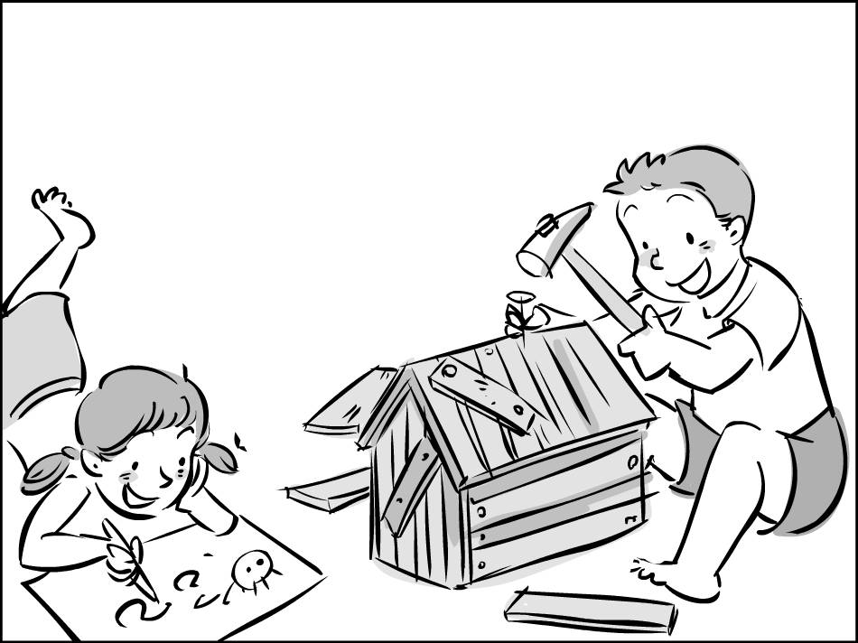
(A)
For question 1, please look at picture A.

1. ______

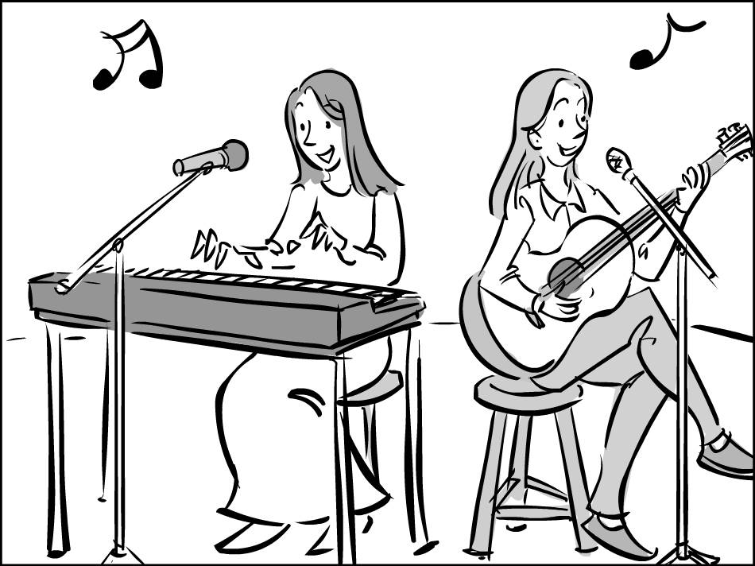
(B)
For questions 2&3, please look at picture B.

2. ______ 3. ______

II. Short Conversations 3 %
Listen to the conversations. Then answer the questions.
4. ______
- Her parent.
- Her self-esteem.
C. Her genes.
D. Her friends.
5. _______
- He’s the only man who hates competition.
- He’s not interested in the woman’s question.
- He loves competition just like the other men.
- He wants the woman to make an exception for him.
6. ______
- Quite a number of cafes.
- Only a few cafes.
- A small number of cafes.
- Quite a few nightclubs.

III. Long Dialogues 2 %
Listen to the Dialogues. Then choose the best answer for two questions.

7. ______
A. She felt queasy.
B. She forgot her homework.
C. She lied to her teacher.
D. She wanted to watch the ball game.

8. ______
A. The nurse’s office.
B. The gym.
C. The hospital.
D. Her classroom.

IV. Passages短文理解 2%
Listen carefully to the passage. Then answer the questions.
9. ______
- He didn’t get good grades at school.
- He made some good friends there.
- He couldn’t find his way home from there.
- He was too young to go there by himself.
10. ______
  - He was really tired.
  - He missed his homework.
  - He lost his parents’ trust.
  - He got extra homework.
(A) I have a problem with blood. I remember once my family was visiting my grandma in the hospital. For various medical reasons, she had just had part of stomach ___11___. My grandma had been a nurse when she was younger, so she could describe the operation ___12___. I was sitting in an armless chair, ___13___ to her account of the boldly operation. The room began to feel warm, and before I knew it, I fainted and fell out of my chair! I woke up on the floor ___14___ a nurse waving smelling salts under my nose. (5.22—23)
11. (A) remove (B) to remove (C) removed (D) was removing
12. (A) at will (B) by birth (C) in place (D) in detail
13. (A) listened (B) listening (C) and listen (D) having listened
14. (A) with (B) of (C) for (D) by
(B) We are surrounded by pictures of models, movie stars and athletes with seemingly perfect bodies. ___15___, we fall short when most of us look in the mirror. But the truth is ___16___ only four percent of women are born with this “ideal” frame. Therefore, it is unwise to try to __17___ up such an impossible standard or risk developing a poor opinion on our won bodies. (5.26—27)
15. (A) By comparison (B) In consequence (C) By no means (D) On the contrary
16. (A) what (B) which (C) that (D) how
17. (A) emphasize (B) measure (C) scribble (D) record
(C) Since 1930, the world’s finest soccer teams have competed for World Cup. ___18___, only a handful of international teams competed. Today, over 200 teams fight for 32 ___19___ Cup berths. This year, besides host nation Germany, some teams, like Brazil, will be a force to be ___20___ with. Meanwhile, several star players will be seeking to ___21___ a name for themselves. So don’t miss the world’s biggest and most-watched event. (6.5-6)
18. (A) For example (B) Back then (C) In contrast (D) Before long
19. (A) coveted (B) coveting (C) to covet (D) to be coveted
20. (A) flocked (B) contended (C) forbidden (D) reckoned
21. (A) make (B) bear (C) earn (D) deserve
(D) Germany’s capital, Berlin, pulses with energy. But after World War II, much of Berlin __22__ in ruins. Rebuilding soon began and ___23___ after the Berlin Wall fell. Berlin now has more construction ___24___ any other city in the world besides Shanghai. With all the construction, Berlin always offers something new to see. And that makes this world-class city the perfect place to visit again and again. (6.12-14)
22. (A) lay (B) set (C) stayed (D) left
23. (A) reunited (B) waylaid (C) accelerated (D) convinced
24. (A) as (B) that (C) than (D) like

25. Sailing around the world in a small boat is a real _______.
(A) backpack (B) adventure (C) lifeguard (D) helmet
26. Without a _______, you won’t be able to enter other countries.
(A) flag (B) native (C) passenger (D) passport
27. If somebody hits you, you should hit back to _______ yourself.
(A) explode (B) destroy (C) defend (D) attack
28. One must _______ the pros and cons of a university before applying.
(A) prove (B) evaluate (C) reduce (D) tolerate
29. They got famous because they _______ good music with a good show.
(A) denied (B) escaped (C) identified (D) combined
30. Bill got a cold yesterday. I think he was _______ by the other kids at school.
(A) nourished (B) breathed (C) infected (D) refreshed
31. My baby boy is starting to talk; he has got a very small _______ of about ten words.
(A) vocabulary (B) academy (C) directory (D) iceberg
32. It was a(n) _______ working day. Everybody went to work, and nothing special happened.
(A) nearby (B) ordinary (C) private (D) distinct
33. I want to improve my English, but my biggest _______ is my fear of speaking to foreigners.
(A) battle (B) strategy (C) victim (D) obstacle
34. There has been a serious _______ between the two countries that could lead to armed conflicts.
(A) colony (B) method (C) dispute (D) refugee
35. The police are investigating the case, but they cannot find any _______ to charge the suspect.
(A) evidence (B) justice (D) license (D) security
36. There is a _______ of serious conflict between employers and workers if things go on like this.
(A) lighthouse (B) possibility (C) relief (D) signal
37. The hunters keep a _______ supply of firewood on hand at their cabin in the mountain.
(A) moist (B) circular (C) sufficient (D) sympathetic
38. To _______ public safety, a “dangerous structure” sign will be put up if a building fails to meet safety requirements.
(A) collapse (B) disagree (C) distribute (D) assure
39. It would be a great _______ if we were required no longer to wear around school uniforms. There would be a complete change on campus.
(A) patriot (B) submarine (C) revolution (D) mission
40. In _______ times, people wore the skins of fierce animals, like lions and tigers, because they believed they could get magic from them.
(A) ancient (B) absurd (C) classic (D) distant

第二部分 遠東課本及課外
I. Vocabulary, Idioms, & Phrases (23%)
41. John is a very ______ friend of mine; that is, we talk about almost everything.
(A) intact (B) innate (C) intimate (D) intensive
42. She _______ closed the door for feat that she might wake up the baby.
(A) tragically (B) cautiously (C)immensely (D) effectively
43. Since Father was laid off by the company, we have to do without under such difficult _______.
(A) phenomenon (B) positions (C) circumstances (D) supervision
44. As a lady, you should modify your sitting _______ to make yourself more graceful.
(A) posture (B) gesture (C) stance (D) pace
45. Regardless of repeated failures, she is not _______ at all; on the contrary, she still sticks to her ideals.
(A) encouraged (B) irritating (C) thrilled (D) frustrated
46. A lot of people went on strike yesterday; the police _______ that the number of demonstrators was about 50,000.
(A) maintained (B) reconsidered (C) determined (D) estimated
47. Those who catch flu are advised to take a sick leave and rest at home, for flu is _______.
(A) adventurous (B) drenching (C) contagious (D) imperative
48. Due to his complicated family background, John thinks and acts in a(n) ______ way than his peers.
(A) elder (B) maturer (C) more unexpectedly (D) more worldly
49. As Jasmine keeps picking a fight with her, Mary has reached the limit of her _______.
(A) awareness (B) reluctance (C) balance (D) patience
50. A man with ________ never shows off or swaggers.
(A) heritage (B) simplicity (C) compassion (D) humility
51.The storm has _______ for a week and caused a lot of destruction.
(A) existed (B) persisted (C) presented (D) attained
52. It is said that he is sprung from noble _______; this may also explain why he lives in a castle.
(A) ancestors (B) relation (C) proverbs (D) awareness
53. The 2006 World Cup is going to take place in Germany, and many hotels are prepared to ______ tourists from all over the world.
(A) involve (B) accommodate (C) command (D) maintain
54. Realizing that she has acted too irrationally, Sally has great _____ for her behavior and apologizes.
(A) advice (B) concept (C) regret (D) stress
55. Melissa is such a perfectionist; she is so ______ of everything that nobody can get along with her.
(A) critical (B) wary (C) effective (D) constructive
56. ______ they met very frequently, but they do not even talk to each other now.
(A) Before long (B) Some other time (C) At one time (D) Shortly afterward
57. After the earthquake, Janet has a nightmare every night. However, with the help of her psychiatrist, she is gradually ______ the shock
(A) pitching in (B) taking off (C) washing away (D) getting over
58. The book indeed sells well. According to the bookstore manager, females _____ half of the buyers.
(A) point out (B) account for (C) get hooked on (D) are in for
59. In the book "The Da Vinci Code", professor Langdon and Sophie tried hard to ______ all the possible clues to the mystery behind Sauniere's death.
(A) knock down (B) touch down (C) chase down (D) turn down
60. ________ you have finished the work, you ought to have a good rest.
(A) Even though (B) Now that (C) Ever since (D) When it comes to
61. Thinking there was no one ______, the thief sneaked into the house and was caught in the police's ambush.
(A) going around (B) making his way (C)stopping by (D) in sight
62. Jen is so ______ to go abroad to study that nothing can change his mind.
(A) adventurous (B) involved (C) determined (D) annoyed
63. Last week, I joined in a chess ______ and finished third. I felt very happy.
(A) comparison (B) competition (C) command (D) consideration

II. Cloze 15%
(A) Reluctant as he was, Tom still had to whitewash the 64 fence. Looking at the clear sky, Tom sat down 65 . However, it was at this hopeless moment 66 an inspiration 67 him. Tom decided to play a trick on his friends and take advantage of them. He looked and acted as if whitewashing 68 such an enjoyable job, and as he wished, he not only rolled in wealth but had his friends whitewash the fence for him. For Tom, this world was never hollow at all..
64. (A) six-foot-height (B)six-feet-high (C)six-foot-high (D) six-feets-high
65. (A) and discouraged (B) discouragingly (C) while felt discouraged (D) discouraged
66. (A) in which (B) and (C) that (D) what
67. (A) flashed into (B) came up with (C) occurred to (D) was happened to
68. (A) were (B) had been (C) being (D) was being
(B) 69 a high EQ, people need to develop their self-awareness, self-control, and people skills. Self-awareness refers to one's self-understanding. 70 , if one can recognize what he/she is feeling and its resulting effects, one is said to have a high self-awareness. 71 self-awareness is believed one's self-understanding, self-control is the ability to handle one's emotions. Taking something unpleasant as a challenge is a good example of fair self-control. Besides self-awareness and self-control, one should also dedicate oneself to developing people skills, 72 can help us read people's emotions and keep our relationships 73 .
69. (A)With (B)To have (C) Having (D) By owning
70. (A)Firstly (B) Also (C) That is (D) On the other hand
71. (A)Because (B)Since (C)Whereas (D)While
72. (A)for these skills (B) that (C) and which (D) they
73. (A)stayed good (B)work well (C)to become smooth (D) going smoothly
(C) Symbolizing the origins of ancestors, clay pots are 74 holy objects by the Paiwan. Nevertheless, it was a pity that the technique of making clay pots had entirely been lost for many years. Fortunately, a man named Sakuliu Pavavalung rediscovered the art. Having a promising future as an artist, Sakuliu decided to stay in his hometown 75 abroad for further studies. He talked with tribal elders, 76 other tribes' pottery skills, and worked day and night 77 with various techniques. Finally, he succeeded 78 the Paiwan's cultural treasures to life.
74. (A) regarded (B) thought as (C) looked upon (D) considered
75. (A) instead going (B) rather than go (C) instead, he went (D) but going
76. (A) when investigated (B)and investigating (C)investigated (D) investigating
77. (A) for experiment (B) while experimented (C) experimented (D) experimenting
78. (A) to bring (B) in bringing (C) and bring (D) by bringing

III. Discourse structure 8%
A textbook that is being used in the western Indian state of Rajasthan has provoked the ire of local women's groups. 79 . According to the textbook, housewives and donkeys are almost the same, 80 . Although the book has raised some eyebrows in the community and sparked protests, state education officials claim that the book was meant to be good clean fun. 81 . Now, state education officials have taken note of the protests. In order to respect the feelings of the protesters, 82 . Retrieved from Bilingual Weekly
(A) except that donkeys are more loyal companions that complain less than housewives
(B) Furthermore, women were not the only groups singled out, and politicians were also compared with donkeys for humorous effect.
(C) The book, which is meant for fourteen-year-olds, drew comparisons between housewives and donkeys.
(D) the education board plans to move the controversial segments from the textbooks

IV. Reading Comprehension 8%
Every year hundreds of thousands of cats and dogs are destroyed by animal pounds throughout the United States. These frightened, homeless creatures are the victims of thoughtless people who cannot or will not care for them. In many instances, unwanted kittens and puppies are born and purposely drowned or abandoned in fields and wooded areas beyond city limits. If the abandoned creatures do not die on the highways or from starvation, they are picked up and taken to research laboratories for medical experiments or to animal shelters where they are held for short periods of time and then put to death.
Even if the stray dogs and cats manage to evade capture, they are likely to suffer from the effects of malnutrition, disease, and frigid weather. Without shots and preventive medications, they are vulnerable to a number of serious diseases, including mange, hook-worm, distemper, rabies, and heart-worm. In addition, they are likely to reproduce and start the whole cycle of suffering all over again for their offspring. Humane Society officials are increasingly overwhelmed with the task of caring for these needy creatures.
Some zoologists and animal-management specialists believe that people should not interfere with nature, particularly the laws of natural selection. They point out that when we vaccinate animals against diseases, we are interfering with their own natural defenses, and in time their natural immunities may be lost altogether. What appears to be kindness is, in the long run, a shortsighted disservice to the animals themselves.
83. What is the main purpose of this article?
  - To describe how serious the problem of stray animals is.
  - To compare two different positions regarding how to handle stray creatures.
  - To suggest the best way of treating stray creatures.
  - To discuss the pros and cons of the laws of natural selection.
84. The meaning of the word "evade" is closest to ___________.
(A) escape (B) pursue (C)run (D)abandon
85. Which of the following statements in this article is based on facts?
(A) People should not interfere with the laws of nature.
(B) If people watch for stray animals, the problem can be eliminated.
(C) Hundreds of thousands of cats and dogs are destroyed each year.
(D) What appears to be kindness is, in the long run, a shortsighted disservice to the animals themselves.
86. Humane Society officials and animal-management specialists hold different views regarding stray animals. Which of the following value statement is reflected in the position taken by Humane Society officials?
(A) Animals should not depend on people for care.
(B) We should not feed stray animals.
(C) The problem of stray animals should eventually cure itself.
(D) Animals should be given proper medical care.

Translation 6%
87. 如果你之前有站在他的立場想想，你就不會如此處理這件事情。(If …)
88. 儘管他沒有對這條新聞做出回應，人們不禁認為他的升遷與賄賂(bribe)有關 (Despite…, …help…)

答案卷

班級 _______ 座號 _______ 姓名 ____________

87. _____________________________________________________________________________

88. _____________________________________________________________________________

Answer Keys 1-76 各 1%；78-86 各 2%；87-88各 3%)
  - CDBBC, ADDAC
11-20 CDBAA, CBBAD
21-30 AACCB, DCBDC
31-40 ABDCA, BCDCA
41-50 CBCAD, DCBDD
51-60 BABCA, CDBCB
61-70 DCBCD, CCBBC
71-80 DADDB, CDBCA
81-86 BDBAC, D

87 If you had been in his shoes,/ you would have handled (or dealt with)/ the matter (in) this way./
88 Despite the fact that he did not respond to the news,/ people could not help relating (or could not but relate)/ his promotion to the bribe./ (or connect/ associate…with)

