台北市立松山高中九十五學年度第一學期高一英文科第一次期中考試題
( 第 1- 60題請在電腦卡上作答)
I. Listening Test: 15%
English 4U-September 2006
Part A
Look at the pictures below. For each, you will hear a question and four possible answers,
A to D. Choose the letter for the best answer (A, B, C, or D).
1. 2. 3.
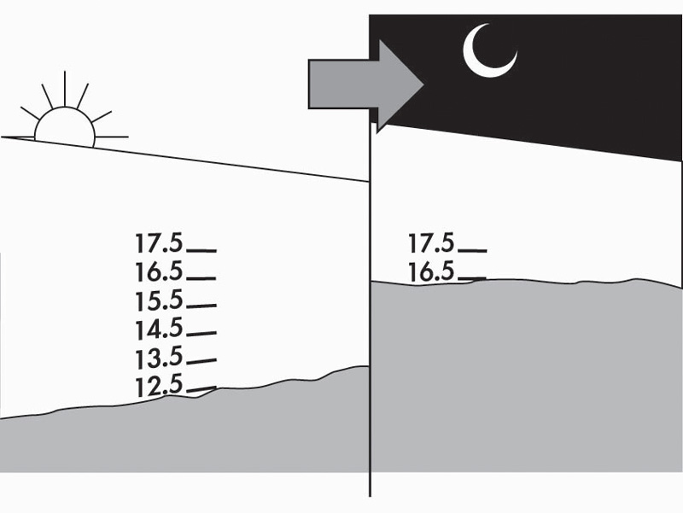
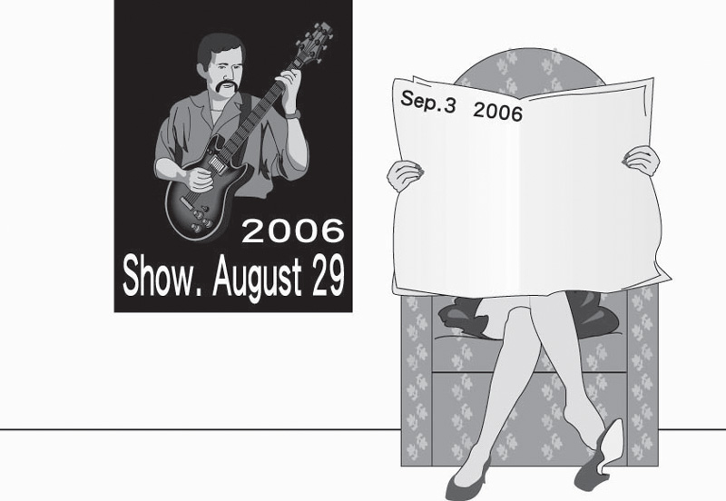
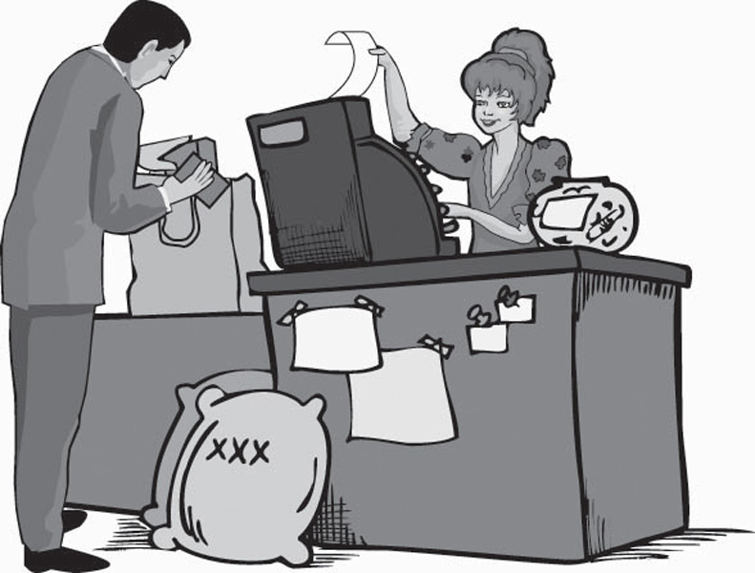

Part B
In part B, you will hear one or more questions or statements. Choose the best response
or reply.
4. (A) I cook it in that oven.
(B) I eat it on the balcony.
(C) I buy it at the supermarket.
(D) I keep it in the basement.
5. (A) To link the towns on the two sides of the mountain.
(B) To give children a place to play baseball safely.
(C) To block animals from coming into the town at night.
(D) To give the trees and flowers in the park more sunlight.
6. (A) Oh no, why did he get fired?
(B) We’d better send him to the hospital.
(C) When will he come back?
(D) Really? Who did he hit?
7. (A) Yes, it went very well.
(B) No, it ended in a fight.
(C) Yes, it was canceled.
(D) No, it was really long.
8. (A) Then take a rest if you’re tired.
(B) What makes you say it’s not healthy?
(C) Oh, so it’s against the law?
(D) Yeah, I think it’s fun, too.
Part C
In part C, you will hear one or more short conversations between a man and a woman, and then a question following each conversation. Choose the best answer to that question.
9. (A) Getting started on working for his new ID card was difficult.
(B) Feeling happy after getting his new ID card was difficult.
(C) Going through the steps to get his new ID card was difficult.
(D) Telling his parents why he got his new ID card was difficult.
10. (A) That the man should get paid for playing tennis.
(B) That the man wasted his time practicing for so long.
(C) That the man has gotten much worse at tennis.
(D) That the man’s long hours of practice were worth it.
11. (A) He was told he would have to work harder.
(B) He lost his job earlier in the day.
(C) He quit his job earlier that day.
(D) He lit a fire by accident.
12. (A) That she always eats them in the park.
(B) That they all come from the forest.
(C) That they’re all cheaper than at other stores.
(D) That they are not changed by humans.

Part D
In part D, you will hear one or more passages and then some questions about them. Choose the best answers to those questions.
Richard likes to read blogs. He gets all the information he needs about the world from blogs. Richard is too busy to read the newspaper every day. His favorite kind of blog is movie reviews. He thinks ordinary people have a better idea about whether a movie is good or bad. Sometimes Richard writes back to the blogger’s message board. He does so to give his opinions on how to make the blogs better. He uses blogs a lot and wants them to be the best that they can be.
13. (A) To tell people what he thinks about the world.
(B) To meet interesting people around the world.
(C) To get the facts he needs about the world.
(D) To stop himself from thinking about the world.
14. (A) Blogs that invite people to parties.
(B) Blogs about people’s views on movies.
(C) Blogs that help him with his homework.
(D) Blogs about funny new jokes.
15. (A) To tell the writers about his life in high school.
(B) To give people the address where he lives.
(C) To ask for more information about a subject.
(D) To give his views on how to make the blogs better.

Textbook (Lungteng English Reader: Book One L1~L4)
II. Cloze Test: 35 %
(1)
Before, I had always hoped to stand out among my peers. In other words, I had wanted to be the big man in my crowd. To me, being a leader meant everyone would listen to me all ears and __16__ I did or said would have a great influence on them. Thus, I did anything crazy to __17__ people’s attention. First, I thought it would be cool to make myself different from the others by __18__ my hair, so I changed it into blond. __19__ a tattoo was the latest fad and I, of course, followed the trend. __20__ I tried any means possible to look “my own way,” I still had a strong desire that I could __21__ by my crowd. I guess that was why I usually hung out all night at a KTV. I spent a lot of time with my “ buddies “ and hopefully they thought of me as part of them. I thought this would make me more popular with the guys. Not until one day did I wake up and come to realize I was __22__ myself. But __23__ I stopped __24__ things like those I had done before, all my friends ignored me. I hated that but did not know what to do.
16.(A)what (B)how (C)that (D)which
17.(A)give (B)attract (C)take (D)make
18.(A)dying (B)drying (C)dyeing (D)dieing
19.(A)Having (B)Have (C)Had (D)Having been
20.(A)Though (B)Because (C)When (D)If
21.(A)accept (B)be accepted (C)have accepted (D)have been accepted
22.(A)not more (B)any more (C)at all (D)no longer
23.(A)as far as (B)as long as (C)as soon as (D)as high as
24.(A)to do (B)doing (C)having done (D)to have done

(2)
Have you wondered __25__ children pick up a language so naturally and easily ? According to studies, it is not because they have greater language abilities __26__ adults. __27__, research shows that an adult’s potential to learn a language is just as good as a __28__. However, children seem to learn a language more __29__ than __30__ of us. Why ? It’s __31__ the way they learn. They learn __32__ simply doing what comes naturally---- they listen, copy and communicate. If we __33__ a close look at how children learn a language, we may find a better, more natural way of learning English.
25.(A)what (B)how (C)why (D)when
26.(A)as (B)that (C)then (D)than
27.(A)In reality (B)No wonder (C)By nature (D)For sure
28.(A)child (B)children (C)child’s (D)children’s
29.(A)frequently (B)slowly (C)quickl (D)normally
30.(A)the rest (B)the other (C)another (D)others
31.(A)because of (B)because that (C)because (D)because so
32.(A)in (B)of (C)with (D)by
33.(A)make (B)take (C)get (D)do

(3)
Nowadays we like to contact one another by email because it offers great advantages. __34__, it’s fast. All we have to do is __35__ the messages and send them out; friends will write back quickly. For another thing, using computer __36__ us to choose our words carefully. We can change our mind __37__ as we want before sending email. Besides, it is a good way __38__ writing, for the computer helps us __39__ our spellings and show errors in grammar. And it is helpful to students; they can email their assignments or reports to the teachers and get back the revised copies __40__. Best of all, we don’t need to __41__ time zones. We can send our thoughts to our friends whenever we want to.

34.(A)For example (B)For instance (C)For one thing (D)In addition to
35.(A)type (B)typing (C)ignore (D)ignoring
36.(A)makes (B)lets (C)enables (D)offers
37.(A)as much time (B)as any times (C)as many times (D)as more times
38.(A)to practicing (B)to practice (C)of practice (D)in practicing
39.(A)do (B)doing (C)check (D)checking
40.(A)all the way (B)by the way (C)in a way (D)in the same way
41.(A)bring about (B)wonder about (C)hang about (D)worry about

(4)
My father had a stroke last winter. That night, I heard my mom screaming my father’s name. I rushed to the room and found him __42__in the chair. We called 119 and waited for the medics to get to our house. Suddenly, a lot of questions __43__ my mind: What was happening? Why him? Why me? I wish I __44__ him that I loved him. When the medics came and rushed him to the hospital, I prayed to God to __45__ my father. Fortunately, my prayer __46__. As the doctor declared that my father would get well, I couldn’t help crying. Since then, I __47__ that nothing is certain. We ought to cherish the things that we have now. Therefore, when the family get together to have dinner, we enjoy __48__ . Now, dinner time isn’t just time to fill our stomachs. It’s time to fill our heads and hearts __49__ memories that will stay with us forever. I strongly believe this: only when it’s almost taken away __50__ what you have.

42.(A)sit (B)sat (C)seated (D)seating
43.(A)got into (B)came into (C)filled in (D)ran into
44.(A)tell (B)telling (C)told (D)had told
45.(A)take (B)spare (C)spoil (D)realize
46.(A)was asked (B)was refused (C)was answered (D)was revealed
47.(A)realized (B)have realized (C)had realized (D)am realizing
48.(A) each other company (B) each other’s company
(C) each other companies (D) each other’s companies
49.(A)for (B)of (C)by (D)with
50.(A)you realize (B)you do realize (C)do you realize (D)realize you

III. Matching: 5 %
51. Unlike his classmates, … (A) where you can talk about music.
52. It’s dangerous…. (B) that he will pass the exam.
53. I like Halloween, (C) to offer help whenever possible.
54. Join an English club….. (D) Tom didn’t show up at the party.
55. The student is certain … (E) but I like Christmas better.
(AB) for a child to play with fire.
(BC) Helen did all she could do to help.

IV. Reading comprehension: 10%
Some English learning tasks need your full attention; for example, if you are writing an essay or doing a translation, you may need to focus on it. But a lot of language learning can be done in trivial time such as when you are waiting for the bus or when you are washing up. In fact, it seems that the best way to learn a language is to work at it little and often. That is, you’ll get better results in regular studying for comparatively short periods of time than in less frequent studying for longer time. Working in this way may be more enjoyable and there is more continuity in your learning.
Use trivial time to listen to English programs on the radio, or to practice new vocabulary. Set aside half an hour or so to watch English movies or English TV programs. Besides, you can also read English newspapers or watch English news on TV to find out what is happening in the rest of the world. Of course, the Internet is the best source of up-to-date news, so make sure that you bookmark useful sites in English. You could surf one or two of these sites for a couple of minutes every time you sit down to use the computer. Although there are many ways to pick up English, you can’t just give up the ways soon after you try them. In fact, if you want to master it, you have to be persistent in the ways you improve your English ability.
56.According to this passage, a lot of language learning can be done in trivial time such as_________.
(A) listening to a lecture (B) taking an exam (C) taking a nap (D) taking a shower
57.There are many ways suggested in this passage to learn English. Which of the following
is NOT mentioned ?
(A) Watching English TV programs.
(B) Surfing the English websites.
(C) Attending classes in language schools.
(D) Listening to English programs on the radio.
58.What does the Internet provide in learning Engllish ?
(A) The latest news for English learners.
(B) The out-of-print news for English learners.
(C) The out-of-fashion news for English learners.
(D) The last news for English learners.
59. According to this passge, which of the following is the best way to learn a language ?
(A) Study for short periods of time frequently.
(B) Study for 8 hours a day without a break.
(C) Study at any time you want to.
(D) Focus on every language task.
60. The word “ persistent “ in the last sentence means _________.
(A) being changeable all the time (B) lasting for a long time
(C) taking new challenges (D) using for a long time

( 以下各題請在答案卷上作答 )
V. Vocabulary: 25%
- It is a Chinese c____m to eat moon cakes and pomelos on the Mid-autumn Festival.
- Talking with foreigners is regarded as an e____e way of learning English.
- John called his sister and left a m___e for her on the answering machine.
- It’s great to live next to a c____e store; I can always get something to eat when I’m hungry.
- It was an o____y day; nothing special happened.
6. Joe’s father had a stroke last summer and it took him a year to r____r.
7. The little boy s____e that he would never lie to his parents and teachers.
- Flea markets are the ideal places for shopping. They usually offer good b____ns to the customers.
- Being nice to your friends is d____y a good idea.
- The Niagara Falls in North America is quite i_____e.
- When I r_____ed I missed my mother’s birthday, I called her to say sorry.
- The table is g____e antique; you must handle it with care.
- The injured person was taken to the hospital by a____e.
- For the students with music p____l, school offers special education to them.
- Parrots are birds loving to m____c how people talk.
- If you have any suggestion, please c____e with me. I am happy to help you.
- To pay her way through college, Amy has been t____ring students after school.
- When left home alone, the little girl felt i____e and could not stop crying.
- With an outgoing p____y, Julia makes friends easily.
- Bad habits are easy to d_____p but hard to get rid of.
- She has trouble learning English _____ ( pronounce ).
- Dental checkup twice a year is _____ ( benefit ) to your health.
- We have _____ ( confident ) that we will win the game.
- Mom is a loving person and she is always_____ ( support ) of my decision.
25.The bodyguards ______ (company) the movie star to the theater last week.

VI. Translation :10% ( 每個空格不只填一字 )
1. Sam 對超人很著迷。他堅持在萬聖節扮成超人而非怪物。
Sam is crazy about Superman. He insists on __1__ Superman __2__ a monster
at Halloween.
- 為了改善英文，Tim儘可能經常聽英語廣播節目
__3__ improve his English, Tim listens to English broadcasting programs __4__.
3. 老師們感到很高興且對學生的進步快速而自豪。
Teachers felt very happy and t__5__ their students’ progress.
4. 總之，有幽默感的人是受歡迎的。
__6__, a person with a __7__ is popular.
5. 不要把父母給你的愛與關懷視為理所當然。
Don’t __8__ all the care and love your parents give you.
6. 當她聽到壞消息，眼淚奪眶而出。
She __9__ when she heard the bad news.
7. 我們應該藉著電子郵件保持聯繫。
We should __10__ with each other by email.

台北市立松山高中九十五學年度第一學期高一英文科第一次期中考答案紙

Class: _________ No:___________ Name: ______________________

V. Vocabulary : 25%

1. | 2. | 3. | 4.
5. | 6. | .7. | 8.
9. | 10. | 11. | 12.
13. | 14. | 15. | 16.
17. | 18. | 19. | 20.
21. | 22. | 23. | 24.
25.

VI. Translation: 10%

1. | 2.
3. | 4.
5. | 6.
7. | 8.
9. | 10.

