台北市松山高中九十五學年度第一學期高一英文期末考試題

聽力測驗 (共25%) 注意: 第1- 7題唸兩遍

Part A (第1-3題)： 3% 兩遍
Look at the pictures below. For each, you will hear one or two questions and four possible answers, A to D. Write down the letter for the best answer (A, B, C, or D).

Questions 1-2 Question 3
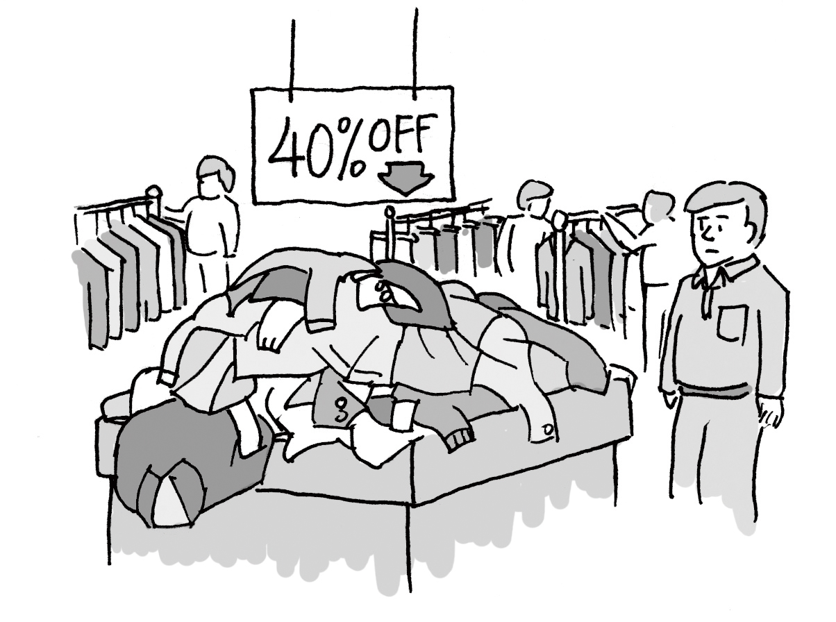
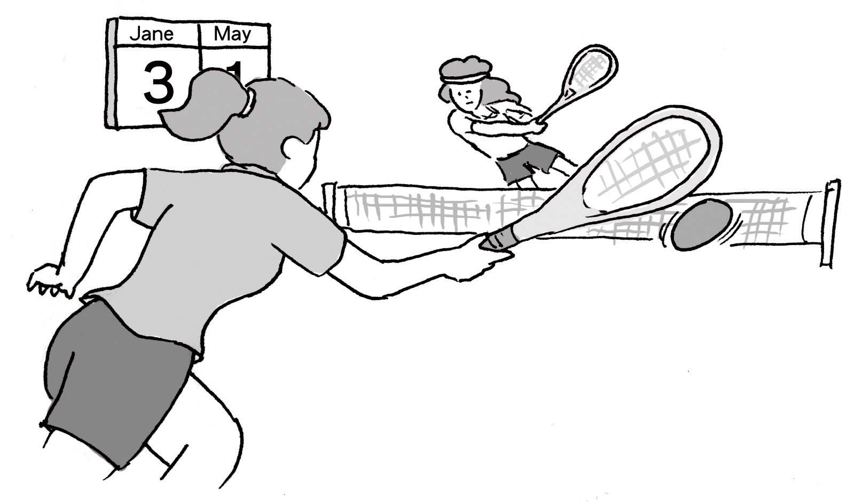

Part B （第4-7題)： 4% 兩遍
In part B, you will hear one or more questions or statements. Choose the best response or reply.

Part C (第8-11題)： 4%
In part C, you will hear one or more short conversations between a man and a woman, and then a question following each conversation. Choose the best answer to that question.
8. (A) That the man is really nice.
(B) That she will help him.
(C) That she is really busy.
(D) That Sarah will make him do all her work.
9. (A) That she’ll make something other than steak.
(B) That she’ll make the steaks at a later time.
(C) That she’ll serve the steak on different dishes.
(D) That she’ll prepare the steaks in a different way.
10. (A) That he doesn’t care whether their team wins the game or not.
(B) That their team’s chances of winning depend on the weather.
(C) That he’ll go down to the park to watch the woman’s next game.
(D) That their team will lose no matter what the weather is like.
11. (A) He still remembers how to extend and lengthen his muscles.
(B) He doesn’t remember anything from his class anymore.
(C) He remembers how to do all the exact poses he was taught.
(D) He only remembers how to twist his muscles painfully.

Part D (第12-15題) : 4%
In part D, you will hear one or more passages and then some questions about them. Choose the best answers to those questions.
Passage 1:

12. (A) To celebrate the closing of the theater.
(B) To welcome foreign visitors to the city.
(C) To try to raise money for poor actors.
(D) To celebrate the theater’s 20th birthday.
13. (A) It combines Beijing opera and Western styles.
(B) It tells the story of life in modern China.
(C) It is performed in English with Chinese music.
- It is the same as an ancient Chinese play.

Passage 2:
14. (A) A barbecue was held outside the building.
(B) Live music was played by bands.
(C) A movie was made about the building.
(D) The stores in the building had a big sale.
15. (A) All the lights are turned off inside the building.
(B) Free tickets to enter the building are handed out.
(C) The colorful lights outside the building light up.
(D) The restaurants in the building give out free food.

4Ｕ字彙: 5% (Some of the forms should be changed in the blanks.)
(A) profit (B) purchase (C)surround (D)concentrate (E)separate (AB) nutritious (AC) competition (AD) revealing

16. They made a _____ by selling their house.
17. Jason was hoping to win the swimming ________.
18. A wall ______ the schoolyard from the street.
19. Blueberries are one of the most _______ and delicious fruits.
20. I need to ______ on my studies.

４U片語: 5% (Some of the forms should be changed in the blanks.)
(A)try on (B)wind up (C) come down to (D)date back to (E)all the rage
(AB) give…the thumbs up (AC) take… to a new level (AD) be accused of

21. I’m wearing chains. They are ______ in fashion today.
22. How come such a nice person could ________ murdering the millionaire?
23. We have to go faster or else we’ll ______ being late.
24. Wow! The coin is an ancient treasure that ________ the Roman Empire.
25. Some people think that talent doesn’t all ________ brain power. Encouragement
is also needed in child’s development.

課本部分(共75%)
I.克漏字選填: 25%
People wonder why the famous cellist Yo-Yo Ma could 26 such a beloved and successful musician. Obviously, his excellent musical skills are an important reason. Another reason is 27 both his family education and his unique viewpoints on music lead to his success. Ma’s father, who is a Chinese, was very strict and expected his children to be 28 . Under his father’s instruction, Ma learned American values and Chinese values at the same time. This kind of growing up in a 29 environment helps to shape Yo-Yo Ma’s music style. Ma does not limit himself to classical music. 30 , he tries to perform different kinds of music. In Yo-Yo Ma’s view, music is a way of bridging the gap between cultures. That is why he is always trying to find ways to 31 the East 31 the West through music. Yo-Yo Ma’s music has won universal recognition. To honor his achievements in music, the Mayor of New York City even had a street
32 Yo-Yo Ma for a day.
26. (A) result in | (B) bump into | (C) develop into | (D) run into
27. ( A) because | (B) which | (C) why | (D) that
28.(A)well-educating | (B) well-behaved | (C)well-mannering | (D) well-done
29. (A) sociable | (B) multi-cultural | (B) respectful | (D) humble
30. (A) Eventually | (B) To our sorrow | (C) Apparently | (D) Instead
31. (A) add… to | (B) beg…for | (C) fill…with | (D) unite …with
32. (A) call | (B) name after | (C) named after | (D) naming after

There is an old saying, “Great inspiration begins with a dream.” For most high school students, it is important to have dreams. In some sense, dreams are ideals or goals which motivate them to work harder. Take Jason for example. He read reports 33 Dr. Jane Goodall when he was in elementary school. For the purpose of 34 her research, Jane Goodall lived for more than twenty-five years in the rainforests of Africa. 35 , she also called attention to the rights of wild animals. 36 by Jane Goodall’s story, Jason has dreamed of becoming a vet and working to protect and save animals.
33. (A) on | (B) for | (C) over | (D) in
34. (A) making | (B) doing | (C) working | (D) taking
35. (A) Beside | (B) In addition to | (C) As a result of | (D) In addition
36. (A) Inspiring | (B) To inspire | (C) Inspired | (D) To be inspired

Puppy love is a type of love between boys and girls, especially when it occurs at a young age, but often doesn’t 37 long. A typical example is Peter’s falling in love with Jane. Peter and Jane were classmates. To 38 Jane’s attention and win her heart, Peter played some tricks. He first put a peach on Jane’s desk. He then showed her a fancy picture—a house 39 . Finally, he showed her the notebook in which “I Need Your Kiss!” was written. Jane 40 these “gifts” in the beginning. However, she gradually became interested in Peter. Although she blushed at Peter’s words, she felt 41 .
37.(A) last | (B) subside | (C) desire | (D) resemble
38. (A) pay | (B) catch | (C) focus | (D) achieve
39. (A) which have some smoke |  | (B) with some smoke came out of the chimney
(C) with some flowers around it |  | (D) with a fence surrounds it
40. (A) insisted | (B) assisted | (C) resisted | (D) existed
41. (A) pleasing | (B) pleased | (C) pleasure | (D) delightful
There is one basic rule of farm life: Don’t get emotionally attached to the animals. 42 most farmers in the village, Mr. Arable plans to kill the little pig near Christmas. 43 hearing the news, young Fern Arable can’t help herself. She loves the little pig and will surely 44 ways to save him. She begs to keep him 45 her pet. At first, her father won’t allow it, but then agrees Fern can keep him, 46 this will teach her the hard reality of life on the farm. Fern gives the pig the name “Wilbur”. Wherever she goes, she 47 this new pet.
As time goes by, Wilbur turns into 48 strong and healthy a pig 48 he can no longer be kept in the house. Mr. Arable 49 that Wilbur stop acting like a family pet and start living like a farm pig. He praises his daughter for bringing him up so well and sends Wilbur down the road to her Uncle Zuckerma’s farm. Fern is heartbroken. 50 , she fears that her pig will turn out to be a Christmas dish on the dinner table.
42. (A) Unlike  43. (A) At  44. (A) lead  45. (A) as  46. (A) believes  47. (A) follows  48. (A) such…that  49. (A) discovers  50. (A) In fact | (B) Like  (B) In  (B) think  (B) for  (B) believing  (B) keeps in touch with  (B) so…that  (B) expects  (B) As a result | (C) Dislike  (C) On  (C) look for  (C) into  (C) and believe  (C) is combined with  (C) whether…or  (C) appears  (C) This way | (D) Likely  (D) Over  (D) in search of  (D) from  (D) and believing  (D) is followed by  (D) either…or  (D) insists  (D) For one thing
II. 文意選填: 5%
(A)resulted from | (B) got into | (C) regard as | (D) serve as
(E) comment | (AB) dependable | (AC) tolerant | (AD) for a while
(AE) for life | (BC) urge
Good teachers are not just persons who assign homework, give examinations and 51 students to work harder. In fact, good teachers teach students lessons
52 and inspire them to think and live independently. They 53 a bridge over which students cross to a new understanding of the world. Jason felt lucky to have a good teacher, Miss Lee, in senior high school. Once he 54 a big quarrel with his classmate over a small thing. Miss Lee led him to understand that things are not always black and white and that it is crucial to be more 55 of others.

III. 配合題: 5%

56. My brother is not good at driving,  57. You should get up earlier  58. As nature changes with seasons,  59. How I wish  60. By the time he arrived at the theater, | (A) so is his girlfriend.  (B) I could have joined the party last week.  (C) just like the green doesn’t stay long.  (D) the concert had started.  (E) lest you should catch the first bus.  (AB) so as to attend the meeting on time.  (AC) so do human beings with the age.  (AD) nor is my sister.

IV. 閱讀測驗: 10%
(A) People have always dreamed of being able to walk on the moon. In 1969, this dream was made possible when an American named Neil Armstrong became the first person to step onto the lunar surface.
Neil Armstrong was born in August 1930. He grew up during the Second World War and as a young boy, all he wanted to do was fly. On his sixteenth birthday, he received his pilot’s license. Armstrong joined the US Navy as a pilot when he was nineteen and afterwards, went to university where he studied flight engineering. In 1955, Armstrong became a test pilot for new aircraft.
In 1962, the National Aeromautic Space Administration (NASA) selected Armstrong to become an astronaut. In 1969, NASA offered Armstrong the greatest challenge in space exploration. They chose him to be the commander on the first manned mission to the moon.
In July 1969, Neil Armstrong and Edwin Aldrin set off for the moon on the rocket Apollo 11. Their rocket took two days to travel 384,000 kilometers to reach the moon. People around the world were anxious as they watched television for news of the mission. On July 20 1969, the rocket landed safely. Shortly afterwards, Neil Armstrong opened the hatch and stepped out. Armstrong’s first words on the lunar surface were: “That’s one small step for man, and one great leap for mankind.”
When Armstrong retired from NASA in 1971, he was the most famous astronaut in the world. Ever since, Neil Armstrong continued to speak about his experience on the moon and space exploration. In the future, he will certainly be remembered as the man who made the greatest dream of mankind a reality.

- Armstrong went to college after he _______________.
  - became a test pilot
  - served in the military
  - went on a mission to the moon
  - was selected to become an astronaut

- According to the article, which statement is NOT true?
(A) Armstrong had a dream of being able to fly since his childhood.
(B) Armstrong’s mission to the moon was a great achievement to mankind.
(C) Armstrong did nothing related to his flying experience after his retirement.
(D) No man ever traveled to the moon before Armstrong’s mission on Apollo 11.

(B) In the winter of 1818 at St. Nicholas' Church in Obendorf, a village not far from Salzburg, Joseph Mohr, assistant to the priest, was faced with a problem. It was only days before Christmas, and the church organ, so important in providing music for the services, was broken and would not be repaired before Christmas.
While worrying about the situation, Mohr suddenly remembered that two years earlier, he had written a simple poem, easily understood by the people of the village, which expressed the wonder of the birth of the Christ Child. The next day Mohr went to see the church organist, Franz Gruber, to compose music for his poem, so that they might sing it together using a guitar as an accompanying instrument. Since it was an emergency, it took Gruber only a couple of hours to come up with the melody.
Thus, the newly-composed carol was first performed during the Christmas Eve midnight service held at St. Nicholas' Church on December 24, 1818. However, it was not widely known until some years later, in 1825 when Carl Mauracher was rebuilding the broken organ, that a handwritten copy of the words and accompanying sheet music was discovered in the organ loft.
Mauracher took the music and words of “Silent Night” back to his own Alpine village, Kapfing. It soon became a favored song with the traveling singers. Thus, "Silent Night, Holy Night" spread as these choirs journeyed the countryside, singing their songs.
Silent night! Holy night!
All is calm, all is bright!
‘Round yon virgin mother and child!
Holy infant, so tender and mild,
Sleep in heavenly peace,
Sleep in heavenly peace.

- Which statement is true about Mauracher?
(A) He is a church organist.
(B) He is a traveling singer.
(C) He is a poet and musician.
(D)He is an organ repairman.

- What was the problem Joseph Mohr met with?
(A) He did not know what to speak to people at the service.
(B) His church did not have any choirs to sing the Christmas carol.
(C) The church organ did not work and get fixed before Christmas.
(D) He did not know how to express the wonder of the birth of the Christ Child.

- According to the article, which statement is true?
(A)“Silent Night” was first written in German.
(B)“Silent Night” was first sung without any musical instrument.
(C)The melody of “Silent Night” was first played by the organ.
(D)“Silent Night” was written in the form of a poem with the rhyme pattern of aabbaa.

V. 文意字彙: 20%
- My favorite singer was n______ted for the best female singer of the year. I hope she can win the award.
- The restaurant is famous for its delicious Japanese food. However, to my disappointment, the service there is poor and doesn’t live up to my e__________ns.
- Darwin’s Theory of E_______n is an important book in biology. It studies the gradual development of animals and plants as they adapt to the changes in the environment.
- While he was serving in the m______y, his girlfriend broke up with him and made him brokenhearted.
- After my uncle retired, he worked as a v______r in the hospital to help the sick.
- We may learn to a_______e and enjoy the beauty of Nature. It is good for mental health,
- My mother is good at b______ging with street vendors; she always buys things at a pretty low price.
- When we make some mistakes, we have to face them. We can’t p_____d nothing happens.
- Peter, a tour guide, enjoys a life full of a_______e. He travels a lot and experiences new and surprising things.
- As we grow up, we need to learn to see things from different p_______es. Otherwise, we might become too narrow-minded or stubborn.
- High school life is an important stage in life. It is time when we learn to be independent and take r_______y for what we have done.
- We need to build up a ______(fluent) in spoken English if we want to go to America for advanced studies.
- A great number of fans were amazed at the _________ (reveal) about the famous singer’s private life in the newspapers.
- __________(create) thinking is crucial to good education. Students should be encouraged to think about problems in a new way.
- Barbara is one of the most valued e______es in the company. Few workers are as capable and responsible as she. No wonder she is well-paid.
- It is a Chinese t________n to offer red envelopes on Chinese New Year’s Eve.
The custom has been passed down for generations.
- The express company promises to d______r goods and letters within 48 hours.
83. You had better be careful to r______e your daily schedule, so that you can get
everything done under your control.
- To appreciate the first sunlight of 2007, they arrived at the beach at d_______n waiting for the sunrise.
- Bruce d_______yed his parents and was told to be grounded for the weekend.
His parents were really mad at his acting against the family rules.

VI. 翻譯填充: 10% (每格不只一字)
86-87. 雖然他很窮,他盡力給小孩最好的教育。
D_____________________ he was poor, he __________ to offer his children good education.
88-89. 該是你採取一些步驟實現夢想的時候。
It is time for you to _____________________ to ______________________.
90-91. 這張照片讓我想起已故的祖父,我熱淚奪框而出。
This picture ________________ my late grandfather; I b_________________.
92-93. 他從學校出來，發現腳踏車被偷了。他將為自己的粗心接受責難。
He came out of school and . He would t________________ his carelessness.
94-95 自那時以後，她不再看輕窮人。
She has never the poor _________________.

台北市松山高中九十五學年度第一學期高一英文期末考答案紙
班級________________ 座號____________ 姓名________________

V. 文意字彙: 20%

66. | 67. | 68. | 69.
70. | 71. | 72. | 73.
74. | 75. | 76. | 77.
78. | 79. | 80. | 81.
82. | 83. | 84. | 85.

VI. 翻譯填充: 10%

86. | 87.
88. | 89.
90. | 91.
92. | 93.
94. | 95.

950103 高一英文期末考解答

(除61-65 各2%，餘皆1%)

1-15 BDCCA CBDDB ADABC
16-20 A /AC /E /AB / D 21-25 E/AD /B /D /C

26-32 CDBBDDC 33-36 ABDC
37-41 ABCCB 42-50 BCCABDADA
51-55 BC/ AE / D / B / AC 56-60 AD/ AB / C / B / D
61-65 BCDCA

66-69 nominated expectations Evolution military
70-73 volunteer appreciate bargaining pretend
74-77 adventure perspectives responsibility fluency
78-81 revelation(s) Creative employees tradition
82-85 deliver regulate dawn disobeyed

86. Despite the fact that 87. tried his (level)/(utmost) best
utmost

88. take some steps 89. fulfill/ realize/ carry out your dream
make your dream fulfilled/realized/
carried out/ come true

90. reminded me of 91. burst out crying/ burst into tears

92. found his bike stolen 93. take the blame for

94. looked down on/ upon 95. (ever) since then

