台北市立松山高中九十五學年度第二學期高一英文科第一次期中考試題

(第1-60題請在電腦卡上作答)
I. Listening Test: 15%
(A) Matching
In this section, you’ll hear three different sentences. Please choose the best picture that matches each sentence, and fill A, B or C in the blank.
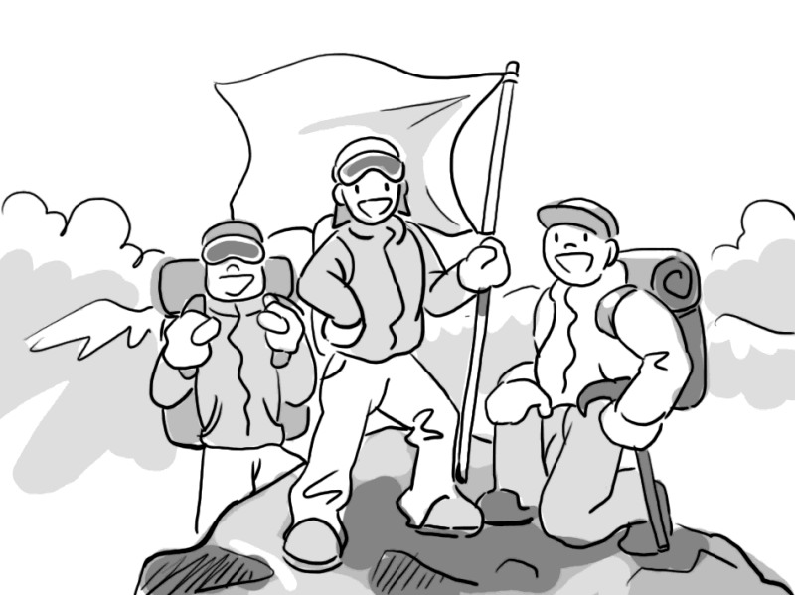  1. _______ | 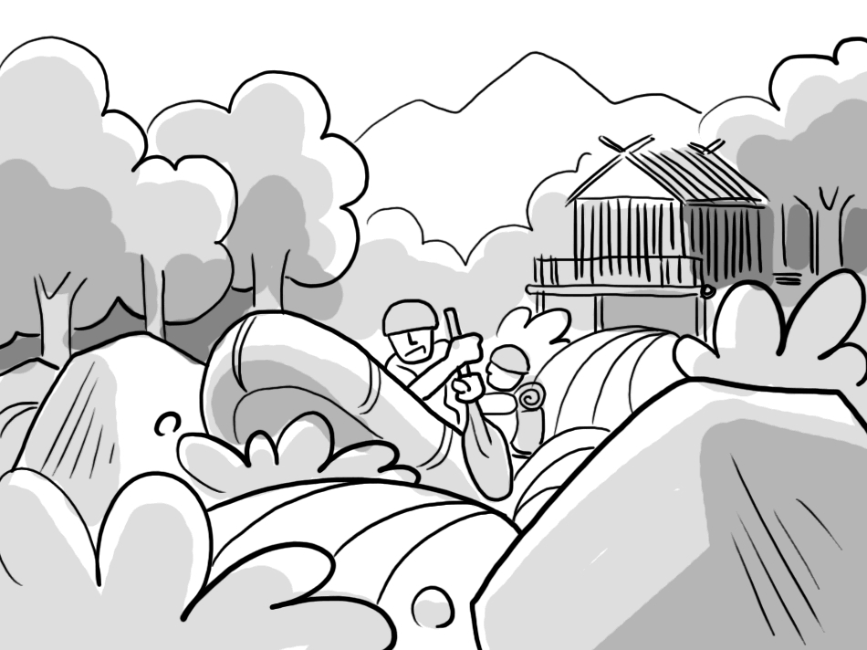  2. _______ | 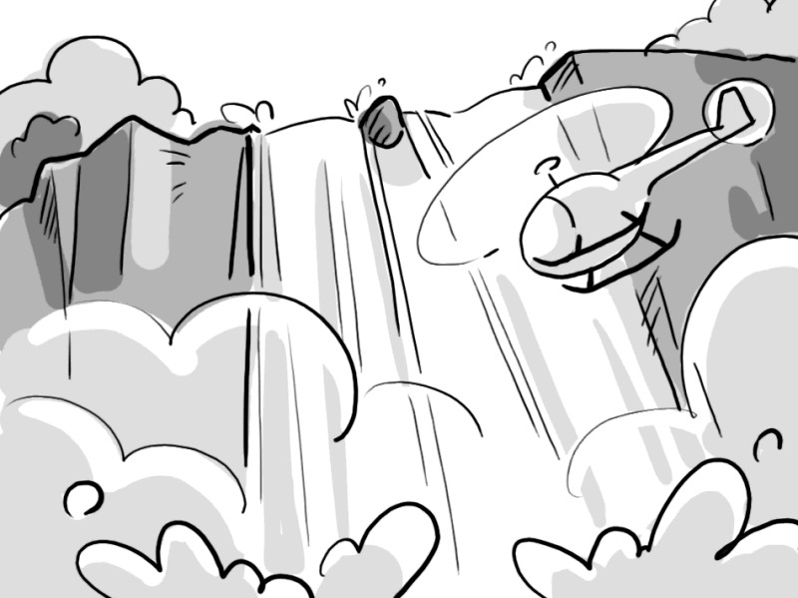  3. _______

(B) Best Response
Choose the best response to each question or statement.

4. | A. He must be terribly spoiled.  B. What are friends for?  C. You must be furious.  D. That was so kind of him.
5. | A. Don’t blindly follow the herd.  B. That’s something an adult does.  C. You should never refuse your friends.  D. Why do you enjoy smoking?
6. | A. He didn’t want to be a fortuneteller.  B. Can’t you just stop being envious?  C. It’s said he invested in real estate.  D. He is a poor man.
7. | A. Why are your hands so clumsy?  B. Then I guess your hands are tied.  C. Why not use your feet instead?  D. Rub them together to warm them up.
8. | A. I am not so happy about it.  B. I poured some rain on it.  C. I walked through the mist.  D. I should’ve let you know earlier.
9. | A. They want more simulated exhibits.  B. They want us to interact with them.  C. They want to teach us about science.  D. They want to prevent our observation.
10. | A. It was very creepy.  B. It was admission free.  C. Think twice before you ask.  D. Have you ever seen a torture device?
(C) Short Conversations
Listen to the conversations. Then choose the best answer for each question.

11. | - The coming rain spoiled her plan.  - She doesn’t join any activities on the weekends.  - Watching TV is her temporary plan.  - Her roommates stood her up.
12. | - The woman has a big appetite.  - The watch is very expensive.  - The shoes cost more than the watch.  - The shoes have holes in them.
13. | - The novel spoiled his appetite.  - He doesn’t like their smell.  - He is not hungry.  - He wants to finish the novel first.
14. | - Once in a lifetime.  - It’s a deal.  - It’s hard for me to catch on.  - But I can’t do white-water rafting.
15. | - Dinosaur skeletons.  - Plant fossils.  - Space capsules.  - An art show.

II. Fill-in: 10%
Please fill in the following sentences with the correct word or phrase in the box.

(A) persistent (B) simulated (C) wilderness (D) charged (E) particles (AB) tribal
(BC) garlic (CD) moody (DE) launch (AC) appetite (AD) pour

16. Lisa is too _______ to make friends with. She gets annoyed easily.
17. You can experience a _______ flight into outer space in a science museum.
18. Crossing the frozen _______ of Alaska is a thrilling adventure.
19. In northern Thailand, you can stay in villages of _______ people and experience their way of life.
20. The company is going to _______ a new model next week.
21. I can’t call you right now because my cell phone is not _______.

(A) scuba diving (B) upper class (C) street hockey (D) admission fee
(E) a stock trader (AB) space capsule (BC) the Article Circle
(CD) an adrenaline rush

22. John made a fortune as _______ in New York.
23. Justin saw large sea turtles swimming alongside schools of tropical fish when he went _______.
24. Bungee jumping is surely to promise you ________.
25. In the old days, only people from _______ could enter museums.

III. Cloze: 25%
Mr. Yeh, my best friend, told me that he deeply falls in love with a pretty girl, Miss Sparrow. He got more fun from watching her in the classroom _(26)_ doing the reading in his study. Since Mr. Yeh is an honorable student, he feels tough in pursuit of his dream lover. He could _(27)_ catch her eyes by playing belly dance to her face nor _(28)_ her laugh by playing jokes on his classmates. He wondered what to do and _(29)_ to do it well to arouse her curiosity to him. As a matter of fact, he once gave Miss Sparrow a “love spoon” in token of his love toward her, but it seemed to be useless. _(30)_, he struggled for her love unfailingly and decided to make a cake on her birthday. _(31)_ everything done, Mr. Yeh took the cake into the room. His another classmate, Mr. Cool, _(32)_ the applecart. He touched Mr. Yeh on the shoulder, _(33)_ let the cake _(34)_ his hand and fall onto the ground. The mashed cake couldn’t work of course, but Mr. Yeh’s thoughtfulness at this time really touched Miss Sparrow’s heart. From that time on, they’ve gone stay for a long while. Their story reminds me _(35)_ the saying: “Love conquers all.”

( ) 26. (A) by (B) that (C) than (D) instead of
( ) 27. (A) neither (B) either (C) scarcely (D) hardly
( ) 28. (A) making (B) to make (C) made (D) make
( ) 29. (A) what (B) that (C) how (D) which
( ) 30. (A) Still (B) Hence (C) Whatsoever (D) Although
( ) 31. (A) On (B) For (C) Upon (D) With
( ) 32. (A) handle (B) blinked (C) conditioned (D) upset
( ) 33. (A) that (B) which (C) whose (D) of which
( ) 34. (A) sprang up (B) slipping off (C) to slip off (D) slip off
( ) 35. (A) to (B) on (C) of (D) about

Asked by one of my students the other day what he should do to_(36)_ his relationship with his parents, I _(37)_ suggesting that he read some nice books. As food is to the body, _(38)_ books to the mind. Reading does good to a rebellious student. However, not every book is _(39)_ reading. You cannot be too careful in choosing one as your mentor. A very popular book of advice for young people, _(40)_ “Chicken Soup for the Teenage Soul” is often thought to be a worthwhile book. One could get a lot from reading it. The book I want him to read deserves not only sipping but meditating _(41)_. He will be _(42)_ his parents want him to be. I see no reason why he shouldn’t take my advice seriously. For one thing, he will have no difficulty (43)_ his parents. For another, he won’t get into trouble anymore. No one ever said it was easy growing up. Only when you get in touch with books _(44)_ the solution to your problems. I don’t know whether my student will take his defeat well, but I will be happy he grows up through _(45)_.
( ) 36. (A) fix up (B) mess up (C) set off (D) slip off
( ) 37. (A) was no hesitating (B) didn’t fail to
(C) couldn’t help (D) couldn’t help but
( ) 38. (A) is that (B) so are (C) as are (D) so do
( ) 39. (A) worthy of (B) worthwhile (C) worthy (D) worth
( ) 40. (A) to entitle (B) entitling (C) entitled (D) entitle
( ) 41. (A) as well (B) alike (C) alone (D) like
( ) 42. (A) the moment (B) the instant (C) the way (D) the minute
( ) 43. (A) communicating with (B) to talk to (C) chat with (D) on having a chat with
( ) 44. (A) you will find out (B) can you find
(C) you might get the idea about (D) he can look them in the eye
( ) 45. (A) trial and error (B) castle in the cloud
(C) mental and physical health (D) keep body and soul together

As soon as my sister went to primary school, the school staff there _(46)_ impressed how talented she was. They made a deal with her, and tried to train her to be an honorable student. Unfortunately, my sister was good at everything except _(47) an examination. So they made some changes and gave her nothing but riddles to answer. My sister sat in front of teachers _(48)_ by her peers. She _(49)_ her peers and was immediately claimed to be “Riddle Queen” of the year. Even though her performances satisfied her teachers and parents, they’re still under the impression that my sister should be the top student _(50)_ she paid more attention to her studies.
( ) 46. (A) will be (B) was (C) are (D) have been
( ) 47. (A) taking (B) to take (C) sat for (D) took
( ) 48. (A) to surround (B) surround (C) surrounding (D) surrounded
( ) 49. (A) outnumbered (B) outwitted (C) outraged (D) outlay
( ) 50. (A) at that (B) on no condition
(C) on condition that (D) in that

IV. Matching: 5%
51. Rome was not build in a day; that is, |  | (A) uses a cell phone.
52. I will mail the letter as soon as |  | (B) read comic books.
53. Louis neither took a shower |  | (C) the TV show is over.
54. Not everyone |  | (D) nor brushed his teeth.
55. Instead of feeling bad about yourself, |  | (E) I will put a stamp on it.
 |  | (AB) and Diana didn’t, either.
 |  | (BC) you can’t do anything to change.
 |  | (CD) you should try to accept yourself.
 |  | (DE) great things in life take time to achieve.

V. Reading comprehension: 10%
We all will miss our favorite poet who passed away from a heart attack on May 10, 1999. He will be remembered for generations to come through the joy he will continue to bring to children and adults through his life's work.
Shel Silverstein, was born in Chicago, Illinois, on September 25, 1930. His full name was Sheldon Allan Silverstein. He is best known in children's literature for his poetry; however, he was also a cartoonist, composer, lyricist and folksinger.
Shel began writing as a young boy in Chicago. Although he would rather have been playing baseball or chasing girls, he could not catch or hit a ball, and the girls were not interested in him. He gave his energies to writing. He developed his very own writing style at a young age and was unfamiliar with the poetry of the great poets of his time. "I was so lucky that I didn't have anyone to copy, be impressed by. I had developed my own style, I was creating before I knew there was a Thurber, a Benchley, a Price and a Steinberg. I never saw their work until I was around thirty ." By the time girls were interested in him, he was involved in his work.
Silverstein never planned on writing and drawing for children. His friend, Tomi Ungerer, brought him to Ursula Nordstom's office where she convinced him to do children's books. One of his earliest and most successful books, The Giving Tree, was rejected by editor William Cole. Cole felt that the book fell between adults' and children's literature and would never sell. In Silverstein's eyes, it was a story about two people; one gives and the other takes. Ultimately, both adults and children embraced the book. He hoped that people, no matter what age, could identify with his other books as well. His works include Falling Up (1996), Where the Sidewalk Ends (1981), A Light in the Attic (1981), The Missing Piece (1982), The Missing Piece Meets the Big O. He won awards for all three books: The Michigan Young Readers Award for Where the Sidewalk Ends (1981); a School Library Journal Best Books (1982) for A Light in the Attic, an International Reading Association's Children's Choices Award for The Missing Piece Meets the Big O.

- Thurber, Benchley, Price and Steinberg are _______.
(A) names of writers (B) styles of poetry
(C) famous composers (D) book publishers

- Shel Silverstein’s target readers are _______.
(A) children (B) teenagers (C) adults (D) people of different ages

- Which of the following statement is TRUE?
(A) Though interested in sport, Shel Silverstein was not good at it.
(B) Shel Silverstein decided to write books for children when he was young.
(C) The Giving Tree was immediately accepted by the editor and soon published.
(D) The Giving Tree won Shel Silverstein 3 awards.

They huddled inside the storm door—two children in ragged outgrown coats.
"Any old papers, lady?”
I was busy. I wanted to say no—until I looked down at their feet. Thin little sandals, sopped with sleet.
"Come in and I'll make you a cup of hot cocoa.”
There was no conversation. Their soggy sandals left marks upon the hearthstone. I served them cocoa and toast with jam to fortify against the chill outside. Then I went back to the kitchen and started again on my household budget.
The silence in the front room struck through to me. I looked in. The girl held the empty cup in her hands, looking at it. The boy asked in a flat voice, "Lady . . . are you rich?"
“Am I rich? Mercy, no!"
I looked at my shabby slipcovers. The girl put her cup back in its saucer—carefully.
“Your cups match your saucers."
Her voice was old, with a hunger that was not of the stomach. They left then, holding their bundles of papers against the wind. They hadn't said thank you. They didn't need to. They had done more than that. Plain blue pottery cups and saucers. But they matched.
I tested the potatoes and stirred the gravy. Potatoes and brown gravy, a roof over our heads, my man with a good steady job—these things matched, too.
I moved the chairs back from the fire and tidied the living room. The muddy prints of small sandals were still wet upon my hearth. I let them be. I want them there in case I ever forget again how very rich I am.

- The author tried to tell us that _______.
(A) she is quite well off
(B) people should donate money to help homeless children
(C) it is important to be grateful for what we already have
(D) cups should always match saucers

- Which of the following statement is TRUE?
(A) The children had coffee, potatoes and gravy at the lady’s place.
(B) The little girl in the story had a good taste in cups and saucers
(C) The paper the children asked for was to protect them from the cold wind.
(D) The lady left the muddy prints to show off her wealth.

(以下各題請在答案卷上作答)
VI. Vocabulary & Derivatives: 25%
- Miss. M.I.T is an iron-minded lady, and she always r____ts everyone to follow her steps.
- John was caught stealing money from the bank, so he received a s_____e of ten years; that is, he was put in the prison for no less than 10 years.
- In order to make a nest, the birds must g_____r all leaves and twigs they can find.
- One who scores high in the test is not n_____y a good student. Sometimes, we have to take his attitude toward studies into account.
- It’s unbelievable that John should make such a s____t against the segregation. He has been considered a peace-loving person.
- It makes no d____e whether Larry proposed to Helen last week. They eloped the day before yesterday.
- As the approaching of the speech contest, John finally c____ed his fear of speaking in front of the audience.
- As the train ran by, the house along the rails t_____ed so much that the vase on the table fell to the ground.
- John just lost his love, and he was t___y out of his mind. He even forgot who he was.
- Rescue workers from the Red Cross helped the refugees s____ly.
- In order to run away from the jail, he hid himself in the t____k of the sedan.
- The stolen c____n was found buried under the cell. As it was brought to the king, the king burst into tears with joy.
- Mr. Hsu has m____ ed a lot since he went to college. He is now a grown-up.
- The sunlight was so strong that I had to s____e my eyes with a book.
- He put forth a lot of data in r____se to his questions.
- Recently, many young girls have gone to Korea to have their plastic surgery in order to improve their p___l appearances.
- I am not addicted to alcohol, but I want my whiskey s______t this time.
- I was completely e___ted after the 10-mile marathon. I was too tired to walk farther.
- We have to c_____l the meeting because a violent typhoon is going to hit Taiwan.

- He is c____r enough to answer my questions. I want to give him some money as a prize.
- To my _____(embarrass), I had a great fall in front of my students.
- People say that a teacher’s love is ______(condition). He loves his students all the same without regard to their grades.
- The ____(survive) of the earthquake were put in the camping site. They are in need of help.
- Beware of Mr. Lee! He is as _____(slip) as an eel.
- He was granted an _____(honor) degree because of his achievements in Chemistry.

VII. Translation: 10%
① | You should ___26____ junk food, or you’ll get fatter and fatter.  你應該遠離垃圾食物，否則你會愈來愈胖。
② | ___27____ , ___28____ three little pigs.  從前從前，那裡住著三隻小豬。
③ | It ___29____ that teenagers are troublesome.  有人說青少年是令人頭痛的。
④ | As ___30____, digital cameras are as___31____.  事實上，數位相機像手機一樣普遍。
⑤ | When I got my report card, I can’t ___32____.  當我拿到成績單，不禁感到開心。
⑥ | Betsy ____33____, but nothing came out.  Betsy將瓶子反轉，但沒有東西掉出來。
⑦ | You don’t need to let ___34____ decide ___35____.  你不需要讓你的過去決定你現在該是什麼樣的人。
台北市立松山高中九十五學年度第二期高一英文科第一次期中考答案卷
班級：________ 姓名：____________ 座號：________

VI. Vocabulary & Derivatives: 25%
1. |  | 2. |  | 3. |  | 4.
5. |  | 6. |  | 7. |  | 8.
9. |  | 10. |  | 11. |  | 12.
13. |  | 14. |  | 15. |  | 16.
17. |  | 18. |  | 19. |  | 20.
21. |  | 22. |  | 23. |  | 24.
25.

VII. Translation: 10%
26. |  | 27.
28. |  | 29.
30. |  | 31.
32. |  | 33
34. |  | 35

台北市立松山高中九十五學年度第一學期高一英文科第二次期中考
參考答案
1-5 | BACCA | 6-10 | CDCCA
11-15 | ABDBA | 16-20 | CD B C AB DE
21-25 | D E A CD B | 26-30 | CADCA
31-35 | DDBDC | 36-40 | ACBDC
41-45 | ACABA | 46-50 | BADBC
51-55 | DE C D A CD | 56-60 | ADACC

VI. Vocabulary: 25%
1. | requests | 2. | sentence | 3. | gather | 4. | necessarily
5. | statement | 6. | difference | 7. | conquered | 8. | trembled
9. | totally | 10. | selflessly | 11. | trunk | 12. | crown
13. | matured | 14. | shade | 15. | response | 16. | physical
17. | straight | 18. | exhausted | 19. | cancel | 20. | clever
21. | embarrassment | 22. | unconditional | 23. | survivors | 24. | slippery
25. | honorary

VII. Translation: 10%
26. | stay away from | 27. | Once upon a time/ Long, long ago
28. | there lived | 29. | has been said / is said
30. | a matter of fact | 31. | common as cell phones
32. | help feeling happy | 33 | turned the bottle upside down
34. | your past / what you were | 35 | what you are (now / today)

