台北市立松山高中九十五學年度第二學期高一英文科第二次期中考試題
(1-60題請在電腦卡上作答)
I. Listening Test (Studio Classroom--April 2007)

- Matching
In this section, you’ll hear three different sentences. Please choose the best picture that matches each sentence, and fill A, B or C in the blank.

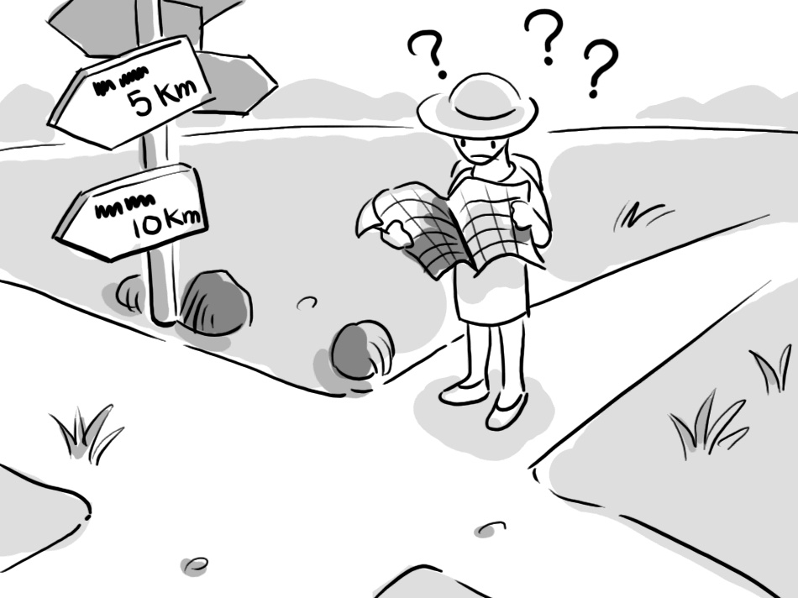
1._______ 2. _______ 3. ______


(B) Best Response
Choose the best response to each question or statement.

4. A. You need to use more imagination.
B. Why are you staring at it for so long?
C. You need to exercise more often.
D. Go home and work on your social skills.

5. A. He must cherish it a lot.
B. Tell him to grow up.
C. Why do you look so happy?
D. You don’t sound sincere.

6. A. What do you think about this composition?
B. It has involved various techniques.
C. It is nothing compared with a book.
D. Can you give some concrete examples?

7. A. Let’s give it a hand.
B. We should put some more weight on it.
C. Just don’t come any closer to it.
D. I’d like to see the debris.

8. A. He must have very keen eyesight.
B. Maybe you should wear glasses instead.
C. What are you searching for?
D. They must be very expensive.

9. A. Yes, I drank it.
B. I’ll get you a cloth to absorb it.
C. Why don’t you just drink water?
D. You should have told me that.

10. A. Because you look happy.
B. Because you got tongue-tied.
C. I didn’t tell anyone about that.
D. Your oral skills are very strong.

(C) Short Conversations
Listen to the conversations. Then choose the best answer for each question.

11. A. She went shopping with her friend.
B. She went to the supermarket with her friend.
C. She had dinner with her friend.
D. She looked for something missing.

12. A. She can’t communicate well with others.
B. Her schoolwork is below average.
C. She is too serious.
D. Others have no confidence in her.

13. A. How people celebrate Easter.
B. What to do on Easter.
C. A TV program on channel 18.
D. Which channel is worth watching.

14. A. He got a raise.
B. He works for a department store.
C. He got a new position.
D. He was replaced by the woman.

15. A. It’s too complicated
B. It requires a lot of effort.
C. It’s constantly changing.
D. It doesn’t pay well.

II. Vocabulary & Idioms: (Choose the best answer)
(A) absorb | (B) spark | (C) exceptional | (D) severely
(E) coincidentally | (AB) replace | (AC) devastating | (AD) dedication
(AE) flunk | (BC) untouched | (BD) resident | (BE) relative

16. It was amazing that a four-month-old polar bear cub could _____ an increase in visitor numbers at the Berlin zoo.
17. The woman claimed to be the manager’s ______ and demanded special discounts.
18. Susan and Stella, _______, chose the same yellow dress for the fashion party last Saturday.
19. Global warming has a ______ effect on the environment; it is probably the greatest threat human beings have ever faced.
20. If you keep wasting time like this, you are bound to ______ your English midterm.

(A) hold down | (B) loosen up | (C) give up
(D) get over | (E) soak up | (AB) hang out
(AC) take notice | (AD) turn out | (AE) go all out

21. Students were encouraged to ____ their minds and bodies through extracurricular activities.
22. All the athletes on the team _____ to win the 400-meter relay race.
23. It is nice to visit National Palace Museum and ______ the artistic atmosphere.
24. The secret of his success is persistence. He sticks to his ideals rather than ______.
25. Joseph believed that he would do a good job on the exam if he could _____ being nervous.
- Cloze Test
(A)
The story of “what goes around comes around” tells us the early life of Winston Churchill. It also reminds us that what we do today has a great influence 26 our future. The story goes that a kind farmer named Fleming accidentally spotted a boy falling into a ditch full of mud. He then jumped into the ditch, 27 the boy 27 the mud. 28 the farmer’s kind deed, the boy’s father, Lord Randolph Churchill offered to educate Fleming’s son together with little Winston Churchill. Farmer Fleming agreed to the idea. As time went by, Farmer Fleming’s son, Alexander Fleming, 29 to be a biologist and pharmacologist, who later was 30 the discoverer of penicillin. Fate seems to have a sense of humor. Years later, penicillin saved the life of Winston Churchill. This story was just one example of the 31 Winston Churchill faced in his early life. According to historians, Winston Churchill did poorly in school and had a distant relationship with his father. However, Churchill’s unique strength of personality helped him to overcome difficulties in his life and became one of the great prime ministers in English history.

26. (A) about | (B) in | (C) on | (D) over
27. (A) freed…from |  | (B) that protected…from
(C) protecting…from |  | (D) freeing… from
28.(A) With a view to repay |  | (B) Repaying
(C) To reward |  | (D) Having rewarded
29.(A) fixed up | (B) turned out | (C) turned into | (D) carried out
30.(A) known for | (B) known as | (C) known to | (D) known by
31. (A) targets | (B) policies | (C) enemies | (D) misfortunes

(B)
Good communicative skills are important in modern society. For example, 32__ talking with foreigners or new acquaintances, we should be cautious not to offend them or cause unpleasant feelings. Therefore, it is necessary for us to know what topics are appropriate for conversations. The first basic guideline is 33 we should avoid personal topics, 34 salary, family life and age. Besides, what we can talk about also 35 the nationalities of the people we talk to. Topics like race, religion and political issues may cause strong feelings in Americans. So it is best to avoid them. Australians, on the other hand, talk quite freely about everything. In fact, Australians seem to enjoy lively conversation 36 they express strong viewpoints. However, they don’t like to hear people 37 their accomplishments. Besides these taboo topics, there are other safe topics. Headlines news, movies and sports are good topics for conversation. So, it is better to stay 38 on what is going on in the world.

32.(A) on | (B) in | (C) because | (D) to
33.(A) that | (B) what | (C) which | (D) why
34. (A) included | (B) that include | (C) inclusive of | (D) to include
35. (A) counts on | (B) depend on | (C) relied on | (D) lives on
36. (A) what | (B) which | (C) that | (D) in which
37. (A) talked about | (B) boast of | (C) to discuss | (D) proud of
38. (A) current | (B) unusual | (C) informing | (D) balanced
(C)
Children acquire some valuable philosophy in kindergarten. For example, they learn how to get along with others such as sharing everything with others, and not taking things that do not __39__ them. They are taught to take the responsibility for their own behavior, like putting things back where they __40__ them. Furthermore, they are required to pay attention to __41__, which includes saying sorry when doing something wrong, and expressing their appreciation when others offer help. They are advised to __42__ traffic while walking on the street. What children learn during this period will help develop their character and enable them to get along with others as members of society some day.

39. (A) appear to (B) belong to (C) happen to (D) look to
40. (A) get (B) founded (C) take (D) found
41. (A) ecology (B) hygiene (C) manners (D) nature
42. (A) watch for (B) call for (C) stand for (D) look for

(D)
Salt is a white colorless substance that is found both in sea water and in the soil and mineral deposits in the earth. Animals including humans need salt in their diets. Since ancient times, salt __43__ keep food in good condition. Also, it was a very important item on the table of the royalty. Historical documents __44__ that salt was placed in front of the king and important guests at the king’s table __45__ near the salt. Moreover, early trade routes and many of the first roads were built for transporting salt. In the Roman Empire, salt was carried from the salt mines to Rome __46__ one of the most important roads. Guards __47__ along the road to protect against salt thieves. In fact, salt was viewed as __48__ a precious item __48__ people came up with some laws to protect it. It was estimated that around ten thousand people __49__ for stealing salt during the nineteenth century. In modern times, __50__ being a food seasoning, salt has many uses such as making glass and airplane parts, killing the weeds and dyeing cloth. It goes without saying that salt plays a vital role in our lives.

43. (A) was used to | (B) has used to | (C) has been used to | (D) has used to
44.(A) appear | (B) reveal | (C) observe | (D) remain
45. (A) seated | (B) were sat | (C) were seating | (D) were seated
46. (A) on | (B) with | (C) in | (D) by
47. (A) were caught | (B) were released | (C) were stationed | (D) were taken
48. (A) enough…for | (B) such … that | (C) so … as to | (D) so … that
49. (A) put to jail | (B) putting to jail | (C) were put in jail | (D) be put in jail
50. (A) in addition to | (B) beside | (C) except | (D) in addition

IV. Matching (答案選項不重覆)
51. Most teenagers wish to
52.With great efforts,
53. One of the severest hurricanes
54. The government supply the homeless
55 What a better world we would make

(A) were the ones that took place in Oregon.
(B) and he finally succeeded.
- the doctor saved the life of the girl.
- be seen as adults rather than as kids.
- if there are no war and hunger.
(AB) was the one that occurred in New Orleans.
(AC) for what they need.
(AD) if everybody helped one another.
(AE) with food and clothing

V. Reading Comprehension:
Garlic is one of the oldest known medicinal plants, and it's been credited with fighting heart disease, lowering blood pressure and helping to fight off colds. However, the therapeutic qualities of garlic are nothing new. Sanskrit records show that garlic remedies were put into use in India 5,000 years ago, while Chinese medicine has recognized garlic's powers for over 3,000 years. Even Louis Pasteur, who discovered penicillin, recognized the anti-bacterial powers of garlic back in 1858. And during World War One surgeons regularly used garlic juice to stop wounds turning septic.
So, what is it about garlic that makes it beneficial to our health? When cloves are chewed, crushed or cut, they release a sulphur-bearing compound called allicin - the chemical that gives garlic its strong and sharp taste and smell. And it's the allicin that scientists have discovered is the magic ingredient thought to be responsible for garlic's therapeutic qualities.
Most of the modern research on garlic has concentrated on its ability to lower cholesterol and blood pressure as well as offering protection against strokes and heart disease. For example, when the Journal of the Royal College of Physicians reviewed data on cholesterol in 1993, it found that after just four weeks there was a 12 per cent reduction in cholesterol levels in the research groups that had taken garlic.
Research into the benefits of garlic are continuing all the time and some scientists have been reviewing evidence that suggests it may even help to protect against stomach cancer. The thinking behind this is that the allicin compounds, contained in garlic, may help prevent cancerous changes in the stomach wall. While more research is clearly needed, there is little doubt that a little garlic, every day, can go a long way in helping to protect, as well as boost, your health.

- What is the best title for the article?
  - Garlic used in cooking and curing diseases.
  - Garlic and the development of modern medicine
  - The side effects of garlic
  - The health benefits of garlic
- According to the article, garlic is helpful to protect against many diseases, which do
NOT include ________.
(A) stomach cancer (B) pneumonia (C) strokes (D) colds
58. Which of the following statements is true?
  - In World War One, garlic was used by surgeons to stop bleeding.
  - Penicillin was a magic ingredient found in garlic.
  - Indians probably used garlic remedies earlier than the Chinese.
  - Garlic doesn’t have therapeutic qualities.

While some disobedient students may be expelled from school, according to a recent report, Singapore’s Ministry of Education will not hesitate to cane troublesome students in cases where they feel that such a form of discipline is appropriate.
Caning as a form of punishment in Singapore become widely publicized in 1995, when American teenager Michael Fey received four lashed for vandalizing cars. Spanking, the type of punishment carried out in schools, is much gentler than the forceful flogging of bare buttocks administered to average of 1,000 convicted criminals each year in Singapore.
With an increase in stealing, vandalism, loitering, gambling, alcohol and drug abuse in schools, the Ministry of Education has given permission to principals, vice principals and senior teachers to cane students when necessary. The Ministry stated that the type of problems encountered by the schools reflect the changes in society; complex and dangerous crimes, they say, demand harsh punishments.

59. What is the main idea of the passage?
(A) Vandals may be punished by being caned.
(B) Caning is a form of punishment for criminals.
(C) Adults may be caned for committing a crime.
(D) Caning is a form of discipline in Singaporean schools.
60. Based on the text, students may be caned because of ______________.
(A) taking drugs (B) failing the exams
(C) cutting class (D) driving while drunk

(以下答案請在答案卷上作答)
- Vocabulary: (23%)
- Being mature means that we learn to think and behave in an adult manner. That is, we are able to make wise decisions and take the c______es of our actions.
- Nancy is a famous writer of romantic f_____n. Her imaginary love stories are popular with teenage girls.
- John is an honest and kindhearted man. He always c_____gs to the belief that you should not do to others what you would not have others do to you.
- Before taking a trip to my favorite country France, I have done some r_____h to find out the cheapest way to travel there.
- Kevin is an outstanding student in high school. His parents are proud of his academic a_______ts.
- Most artists are very in_____c. They often have unique styles.
- G_______t of the people, by the people and for the people is a political ideal advocated by Dr. Sun Yat-sen.
- In my parents’ o______n, it is better not to get addicted to coffee. They think that drinking too much coffee is bad for health.
- A m______o is a small flying insect that sucks the blood of people and animals.
- Before announcing the results of the contest, the teacher asked the students to s____e down and stop talking.
- To protect our environment, we must plant new trees and p_____e our woodlands.
- P____c bags are harmful to the environment because they take up to 1000 years to biodegrade in landfills.
- Jim always p____rs cold water on my plans, so I won’t tell him my ideas any more.
- W___m is the ability, developed through experience, insight and reflection.
- Though Mr. Lin does not make a lot of money, he donates a small a____t of it to charities.
- Leaders from the world’s leading industrial n____ns will attend the meeting in Paris.
- The study shows that the rising temperature of this area causes ice cover to break off and m____t away.
- I owe my friends a great debt of _______ (grateful) because they always encourage and support me when I am in trouble.
- Jane has a strong ________(prefer) for coffee. She drinks four cups of coffee every day.
- The boss keeps reminding his employees to wear ______ (protect) glasses when they are working.
- Doctor advised that Mr. Lin have a ______ (balance) diet and do exercise regularly.
- The accident brought an ______ (ecology) disaster to the small town.
- The mother was driven ______ (sane) after knowing her beloved son was involved in the murder.

Translation :(12%) (每格不只一字)
- 老師強調正面思考的重要並告訴我們應該妥善處理負面情緒。
Our teacher p______24_____ the importance of positive thinking and told us that we were s_____25______ deal with negative feelings well.
- 他寧願到理髮店理髮而不願到美容院。
He p_____26_____ to a barbershop for his haircut r_____27_____ to a hair salon.
- 學習外國文化的一部份就是對自己與別人的文化差異要有敏感度。
Part of learning about a foreign culture is b_____28______ the differences between your culture and another.
- 爬得越高，看得越遠
T______29______ your climb, _______30_______ you can see.
5. 贏球的指導原則就是團結互相幫助。
The G____31___ of winning the game is to s____32___ .
6. 無論比賽結果如何，我們都不能放棄。
_____33____ the result of the game may be, we won’t give up.
7. 為了養家，她大學畢業後就進入社會謀生。
To support her family, she w___34_______ right after ___35______ the university.

