臺北市立松山高中九十五學年度第二學期高一英文科期末考試題
(1—68題請在電腦卡上作答)
I. Studio Classroom: May 2007 (25 %)
Part A--Listening Section
I. Matching (In this section, you’ll hear three different sentences. Please choose the best picture that matches each sentence, and fill A, B or C in the blank.)
1 2 3
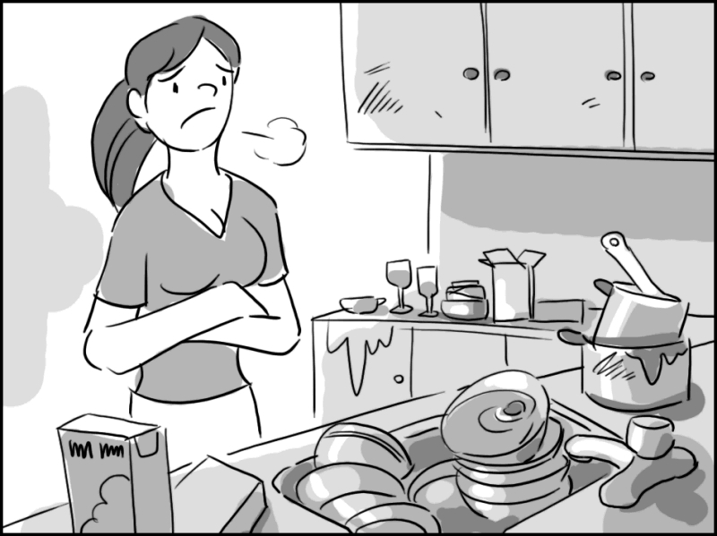
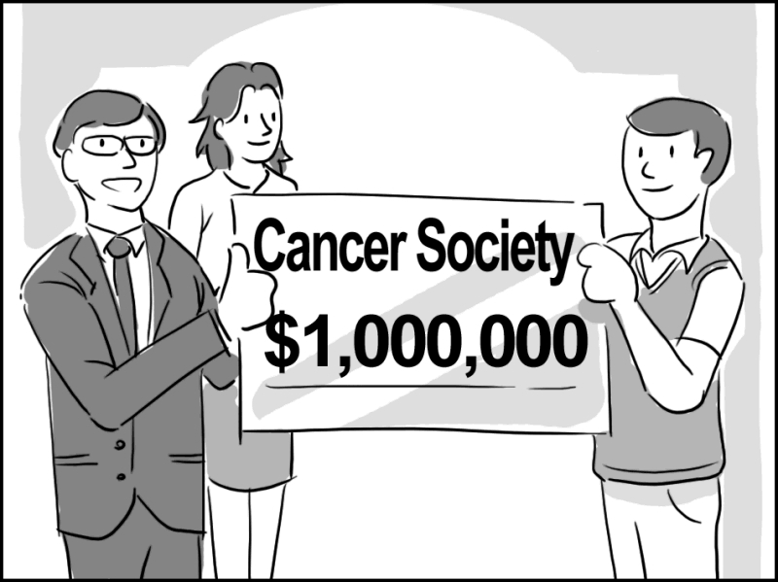
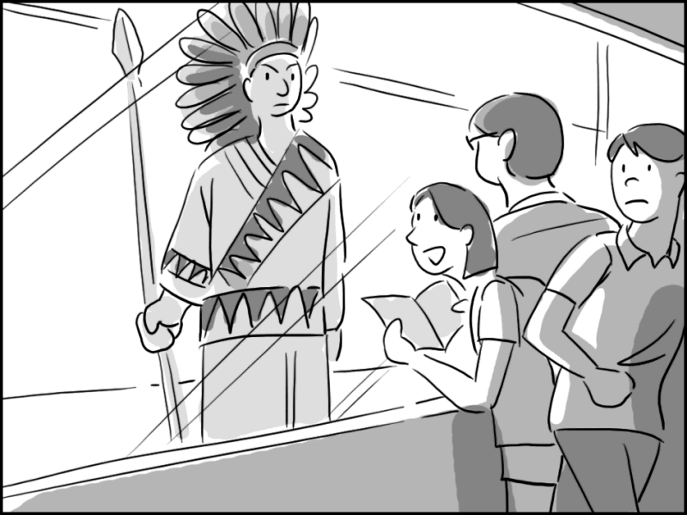

II. Best Response (Choose the best response to each question or statement.)
4. A. Do you really think I can?
B. He has to grow up.
C. I can’t recognize your voice.
D. Do you really sound like her?
5. A. Which corner?
B. That’s not funny.
C. I can’t believe it is here so soon.
D. I don’t think I can take this.
6. A. I’m glad to hear you feel better now.
B. That sounds like a big treat.
C. I hope it isn’t too serious.
D. Will you have to wear it very long?
7. A. I’ll take another class next week.
B. I thought I just spoke Chinese.
C. I need some more definition.
D. My hard work has finally paid off.
III. Short Conversations (Listen to the conversations. Then choose the best answer for each question.)
8. A. The man just released a new CD.
B. Watching movies is the woman’s favorite pastime.
C. The woman wants to borrow the CD from the man.
D. The woman wants to have her own movie studio.
9. A. Something to keep her money in.
B. Something to keep her bathroom tidy.
C. Something to keep her magazines.
D. Something to keep her food fresh.
10. A. Traffic would be a problem for the bike ride.
B. The girl can’t ride a bicycle well.
C. Urban areas have been greatly altered.
D. It’s illegal to ride a bicycle there.

Part B--Reading Section
I. Vocabulary & Phrases (Choose the word or phrase that best completes the sentences.
A. impressive | B. explosive | C. appreciate | D. ponder | E. spy
AB. satellite | AC. typical | AD. community | AE. forbidding | BC. avoidable
11. The couple ____________s every moment they are together.
12. The _____________ makes it possible for us to watch the Olympic Games live on TV.
13. All the ____________residents gathered to discuss the security problem in this area.
14. If you are careful, some mistakes are ____________.
15. My mother is a(n) ____________ Chinese woman—thrifty and diligent.
16. “I Have a Dream” by Dr. King is a(n) ________ and influential speech in American history.
17. He has ________ed the problem for days, but still can’t figure out a solution.
18. She asked her husband’s secretary to ___________ on him and report to her every week.
A. catch my breath | B. worn out | C. hold on | D. cried out | E. keep me company
AB. carry a tune |  | AC. ask me out |  | AD. in particular
19. I loved the meal, the sweet and sour pork ____________.
20. After running for twenty minutes, I stopped to ______________.
21. Students __________ in protest when the teacher said he was going to give a pop quiz.
22. It’s a long journey and I’m glad you are here to _____________.
23. Can you ________ a minute? I’ll check my schedule to see if I’m available that day.
24. I don’t like to sing because I can’t even _____________.
25. He was really ___________ after working all day.
II. Textbook: Lessons 2, 5, 9—12 (75 %)
克漏字 22 %
Helping wildlife survive is 26 around the world. Right here in Taiwan, due to the growing number of human population, industrial development, and the pollution of coastal wetlands, animals 27 lose. WWF, or World Wildlife Fund has been trying to preserve nature. The organization sets up offices and operations around the world. The initial focus of its activities is the protection of 28 . With such human efforts to protect natural environment from becoming 29 wildlife, animals will not be in danger of extinction. Besides, when we create safer space for them, we also create a better living environment for ourselves. That’s why WWF also expands into other such areas as the preservation of biological diversities (多樣), sustainable use of natural resources (資源), and the 30 of pollution and wasteful consumption (消費).
26. a. a matter of concern b. an expert’s business c. likely d. relatively important
27. a. are doomed to b. are unlikely to c. are used to d. will slightly
28. a. endangered species b. migratory birds c. pandas in captivity d. wildlife biologists
29. a. negative b. reproductive c. suited to d. unsuitable for
30. a. production b. reduction c. spread d. technology
The Bermuda Triangle is one of the most heavily-sailed shipping lanes in the world, with ships 31 through it daily for ports in the Americas and Europe, as well as the Caribbean Islands. It is also a heavily flown route for commercial and private aircraft 31 for Florida, the Carribean, and South America. The violent ocean current, flowing through the Triangle after leaving the Gulf of Mexico, may have 32 a number of disappearances. Sudden storms can appear, and in the summer to late fall the occasional hurricanes (颶風) 33 the area. The combination of heavy maritime traffic and violent weather causes vessels (船隻) to be lost 34 —especially before improved telecommunications (電子通訊), radar, and satellite (人造衛星) technology, which arrived late in the 20th century. In fact, 35 disappearances is relatively small considering 35 ships and aircraft passing through on a regular basis.
31. a. crossed . . . left b. crossing . . . leaving
c. having crossed . . . having left d. to cross . . . to leave
32. a. come into contact with b. contributed to c. encountered d. had an effect
33. a. end up b. have a hold on c. hold on to d. strike
34. a. at the same time b. in common c. in conclusion d. without a trace
35. a. a number of . . . a number of b. the cause of . . . the cause of
c. the number of . . . the number of d. the reason for . . . the reason for
Chicken Soup for the Soul is a series of books, usually featuring a collection of short, 36 stories and essays. The name "Chicken Soup" was chosen for this series because of the use of chicken soup as a home remedy for the 37 . There have been numerous volumes of Chicken Soup issued. Many of the books are directed at specific groups of people: Chicken Soup for the Mother's Soul, Chicken Soup for the Prisoner's Soul, Chicken Soup for the 38 Soul, Chicken Soup for the Grandparent's Soul, etc. The Chicken Soup for the Teenage Soul series is one of the first series of non-fiction books which are popular among teens in the US, Canada, the UK and Australia. It helps young people like you to figure out how to 39 difficulties in life, such as how to cope with 40 .
36. a. approved b. inspirational c. religious d. survival
37. a. individual b. insensitive c. relative d. sick
38. a. Insect’s b. Theme’s c. Trial’s d. Volunteer’s
39. a. be filled with b. clean up c. fulfill d. handle
40. a. being worthwhile b. making mistakes c. the way you talk d. what you are
Genetically Modified (GM) foods are produced from genetically modified organisms (GMO) with their DNA 41 through genetic engineering techniques. They have been available since the 1990s. Supporters tend to 42 GM foods as more delicious, easier and cheaper to grow. Besides, 43 chemicals are needed and 43 nature land than farm land will thus be left. What’s best, GM foods technology will help 44 the environment. Still, negative side to growing and eating GM foods can’t be overlooked. 45 , will the chemical substances in GM foods and the reproduction of GM plants and animals affect the cycle of nature? Therefore, more testing is needed to 46 the long-lasting effects of GM foods on human health. By the way, when human beings 47 nature, we are playing God. Will the consequences destroy us in the long run?
41. a. alternated b. alternating c. to change d. modified
42. a. consider b. look at c. refer to d. think about
43. a. fewer . . . more b. more . . . less c. no . . . less d. no . . . better
44. a. clean out b. fix up c. protect against d. strike down
45. a. Beyond question b. For example c. In vain d. To date
46. a. be fond of b. get over c. make sure of d. turn out
47. a. are interested in b. be absorbed in c. interfere with d. result in
文意選填 8 %
a. acquaitance b. company c. forming d. indicating e. invited
“Everything ok” is shown in European countries, especially between pilots and divers, with the sign of the thumb (大姆指) and forefinger (食指) 48 an “O”. The sign means in Japan “now we may talk about money,” while in southern France it means totally the contrary “nothing, no value or money at all.” In some Latin American countries and Russia it is an indecent sexual sign.
If 49 to dinner, in some Asian countries and Central America it is well-mannered to leave right after the dinner: the ones who don’t leave may indicate they have not eaten enough. However, in India, Europe and North America this is considered rude, 50 that the guest only wanted to eat but wouldn’t enjoy the 51 of the hosts.
a. be seen as b. contact c. indication d. while e. regard as
In Africa, avoiding eye 52 or looking at the ground when talking to one’s parents, an elder, or someone of higher social status is a sign of respect. In contrast, the same action is the 53 of deception (欺騙) or shame (on the part of the doer) in North America and most of Europe.
In African, South American and Mediterranean (地中海的) cultures, talking and laughing loudly in the streets and public places is widely accepted, 54 in Western Euorpean and Asian cultures it is considered rude and may 55 self-centered or attention-seeking.
配合題 8 %
56. Not every pair of shoes a. is not necessarily the best.
57. His parents couldn’t help but b. are waterproof.
58. The boy as well as his parents c. holding on to their viewpoints.
59. Expnesive stuff d. is handicapped.
e. be concerned about the result.
* * * * * * * * * * * * * * * * * *
60. He preferred to be left alone a. when talked to by strangers.
61. He may have broken the vase b. rather than join us in the party.
62. By the time the parents arrived, c. instead of going home alone.
63. The shy boy immediately d. but I didn’t know for sure.
hid behind his mother, e. the victim of the car accident
had been sent to hospital.
閱讀測驗 10 %
(A) There are millions of wild animals killed every year. Though conservation laws have been established to protect wildlife, not everyone follows those laws. In some poor countries, especially in Africa, an elephant is big enough to feed a family for a month; therefore, people do not care about breaking the laws and being fined. The illegal killing of wildlife for meat or for trade is quite popular in these poor countries where low pay and poverty are quite common. A lot of people cannot afford expensive food such as meat, so they turn to hunt animals to get meat and money. In this way, they not only break the balance of nature but also kill beautiful creatures.
This kind of situation is really sad, but for these people, if they cannot feed the whole family, they will go on hunting and killing wildlife. What is worse, more and more trade of wildlife is not for our living, but for our greed and selfishness. Huge amounts of ivory and animal fur are exported from Africa. They are made into decorations and furry coats, and then people get profits from them. This happens day after day! If we do not try to stop it, there will be an even greater decrease in the wildlife population!
64. According to this article, which of the following actions is NOT illegal?
(a) Hunting a tiger in Africa. (b) Killing an elephant to get ivory.
(c) Exporting animal fur to make money. (d) Watching wild animals in Africa.
65. Which of the following is TRUE?
(a) With conservation laws established, more and more animals have survived.
(b) Poor people in Africa hunt animals to get food and feed their families.
(c) Exporting fur and ivory, people will be fined; therefore, they stop this action.
(d) Illegal killing of wildlife doesn’t affect the balance of nature at all.
(B) Recently, there has been a lot of attention and arguments about genetically modified (GM) foods. Here are some things about GM foods.
There are several reasons why people create GM foods, including stopping the insects from destroying the plants and increasing the harvest (收成) and nutrition (營養) of plants. However, many people have great fear of GM foods.
GM foods are made by changing the DNA of plants, and this method usually makes use of bacteria and viruses. Some people worry that if the bacteria and viruses can move to modify plants, they can even pass into animals or humans. And in this way, people might have allergic reactions to GM foods; some allergic (過敏的) reactions may be fatal (致命的).
Some people worry that weed killer (除草劑) and pesticides used on the crops may remain in the plants themselves and cause damage to the environment. The chemicals would also threaten nearby animals and plants. However, one chemical company claimed that every GM food could be produced only after seven scientific committees (委員會) and four government departments in the U.S. approved of it. But people seem not satisfied with this announcement. Finally, in order to avoid the dangerous allergic reactions to GM foods, experts suggest that genes should be added to plants or changed only when they are needed.
66. According to the article, which is NOT the main reason for people to make GM foods?
(a) To increase the amount of harvests. (b) To increase the nutrition of plants.
(c) To destroy the plants and the viruses. (d) To reduce the insects that harm the plants.
67. According to this article, GM foods are made by using ______ to change the DNA of plants.
(a) viruses (b) weed killer (c) pesticides (d) animals
68. Which of the following is TRUE?
(a) People in every country welcome GM foods and want to make more GM foods.
(b) GM foods are more healthful and safer; there is nothing to worry about GM foods.
(c) Experts can solve all problems of GM foods, including the problem of chemicals.
(d) Some people might have fatal allergic reactions to GM foods.
文意字彙及詞類變化 17 %
1. P______l education is as important as such academic subjects as English, math, or chemistry.
2. The novel e_________ed Gone with the Wind is adapted (改編) by students to put on a play.
3. His hard work d_________ed praise. All his friends said, “Congratulations!” to him.
4. The teacher places great e_________s on doing homework neatly.
5. A melting pot is a country which c_________ts of people of various races living side by side.
6. A replacement teacher (代課老師) will teach you t______ly before your teacher comes back.
7. The e__________e of life in outer space is still open to discussion.
8. The beautiful music s__________ed our romantic imagination.
9. D______e all his efforts, he didn’t make it; that is, though he had tried his best, he still failed.
10. Take all the necessary __________ (equip) with you when trekking.
11. All survived the air crash, __________ (include) of the pilot.
12. The __________ (mystery) guest didn’t show up until the last minute.
13. I greatly appreciate your __________ (approve) of my project.
14. Here in his diary are his __________ (reflect) on life.
15. In modern times the power of a country depends a lot on its _________ (technology) development.
16. Good communication skills will help improve our _________ (relate) with people.
17. The heavy storm was _________ (destroy) to the rice crop, which destroyed everything.
翻譯 10 % (每格至少兩個字，全對才得分)
時間會證明全球暖化會造成多少環境的傷害。
1 how much 2 will global warming cause.
利用在學的時間裝備好關鍵能力。
3 your school days to 4 with key ability.
如果你儘快採取行動，很可能你會趕上。
If you 5 as soon as possible, 6 that you’ll catch up.
我們開車時不該打手機。
We’re 7 use cell phones while driving.
因為他的勇氣與決心John結果經營一家自己的公司。
With his courage and determination, John 8 a company of his own.
在閱讀英文文章時，有時你會遇到一些法文字。
In reading an English article, sometimes you’ll 9 some French words.
這位華裔英國男孩一點也不習慣講中文。
The British born Chinese boy is 10 Chinese at all.

臺北市立松山高中九十五學年度第二學期高一英文科期末考答案卷
Class ___________ Name ________________ No._________ Score
文意字彙 及 詞類變化 17 %
1 | 2 | 3
4 | 5 | 6
7 | 8 | 9
10 | 11 | 12
13 | 14 | 15
16 | 17
翻譯 10 % (每格至少兩個字，全對才得分)
1 | 2
3 | 4
5 | 6
7 | 8
9 | 10

