台北市立松山高中九十六學年度第一學期高一英文科第一次期中考

Part A :Live ABC Magazine September 2007
- Listening Test: 10%

Part A: Picture Questions
Look at each picture and answer the question.

1.
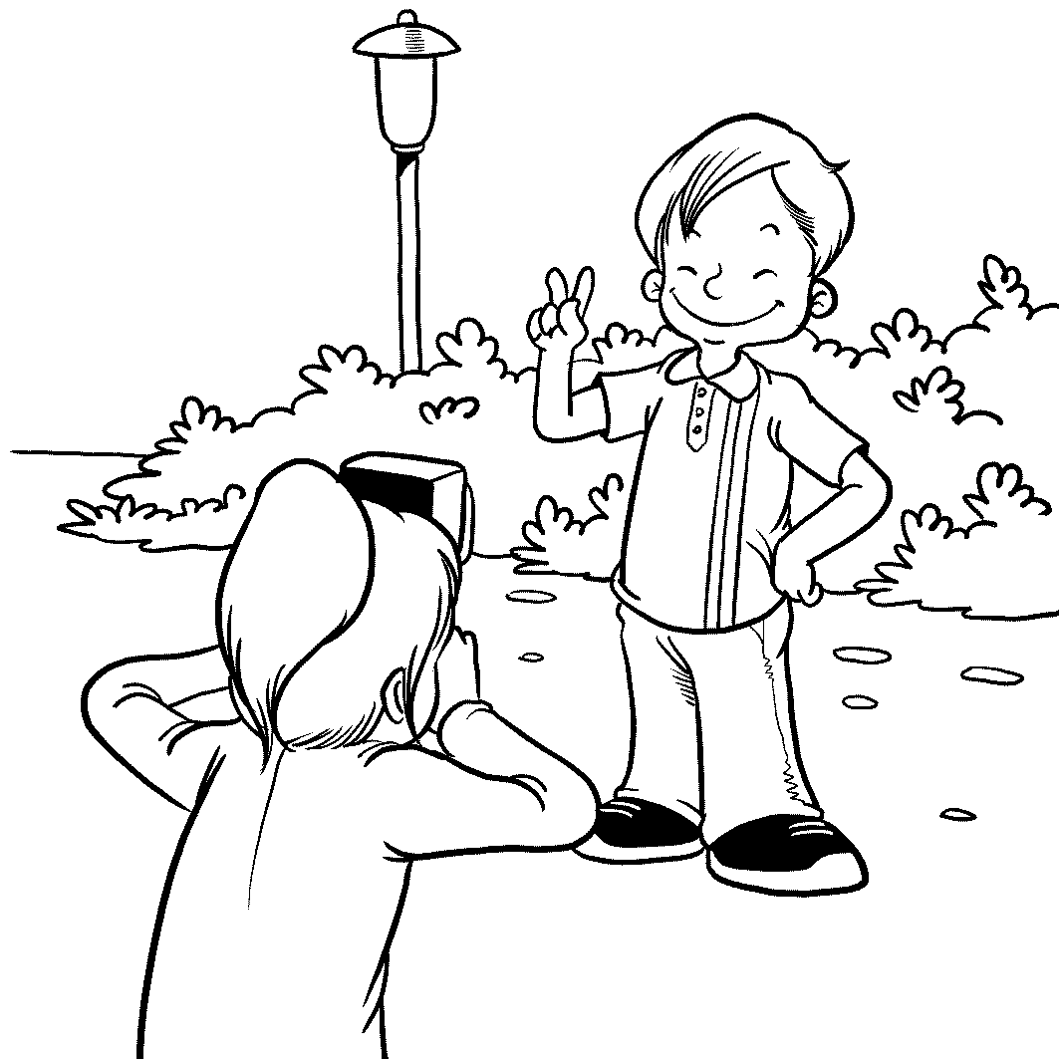
2.
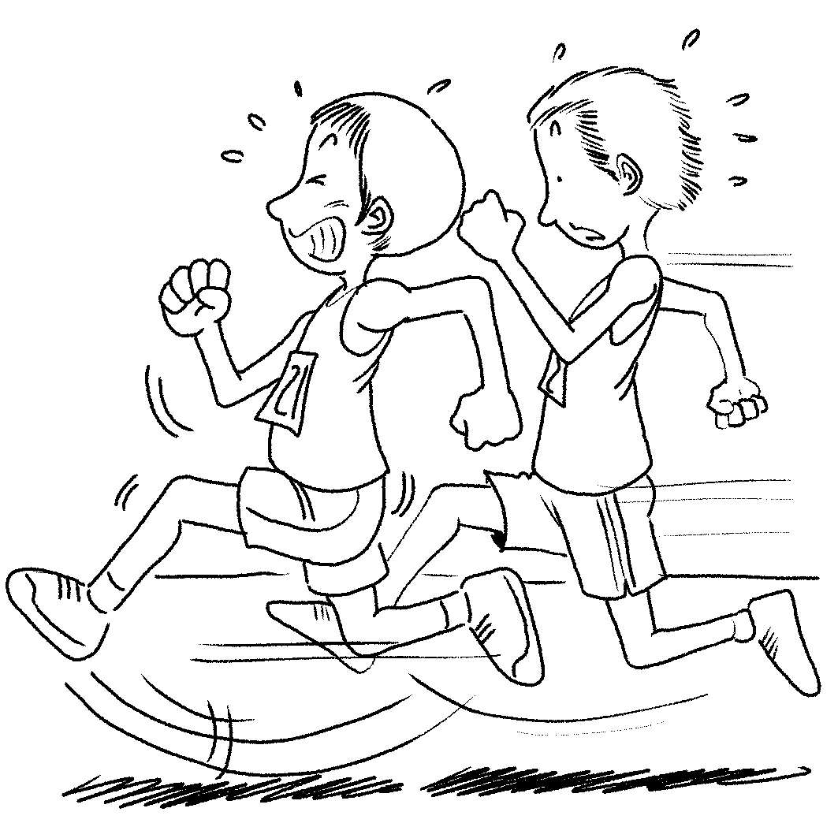

Part B: Best Response Questions
Listen to the statement or question and choose the best response.

3. (A) Sure. I will probably get thirsty later.
(B) No thanks. This one should be enough to keep me warm.
(C) Maybe. What kind of books do you have?
(D) No thanks. I’ll finish it by myself.

4. (A) Yes, she said she got hurt in a car accident.
(B) Yeah, I’ve been looking for a scarf like that.
(C) She gets so dirty when she plays sports.
- Yeah, I wonder how she could afford them!

5. (A) I’m glad you are so excited about going.
(B) Now that you’ve graduated, you must be like a fish in water.
(C) Don’t worry. I’m sure you will do just fine.
(D) No problem. I can help you find a good instructor.

Part C: Conversation Questions
Listen to each conversation and answer the question.

6. (A) Where she lives.
(B) Where she was born.
(C) Where she is going to next.
(D) What her favorite place is.

7. (A) Anyone can enter in the race.
(B) There will be many people in the race.
(C) It will be difficult to compete in the race.
(D) It will probably cost money to enter in the race.

8. (A) If the necklace is worth anything.
(B) If the necklace is hand-made.
(C) If the necklace is insured.
(D) If she would give him the necklace.

Part D: Short Talk Questions
Listen to the paragraph and answer the questions.

9. (A) That he was falling apart.
(B) That he had no crown.
(C) That he was sad.
(D) That he had no heart.

10. (A) He sees that people are working too hard.
(B) He sees that people helping one another.
(C) He sees that people going through difficult times.
- He sees that people are too cold to visit him.

Vocabulary: 10 %
11.The ______ of Liberty, a gift from France to America, is a symbol of freedom that welcome people from abroad coming to America.
(A) State (B) Statue (C) Status (D) Stature
12. Because winter is _______, we need to buy some warm clothes.
(A) appointing (B) affecting (C) allowing (D) approaching
13.When Louis Armstrong was a teenager, he _______ money for a living.
(A) raised (B) spent (C) earned (D) grew
14. The doctor says that Chien-Ming Wang’s _______ is not too bad.
(A) elbow (B) appearance (C) injury (D) career
15. There is a heart-shaped red _______ in the center of Rose’s necklace.
(A) jewel (B) junk (C) junior (D) jeweler
16. On Christmas Eve, the principal ________ candy to the students.
(A) passed out (B) pointed out (C) run for (D) got down
17. The _______ Professor Wang conducted showed that many teenagers enjoyed playing on-line games.
(A) event (B) honor (C) survey (D) contest
18. We are _________ visiting our grandparents this coming holiday.
(A) looking forward to (B) looking down on (C) looking around (D) looking ahead
19. ________ batteries are safer for our environment.
(A) Traditional (B) Original (C) Ready-to-use (D) Rechargeable
20. Bill Gate’s Microsoft is a(n)______ company that has lots of offices around the world.
(A) international (B) national (C) regional (D) challenging

Cloze Test: 15%
A. In San Francisco, cultural differences (21)______ between the different groups of people in the beginning. But these days, San Franciscans are (22)______ being open to all kinds of people and beliefs. The best example of this is the hippies. In the 1960s and 70s, thousands of longhaired Flower Children came to San Francisco to find peace, love, and acceptance. The Golden Gate Bridge is a (23)______ of San Francisco that is often photographed. Another popular spot is the Fisherman’s Wharf, (24)______ is interesting for the whole family. You can shop for gifts; watch the sea lions, and (25)______ great seafood. Everyone loves the sights, activities and food of this city.

21. (A) looked in trouble (B) asked trouble (C) took trouble (D) caused trouble
22. (A) known as (B) known for (C) known of (D) known to
23. (A) symbol (B) sign (C) souvenir (D) record
24. (A) that (B) which (C) where (D) what
25. (A) eat (B) to eat (C) eating (D) for eating

B. In Colorado, a teacher gives each of her students a brown bag. Inside the bag are twelve special gifts. The teacher tells her students that each gift may seem strange at first, but each has a special meaning. Some of the gift are: a toothpick (26)______ other people’s good qualities, a band-aid (27)______ the wounded feelings of others, chocolate to (28)______ the students when they feel sad, a coin to remind the students they are (29)______ and special . This brown-bag story moved the famous writer, Chien-Chen. She was so touched by it that she wrote a book. It’s called Twelve Welcome Gifts from a Teacher. The book has gotten many (30)______ reviews. As Teacher’s Day comes, we should all keep these special gifts (31)______. Let’s make school a warm place together.

(A) in mind (B) positive (C) to mend (D) to pick out (AB) in touch (AC) comfort (AD) valuable

C. Granny Peach suffered the tragedy of losing family members. Most of us would have lived in pain and sorrow, (32) ______ Granny chooses love and courage. She does not focus on her worries. Granny says that when you can’t seem to stop worrying about something, just hide a blanket (33)______ all the worries will go away. She has seen and accepted the truth that tragedy is a part of life. She says that in order for peach trees to produce the best peaches, they need the (34)______ of the frost, the (34)______ thunder and the (34)______ sun. Likewise, trying moments in life are needed for us to enjoy happiness. The story of Granny Peach and her family (35)_______ about love and seeing the beauty of life.

32. (A) however (B) and (C) as well as (D) but
33. (A) , then (B) and then (C) so (D) for
34. (A) frozen…blasted…scorched (B) frozen…blasted…scorching
(C) freezing…blasting…scorching (D) frozen…blasting…scorching
35. (A) is (B) are (C) were (D) has been

Part B Textbook (Lungteng English Reader: Book One L1~L4)

I. Cloze (1% for each item)

A. Does being popular really mean being part of the in-crowd? Quite a few teenagers may say yes when ____36_____. However, it means more than that. Some of the teenagers try to be accepted by ____37___their hair, or ___37___a tattoo. But ___38___ they stop ___39____ with their friends all day long, they are ignored. They don’t realize the real meaning of being popular ____40__ they are ignored by their friends. Being popular really means being yourself and ____41___ a lot of different kinds of people. People like you ____42______. You don’t have to try hard to please everyone. ____43____, you should always be yourself, __44____means you __45__yourself and always know to develop your talents. Besides, be sincere to others from the bottom of your heart and always treat people nicely. In this way, you surely can be a popular person.

36. a. he is asked b. they are asked c. they being asked d. he asks
37. a. dying , getting b. dye, get c. being dyed, got d. dyeing, getting
38. a. as far as b. as soon as c. as a result d. no sooner
39. a. to hang around b. to get hung up c. hanging out d. getting hung around
40. a. when b. that c. after d. until
41. a. being able to get along with b. be capable of getting along with
c. being able with d. be able to dealing with
42. a. for who are you b. because who you are
c. for who you are d. because of who are you
43. a. Instead b. Accordingly c. Therefore d. Besides
44. a. that b. which c. it d. this
45. a. have confidence in b. being confident of c. have confidence of d. are confident with

B. It is not surprising that e-mails can catch on in our lives for it offers lots of benefits. Here are some reasons for its popularity. ____46_____, it’s easier for us ___47____our keypals around the world through e-mails than by talking to them face to face. For another, unlike talking on the phone, writing e-mails ____48____ our words carefully. We can change our minds _____49_____ we want before we send our e-mails. Another good reason to use e-mails is that there is no problem ___50__ time zones. Our friends can read our messages and write back ____51___ their own convenience. Besides, we can turn in our homework through e-mails and get back the ___52____ copies the same way. Writing on a computer is ___53____a personal writing tutor because it helps to correct the spellings and mistakes. With so many benefits, it is ____54____ to be regarded as a good tool for communication.

46. a. On the one hand b. For one thing c. Most important of all d. After all
47. a. to communicate b. keeping in touch with
c. to keeping in touch with d. to keep in contact with
48. a. allow us choose b. allows us choosing
c. allow our choosing d. allows us to choose
49. a. as many times as b. more times than
c. as much time as d. the same time as
50. a. for b. to c. with d.. of
51. a. with b. for c. in d. at
52. a. correcting b. correct c. corrected d. correction
53. a. like having b. like to have c. similar to have d. the same like having
54. a. for free b. for sure c. for good d. for all

C. It happened on January morning. I heard my mom ___55___up the stairs, ___55____my name. When I saw tears in her eyes and her _____56___ look, I learned that something wrong with my father. I ran downstairs and found him __57___ in a chair . Apparently, he had lost his consciousness at that moment. After he was sent to the hospital, the doctor gave him a quick exam and sent him to the ICU. We were too anxious ____58___, _____59___ on the bench waiting. It must have ___60__ a century before the doctor finally came out of the ICU and explained to us that my father had had a stroke. All of us ____61___. During the days in the hospital, I prayed to God for sparing my father. I was really afraid I might no longer have the chance to express my love to my loving father. Luckily, my prayer was answered. My heart was ___62__ appreciation for God’s kindness. Since then, I __63____ that I have to treasure everything I have and know to express my affection to the person I love.

55. a. run, to scream b. run, screamed c. running , screaming d. running, screamed
56. a. worrying b. scary c. terrified d. frightening
57. a. sat b. seating c. sitting d. seated himself
58. a. not to talk b. to talk c. so not to talk d. that we don’t talk
59. a. seated b. sat c. seated ourselves d. seating
60. a. cost b. spent c. taken d had
61. a. bursted into tears b. burst into tears c. burst out tears d. bursted out crying
62.a. full with b. fill of c. fulled of d. filled with
63.a. have realized b. had realized c. realized d. realize

II. Matching 8% ( 請選出適當的選項，組合成合文法語意的句子)

64. The water was
65. All the earthquake victims were
66.Although my parents work,
67. My computer broke down last week,

a. so I took it to the shop for repair.
b. they find time to help me with my homework every evening.
c. but they still care much about me.
d. running away.
ab. left running in the shower last night.
ac. run away from their hometown
ad. moved to a safer place by the government.

III. Reading comprehension 8%

The Internet is an amazing source for language practice. Today, about 80 percent of all World Wide Web (www) sites around the world are in English, so wherever you are, if you have a computer, you can easily find English on the Internet. Here are some suggestions for individual English practice on the Internet.

Activities and exercises. Many publishers and language schools around the world have their own Web sites and offer various activities and exercises in English. For example, www.eslcafe.com and www.longman.com offer many different opportunities to practice English. There are also Web sites that offer English courses on line, such as www.EnglishSuccess.com. These sites have many different types of courses. Many of these courses are taught by an English teacher who grades your progress from anywhere around the world after you register and pay for a course. One good thing about on-line courses is that you can study whenever you want to and for as long or as long a time as you want to.

E-mail. If you do not have an e-mail account, now is the time to get one so that you can communicate with people around the world in English. Several e-mail servers are free: www.hotmail.com, for example, offers a free e-mail account. To find e-mail “pen pals,” log onto a site such as Dave’s ESL café (www.eslcafe.com) and you will find lists of people you can “talk” to by-mail.
(adapted from H. Douglas Brown’s Strategies for Success)

68. Which of the following is most likely to be the topic of the passage?
(A) The advantages and disadvantages of the Internet.
(B) The introduction of some free servers.
(C) The surprising sources of the Internet for language practice.
(D) How to register an English course and go shopping on the Internet?

69. According to the passage, which of the following statements is INCORRECT?
(A) There are web sites that provide on-line English courses.
(B) The web site, www.longman.com, offers lists of people you can contact.
(C) One of the advantages of on-line courses is that you can study whenever you want.
(D) We can get a free e-mail account from hotmail.com.

70. The word, “register,” on the second paragraph refers to _________
(A) enter one’s name on the list
(B) write down one’s address
(C) delete one’s name on the list
(D) change one’s personal information

71. According to the passage, people can do many things through Internet EXCEPT _______
(A) practicing English
(B) getting a free e-mail account.
(C) keeping in touch with friends by sending e-mails.
(D) getting a free English on-line course.

III. Vocabulary 15%
- The audience stared at the magician in a________t as the magician produced a pigeon out of nowhere.
- The p_______l side effects of the drug are unknown, so you have to consult the doctor before you take it.
- David’s f_________t use of new words helps him remember their meanings. Repetition is important for learning a language.
- For many learners of English, the p______n of “th” is difficult.
- Do you s_____r on your honor never to tell anyone the secret?
- The beautiful teapot costs only NT$39. It’s a real b____n.
- Sometimes a simple, g_________e smile and ‘hi” can begin a friendship because sincerity is important for keeping a friendship
- The bodyguards a_______ied the movie star to the theater because tens of thousands of people were attracted to see her.
- It was an o________y day; nothing special happened on that day.
- In order to protect our beautiful earth, the government should take e______e measures to promote recycling.
- Anderson showed his a_________c talent in his youth---he was good at baseball playing and swimming.
- Raymond’s eloquence made a deep i________n on his teacher, so his teacher recommended him to attend the speech contest.
- The rich usually have a s______h attitude towards the poor or the minority, so they are not welcome.
- The teacher was very ________(insist) on cleaning the classroom.
- Dictionaries are ________(benefit) to learners to know the meanings of new words when they are reading.

IV. Translation (每格均超過兩個字) 6%
- Charlie 因擅長多數的運動能力而自豪‧
Charlie ______1____ his ability to play most sports well.
- 你今年準備打扮成什麼呢？
What are you going to ____2_____ this year?
- 我從未玩過「不給糖就搗蛋」的活動‧
I have never ______3____.
4. 當你閱讀時，不要擔心所有的生字；也就是說，不要馬上查字典‧
When you are reading, don’t _____4___(hang) all the new words; namely, don’t __5___ the dictionary right away.
5. 別認為父母給你的愛都是理所當然的‧
Don’t ____6____ all the love your parents give you.

台北市松山高級中學九十六學年度第一學期英文科第一次期中考高一
班級______ 座號______ 姓名____________

III. Vocabulary 15%
1 | 2 | 3 | 4
5 | 6 | 7 | 8
9 | 10 | 11 | 12
13 | 14 | 15

IV. Translation 6%
1 | 2
3 | 4
5 | 6

台北市松山高級中學九十六學年度第一學期英文科第一次期中考高一
班級______ 座號______ 姓名____________

III. Vocabulary 15%
1 amazement | 2 potential | 3 frequent | 4 pronunciation
5 swear | 6 bargain | 7 genuine | 8 accompanied
9 ordinary | 10 effective | 11 athletic | 12 impression
13 snobbish | 14 insistent | 15 beneficial

IV. Translation 6%
1  is proud of / takes pride in | 2  dress up as
3  gone trick-or-treating | 4  get hung up on
5  look up the word(s) in | 6  take for granted

1-10 BABDA BCACC 11-20 BDCCA ACADA
21-30 DBABA DC AC AD B 31-40 ADBCA BDBCD
41-50 ACABA BDDAC 51-60 DCABC CCBAC
61-71 BDA AB AD BACBAD

