台北市立松山高中九十六學年度第一學期高二第一次期中考英文科試題
姓名 座號

Part A- Listening Section

I. Pictures 看圖辨義
Listen to the questions. Then choose the best answer according to each picture.

A. Question 1

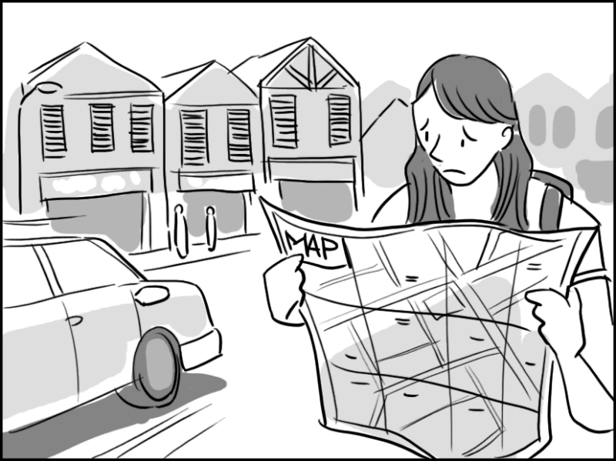

1. ______ _

B. Question 2

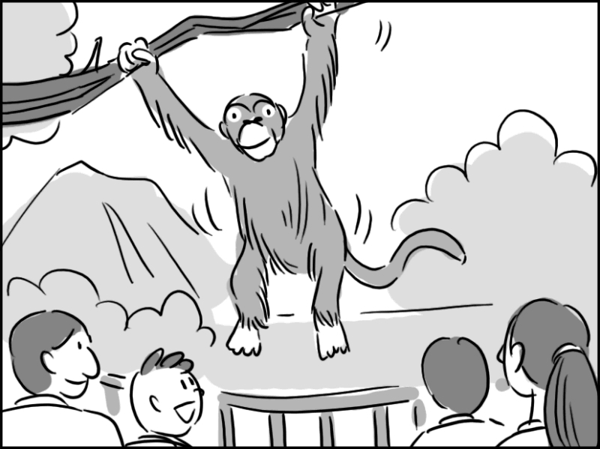

2. ______ _

II. Best Response 最佳回應句
Choose the best response to each question or statement.

3. A. He patted me on the back.
B. He was quite deceived.
C. He shouldn’t have done it.
D. He admitted it himself.

4. A. You’re being too skeptical.
B. I prefer lying on my bed.
C. Why do you believe me?
D. Please take that back.

5. A. He is a student.
B. He’s particularly tall.
C. He won’t tell me.
D. He must be wrong.

6. A. You can manage.
B. It’s so nice of you.
C. That's what I need.
D. I’ll give you a hand.
III. Short Conversations 簡短會話
Listen to the conversations. Then choose the best answer for each question.

7. A. She was afraid Tan-shui was too crowded
B. She is not so interested in eating.

C. The restaurant is often too crowded.
D. Brian and Jenny are more than friends.

8. A. He is too critical.
B. He never goes shopping without buying him something.
C. He treats the woman better.
D. He spends all of his money on the woman.

9. A. They face time constraints.
B. They have to finish the project by five thirty.
C. The man feels very tired and thirsty.
D. The man wants to take a walk.

10.A. She thinks listening to the speech was a waste of time.
B. She thinks the new history teacher is too young to make wise judgments.
C. She thinks the man should have gone to the speech.
D. She thinks the speech was the most interesting one she has ever heard.

11. A. One year.
B. Ten years.
C. More than twenty years.
D. At least one year and a half.

12.A. His innovative style.
B. His sincere attitude.
C. His beautiful language.
D. His pure luck.

IV. Short Talk 短文
Listen to the passage. Then choose the best answer for each question.

13.
A. The benefits of joining a basketball team.
B. How to use binoculars while hiking.
C. What you can do to be active on weekends.
D. Cheap and interesting hobbies.

14.
A. Getting fresh air.
B. Watching TV all day.
C. Walking around your neighborhood.
D. Going for a hike in the mountains.

15.
A. In your dreams while you’re sleeping in.
B. In the mountains or in your neighborhood.
C. While you’re driving in the countryside.
D. At the tennis or basketball court.

Part B- Reading Section

I. Vocabulary & Phrases 詞彙與慣用語
Choose the word or phrase that best completes the sentences.

16. Mary’s dad _____ agreed to let her study abroad alone.
A. critically B. skeptically
C. reluctantly D. abundantly

17. I see little _____ between your major at school and the job you do now.
A. challenge B. connection
C. curriculum D. assignment

18. The _____ method aims to find the differences as well as similarities between two things.
A. insensitive B. defensive
C. comparative D. distinguished

19. According to Buddhism, everything that happens to us is a(n) _____ of our previous actions.
A. mentor B. medium
C. substitute D. consequence

20. Everyone has the _____ to achieve what they want as long as they stick to their dreams and never give up.
A. motto B. constraint
C. potential D. self-esteem

21. My mom has many virtues such as _____ and generosity.
A. suspense B. performance
C. perseverance D. behavior

22. The photographer snapped pictures from many different _____, hoping to get the best picture.
A. reserves B. celebrities
C. provinces D. perspectives

23. Before we do an experiment, our chemistry teacher______ the process for us.
A. demonstrates B. beckons
C. deceives D. innovates

24. The two companies agreed to _____ a formal agreement.
A. draw up B. set apart
C. take notes on D. turn down

25. The _____ silence is killing me. Just say something.
A. virtual B. awkward
C. integral D. essential

26. Those who _____ the ability to speak Chinese and English are much in demand in the market.
A. challenge B. possess
C. enhance D. abound

27. Nobody can _____ his/her wrongdoing. Sooner or later, s/he will have to pay for it.
A. catch up with B. be in no mood for
C. get away with D. have a pat on

II. Cloze Test綜合測驗
Read the passage and fill in each blank with the correct word or phrase.

(For questions 28-32)
Lam Tungsang is a famous photographer and teacher in Hong Kong. Lam never leaves home 28 some kind of camera. Why? According to him, “You have to be ready because you never know what is waiting for you.” A philosophy major in university and a world traveler now, Lam looks at the world through the eyes of a philosopher, which 29 helps him express himself through photography. 30 traveling and photographing, he also teaches media education to first graders at a new school in Hong Kong. At first, he was very conservative in his approach and tried to avoid making any mistakes. But in the end, he decided the only thing he had to lose was his job, so he 31 go all out and do the best he could. The class was very successful. Lam believes this is because his students listen to him and learn from him, and he, 32 , listens to them and learns from them. Thus, teacher and students alike learn a lot and have great fun in class.

28. A. if not B. without C. what if D. instead

29. A. in time B. on time C. in turn D. by turns

30. A. In contrast with B. For the sake of C. In addition to D. For the good of

31. A. just the same B. might as well C. had better not D. can’t help but

32. A. otherwise B. clockwise C. likewise D. counterclockwise

(For questions 33-37)
Ron never intended to become a teacher. But that changed when he visited a school near his home in North Carolina. A student asked if Ron would be his teacher, and Ron couldn’t refuse. So Ron accepted the job and the challenge of raising the class’s low test scores. Ron’s unique methods 33 raised test scores, they also gained worldwide attention. Five years later, Ron moved to Harlem, a low-income neighborhood in New York City. He made an effort to 34 students by visiting their families and learning their recess games. When he first started teaching, a colleague told him, “As long as you can affect the life of one child, you’ve been a success.” But Ron is determined to change every student’s life 35 . Now, he influences students outside of America as well. 36 in over 25 countries, his book, The Essential 55, has inspired teachers and parents alike to affect their children. The book contains Clark’s rules for everything from good manners to having a good attitude. It even encourages students to live life 37 . Rule 51 says, “Live so that you will never have regrets.” What is the essence of education? Maybe we can find the answer in Ron’s story and his rules.

33. A. not only B. as well C. along with D. both

34. A. approve of B. challenge with C. connect with D. dispose of

- A. for the worse B. for the better C. for good D. for nothing

- A. To publish B. Published C. To be published D. Publishing

- A. to the fullest B. in the end C. at its fullest D. in a nutshell

III. Reading Comprehension閱讀理解
Read the paragraph. Then answer the questions.

(For questions 38-40)
Physical injuries often heal very quickly, but mental scars often last much longer. That’s why we need to choose the right words to say. Words have the power to build us up or tear us down. Unfortunately, all too often we overlook the impact our words can have on others. For example, when asking for a refund, if we use warm, friendly language, chances are the clerk will respond in a similar manner. But if we don’t watch our mouth and use harsh, critical language, the clerk may very well become defensive and unwilling to provide good service.
It might be embarrassing to admit it, but we all talk to ourselves, consciously or unconsciously, from time to time. Actually, talking to ourselves is nothing to be ashamed of. More and more experts believe talking to ourselves aloud is a healthy habit. But beware: a great deal of self-talk tends to be negative. So next time when you accomplish something, don’t forget to give yourself a verbal pat on the back. It will motivate you to do even better next time!

38. What does the writer say about physical pains and mental pains?
A. Physical pains can be cured.
B. Some physical pains can distract our mind from suffering.
C. Many physical pains have a psychological cause.
D. For some people, physical pains have become part of their lives.

39. What is the main idea of the passage?
A. The development of language and the power of words are keys to our success.
B. Well-chosen words convey hope and warmth.
C. Words are the most powerful weapon people have.
D. Words have the power to hurt and heal.

40. Which statement is NOT true about “self-talk?”
A. Self-talk is often negative.
B. Self-talk is not abnormal.
C. Self-talk can serve to increase confidence.
D. Self-talk has little influence over how we behave.
Textbook Lungteng English Reader Book 3 L1-L4
I Cloze( 22% )
(A) We are so used to colors that we seldom think that colors, 41 much to do with our life , convey some interesting meanings. Symbolically, red may be used to 42 for danger, largely due to the fact that reds have illusion of appearing nearer than other colors
43 have greater impact. In color psychology, 44 , the colors of danger are yellow and black.
Colors have been used for years in medical treatment. Red, for example, is the color of energy and power. It is used for burning out cancer, drying up weeping sores or wounds. Besides, it will help with depression. However, when 45 to red for a considerable time, it will 46 you agitated or even aggressive. 47 red color is apt to increase bodily tension, green and blue colors 48 to release tension and have lesser physiological effect. In color symbolism, green is representative of envy in many cultures; however, it has a strong 49 with balance in color psychology.
Various cultures see colors differently. In the East, white is symbolic of mourning and death, whereas it is the color for brides in most Western countries.As with everything else, the interpretation of color is dependent on the culture 50 someone is raised.
41. A. have B. to have C. having D. being
42. A. represent B. suggesting C. stand D. symbolizing
43. A. and therefore B. so C. thus D. but to
44. A. in comparison B. as a result C. on the other hand D. for one thing
45. A. exposing B. exposed C. to expose D. in exposure
46. A. cause B. produce C. make D. lead
47. A. Because B. Unlikely C. Likewise D. While
48. A. is likely B. are easy C. tend D. draw
49. A. competition B. attachment C. meditation D. association
50. A. which B. where C. how D. what

(B) Inventions, big or small in size, change the way we live. How do they 51 ? Some inventors think of ideas to help solve problems they face in life, 52 brainstorming. Others find solutions by observing everyday things around them. Still others make inventions with some small things of little value.
Brainstorming is used to generate a large number of ideas for the solutions to a problem.When 53 problems, most inventors think of 54 many solutions 54 and then test which ones are workable. For example, there are a variety of alarm clocks 55 to wake up various types of sleepers. If none of the alarm clocks works for you and you still have trouble 56 up in the morning, it’s time you 57 one that will keep shaking you 58 you wake up.
59 James Watt invented steam engine 59 observing the different types of steam engines 60 at that time. By the time he was born, there were various steam engines in use. What he did was to improve the existing steam engines and he made it.
Sometimes from your collection of 61 , a sudden inspiration may 62 you . For instance, you may come upon a small pulley, a clothespin, and a ball of string. After a little brainstorming, you might think of a message delivery device or something.
51. A. come into existence B. keep in good hands
C. turn out to be D. make a point
52. A. which called B. is called C. which is called D. calling
53. A. faced against B. coming across C. fogging up D. called on to
54. A. so---that they can do B. as---as possible
C. as possible---as they can D. how---they can have
55. A. designed B. designing C. to design D. are designed
56. A. to wake B. in waking C. waken D. waking
57. A. invent B. are to invent C. invented D. have to invent
58. A. when B. until C. except D. if
- What---was to B. How---was by C. What---was D. How---was
60. A. appearing B. appeared C. which appears D. that appearing
61. A. pros and cons B. odds and ends C. do’s and don’ts D. ups and downs
62. A. strike to B. flash to C. come up with D. suggest itself to

II Phrases and Idioms(5%) 選出最適合各題句意的片語
- on her way B. go well C. get rid of D. on pins and needles
AB. in no way AC. beware of AD. draw near BC. with caution
63. This ________ changes the fact that she has behaved foolishly.
64. When she is ________ out of work, she spotted a beautiful watch.
65. Handle the vase ________ so that you may not break it.
66. The little boy dared not _______ to the fierce dog.
67. On a crowded bus you should ________ pickpockets.

III Reading Comprehension 6%
There is a considerable generation gap between our generation and the future one. We were raised with many more rules and were taught to show respect for authority, such as teachers and elders. We heard the word ”No” a lot. Thereby we learned a lot about what is admissible and not. We had been taught since young age, by methods soft and rough, to consider the feelings of others.
However, it seems that many young children are overly indulged. They are carried to one recreational situation after another. Birthdays and holidays are celebrated out of all proportion. Parents and teachers move heaven and earth to elevate their self-esteem. The idea of elevating self-esteem is positive. But we old-timers wonder and worry: what will happen when the kids’ feet hit the ground, when they must confront the realities of the world?
Kids certainly need a balance between control and freedom, reward and punishment. Parents can’t be the best and biggest friends of their kids. A child should learn how to deal with frustration and disappointment. He needs time and space to figure out a solution by himself. After all, self-esteem is gained from real achievement, not just unconditional acceptance of all behavior.

68. What does the phrase “move heaven and earth” mean?
A. try very hard B. love deeply C. support happily
D. strongly propose
69. In this passage, the author points out that the children of his generation__________.
A. were better disciplined B. had higher self-esteem
C. had more frustrations D. enjoyed much freedom
70. The author suggests that the parents of the young generation should __________.
A. elevate their kids’ self-esteem B. become their kids’ great friends
C. provide their kids with more entertainment
D. allow their kids to confront the real world

以下各題請將答案寫在答案卷Answer Sheet上
I Vocabulary 20%
- He is as s n as a mule. He doesn’t easily change his mind.
- A: Is the bus stop on this side? B: No, it’s on the o e side.
- Mr. Ross favors traditional values and views. He is inclined to oppose change. For example, he still thinks that women should wear dresses and skirts. He is reeally c e.
- The contest is very c e with hundreds of entries, coming from 26 different countries in all regions of the world.
- I didn’t feel g y at all because I didn’t do any wrong things.
- Without any delay, he answered the letter p y when he received it.
- The fever has weakened my v y and energy.
- I did this with a clear c e and I feel I did nothing wrong.
- The one-thousand-dollar bill on the desk is missing. It has simply v hed.
- Linda wanted to sell her used car, so she put an a t on a website for vehicles.
- The cell phone today comes with standard and extra f ns such as a phone directory, clock, calculator, automatic redial, games, storage of incoming numbers, etc.
- Taipei Mayor Hau Lung-bin ordered all large tour buses operating in the city should be
i ted following a bus crash on Yangmingshan that killed eight people.
- A real trial began when I stood on the p m trying to deliver my speech. My mind went blank and my legs trembled.
- I can’t read map and have no sense of d n. It’s fairIy easy for me to get lost.
- He spent a lot of time making all the arrangements for the concert. It turned out that the concert was excellently o zed.
- The policeman felt there was something wrong with the young man and became s s of him, asking why he was standing there.
- He can speak English, Chinese, German, French, and Italian. He has a g s for languages.
- Mr. Wilson is in m n. He has been thinking about something deeply.
- A mousetrap is a d e used for catching or killing small rodents, especially mice.
- We don’t know where the news came from because the reporter refused to reveal the
s e of the information.
II Translation (7%)
- 據說喜歡綠色的人經常是冷靜且理性但同時也可能我行我素。(3%)
- 不要嘲笑這些看起來愚蠢的想法。他們也許會引領你把不便之處化成有用的東西。(4%)

台北市立松山高中九十六學年度第一學期高二第一次期中考英文科
Answer Sheet

班級________ 姓名 ___________ 座號 ____

I Vocabulary
1 | 2 | 3 | 4
5 | 6 | 7 | 8
9 | 10 | 11 | 12
13 | 14 | 15 | 16
17 | 18 | 19 | 20
II Translation (7%)

1. ________________________________________________________________________ (3%)

2.________________________________________________________________________
(4%)

台北市立松山高中九十六學年度第一學期高二第一次期中考英文科
Answer Sheet

班級________ 姓名 ___________ 座號 ____

I Vocabulary
1 stubborn | 2 opposite | 3 conservative | 4 competitive
5 guilty | 6 promptly | 7 vitality | 8 conscience
9 vanished | 10 advertisement | 11 functions | 12 inspected
13 platform | 14 direction | 15 organized | 16 suspicious
17 genius | 18 meditation | 19 device | 20 source
II Translation (7%)

- It is said that /people who like green color are often calm and

well-balanced /but at the same time they may go their own way. (3%)

- Don’t laugh at those ideas /that look stupid. /They may lead you to/ turn

inconveniences into something useful. (4%)

1-6 CCDABD
7-12 DCAABA
13-15 CBB
16-27 CBCDCC
DAABBC
28-32 BCCBC
33-37 ACBBA
38-40 ADD
41-50 CCACB CDCDB
51-62 ACBBA DCBBA BD
63-67 AB A BC AD AC
68-70 AAD

