台北市松山高中九十六學年度第一學期高三第一次期中考英文科試題
Part A: Ivy League Analytical English September 2007
Vocabulary 2500-4500
I. Ivy 15%
- The power company ___ the electricity because poor John didn’t pay the bill last month.
A. cut off B. dealt with C. hung out D. ended up
2. Tina burst into tears after she ___ her boyfriend ___ at the airport,
A. carried /out B. showed/ up C. saw/ off D. left / out
3. For the most part, juvenile delinquency ____ family troubles.
A. arises from B. benefits from C. shares with D. confronts with
4. An arrogant person tends to think that the whole world ____ him or her.
A. centers around B hangs around C. recovers from D. comes down
5. ____ the company rules, you have to quit smoking in the office building.
A. By the name of B. In keeping with C. In honor of D. In contrast with

Choose the most proper answer from the words offered.
A. assist B. bring forth C. determine D. eliminate E. heredity
F. infected G. look forward to H. on average I. signifies J. thought of as

Baldness is part of life for some. For others, a shiny bald spot is not something to _6_. Various reasons _7_ baldness. However, the most important one is _8_. Your family genes _9_ whether you’ll go bald or not. Nevertheless, many renowned bald men are _10_ charming and sexy.

6500 people in Africa die of AIDS every day _11_. Hoping to help those _12_ with HIV, U2 singer Bono and his friends started the RED organization. They used RED partly because red is the color of blood and _13_ an emergency. The idea was to urge other companies to work together to _14_ the increasing trend of AIDS deaths. Now, many famous brands such as Apple, Converse have joined to _15_ in the fight against the fatal disease.

II. Vocabulary 2500-4500 30%
16. He wants each ___ of the Harry Potter series as his birthday present.
A. volume B. violence C. violation D. violator
17. Sue’s Grandpa bought several bottles of French wine from Paris as ___ of his trip.
A. screwdriver B. souvenir C. shepherd D. stadium
18. Whenever you purchase something, you’ll get a ___.
A. rebellion B. recognition C. reference D. receipt
19. The notorious rich girl paid the ____ for her crimes with five months in jail.
A. penalty B. portray C. parachute D. prediction
20. The management refused to ___ with the labor even if the labor threatened to go on strike.
A. negotiate B. neglect C. nourish D. nibble
21. You ___ Jenny when you talked about her ex-boyfriend.
A. withdrew B. offended C. intensified D. confined
22. I don’t feel like getting ___ in the quarrel between my coworkers.
A. involved B. disguised C. protest D. bankrupt
23. The foreign professor may come from London because he has a British ___.
A. adverb B. accent C. access D. agent
24. China ___ its citizens to hunt the panda.
A. suffers B. persuades C. forbids D. produces
25. Young travelers without much money often stay in the ___.
A. hostel B. harmony C. hatred D. hive
26. The dictator, related to the massacre, was infamous for ___.
A. council B. crunch C. cruelty D. counterpart
27. I ___ the spots on my face with make-up.
A. distributed B. distinguished C. disgusted D. disguised
28. He chose ___ life over his career to spend more time with his children.
A. essential B. inferior C. sufficient D. domestic
29. There has been a ___ increase in the use of iPod in the world recently.
A. fluent B. substantial C. pessimistic D. mutual
30. I didn’t do anything wrong so my ___ is clear.
A. bacteria B. ambition C. intonation D. conscience
Part B: Textbook Book 5 Lesson 1-5
III. 篇章結構：10%
Once upon a time, a semi-barbaric king in a faraway land decided the fate of his accused subject at a public arena. When the day came for the accused to be put on trial, he had to choose to open one of the twin doors directly opposite him to prove himself innocent or guilty. Out from one would spring a hungry tiger, which would tear him into pieces at once; out from the other would come a desirable maiden, who would marry him right there. 31
One day, the king saw his beloved daughter and a young man of low social status embracing in the palace garden. 32 On the trial day, as the young man, a grand youth, advanced into the arena, he expected the princess to tell him the secret of what lay behind the two doors. So his eyes were fixed on the princess. 33 Looking down at her lover on her throne, the princess was caught in a dilemma as to whether to let the fierce tiger or the fair lady have her lover. 34 But what was her decision? Her heart, at the moment, was overflowed with love, jealousy, and even hatred. 35 And in a flash, the princess made her decision as she raised her hand and moved it quickly to the right. Then, with no further hesitation, the young man went to the right door and opened it.
- After all, he was convinced that where there is no trust, there is no love.
- How her soul burned in agony.
- This way, only luck would guide the accused in his choice.
- Needless to say, it was her decision that counted.
E. He immediately cast the princess’ lover into prison and set a date for trial.
IV. 綜合測驗：35%
Published in 1962, Silent Spring was widely read, spending several weeks on New York Times best-seller list, and launched the global environmental movement. The author, Rachel Carson, proposed a biotic approach to pest control as a(n) 36 to DDT, claiming that DDT had been found to cause birds’ thinner egg shells and bring about 37 problems and death. Moreover, she urged government and people everywhere to have a new 38 of natural world, in which all life should be in 39 with its surroundings. Largely because of the immense effect of her book, a reversal 40 policy was spurred in the United States.

36. A. alternative B. chemical C. panorama D. ban
37. A. productive B. reproductive C. forbidden D. verifiable
38. A. acquaintance B. blight C. excerpt D. awareness
39. A. accordance B. counterpart C. harmony D. contrast
40. A. pollination B. pesticide C. vegetation D. luxury

Most of us, people who can see, always take everything around us 41 . Even in face of such spectacular sights 42 sunrise or sunset, it 43 to us that we should stop to appreciate them. Our “windows of the soul” seem to 44 accustomed to the routine of our surroundings, which leads us to see nothing 45 note. We can’t help but admit that the seeing 46 see little. What a great pity!
According to Three Days to See, it would be a blessing if each of us 47 blind and deaf for a few days at 48 during our early adult life. Darkness would make us more appreciative of sight; silence would teach us the joys of sound. Furthermore, Helen Keller, who can only see through her fingertips, gives this advice to those who have eyes: Use your eyes as if tomorrow you 49 be blind. Also use the other senses as if you 49 lose them tomorrow.

41. A. into account B. into consideration C. for instance D. for granted
42. A. that B. like C. as D. with
43. A. ever strikes B. little occurs C. crosses a little D. even happens
44. A. have got B. be got C. being D. have
45. A. worth B. worthy to C. worthy of D. worthwhile
46. A. incredulously B. vehemently C. apparently D. insanely
47. A. was gone B. had become C. had been struck D. were stricken
48. A. some time B. some times C. sometimes D. some time or another
49. A. will B. would C. are to D. were to

Bereaved of my dear grandma, my family got lost in sorrow. When we had to empty her house, I 50 her night-table drawer and 51 the basic readers, with which my grandma and I had undertaken a secret project at my age of 14. Because my grandma 52 Greece and missed her chances of learning English in early days, I took it 53 myself to teach her how to read out of gratitude, just as she had given me so much useful and practical knowledge. 54 , she had taught me about the Greek heritage. At that time, despite the fact that I was 55 under wing by a favorite teacher, it would be horror of horrors 56 I be seen. As an adolescent, I consider it beneath my 57 . So I stealthily 58 the elementary school and quickly dropped a bundle of basic reading books into a bag 59 anyone see me with something from “little kids” school. Afterwards, my grandma and I spent several wonderful months together in the process of reading lessons. Looking back those days, I realized that the special experience, like magic, should 60 a lifetime of memories.

50. A. tended to B. saw into C. checked it with D. went through
51. A. saw after B. came upon C. lay over D. settled on
52. A. migrated from B. immigrated from C. immigrated to D. emigrated to
53. A. apart B. over C. upon D. for
54. A. Above all B. After all C. In short D. No wonder
55. A. taken B. awaken C. made D. protested
56. A. will B. shall C. would D. should
57. A. pride B. tenderness C. dignity D. compassion
58. A. scratched out B. crept into C. emerged from D. poured through
59. A. so that B. for fear of C. until D. lest
60. A. make for B. make way to C. make out D. make up for

Geographically, Taiwan, a mountainous island, lies in the west of the Pacific Ocean. Of all the natural disasters, typhoons and earthquakes are most likely to hit Taiwan every year. The former usually 61 raging storms and awful floods; the 62 always result in landslides and the collapse of buildings. Accordingly, 63 they take place in the crowded cities or in the mountains far away from inhabited areas, they cause 64 of deaths and 64 of destruction, including 65 water supply, transport and telecommunications services.
Such being the case, how can we prepare ourselves and prevent the damage to the minimum extent? Besides the weather forecast, scientific observation and extra-sensory 66 of certain animals are looked upon as warning signs. People are also advised to follow suggestions from experts: build earthquake- 67 buildings, 68 homes regularly, conserve food and water supply, etc. What’s more, scientists, seismologists in particular, hope to predict them more accurately by means of modern instruments to alleviate damage. Even so, residents in Taiwan still have to do their level best to take 69 against the 70 disasters in advance.

61. A. result from B. come from C. contribute to D. give way to
62. A. last B. later C. latest D. latter
63. A. if B. whatever C. whether D. no matter where
64. A. the great number/ the large amount B. a large number/ a vast amount
C. a good deal/ plenty of D. a great deal/ an abundance of
65. A. disrupted B. interrupting C. recurring D. erupted
66. A. detection B. alternate C. indication D. perception
67. A. prone B. proof C. related D. wired
68. A. reinforce B. extinguish C. withstand D. purify
69. A. predictions B. preparations C. preventions D. precautions
70. A. traumatic B. devastated C. destructed D. fallible

V. Reading Comprehension 10%
Worldwide, there are an estimated 300 million people suffering from obesity. In the United States, 32 percent of the population is considered obese.
Scientists have identified a genetic “master switch”, the adipose gene. From worms to mammals, this gene controls fat formation. They found the gene, which is also present in humans, is like a master switch that tells the body whether to accumulate or burn fat.
The discovery of the function of the adipose gene could lead to the development of new treatments to fight obesity. US researchers, whose work is published in the journal Cell Metabolism, showed animals created with greater adipose activity were thinner than average.
The gene was first discovered in overweight fruit flies more than 50 years ago. At the time of its discovery, the gene's role in the body was a mystery. If it works similarly in humans, the findings could lead to a new weapon to control our burgeoning waistlines.
- What is the article mainly about?
  - People worldwide are concerned their looks and weight.
  - Scientists discovered the fat gene as well as its function.
  - According to the data shown, 32 percent of Americans are regarded as fat.
  - Researchers found overweight fruit flies in their studies.
72. Which of the following statement is TRUE?
- Researchers discovering the adipose gene work for the journal Cell Metabolism.
- The adipose gene tells the body whether to store or burn fat.
- Only in human beings can the adipose gene be found.
- Approximately fifty years ago, people solved the mystery of the adipose gene.

The iPhone is popular - but how popular? And will it live up to all the hype?
Apple's new mobile handset was the top-selling smart-phone in July, its first full month on sale. The 220,000 iPhones consumers bought that month accounted for 1.8 percent of all cell phones purchased in the United States in July. The iPhone even outsold LG's popular Chocolate handset.
Some of the iPhone's success in July can be attributed to pent-up demand following months of hype. Real proof of success will come in the coming months as demand patterns stabilize. The gadget’s audience is composed of 52 percent males and 48 percent females, and most of them (57 percent. are 35 years of age or younger. Nearly two-thirds, or 62 percent, of iPhone buyers in July had a four-college degree or more education.
73. What is the educational background of the most iPhones buyers ?
A. People with a four-college degree or more education.
B. People who are illiterate.
C. People who can barely read.
D. People graduated from high school.
74. What month did iPhones hit the market this year?
A. July. B. May. C. April. D. June.
75. What does the word “pent-up” mean in this article?
A. exciting B. absurd C. anxious D. repressed

Part C:
Writing 100%

Have you ever experienced the shock of an earthquake? What happened in the earthquake? What did you respond to the earthquake? Please write around 120 words to express the experience according to the pictures below. ( Please write on Page 7)

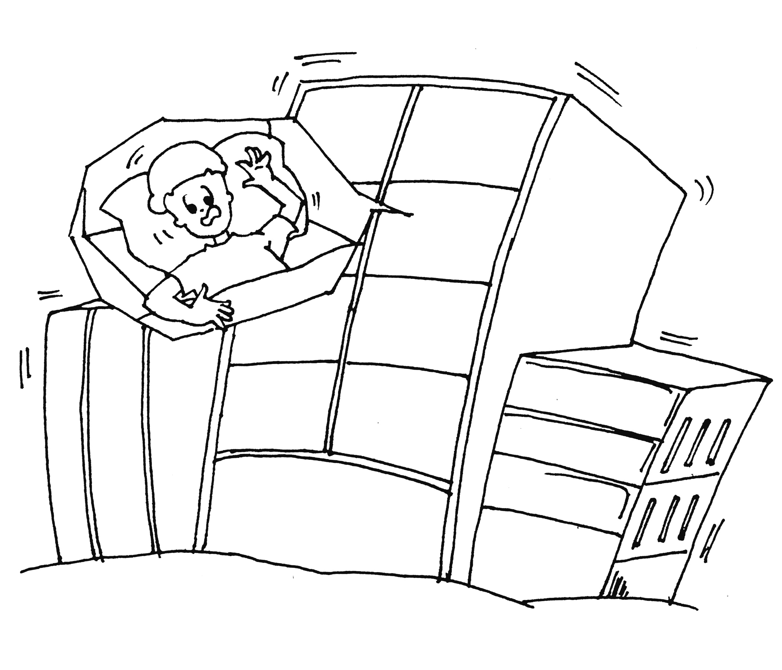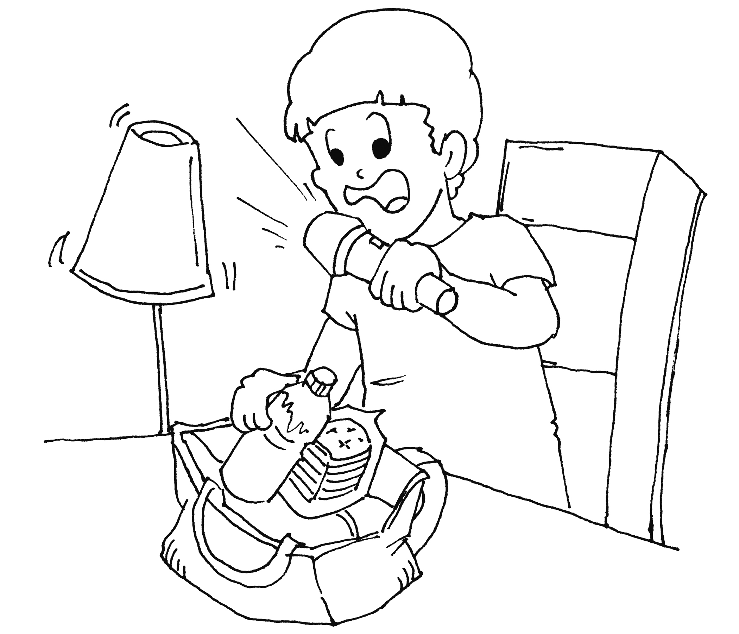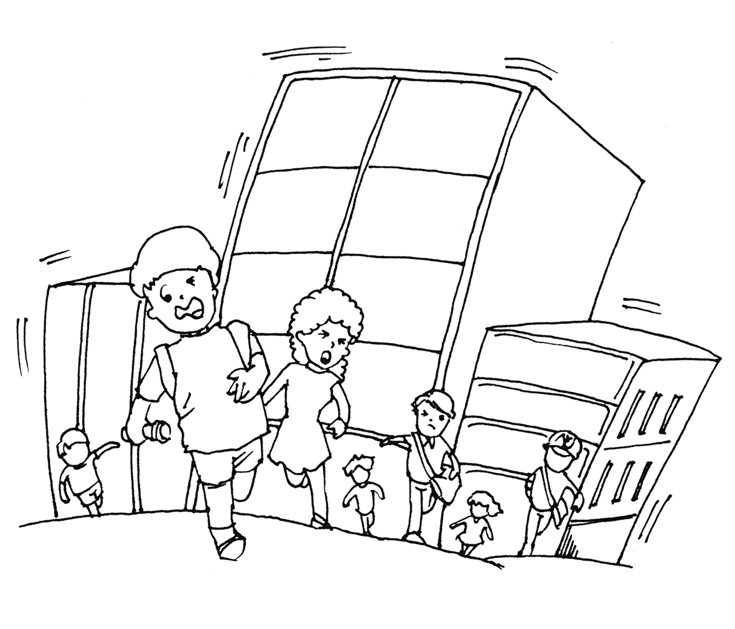

台北市松山高中九十六學年度第一學期高三第一次期中考英文科試題
WRITING Class_____ No. ___ Name:
_____________________________________________________________________________________
_____________________________________________________________________________________
_____________________________________________________________________________________
_____________________________________________________________________________________
_____________________________________________________________________________________
_____________________________________________________________________________________
_____________________________________________________________________________________
_____________________________________________________________________________________
_____________________________________________________________________________________
_____________________________________________________________________________________
_____________________________________________________________________________________
_____________________________________________________________________________________
_____________________________________________________________________________________
_____________________________________________________________________________________
_____________________________________________________________________________________
_____________________________________________________________________________________
_____________________________________________________________________________________
_____________________________________________________________________________________
_____________________________________________________________________________________
台北市松山高中九十六學年度第一學期高三第一次期中考英文科試題
Key
I. 每題1分
1-5 A C A A B 6-10 G B E C J 11-15 H F I D A
II. 每題2分
16-20 A B D A A 21-25 B A B C A 26-30 C D D B D
III. 每題2分
31-35 C E A D B
IV. 每題1分
36-40 A B D C B 41-45 D C B A C 46-50 C D A B D
51-55 B B C A A 56-60 D C B D A 61-65 C D C B A 66-70 D B A D A
V. 每題2分
71-75 B B A A D

