台北市立松山高中九十六學年度第一學期高一英文科第二次期中考

Part One：Live Magazine October and November Week 1 2007

I. Listening test: 10%

Part A: Picture Questions
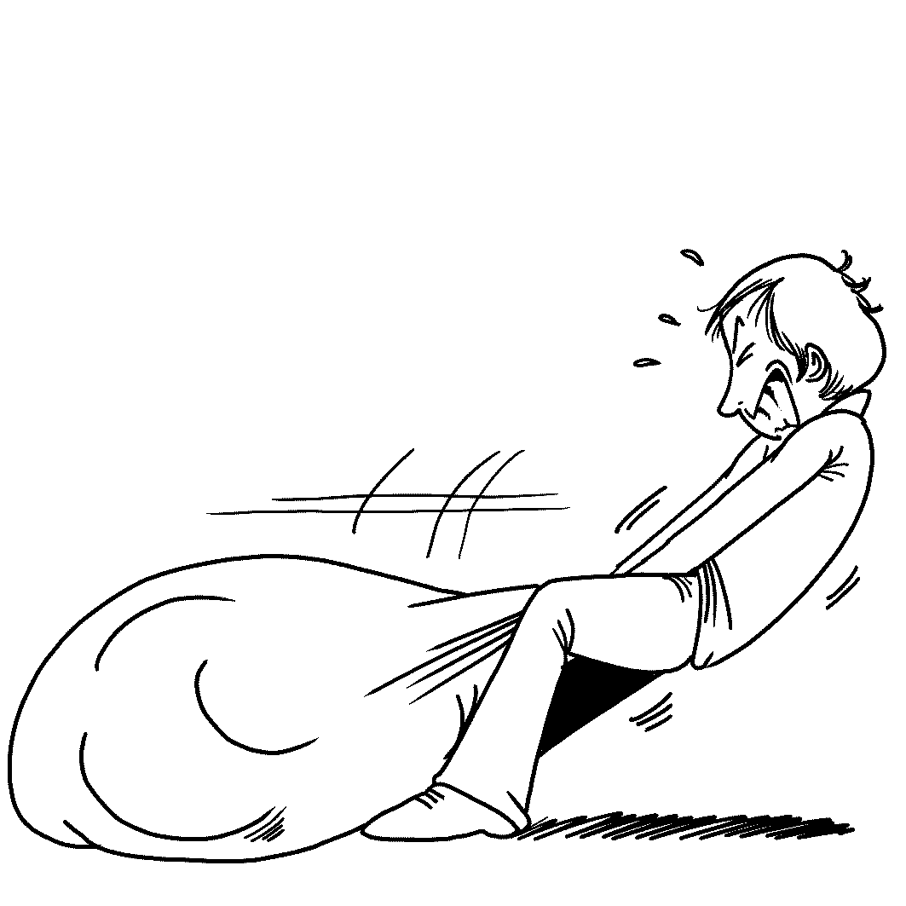
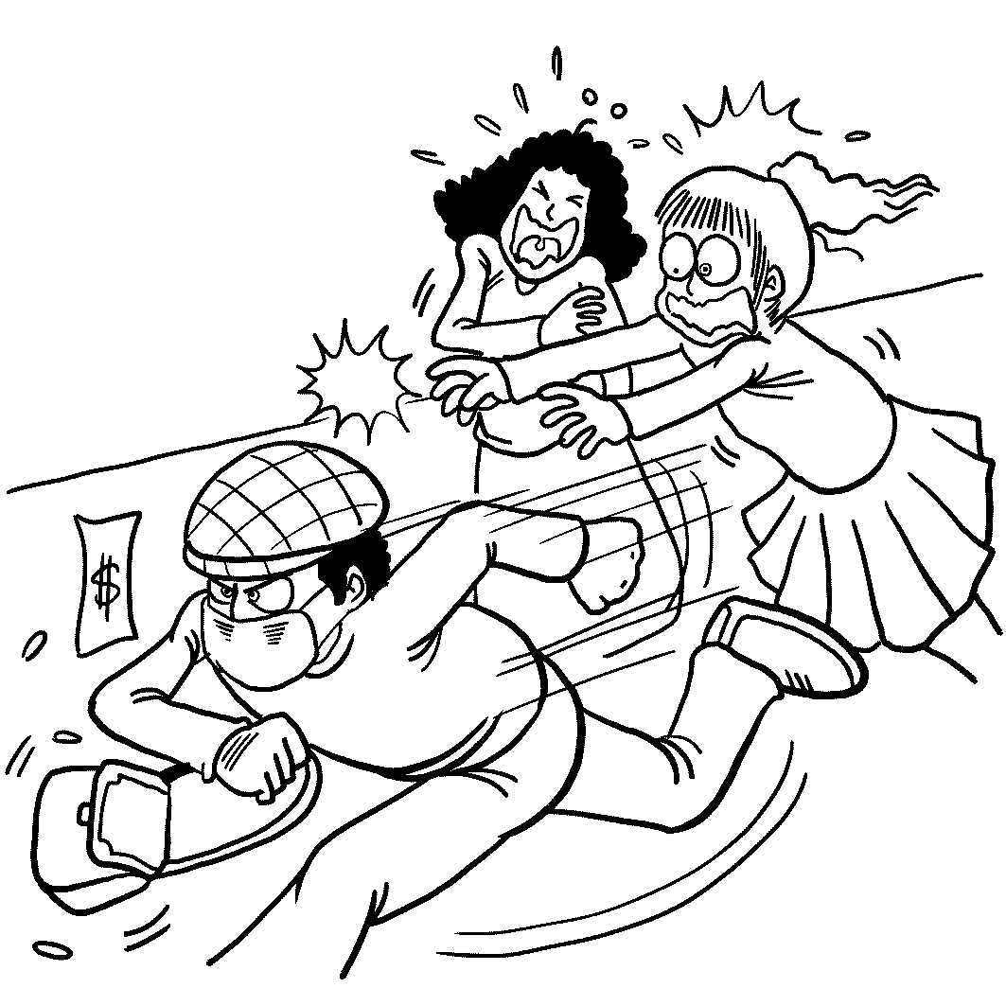
Look at each picture and answer the question.
1. 2.

Part B: Best Response Questions
Listen to the statement or question and choose the best response.
3. (A) No thanks. I don’t like playing sports.
(B) Sure. I’ll watch you from over here.
(C) Yeah. I’d better get home now and study.
(D) Sure. Let me explain it to you.
4. (A) Yeah, he really likes to lick people’s faces.
(B) That’s great that you got a new dog.
(C) That’s nice that you would look after him.
(D) Oh, no! Did he actually bite you?
5. (A) I think I need to buy a more comfortable bed.
(B) You can buy them at any drug store.
(C) Yeah. They are making me very sleepy.
(D) No. I don’t want to see any more doctors.
Part C: Conversation Questions
Listen to each conversation and answer the question.
6. (A) It made him laugh a lot.
(B) It is very moving and emotional.
(C) It is fun to read.
(D) It is very useful.
7. (A) Something worn by kings.
(B) Something to hold his pants up.
(C) Something for his feet.
(D) Something that is used for fighting.
8. (A) He wishes he had stayed home.
(B) He is disappointed by the festival.
(C) He is having the best time ever.
(D) He thinks the festival will be better later on.
Part D: Short Talk Questions
Listen to the following paragraphs and answer the questions.
9. (A) Children in the United States.
(B) Adults in Taiwan.
(C) Children in Europe.
(D) Children around the world.
10. (A) Affect brain development.
(B) Cause heart failure.
(C) Affect how tall you will be.
(D) Make you break out in pimples.

II. Vocabulary: 10%
11. With his abundant ______ knowledge of art, he can tell us everything about this painter. (A) background (B) underground (C) playground (D) undermine
12. That the ______ of the U.S.A. is Washington DC, not New York, has been taught in geography class, hasn’t it?
(A) city (B) president (C) center (D) capital
- Before you go out to the Jay’s concert, you have to clean up your room. You can’t leave your room a _________.
(A) mass (B) amass (C) mess (D) messed
14. In my ______, I suggest that we should decide which country to go, and then we can get into our trip.
(A) opinion (B) word (C) brain (D) onion
15. The most interesting part of the Lantern Festival activities is to answer lots of wit ______ with friends.
(A) puzzles (B) riddles (C) maze (D) middle
- She waited ______ for her boyfriend in the front of the theater because the movie had
started for five minutes.
(A) impatiently (B) delightedly (C) happily (D) unconsciously

17. Of the workers in this company, the _______ age is around 35, so you are probably the youngest one here.
(A) amount (B) ordinary (C) beverage (D) average
18. The color of the white tablecloth turned yellow. My mother ____ it with another new one.
(A) exchanged (B) replaced (C) transferred (D) replanted
- Mr. Wang has moved to L.A. for more than twenty years. This time he came back to Taipei, everything had changed and looked very ______
(A) similar (B) dissimilar (C) unfamiliar (D) unfeminine
- To make this district better, the government decided to ______ the old builings next Sunday, and rebuild the new ones.
(A) knock off (B) blow up (C) burn up (D) strike off

III Cloze Test : 15%
A.
A Connecticut Yankee was 21 and woke up 1,300 years in the past. He met a girl, Alisande, who went with him to save forty-four princesses. Alisande said the castle was just over the hill, but when the Yankee went to look, 22 he saw was a dirty pigsty and some pigs. He told Alisande this, but she 23 the princesses were there and that an enchantment was making the Yankee 24 to see the truth. Since the Yankee liked Alisande, he told her to go and 25 while he went and bought the pigs. Alisande told him that he did a noble deed and she would follow him wherever he went. The Yankee and Alisande rode off and faced the future together.
21. (A) hit off (B) knocked out (C) kicked out (D) beaten on
22. (A) that (B) all which (C) which (D) all
23. (A) persisted in (B) resisted that (C) insisted that (D) desisted from
24. (A) enable (B) able (C) disabling (D) unable
25. (A) hide (B) hid (C) hiding (D) hidden
B.
The New York Village Halloween parade is so special because of its creativity. It is natural that the coolest costumes and puppets appear here since New York is the world’s design and fashion center. Each year, a theme is chosen for marchers and puppeteers. After 26 what the theme is, these creative minds go to work. Though the city was 27 by the 9-11 attacks on New York in 2001, 28 the New York Village parade continued. The theme that was chosen that year was to show that New York would become strong again. Puppeteers created a huge, 29 phoenix with that in mind. And again this year, the Village Halloween Parade will bring all of New York together 30 Halloween.
26. (A) find out (B) finding out (C) found out (D) founding out
27. (A) dishonored (B) disintegrated (C) dismissed (D) disheartened
28. (A) but (B)  (C) so (D) and
29. (A) glowing (B) shining (C) glowed (D) shone
30. (A) in the hope of (B) in the habit of (C) in the spirit of (D) by the custom of
C
Penny Jiang does not want a dog or a cat as a pet. She loved her pet rabbit, Pupu, 31 . She treats him like her baby. She has clothes for him to wear, though she admits that he doesn’t really like to wear clothes. He can be naughty sometimes, but Penny says he is too cute to 32 him. Andy Xi’s has a pet beetle 33 La-bi. He knows that some people think it is 34 to have a pet beetle, but some people have told him how cute La-bi is. Beetles live in small 35 , so they are very easy to take care. Whatever kind of pet you want to get, spend some time with it before you make this life-long decision.

(A) disgusting (B) anger (C) named (D) at the first sight (AB) calls
(AC) fish tanks (AD) aquariums (BC) stay mad at (BD) adorable
Part Two： Textbook (Lungteng English Reader: Book One L5-6, L8)
I. Cloze Test 25 %(1% for each item)
A.
Tom, the boy in The Adventures of Tom Sawyer, by Mark Twain, was very naughty. He behaved badly on 36 in class so that the teacher would punish him and make him sit near the new girl, Becky, on the girls’ side of the classroom. When Tom sat down on the chair, Becky moved herself away 37 her head. To catch her attention, Tom 38 a peach before her, but it was pushed away by her. Tom didn’t give up and the peach 39 before her again. At the third time, Becky let it 40 . Then Tom began to draw something, and hid it with his left hand. He pretended not 41 Becky was trying to look at what it was. Becky 42 Tom 42 it and started to be interested in what he did. Tom pleased Becky by playing some tricks like those mentioned above and enjoyed making her laugh. The teacher found out his tricks. Then he 43 Tom 43 the ear, 43 him cross the classroom. He ordered Tom to sit down in his own seat. Tom’s ear hurt, but his heart was full of joy.
36. (A) purpose (B) propose (C) oppose (D) purposely
37. (A) and tossed up (B) with a toss of (C) and tossed (D) at a toss of
38. (A)lie (B) lay (C) laid (D) lain
39. (A)lying (B) lied (C) lay (D) laid
40. (A)remain (B) remaining (C) remains (D) remained
41. (A) to concentrate on (B) to be aware that (C) to notice of (D) to beware that
42. (A) begs； to show (B) begging；showing
(C) was begging；showing (D) begged；to show
43. (A)seized…by；dragged (B) seizing…on；dragged
(C)seizing… on；dragging (D) seized…by；dragging
B.
Teachers are often regarded as those who assign homework, examinations and urged students__44__ their best. But Nikos Kazantzakis reminds us __45__ teachers do much more. Teachers play the role of bridges __46_ which students cross to a new understanding of the world. They pass on the morals and philosophies __47_ students can learn and think on their own.
A girl talked about __48__ to her in her elementary school days. She quarreled with a boy about the color of an object. Neither of them would __49__. Then the teacher asked them to go to the front of the classroom. As they were standing at different places, they had entirely different answers as to the color of the object. It was an object __50__ sides. The teacher’s intention of doing so was to make them observe the same object in different ways. And the girl’s understanding was __51__ no one is completely right or wrong.

44. (A)doing (B)to do (C)on doing (D)do
45. (A)of (B)what (C)that (D)for
46. (A)over (B)in (C)by (D)with
47. (A)in order to (B)so as that (C)in order that (D)so as to
48. (A)what happened (B)what has happened
(C)what had been happened (D)what had happened
49. (A)give away (B)give in (C)give off (D)give up
50. (A)which with differently colored (B)which has differently colored
(C)which had differently colored (D)with different colored
51. (A)why (B)what (C)that (D)which

You may be jealous of someone who has the Midas touch. Yet, the story of King Midas
reminds us __52___ the danger it may cause.
Having treated one of god Dionysus’ friends well, Midas was granted a wish by Dionysus, the god of wine. Midas owned the power to __53__ everything he touched __53__ gold. In the beginning, he was excited about this __54__ power. He touched everything in sight and made his garden _55__ golden flowers and golden trees. After a short time, Midas felt hungry and tried to __56__ the apples in the tree. The apples were changed into gold at once. Midas was shocked at __57__. All the gold in the world would be of no use if he __58__ going to die of starvation. And he was grief-stricken when he accidentally transformed his daughter into a golden statue. Dionysus knew that Midas __59__ a lesson and took away his power. Everything changed back to the way it had been before. Midas was __60___.

52. (A)of (B)to (C)that (D)with
53. (A)take…into (B)enter…into (C)put…into (D)turn…into
54. (A)new-find (B)new-founded (C)new-found (D)new-finding
55. (A)is full of (B)filling with (C)to fill up (D)filled with
56. (A)bring out (B)reach for (C)replace for (D)spread out
57. (A)so terrible sight (B)such a terrible sight
(C)so a terrible sight (D)such terrible a sight
58. (A)is (B)was (C)were (D)will be
59. (A)learned (B)had learned (C)have learned (D)had been learned
60. (A)not a greedy king no more (B)not a greedy king any longer
(C)a greedy king no longer (D)a greedy king any more
II. Matching 5%(1% for each item)
61. I think of David
62. John had tried so hard
63. The manager made his secretary
64. Our neighbors blamed us
65. What would you do

(A) that parents are proud of.
(B) send an e-mail message to his wife.
(C) that he won the girl’s heart in the end.
(D) if you had found out the truth?
(AB) a nice and friendly guy.
(AC) return the book to her next time.
(AD) if you were the father of the child?
(BC) for our making noises at night.
(BD) as a diligent and honest boy.
III. Reading Comprehension 8%(2% for each item)
These days, homeschooling is on the rise. More and more parents choose to provide education for their children in their own home.
Why do these parents choose homeschooling? Some believe that children in public schools experience too much peer pressure, making it harder for them to develop good character traits. Other parents are not satisfied with the teaching programs of standard schools. They want to decide what is important for their children to learn. Besides, home schools allow children to work at a level that is appropriate to their own developmental stage. Skills and concepts can be introduced at the right time.
Teaching methods at homeschool vary. Some parents follow a strict schedule and imitate
a traditional school environment. Other parents follow a radical form of homeschooling in which they do not give grades or tests and allow their children to study whatever they want. More parents, however, follow the middle path to provide a balance between freedom and structure.
Recent studies in the United States have shown that homeschooled children score just as high as regular students. They tend to do better in subjects like English and art, but they are slightly less skilled at math and science.
Homeschooling can be expensive, and at least one parent must be home full-time to supervise the education. Besides, many homeschooled students are socially isolated. They may want to belong to school teams. Homeschooling also requires a lot of discipline form both the parents and the children. However, it is generally believed that homeschooling brings more benefits than traditional education.

66. What is the author’s views toward homeschooling?
(A) Doubtful. (B) For it. (C) Against it. (D) Uncertain.
67. In the third paragraph, “a radical form ” provides children with a lot of ________.
(A) freedom (B) structure (C) peer pressure (D) homework
68.Which of the following is NOT true about homeschooling?
(A) Homeschooling requires a large amount of money.
(B) One parent has to be home full-time to keep an eye on children.
(C) Homeschooling children might get too much peer pressure.
(D) Parent can decide whether homeschooling is right for their family.
69. From the passage, we know that _____________________.
(A) only parents can decide whether homeschooling is right for their family
(B) homeschooled students do poorly on academic tests
(C) parents who homeschool children are generally more knowledgable
(D) homeschooled children might be lonely

(以下題目請在答案卷上作答)
IV. Vocabulary 18%(1% for each item)
1. The firefighter was seen as a h___o for saving the child from the burning building.
2. As soon as the alarm clock went off, Jim got up and left for school i_____y.
3. Out of c_____y, Pandora opened the box that Zeus sent her and all the evils came out to do mankind harm.
4. Growing up in a poor family, Peter didn’t have the chance to receive any schooling during his l_____e.
5. The family’s s_____n became even more difficult after the parents died in the air crash.
6. The audience gave a s____h of disappointment after learning the Yankees had lost the game.
7. When the police arrived on the s____e, the robbers had already escaped.
8. Her high paying job enables her to become economically i_____t of her family.
9. The author of the book views the issue from a historical p_____e.
10. It is o_____s that the more you study, the more you know.
11. In Taiwan, many students are s_____ling with math and physics. To them, the two subjects are very difficult.
12. The woman felt her whole world c____ed when she got the message that her only son was killed in the fire.
13. The drunken driver had to take full r_____y for the accident.
14. The thieves tried to break into the apartment to steal the v____es during the New Year.
15. Sad to say, a lot of _____ (pretend) politicians claim that they are serving the people.
16. The teacher gave us great _____ (encourage) to achieve our goals.
17. The ghost story told by the teacher was so _____ (frighten) that all of kids cried out because of fear.
18. The _____ (reveal) that Christine was the winner of the contest amazed all of us.
V. Translation 9%(1% for each item) (每格均超過兩個字)
1. Laura勇敢地面對在她眼前的問題而非讓自己崩潰。
Laura bravely faced the problems in front of her i 1 .
2.我們不想跟Jimmy爭論，因為他總是佔上風。
We don’t want to 2 Jimmy because he always 3 .
3. 因為Tom在課堂中睡著，老師敲他的頭。
Because Tom 4 during class, the teacher 5 .
4. 我們深信Andy會遵守諾言。
We are 6 Andy 7 .
5.事情並非絕對的，你必須站在對方的立場。
Things are not always 8 ; you have to 9 .

台北市松山高中九十六學年度第一學期高一英文科第二次期中考 答案卷
班級 座號: 姓名:
IV. Vocabulary:18%
1 |  | 2 |  | 3 |  | 4
5 |  | 6 |  | 7 |  | 8
9 |  | 10 |  | 11 |  | 12
13 |  | 14 |  | 15 |  | 16
17 |  | 18

V. Translation:9%
1 |  | 2
3 |  | 4
5 |  | 6
7 |  | 8
9

台北市松山高中九十六學年度第一學期高一英文科第二次期中考 答案卷
班級 座號: 姓名:
IV. Vocabulary:18%
1 | hero | 2 | immediately | 3 | curiosity | 4 | lifetime
5 | situation | 6 | sigh | 7 | scene | 8 | independent
9 | perspective | 10 | obvious | 11 | struggling | 12 | collapsed/  changed
13 | responsibility | 14 | valuables | 15 | pretentious | 16 | encouragement
17 | frightening | 18 | revelation

V. Translation:9%
1 | instead of breaking down/ collapsing  instead of making herself break down/collapse | 2 | argue with /have an argument with
3 | gets/gains/has/takes the upper hand | 4 | fell asleep
5 | hit/knocked him on the head  hit/knocked his head | 6 | convinced that/ deeply convinced
7 | will keep his/a/the promise  won’t break his/a/the promise | 8 | black or white
9 | stand in the other person’s shoes stand in other people’s shoes  the other’s others’
1-5 ACADC 6-10 DACAA
11-15 ADCAB 16-20 ADBCB
21-25 BDCDA 26-30 BDB AorB C
31-35 D BC C A AC or AD 36-43 A BorC CCABDD
44-51 BCACDBCC 52-60 ADCDBBCBB
61-65 BD C B BC AD 66-69 BACD

