台北市松山高中九十六學年度第一學期期末考高一英文科試題

Part A: Live ABC Magazine (December, January week 1)

I. Listening Test: 10%

Part A: Picture Questions
Look at each picture and answer the question.

( ) | 1. | 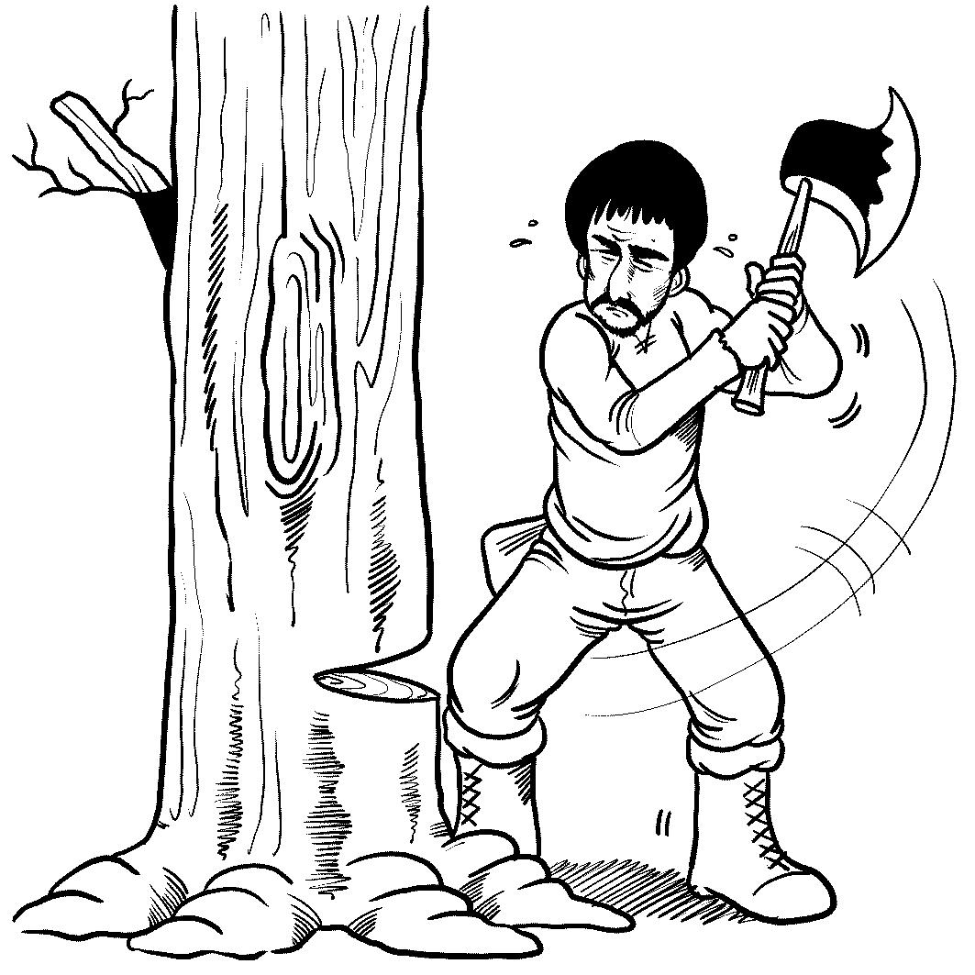 | ( ) | 2. | 

Part B: Best Response Questions
Listen to the statement or question and choose the best response.
( ) 3. (A) I like ice cream more than cake, too.
(B) I agree. I don’t like ice cream very much.
(C) Sure. You can have both cake and ice cream.
(D) Why don’t you want cake and ice cream?

( ) 4. (A) Of course. It was my pleasure to watch him.
(B) It’s OK. I’m sure we will find him very soon.
(C) Sure. I would love to help you buy a dog.
(D) No, I don’t think you should get a dog.

( ) 5. (A) OK. We should go to the library.
(B) How about a party and then dancing?
(C) But the house isn’t really messy.
(D) Yeah, I’m tired from working so hard.

Part C: Conversation Questions
Listen to each conversation and answer the question.
( ) 6. (A) It is his job.
(B) He enjoys eating it.
(C) He has to have it.
(D) It is for someone else.
( ) 7. (A) One that is smaller.
(B) One that has more equipment.
(C) One that looks better.
(D) One that is a newer model.

( ) 8. (A) Fire John.
(B) Find out where John is.
(C) Do John’s job.
(D) Have a talk with John.

Part D: Short Talk
Listen to the following paragraphs and answer the questions.

( ) 9. (A) Coal.
(B) A carrot.
(C) Sticks.
(D) A button.

( ) 10. (A) The snow was magic.
(B) The coals were magic.
(C) Karen put a magic spell on him.
- The hat was magic.

II. Vocabulary: 10%
11. There is a saying, “Birds of a feather _____ together.” People with similar traits tend to get together.
(A) benefit (B) flock (C) collect (D) vanish
12. A: What’s the _____ of Taiwan? B: It’s about 23 million.
(A) population (B) experience (C) existence (D) temperature
13. In Italy, throwing old belongings out of the window is a _____ of letting go of the past.
(A) journal (B) jungle (C) sample (D) symbol
14. If you want to rent a _____ apartment (about 15 pings) in downtown Taipei, it will cost you around 15,000 to 20,000 NT dollars per month.
(A) spacious (B) stiff (C) stable (D) sore
15. My boyfriend gave me a ______ for luck to decorate my mobile phone.
(A) county (B) charm (C) chill (D) citizen
16. I have seen many mistakes in your composition. That is, there is considerable room for _____ in your writing.
(A) government (B) improvement (C) achievement (D) instrument
17. Although Carla is smart and beautiful, yet she is still _____. She sets a good example for our class.
(A) humble (B) particular (C) experienced (D) ordinary
18. Ice, snow and frost are the examples of water in the _____ state.
(A) joyful (B) previous (C) gentle (D) solid
19. These _____ scooters remind Vespa collectors of the good, old days.
(A) frequent (B) positive (C) vintage (D) calm
20. It is important for mountain climbers to use a map and a _____ to find their way.
(A) compass (B) button (C) bucket (D) package

III. Cloze Test: 15%
- Many scientists formerly had difficulties __21__ field research because they couldn’t climb tall trees. Now, with Su’s help, professors and university students are able to __22__ new species from any treetop.
Su says that he has gained a sense of __23__ by allowing his students to see the world from a new angle. Whoever has mastered this art and seen the world from the top of a 200-year-old tree can’t help but __24__ more humble and open his mind to the world around them.
Elliot Su, a news photographer, retired at age 50 and became a tree climber. He has __25__ his new career, and he is sharing the greatness of nature with the world.

21. (A) for (B) about (C) at (D) with
22. (A) create (B) discover (C) invent (D) make
23. (A) humor (B) direction (C) achievement (D) responsibility
24. (A) feel (B) feeling (C) to feel (D) felt
25. (A) been at risk of (B) lost track of
(C) found greener pastures with (D) made up for

B. When winter comes to Oregon, the mountains are blanketed __26__ snow. I determined to let my brother, an experienced snowboarder, __27__ the ropes of his favorite winter sport, snowboarding.
With all the gear, we tried the easiest slop first. I __28__ as the chair of the ski lift swung in behind me and lifted me off the ground. It seemed that we were floating over a field of snow. However, no sooner had I got off the ski lift than I lost my balance and slid the rest of the way on my stomach after. I felt so embarrassed.
Every weight change on a snowboard causes some effect. I soon __29__ putting too much weight on the edge of the snowboard, which made my snowboard flip me into the snow—often face-first. After several tries, the best moment of the day was the first time I ___30___ to the bottom of the slope without falling. I felt like I had mastered the mountain.

26. (A) over (B) with (C) of (D) in
- (A) to learn (B) know (C) show me (D) to teach me
- (A) felt a rush of excitement (D) feel butterflies
(C) had a lot on my mind (D) had something up my sleeve
- (A) looked forward to (B) developed a habit of
(C) walked up to (D) majored in
30. (A) took over (B) zigzag down (C) had a point (D) made it

- Matching
With the approach of winter, bears head into caves to hibernate, and birds fly south to escape the cold. Though they will be back in the spring, there are certain animals that we may never see again. __31__. Unless something is done soon, they may be gone forever.
The Baiji, for example, is a rare freshwater dolphin found only in China’s Yangtze River. They are seldom seen these days. __32__. There are so few, if any, of course “goddesses of the Yangtze” left that their extinction is a sure thing. In Africa, the Hirola is at risk, too.
We can’t overemphasize the importance of protecting the environment. This is particularly vital for many of nature’s smallest creatures, such as bumblebee bats and pygmy hippos. __33__.
Fortunately, steps are being taken to save these animals. __34__. It is also training scientists to protect endangered species and their habitats. However, polar bears, penguins, and Bactrian camels are also endangered. __35__. Is this a case of too little or too late? Only time will tell.

(A) They are often the first to feel the effects of any environmental changes.
(B) With the increase of those endangered animals, EDGE has its work cut out for it.
(C) The EDGE of Existence program is raising public awareness about this problem.
(D) These animals, known as endangered species, are on the edge of extinction.
(E) Overhunting and pollution of its habitat have led to its possible disappearance.

Part B Textbook (Book One L4, L8, L9 – 12)

I. Cloze Test: 19%
- Poetry is a literary form written in lines. At the end of the lines, the words often rhyme. __36__, the rhyming words have almost the same sounds. For instance, “gold” rhymes with “hold,” and “leaf” rhymes with “__37__.” Also there is a tempo in each line which is called rhythm. If we hear someone saying, “Hickory Dickory Dock,” we may sense that the words __38__ the ticking of a clock. Therefore, we can say poetry has rhyme as __39__ as rhythm.
In reading a poem, we have to consider its meaning. It’s easier for us if we attempt to read the poem as a series of sentences. When we do so, the meaning of the poem __40__ clearer. The image of the poem is important, too. If we can feel the way the poet feels, and realize what the poet wants to __41__, the poem will become more beautiful and significant. So, __42__ reading aloud and picturing the images in reading a poem.

36. (A) Additionally (B) However (C) At first (D) That is
37. (A) bless (B) bud (C) grief (D) plants
38. (A) turn into (B) are similar with (C) are filled with (D) sound like
39. (A) long (B) far (C) well (D) soon
40. (A) appears (B) becomes (C) feels (D) keeps
41. (A) express (B) expose (C) chant (D) hold
42. (A) let’s (B) try to (C) get to (D) enjoy

B. I guess most of you may have heard of the song, “Rudolph, the red-nosed reindeer,” and it’s not difficult for us to find Rudolph’s pictures __43__ on many Christmas cards. In the beginning, Santa Claus had only eight reindeer and their job was to pull Santa’s sleigh full of toys for good children. Then, in the 1940s, an American department store was __44__ a way to sell more goods at Christmas. So one of the employees __45__ the character of Rudolph. Unlike the other reindeer, Rudolph found himself not __46__ by the others. The other reindeer even made fun of him for his appearance, and __47__. One Christmas Eve, Santa Claus was worried that no one could __48__ his sleigh. Suddenly, Rudolph’s shiny nose crossed his mind. Santa made Rudolph show the way. __49__ Rudolph’s help, Santa finally delivered the presents on time.

43. (A) appearing (B) to be appeared (C) appeared (D) appear
44. (A) looking down on (B) looking for (C) looking up to (D) looking into
45. (A) imagined (B) painted (C) created (D) developed
46. (A) accepting (B) accepted (C) to accept (D) accept
47. (A) saw him through (B) called him names
(C) got along with him (D) took pride in him
48. (A) carry on (B) travel (C) lead (D) guide
49. (A) As a result of (B) Because (C) Except for (D) In additional to

- Florence Nightingale was born to wealthy British parents. She __50__ “Florence” because she was born in the city of Florence, Italy. Like most girls from rich families, she was __51__ in literature, music, and art. She often traveled with her parents and learned to speak many languages. After spending some time reading nursing books secretly, she enjoyed helping sick people and wounded animals. In those days, hospitals were often dirty and nurses were __52__. Nightingale felt that women could do more to improve hospitals. Although her family strongly opposed her decision, she had __53__ her mind to help the sick. She went to a hospital in Germany to study nursing. After graduation, she returned to London and got a job running a hospital. In 1854, England was fighting a war against Russia. She __54__ to take 38 nurses she had trained herself to look after the wounded soldiers. At first, no one believed that these women could help. But in fact, they really made a great difference.

50. (A) named (B) was called (C) gave a name (D) named after
51. (A) well-known (B) kind-hearted (C) well-educated (D) well-mannered
52. (A) tolerant (B) untrained (C) respectful (D) attractive
53. (A) changed (B) lost (C) made up (D) turned to
54. (A) decided (B) assigned (C) educated (D) combined

II. Matching: 10% (請選出最合適的答案，選項不重複。)
55. Instead of laughing at her, (A) nor does Jane.
56. Sara stayed up all night; (B) that’s why she has few friends.
57. Tine doesn’t listen to rap music (C) Becky gave her a hand.
58. Jenny won’t stay long there, (D) lest her mother should worry.
59. Emily has a bad temper and (AB) so do my sister and I.
(AC) therefore, she feels tired now.

III. Reading Comprehension: 6%
Most heroes are people like you. But what makes them heroes? They find special courage when they need it. They are brave enough to help in an emergency while others may stand by. A hero sees what needs to be done and does it.
Sometimes heroes are rewarded for their brave acts. One such reward is the Carnegie Medal. It is given to people who act bravely and face danger to save the lives of others.
The medal was named after Andrew Carnegie. In 1886, Carnegie heard about a young man by the name of William Hunter who lost his life trying to save two other boys from drowning. Later, Carnegie became a very rich businessman and set aside money to honor heroes like William. Sometimes these heroes are in need or are hurt. If so, they receive money as well as the Carnegie Medal.
Over 6,000 people have received the Carnegie Medal. Some have saved people from drowning or from burning buildings. Others have pulled people in front of moving trains or saved them from attacks by wild animals. All these heroes have one thing in common, however. They put someone else’s safety ahead of their own.

- What is the main idea of this passage?
  - Carnegie was a rich businessman and helped many people.
  - William Hunter was a very courageous man.
  - Some heroes have been rewarded for their bravery.
  - Hunter saved Carnegie from drowning.
- The Carnegie Medal is given to those who are
  - poor and wounded (B) rich and well-know
(C) young and brave (D) unselfish and courageous
62. Which of the following statements is NOT true?
- Over 6,000 people are Carnegie Medal recipients.
- William Hunter died from saving two other people.
- Carnegie knew William Hunter in person.
- Some heroes have received money and the Medal.

IV. Vocabulary 20 %
- The mountain climbers got lost in the mountains, but they e y found their way back.
- The d t child went to the park even though her mother told her not to.
- We would like some information about Professor Richards’ i y courses in Accounting.
- There is a great deal of r e between the mother and the daughter. They look like twin sisters. I can’t tell them apart.
- The famous writer based his latest novel on a number of ancient l ds.
- The streetlight standing on the corner g ed dimly last night.
- T e is very important in getting along with other people, as we need to accept individual differences.
- Sean’s accent is c c of British English, isn’t it? It’s different from
American English.
- He's been n d by the Democratic Party as their candidate in the next
election.
- After Yo-Yo Ma finished his performance, the audience applauded in a n.
- During the winter, the s rs in many cities are crowded with homeless people.
- The report you are reading is about how swallows find their way home on their long j y of migration.
- Because of the s n problem, African countries need more donations of food and clothing from developed countries.
- It isn’t right to take for g d what your parents have given you all the time.
- Drunken driving is an act of f s. Smart people won’t do such a silly thing.
- The police carefully e ned the scene to look for clues to the cause of the fire.
- The accident victim was urgently taken to hospital by an a e.
- Some students would like to visit second-hand bookstores because they can buy the books they like at a b n.
- The little girl was f ned by the vampire in the horror movie she had seen last night.
- As we know, Charles Darwin is the first scientist that developed the theory of
e n.

V. Translation: 10% (每一格字數不限於一字)
- 有句話說：「偉大的靈感源自於一場夢。」Robin但願能成為一位獸醫。
As the proverb __1__, “__2__ begins with a dream.” Robin hopes to be a vet.
2.他以前喜歡捉弄同學，現在他專心於課業。
In the past, he liked to __3__ on his classmates, but now he _4__ his studies.
- 儘管他過去常浪費許多時間，但他現在不會了。
_D_5__ that he __6__ waste a lot of time, he doesn’t now.
- 他為流浪狗發聲，而他的事蹟將被記載在歷史上。
He is __7__ stray dogs, and his deeds will __8__.`
5.只要他努力，夢想將無不實現的。
__9__ he studies hard, he won’t leave his dream __10__.

台北市松山高中九十六學年度第一學期高一英文期末考解答
V. 文意字彙: 20%
1. eventually | 2. disobedient | 3. introductory | 4. resemblance
5. legends | 6. glowed | 7. Tolerance | 8. characteristic
9. nominated | 10. appreciation | 11. shelters | 12. journey
13. starvation | 14. granted | 15. foolishness | 16. examined
17. ambulance | 18. bargain | 19. frightened | 20. evolution
VI. 翻譯: 10%
1. goes/runs/says | 2. Great /Grand inspiration
3. play jokes/tricks  play a joke/trick | 4. pays/gives attention to,  focuses/fixes/concentrates (his attention) on,  devotes himself / his attention to
5. Despite the fact | 6. used to
7. a voice for / the voice for | 8. go down / be recorded/be written in (the) history
9. As long as | 10. unfulfilled

1-5 | BBBAB | 6-10 | CDCBD
11-15 | BADAB | 16-20 | BADCA
21-25 | DBCAC | 26-30 | BCABD
31-35 | DEACB | 36-40 | DCDC B/(A)
41-45 | ADCBC | 46-50 | BB D/(C) AB
51-55 | CBCAC | 56-62 | AC A D B C D C

