台北市立松山高中九十六學年度第二學期高一英文科期末考

Part One: Eglish4U May and June Week1 2008, Vocabulary builder Part 3 Unit 1-Unit12

I. Listening test 10%
Part A Look at the pictures below. For each, you will hear one or two questions and four possible answers, A to D. Write down the letter for the best answer (A, B, C, or D).

Questions 1-2
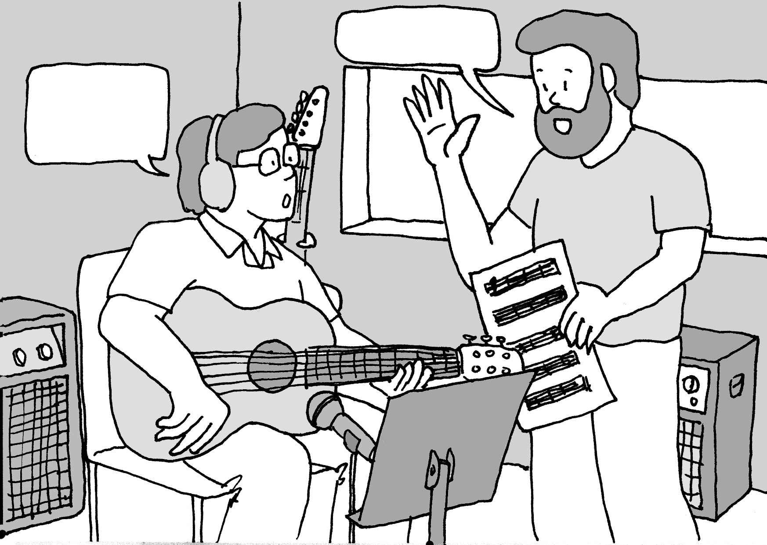

1. 2.

Part B you will hear one or more questions or statements. Choose the best response or reply.

3. (A) The building is called Sky Tower.
(B) He says he is a salesperson.
(C) Everyone calls him Mr. Smith.
(D) The company’s name is RNC.

4. (A) No, I don’t know anyone who lives there.
(B) Yes, I’d like a nice shirt if you have time.
(C) No, I actually think it’s really beautiful.
(D) Yes, I’ve read a lot about its history.

5. (A) No, it’s not expensive.
(B) No, it doesn’t taste bad.
(C) No, it is in the form of a pill.
(D) No, it’s in the bathroom.

Part C you will hear one or more short conversations between a man and a woman, and then a question following each conversation. Choose the best answer to that question.
6. (A) Give a speech in class.
(B) Go to class quickly.
(C) Write a big test.
(D) Tell the school she’s sick.
7. (A) Timmy had a fight with Rick.
(B) Rick didn’t treat Timmy kindly.
(C) Timmy actually hates Rick.
(D) Rick is not a real person.
8. (A) She’s too busy to cut the man’s hair.
(B) The man is really making her angry.
(C) She’s finished cutting the man’s hair.
- The man looks silly with long hair.

Part D 2 %
In part D, you will hear one or more passages and then some questions about them. Choose the best answers to those questions.
9. (A) One that moves people around the city.
(B) One that brings water to people’s homes.
(C) One that keeps people safe on the streets.
(D) One that lights up the city at nighttime.
10. (A) They were completely empty.
(B) They were painted a new color.
(C) They were crowded with people.
(D) They had new windows installed.

II. Cloze Test : 20%
A.
Youtube having millions of videos from people around the world is one popular website 11_ the most people to browse. Everyone can freely watch various kinds of videos without any 12 . However, if you want to save your favorite videos or post videos of your own, it’s best to sign up. That is, you should enter your email address, choose a username and password, then describe your channel, and choose the colors you like. Also, you add a personal profile and contact information. If you want to be famous, you just simply make your own video with your camera. Then, get your video 13 on-line. If people like your videos, they 14 to your channel and leave their comments. Youtube provides opportunities for many people who would like to show themselves to the world 15 their videos.

11. (A) appealing (B) appealed (C) which appeal (D) which is appealed
12. (A) signature (B) deposition (C) account (D) instruction
13. (A) post (B) posted (C) posting (D) to post
14. (A) prescribe (B) transcribe (C) inscribe (D) subscribe
15. (A) with showing (B) without making
(C) by uploading (D) through setting up
B.
Venice, built on hundreds of islands, seems to have risen out of the sea. The beauty of the water 16 its usefulness. Over the city, thousands of 17 status means the saint of Venice St. Mark, 18 virtue, strength and courage, and the old buildings display Venice’s rich history of religion and art. At the height of its wealth centuries ago, in Venice ships carried a variety of goods from distant land, which were sold to 19 countries. In addition to appreciating its history and beauty, the tourists can also take home a piece of Venice’s history, such as beautiful items of glass created following the proud Venetian glass blowing tradition, and the unique Venetian masks worn in the 20 Carnival, one of the biggest events in Venice. During Carnival, the rich and poor, young and old people mixing together with masks come out to dance the night away.

16. (A) is compared exclusively at (B) is matched only by
(C) is partially thought of as (D) is packed mainly with
17. (A) lion-winging (B) lion-like (C) wing-lioned (D) winged-lion
18. (A) who represented to (B) who stood up
(C) standing for (D) representing as
19. (A) succeeding (B) promising (C) neighboring (D) isolating
20. (A) biennial (B) annual (C) centennial (D) perennial

C.
The Cleaners, exhibited in Taiwan now, was one of Millet’s masterpieces. Millet, born the son of farmers in a small town, was the first French painter to show country life with 21 . At the age of twenty, Millet left for Paris to fulfill his dream of studying art. However, because of a strong dislike 22 Paris, Millet moved to the small town of Barbizon in 1849, 23 the fresh air reminded Millet of his hometown and made him feel alive again. It was the time that Millet painted his best-known works, including The Sower and The Cleaners. Millet’s art 24 after his death. Though he left behind only about eighty paintings, his style inspired many other great artists, such as Monet and Van Gogh. Today the world remembers Millet as a painter 25 country life as noble and beautiful.

21. (A) dignity (B) stature (C) gravity (D) signet
22. (A) for (B) to (C) at (D) in
23. (A) when (B) which (C) where (D) what
24. (A) became terribly disgraced (B) became less profitable
(C) was extraordinarily antique (D) was highly valued
25. (A) devoting himself to show (B) who was devoted himself to showing
(C) who was devoted to show (D) devoted to showing

D.
“Charlie and Lola” by Lauren Child depicts the simple everyday lives of two siblings, Charlie and Lola, and has successfully captured the hearts of young readers all over the world. On a train in Demark, Child was deeply impressed by a curious and 26 little girl, who kept asking her parents various questions. As a result, she 27 the character “Lola”, 28 her companion, her older brother “Charlie”, and thought of telling a story about her. Both Child’s drawings and her stories are simple and basic as she sets herself quite strict rules in doing a story which 29 very tiny child issues. This way, kids can relate themselves to a life lesson in each story. Now, the stories of Charlie and Lola have 30 on TV and DVD. Lauren Child hopes both children and parents alike will enjoy the heartwarming shows and learn something from them.

(A) alive to (B) came up with (C) as well (D) is based on (E) together with
(AB) come alive (AC) is depended on (AD) adorable (BC) have in mind

III Vocabulary: 10%
31 .On hearing rejection of his parole application, the prisoner remained _________ peaceful .
(A) remediably (B) acceptably (C) remarkably (D) accessibly
32. There are abundant _________ for recreation in our little town.
(A) facilities (B) facilitations (C) festivities (D) feasibilities
33. Johnathon’s mom was pretty mad because he _________ in on-line games all day long, paying little attention to his study.
(A) devoted (B) dedicated (C) involved (D) indulged
34. Riding on a roller-coaster is one of the young’s favorite activity; on the contrary, it is too _________ for the old.
(A) thrilling (B) brilliant (C) accurate (D) enjoyable
35. Japanese like to stand at the gate, bowing _________ to greet their guests.
(A) arrogantly (B) modestly (C) potentially (D) indifferently
36. With a view to renovation of the rivers, the government puts limits on the animal excreta processing to keep the piggeries from _________ the water.
(A) messing (B) lessening (C) contaminating (D) containerizing
37. Doing ten-year cancer research, she finally discovered a _________ treatment which gives the faith of the patients against cancer.
(A) recessionary (B) revolutionary (C) missionary (D) evolutionary
38. Clouds were _________ by the wind. The sky became so clear.
(A) shattered (B) muttered (C) stuttered (D) scattered
39. The First Lady has a good _________ for her devotion to the charity.
(A) celebrity (B) reputation (C) notoriety (D) discretion
40. ________ is medical condition in which a person is so unhappy that they cannot live a normal life.
(A) Progression (B) Regression (C) Recession (D) Depression
Part Two: Textbook (Lungteng English Reader: Book Two L4,5,9,11,12)
I. Cloze test: 27%
A
Helping wildlife has become an urgent global concern because the natural environment unsuitable for wildlife will also be unsuitable for mankind. Not only governments but also people should 41 to prevent endangered animals, 42 when sharing the same space with people, from disappearing forever from the earth . How can we help the animals, such as Formosan black bears 43 because of the population increase? Though 44 come into direct with endangered species, we still can follow some useful suggestions to help them. For example, when seeing a 45 animal on the road, it is a good idea to call an expert, like a veterinarian, to treat its wounds, 46 picking it up or leaving it and walking away. If we make the world safer for wildlife, at the same time we also probably help create a better living environment for human beings.

41. (A) take some actions for (B) take some measures to
(C) have taken some steps to (D) have taken some actions into
42. (A) being doomed to loss (B) doomed to loss
(C) that are doomed to lose (D) which seem to be doomed to lose
43. (A) endangering their lives (B) in danger of existence
(C) being extinct (D) in danger of extinction
44. (A) it is believed that we can (B) we are unlikely to
(C) we are impossible to (D) it is likely that we can
45. (A) wounded (B) poisonous (C) injurious (D) damaged
46. (A) instead (B) unlike (C) rather than (D) inclusive of
B.
For centuries, people who live near a lake in Scotland __47__ a gigantic unknown creature in the lake, which is known __48__ Loch Ness monster. However, no one knows for sure __49__ it looks like. Some say it resembles a long-neck alligator without claws. __50__ have described a giant snake-like animal with a red mouth and huge horns sticking out. Also, __51__ the creature may be a fish-eating dinosaur which has somehow __52__ the modern world. __53__, no such creature has been found until now, even with the most advanced equipment. Another famous monster __54__ in the high areas of the Himalayan mountains of Nepal. __55__ the rumors about large footprints on the upper slopes of the mountains, no one can really prove __56__ creature exists. A similar situation is found in the wilderness areas of the American northwest, __57__ people claim to have seen Bigfoot. Whether these reports are true or not, there is no denying that even with what science has taught us, we still cannot know the answers __58__ these unsolved mysteries.

47. (A) have reported to see (B) have reported seeing
(C) have been reported seeing (D) have reported being seen
48. (A) as (B) for (C) to (D) by
49. (A) how (B) why (C) that (D) what
50. (A) Another (B) The other (C) Others (D) The others
51. (A) people suggested that (B) it had been suggested that
(C) people had suggested that (D) it has been suggested that
52. (A) survived from (B) survived into (C) survived by (D) surviving into
53. (A) Still (B) As a result (C) In a word (D) Therefore
54. (A) it is said that (B) is said live (C) is said to live (D) is said to be lived
55. (A) Although (B) Despite (C) In spite that (D) Even though
56. (A) so a (B) a such (C) such a (D) a so
57. (A) where (B) that (C) so (D) which
58. (A) from (B) of (C) by (D) to
C.
There are advantages and disadvantages to everything and __59__ Modified (GM) foods are no exception. What is good about GM foods? First, they are easier and cheaper to grow, and appear more beautiful. __60__, GM foods are more resistant to warmth and cold; therefore, they can help the __61__ countries out of hunger. Second, GM foods are beneficial to the environment because fewer chemicals will be needed to kill insects. What’s more, __62__ land will be required to grow food and __62__ forests and nature areas can be preserved.
However, it is supposed that GM foods may have some negative effects __63__ positive ones. People who are opposed to GM foods __64__ the fact that they contain chemical substances that may __65__ other forms of life. In addition, they indicate that too little testing __66__ about the long-lasting effects that GM foods may have on our bodies. Though GM foods taste better and last longer, we should buy __67__ foods to avoid the possible danger to our health caused by GM foods.

59. (A) Gene (B) Genetics (C) Genetic (D) Genetically
60. (A) Moreover (B) Except (C) Beside (D) In fact
61. (A) more developed (B) most developed
(C) less developed (D) well developed
62. (A) fewer...less (B) more...fewer (C) fewer ...more (D) less ...more
63. (A) as soon as (B) as long as (C) as well as (D) as possible as
64. (A) look out (B) picked out (C) point out (D) found out
65. (A) be harmful to (B) be good to (C) be related to (D) be due to
66. (A) had been done to learn (B) has been done to learn
(C) has been doing learning (D) had been doing learning
67. (A) organically growing (B) organically grown
(C) growing organically (D) organic grown
II. Reading Comprehension: 6%

In 1993, the Metropolitan Museum of Art reluctantly handed over 363 pieces of gold, silver, precious stones, paintings, and sculptures back to Turkey after a court case. Following increasing calls for the return of artistic objects that were removed decades or centuries ago, some of the world’s leading museums have signed a declaration that they will not hand back the ancient artifacts to their countries of origin. They say people all over the world have only been able to fully appreciate ancient civilizations because these museums have provided access to these artistic objects. The ancient civilizations would not be so deeply admired today if these ancient artifacts were not so widely available to an international public in major museums throughout Europe and America. For instance, Egyptian culture would not have become so well known if the museums had not put Egyptian mummies on display.
The British Museum has not signed the declaration, but says it fully supports it. Over the recent years, it has faced growing pressure to hand back the Elgin Marbles, sculptures taken from the Parthenon in Athens, Greece, in the nineteenth century. But the British Museum has said that the Museum is the best possible place for them. “They must remain here if the museum is to continue to achieve its aim, which is to show the world to the world,” said the director of the museum.

68. Which of the following is NOT mentioned as one of the “countries of origin” in the article?
(A)Britain (B) Egypt (C) Greece (D) Turkey
69. What does “the world” mean in “show the world to the world?”
(A) The leading museums (B) The ancient civilizations
(C) The global village (D) The international public
70. What reason do the major museums provide for not returning back the ancient objects?
- They need those famous ancient objects to attract people from all over the world.
- Ancient civilizations can only be admired if they are removed from their home countries.
- It is better for those objects to stay at a certain place than to be moved around.
(D) Only in the leading museums can the objects be fully appreciated by the world.

III. Matching: 3%
- If he doesn’t show up on time,
72. He has been ill for a week.
73. The parent as well as her children

- it is unlikely that his flight is canceled.
- So was his twin brother.
- enjoys working as a volunteer.
- chances are that his flight is delayed.
(AB) So has his little brother.
(AC) like to help the poor people.
IV. Vocabulary: 16%
- Examinations are a way for teachers to e____e how well their students have learned the material.
- The r____e teams from other countries rushed to mainland China after the killer earthquake hit Sichuan on May 12th.
- The rich man c____ed a lot of money to the victims of the earthquake.
- The government places certain r____ns on the use of cars to ensure safety on the roads.
- Seeing those pictures s____red my childhood memories of traveling to Hongkong.
- Though the weather forecast said it would rain next Saturday, the class was still d___ting whether to go on a hike or not.
- People in the village held a religious c____y to mark the birthday of the goddess that bless the fishing village.
- The worldwide famous violinist’s concert was extremely s_____l for it captured the audience’s attention.
- T____y brings a comfortable life for people, but it also has a bad influence on the environment.
- Most children don’t want their parents to i_____e with their work and private affairs.
- He violated the law, and now he must face the c____es of his actions.
- Uncle Sam will be staying with us t_____ly. He will leave in a few days.
13. The factory was fined one million dollars for putting i_____l waste into the main river of the city.
14. The 9-21 earthquake is the most _____ (destroy) earthquake that has ever hit Taiwan.
15. My teacher puts _____ (emphasize) on the positive attitude toward studying.
16. Our English teacher gave us a detailed ____ (explain) of the grammatical rule so we had a clear idea of it.

V. Translation: 8% (每格至少填2字)

1. 校長的話給了我許多值得思考的東西。
What the principal said certainly gave me _____1____.
2. 由於油價上升，日常生活用品月底前可能會上漲。
___2____ rising oil prices, the prices of daily necessities ___3____ go up towards the end of the month.
3. 科學家們擔心全球暖化造成的問題。全球暖化會帶來嚴重環境破壞嗎？
只有時間能回答。
Scientists ____4___ the problems caused by global warming. Will global warming cause serious environmental damage? Only _____5_____.
4. 李安電影多年來深受好評。但至今，「臥虎藏龍」被視為李安最棒的作品之一。
The movies of Ang Lee have enjoyed great critical approval over the years. But ____6____, Crouching Tiger, Hidden Dragon ___7____as one of Lee’s greatest works.
5. 據說印地安那瓊斯電影第四集中的水晶骷髏來自於馬雅文明。
___8___ that the crystal skulls in the fourth film of Indiana Jones series were originated from Maya civilization.

台北市立松山高中九十六學年度第二學期高一英文科期末考
答案卷
班級 座號 姓名

IV. Vocabulary (16 %)

1. |  | 2. |  | 3. |  | 4.
5. |  | 6. |  | 7. |  | 8.
9. |  | 10. |  | 11. |  | 12.
13. |  | 14. |  | 15. |  | 16.

V. Translation (8 %)

1. |  | 2.
3. |  | 4.
5. |  | 6.
7. |  | 8.

台北市立松山高中九十六學年度第二學期高一英文科期末考
解答
班級 座號 姓名

IV. Vocabulary (16 %)

1. | evaluate | 2. | rescue | 3. | contributed | 4. | restrictions
5. | stirred | 6. | debating | 7. | ceremony | 8. | successful
9. | Technology | 10. | interfere | 11. | consequences | 12. | temporarily
13. | industrial | 14. | destructive | 15. | emphasis | 16. | explanation

V. Translation (8 %)

1. | (much /a lot of ) food for thought | 2. | Due to / Because of / Owing to / As a result of
3. | are likely to | 4. | are concerned about /  are worried about
5. | time will tell | 6. | to date / until now / up to now / up to the present / so far
7. | has been viewed / seen / regarded / taken / thought of / referred to / looked upon | 8. | It is said  People / They say  It has been said

1-10 BDCAC BDCAC
11-20 ACBDC BDCCB
21-30 AACDD AD B E D AB
31-40 CADAB CBDBD
41-46 BDDBAC
47-58 BADC DBACB CAD
59-67 DA CDCCA BB
68-70 ABD
71-73 D AB C

