台北市立松山高級中學九十六學年度二年級第二學期英文科期末考試題

STUDIO CLASSROOM 40%

Part A – Listening Section 14%
I. Pictures 看圖辨義
Listen to the questions. Then choose the best answer according to each picture.

A. Questions 1-2 (6/2)
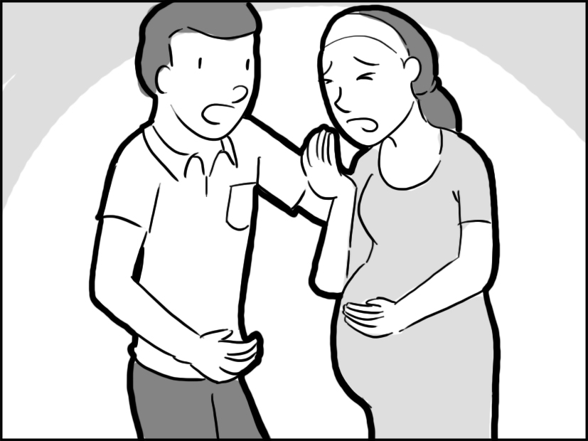

B. Questions 3-4 (6/14)
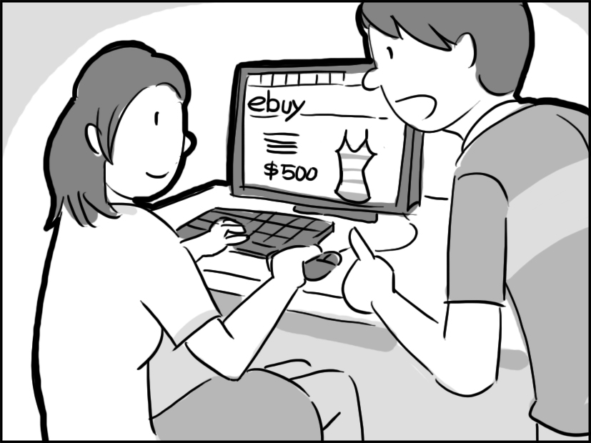

II. Best Response 最佳回應句
Choose the best response to each question or statement.
5.
A. They will taste better with sugar. B. I’ve never had ripe strawberries.
C. I prefer having oranges to strawberries. D. Try giving them more sunlight.
6.
A. I just recovered from a cold. B. I didn’t go to the doctor then.
C. I was telling you I was O.K. D. I was choking on my food.
7.
A. Well, I just came back from school. B. Yes, I’m going on an excursion.
C. Just ask my brother for the keys. D. I’ve been to the museum too.
8.
A. He has mastered two languages. B. He started playing music last year.
C. He taught himself how to run a business. D. He majored in mechanical engineering in college.
III. Short Conversations 簡短會話
Listen to the conversations. Then choose the best answer for each question.
9.
A. She got lost on the street.
B. She was almost robbed.
C. Her money was stolen.
D. Her purse fell on the ground.
10.
A. She will give it to her parents.
B. She will use it to help needy people.
C. She will save it for her first car.
D. She will lend it to her classmates.
11.
A. He wants to do a careful job.
B. He wants to get off work soon.
C. He needs to do other work first.
D. He works slower than others.

IV. Short Talk 短文
Listen to the passage. Then choose the best answer for each question.
12.
A. The importance of being on time for work every day.
B. Common reasons that people argue with each other.
C. What to do when someone from another culture visits.
D. How people from different countries think about time.
13.
A. They are almost never late for a meeting.
B. They are often late for appointments.
C. They are not very friendly to other people.
D. They are not interested in responsibility.
14.
A. Bring a gift when you visit them.
B. Let them visit you anytime.
C. Be on time for meetings.
D. Learn about their home country.

Part B – Reading Section 26%

I. Vocabulary & Phrases 詞彙與慣用語 11%
15. The temperature outside is _____ 22 degrees Celsius, so let’s go out to play.
A. currently B. seasonally C. manually D. informally
16. Before I make any investment, I always talk to my financial ____ first.
A. consultant B. creed C. pamphlet D. budget
17. The girl in the flower shop keeps ____ water on flowers to make them look fresher.
A. screeching B. bumbling C. overlooking D. spraying
18. Though the patient has remained ____ for years, his wife still visits him every day.
A. informal B. manual C. unconscious D. artistic
19. To prevent eye _____, take a break after working half an hour at a computer.
A. tragedy B. strain C. resident D. cube
20. He was awarded the prize for his ___________ to adult education.
A. discrimination B. medication C. dedication D. collection
21. On the snow-covered mountain, no _____ or animals may be spotted.
A. vegetation B. determination C. visibility D. celebration
22. The color white _____ purity in Western culture.
A. exceeds B. devotes C. represents D. stresses
23. I hope I can resist the _____ of food, so that I can successfully lose weight.
A. reformation B. excursion C. temptation D. visibility
24. The number of students who signed up for the activity _____ our expectations.
A. reviewed B. exceeded C. devoted D. leased
25. Children’s good behavior should be _____ by praise while bad behavior should be corrected by punishment.
A. reinforced B. misread C. endangered D. hindered

II. Cloze Test綜合測驗 10%
The security of personal information is what people care about most when they surf the Internet. Now, the answer may 26 the IronKey. It’s a tiny USB drive that encrypts files and protects them with a password. 27 in a metal case, it is both waterproof and tamperproof. If someone tries to open the case or enter the wrong password more than ten times, this will activate its self-destruction function. 28 , the IronKey also provides protection for people who use shared computers or an open wireless network. The drive has its own Web browser that 29 Internet activities through its Secure Sessions Service. The drive leaves practically no trace on computers. In this way, the IronKey offers people security and privacy 30 they go.
- A. attribute to B. lie in C. result from D. consist of
- A. House B. Housing C. Housed D. To house
- A. Instead B. Otherwise C. Thereby D. Besides
- A. pampers B. surveys C. channels D. invests
- A. wherever B. whoever C. whichever D. however

Last summer, I decided to experience the beauty of Auckland in New Zealand, so I picked up my bag and went on my way.
As the plane was landing, what struck me the most was how perfectly clean 31 . With absolutely no smog, vast areas of green stretched beyond my sight and as we flew lower and lower, a crystal clear ocean 32 hundreds of white sails appeared. 33 Auckland is called “the City of Sails!”
Shortly after I arrived, I went to the observation deck of the 192-meter Sky Tower, the tallest structure in the Southern Hemisphere. There I couldn’t help 34 the many “sky jumpers” who went bungee jumping off the tower! Later I visited the Auckland Museum, whose building 35 was a piece of artwork. After dinner I tried the kiwifruits there. They tasted fresher, firmer and sweeter than ones I get in Taiwan. There is still a lot left in Auckland for me to explore and I am sure I’ll go back there for another adventure.
- A. was the air B. was it the air C. the air was D. it was the air
- A. dotted with B. based on C. opposed to D. meant for
- A. In addition B. No wonder C. Above all D. For example
- A. wonder at B. to wonder at C. but wondering at D. wondering at
- A. that B. which C. itself D. another

III. Structure Scramble篇章結構 5%
Situated in the Indian Ocean near Sri Lanka, the archipelago of the Maldives is distinguished as a top class tourist attraction. 36 .
37 These lagoons are formed by the house reefs. They are shallow, giving them a turquoise color that contrasts with the dark blue of the ocean. 38 . Under the water, colorful coral reefs support a variety of sea animals like starfish, sea turtles and schools of brilliantly-colored fish. 39 . People can dive in the deep water outside the shallow lagoons. This is where large fish and animals like sea turtles can be seen.
40 . Their attentive staff members are always ready to assist and will never let you down. Many resorts offer whale and dolphin watching and wind surfing for those who enjoy outdoor activities.
A. People snorkel in the lagoons because they are shallow and thus the coral can be easily seen.
B. The islands are full of luxury resorts.
C. From the air, the 1,190 islands appear as green dots encircled by light-blue lagoons.
D. The balmy weather, white sandy beaches and luxury resorts are ideal for visitors who love water sports.
E. The multi-colored fish are a feast for the eyes.

TEXTBOOK 60 %

I. Cloze Test 18 %
Remains of ancient civilization are places which were designed and built as a lasting public tribute to some individuals or events. By visiting these historical monuments, not only ___41___ awed by how advanced the ancient civilization that existed centuries before you ___42___, but you will also wonder at the mysterious legends behind it. The Great Wall, ___43___, is probably the best-known monument of China, which consists of a network of walls and towers that leave the frontier open in places. Estimates of the total length of the monument ___44___, depending on which sections are included and how they are measured. One of the long-standing myths is that, ___45___ some of the wall is discernible in special radar images taken by satellites, astronauts have confirmed that the existing wall is not several thousand years old, nor is it, as has been widely asserted, visible with the naked eye from outer space.
___46___ the Great Wall of China is the Great Pyramid of Giza. Over a 20-year period, 100,000 laborers built it with about two million stone blocks, ___47___ each weighing more than two tons. Completed in 2560 B.C., it stood 146 meters high. It served ___48___ as a tomb for King Khufu, but also a place of religious activity. After Khufu died, his body was carefully treated and wrapped to preserve it as a mummy. According to ancient Egyptian belief, the pyramid, ___49___ the mummy was placed, provided a place for the monarch to pass into the afterlife. The priests performed rituals to nourish the dead monarch’s spirit, which ___50___ to stay with the body after death.
- (A) you will be (B) you are (C) will you be (D) are you
- (A) would be (B) was (C) are (D) were
- (A) for example (B) in addition (C) however (D) in other words
- (A) varies (B) is various (C) to vary (D) vary
- (A) because (B) despite (C) in case (D) although
- (A) Still another is (B) Even older than
(C) Regardless of (D) When it comes to
- (A) with (B) for (C) if (D) upon
- (A) so much (B) not only (C) as well (D) to the extent
- (A) which (B) where (C) what (D) how
- (A) believes (B) believed (C) is believing (D) was believed

The right to making decisions may not always put us on top of the world. __51__, it may make us feel like we have hit rock bottom for a deadly decision. Of all the choices we make, our diet, which __52__ how we feel, how we look, and even how we live, seems to be a trivial but vital one.
In fact, no decision we make is more important than deciding what to eat. It determines our health! __53__ a variety of food choices every day, we have to consider whether the food __54__ our health or not. Millions of us, for instance, have a great passion for coffee. We take drinking coffee as a morning ritual and __55__ make it a tremendously important commodity across the world. However, __56__ its popularity, some experts assert that coffee helps relieve migraines and absorb medication __57__ others believe it is the culprit in headache and insomnia. For many people, maybe drinking coffee is __58__ decision they have to make.
- (A) As a consequence (B) On the contrary
(C) If ever (D) To put it differently
- (A) affect (B) has an influence
(C) influences on (D) has an impact on
- (A) We face (B) Faced with
(C) Facing with (D) Encountering with
- (A) harms to (B) is harmful
(C) damages (D) cause damage to
- (A) in contrast (B) without a doubt
(C) on the other hand (D) generally speaking
- (A) though (B) in spite
(C) despite the fact (D) regardless of
- (A) whereas (B) until
(C) otherwise (D) because
- (A) by far the most difficult (B) the most very difficult
(C) the much most difficult (D) such the most difficult

II. Reading comprehension 2%
The USDA (the United States Department of Agriculture) released an updated version of the Food Guided Pyramid, calling it MyPyramid, and posted information about it online. This pyramid claims to give the best advice about daily nutrition for Americans of all ages. However, the Harvard School of Public Health disagrees with much of MyPyramid’s information and they have released a new food pyramid of their own in response, called the Healthy Eating Pyramid.
One major difference between the two is that MyPyramid puts red meat, fish, poultry and beans all in the same group. Harvard’s pyramid explains that though fish and poultry are excellent sources of protein, red meat should be avoided because it contains too much fat.
Another problem with MyPyramid is that it says by drinking three glasses of milk per day, we can prevent a bone disease called osteoporosis. The Harvard group believes that there is not enough evidence to prove this, and that the USDA has ignored the millions of Americans who are unable to eat or drink dairy products. Also, Harvard’s Healthy Eating Pyramid does more to promote eating whole grain foods, like oatmeal and whole-wheat bread.
(adapted from Landmark English)
- What is the main purpose of a food pyramid?
(A) To tell you what nutrients red meat contains.
(B) To tell you why milk products benefit people.
(C) To tell you which foods you should and shouldn’t eat.
(D) To tell you what food the ancient Egyptians liked to eat.
- What does this in the eleventh line refer to?
(A) Milk prevents bones disease.
(B) Red meat is beneficial to health.
(C) Millions of Americans can’t drink milk.
(D) Harvard’s pyramid is better than the USDA’s.

III. Vocabulary 28%
- Love of freedom and peace ________ people who live in a democratic country.
(A) detects (B) characterizes (C) outperforms (D) informs
- The force of gravity is _______ to the mass of the object – the greater the mass, the greater the force.
(A) poisonous (B) reasonable (C) proportional (D) strategic
- There are some _______ between the two theories about the origin of humankind. They share some areas in common.
(A) overlaps (B) outlets (C) identities (D) standards
- The Nobel Prize winner attributes his choice of economics as a career partly to his _______ in the Depression era. It does impose an impact on who he later becomes.
(A) management (B) upbringing (C) university (D) manipulation
- Because smoking is bad for one’s health, it is _______ for the government to limit the places where one may smoke.
(A) reasonable (B) coincident (C) carefree (D) disagreeable
- A rise in _______ and a desire to be useful to society help to encourage the participation of prisoners, which proves to be a potential social benefit.
(A) overindulgence (B) performance (C) self-esteem (D) occupation
- Jason _______ protested that he should not have been left out when members of the team were chosen.
(A) approximately (B) indignantly (C) reliably (D) independently
- A job in the _______ world is ideal for someone who is knowledge-oriented and is willing to share with others what he or she knows.
(A) modest (B) ferocious (C) academic (D) virtuous
- Widespread temperature changes in ocean waters worldwide have caused droughts, ______, and changes in storm patterns.
(A) floods (B) earthquakes (C) tornadoes (D) shipwrecks
- In 1971, the political lexicon was enlarged by the term “Ping-Pong ________” when the United States table tennis team spent a week playing—and generally losing—exhibition matches in the People’s Republic of China.
(A) exercise (B) dwarf (C) retreat (D) diplomacy
- Charles likes to ________ his classmates by performing magic tricks. He enjoys pleasing them in this way.
(A) retain (B) entertain (C) detain (D) maintain
- It is better to forgive and forget rather than to hold a(n) _______. So get over your anger as quickly as you can.
(A) majesty (B) grudge (C) virtue (D) aspiration
- The girl was shy, quiet, and _______. That is why she screamed all the way through the scary movie.
(A) tight (B) rock-solid (C) charming (D) timid
- The mountaineers often tend to _______ themselves against the cold with some chocolate.
(A) narrate (B) relish (C) fortify (D) illustrate
- It is generally thought that an honest politician is a _______ in terms, because what he or she says often doesn’t correspond with what he or she does.
(A) reduction (B) contradiction (C) dedication (D) affection
- Scientists and medical researchers working together have developed a new drug against tuberculosis, the most common ________ disease in the world.
(A) infectious (B) continuous (C) previous (D) superstitious
- Happiness lies in contentment. ________ what belongs to others is a deed of greed.
(A) Worshiping (B) Coveting (C) Predicting (D) Enhancing
- The authorities concerned claimed that the cause of the air crash was still unknown and that it is under _________.
(A) prescription (B) separation (C) investigation (D) prediction
- I am of the opinion that ________ effort can always contribute to success.
(A) romantic (B) casual (C) flexible (D) consistent
- The old photos continually ________ memories of my childhood I spent in a small village.
(A) evoke (B) invoke (C) revoke (D) provoke
- Building quake-proof structures is seen as the top priority in such Asian countries as Japan and Taiwan, which are _________ to earthquakes.
(A) subject (B) dramatic (C) hostile (D) feeble
- To be a great writer, you have to strengthen the ability to _________ the personalities and attributes of the characters in your works.
(A) provide (B) originate (C) outline (D) capture
- The exchange student in our class experienced a culture shock and found it difficult to go through a period of _________ to the lifestyle of Taipei.
(A) flattery (B) equipment (C) adjustment (D) satisfaction
- In the MLB, Chien-Ming Wang’s signature ball is his sinker, which _________ a lot of groundouts putting out many batters at first base after they hit a ground ball to an infielder.
(A) beams (B) induces (C) reverses (D) recognizes
- _________ available for sale in a tradition market is often fresher and tastier than sold in supermarkets.
(A) Produce (B) Product (C) Production (D) Productivity
- _________ as Henry is, he does nothing but fool around all day long. He is really ruining his talents.
(A) Accurate (B) Intelligent (C) Psychological (D) Sincere
- Joseph is a man of __________. He clings strongly to his convictions detesting war and all forms of violence, blood sports, meat eating and tobacco.
(A) routines (B) elements (C) compounds (D) principles
- It is ________ that the classroom is haunted, but I think if everybody minded his own business, the world would go round a deal faster than it does.
(A) receded (B) bragged (C) rumored (D) objected

請 將 以 下 試 題 之 答 案 寫 在 本 頁 答 案 紙

Translation (每格至少二字) 12 %

- 他廣泛地閱讀古典文學，希望能暴露在過去的偉大思想中，並增廣他的見聞。
He reads extensively ______1______, hoping to increase _____2_____ the great ideas of the past, and to ______3______ as well.
- 在臺北所有令人印象深刻的建築物之中，最高位首推國立臺灣民主紀念館。
_____4_____ structures in Taipei, ______5______ goes to the National Taiwan _____6_____.
- 多位食物營養方面的專家一致地公開贊成這個理論，吃馬鈴薯並不會令人變胖。
Several experts in food nutrition _____7_____ in favor of the theory that people don’t
______8_____ by eating potatoes.
- 鮮採蔬菜雖然營養，但是他們卻因為沒把有毒的農藥洗乾淨而生病了。
Although the vegetables ______9______ are healthful, they were _____10______ because they did not wash away the toxic chemicals.
- 讚美別人不用花費一分一毫，但是卻可以幫助跨越人與人之間的鴻溝。
It costs nothing _____11_____ to others, which can help _____12_____ between people.

答 案 卷 (請記得寫班級座號與姓名)

Class _____ No _____ Name _____________________

Translation (每格至少二字) 12 %

1. | 2
3 | 4
5 | 6
7 | 8
9 | 10
11 | 12

Answers:
Studio Classroom
1-10
15-20 AADCBC
21-30 ACCBA ACDCA
31-40 CABDC DCAEB

Textbook
41-50 CBADD BABBD
51-60 BDBCB DAACA
61-70 BCABA CBCAD
71-80 BBDCB ABCDA
81-88 ADCBA BC
- In classical literature, his exposure to, broaden his horizons
- Of all the impressive, pride of place, Democratic Memorial Hall
- unanimously come out put on weight/gain weight
- taken sick fresh out of the garden
- to pay a compliment (to) jump the gap

