CRUD always use plural

C: - Create Post method /posts @app.post(“/posts”)

R: - Read Get method /posts/{id} @app.get(“/posts/{id}”)

Get method /posts @app.get(“/posts”)

U: - Update Put method /posts/{id} @app.put(“/posts/{id}”)

D: - Delete Delete method /posts/{id} @app.delete(“/posts/{id}”)

204 no content when we deleting, we not get anything

When we add main.py in app package(folder)

uvicorn app.main:app --reload

from urllib.parse import quote

from sqlalchemy.engine import create_engine

engine = create_engine('mysql+mysqlconnector://user_name:%s@localhost:3306/database' % quote('your_password'))

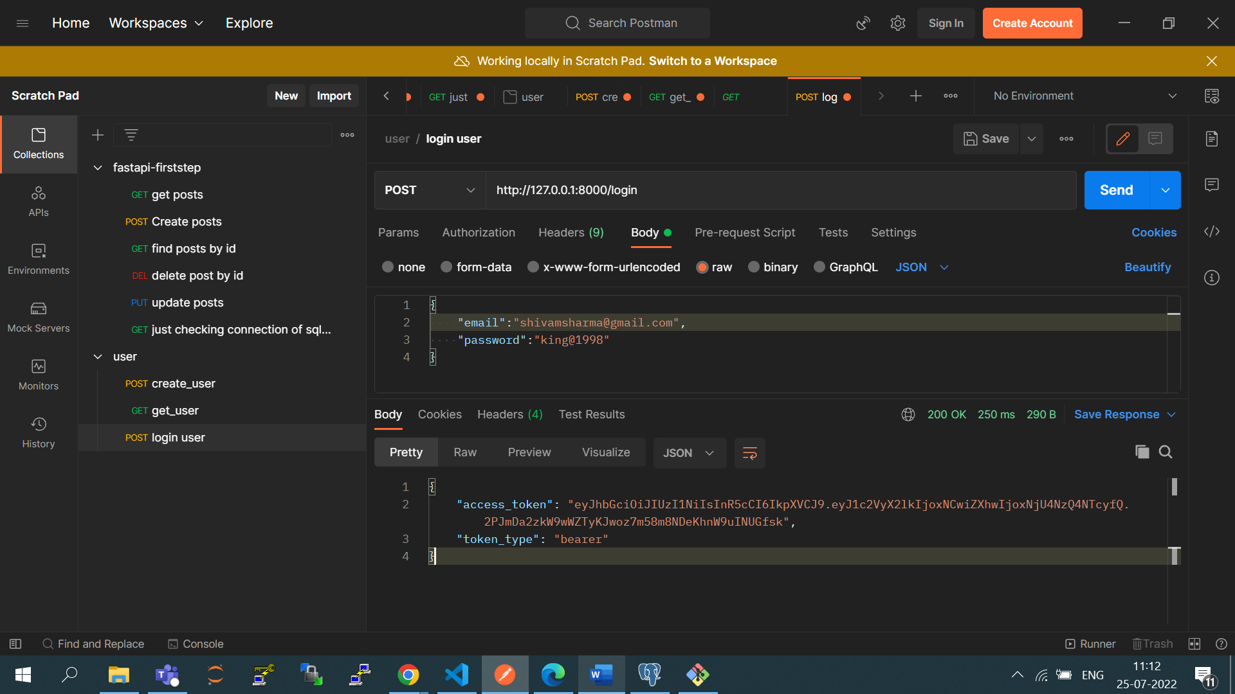

from fastapi.security.oauth2 import OAuth2PasswordRequest

