Technical Design Documentation

1. Project Overview
The ListenBrainz project builds an end-to-end data pipeline that transforms raw music listening events into a structured analytics warehouse. The pipeline supports business reporting, data quality validation, dashboard visualization, and future machine learning enhancement.
The solution uses Google BigQuery as the analytical warehouse, dbt for SQL transformation and data modeling, Python for analysis and data quality checks, Dagster for orchestration, Streamlit for dashboard presentation, and Google Cloud Run for serverless deployment.

2. Business Questions
Business Question | Tables Used | Output
Which artists are most listened to? | fact_listening_events, dim_artist | Top artists table and bar chart
Which songs are most popular? | fact_listening_events, dim_track | Top songs table and bar chart
What time of day do users listen most? | fact_listening_events, dim_time | Time-period chart
How does listening change monthly? | fact_listening_events, dim_date | Latest 24 months line chart
Which users listen most often? | fact_listening_events, dim_user | Top users table and bar chart
Which albums/releases are trending? | fact_listening_events, dim_album | Top releases table and bar chart

3. Pipeline Architecture
The pipeline begins with raw ListenBrainz event data stored in BigQuery. dbt transforms the raw data into a staging model and then into a star schema. Data quality checks validate key fields and relationships. Python notebooks and scripts generate business analysis outputs. Streamlit presents the results as a web dashboard, and Cloud Run hosts the dashboard as a serverless application.
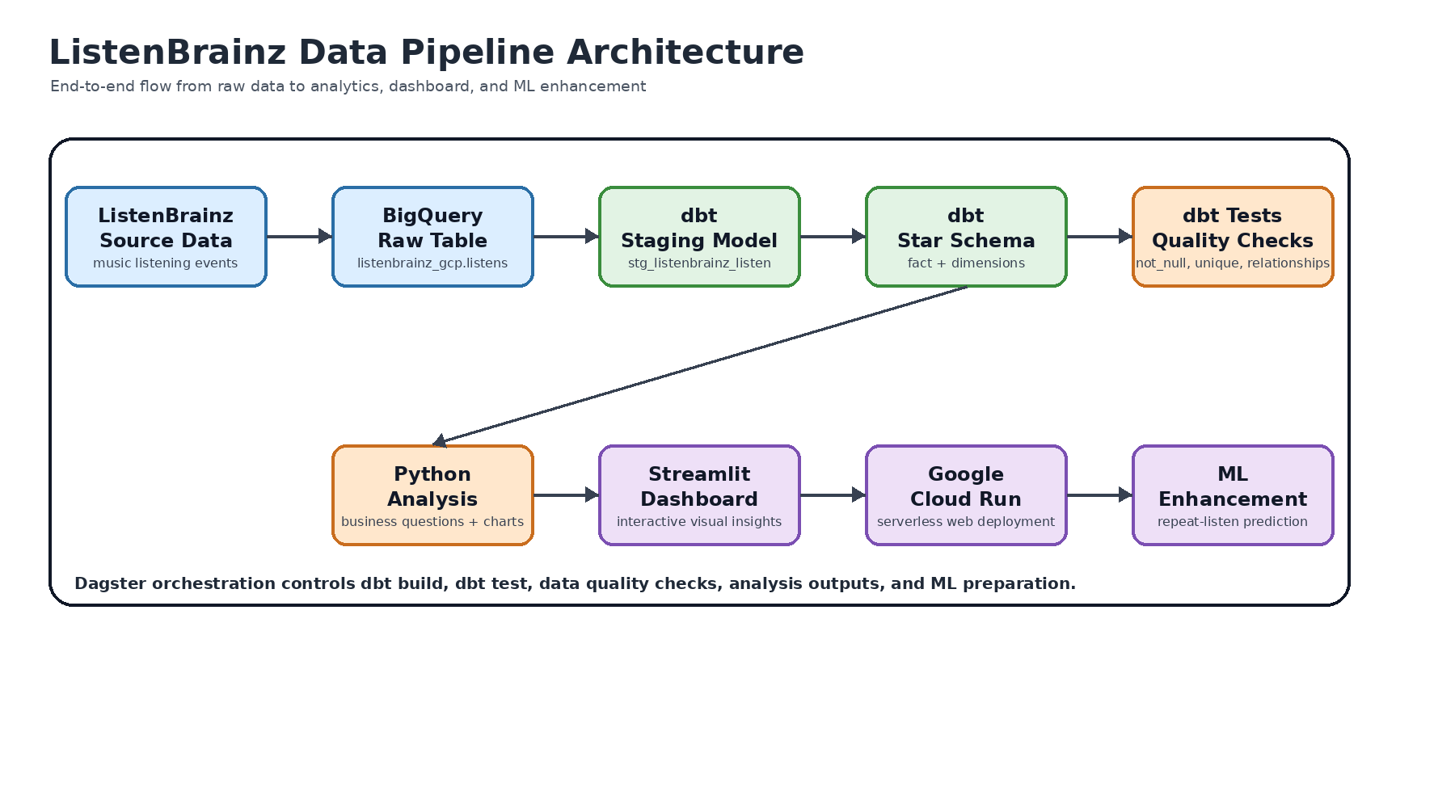
Figure 1. Overall ListenBrainz data pipeline architecture.

4. Code Documentation
The repository separates transformation logic, notebooks, application code, and diagrams. This improves maintainability and allows each part of the pipeline to be tested and deployed independently.
Folder / File | Purpose
listenbrainz_gcp/models/staging/sources.yml | Defines the raw BigQuery source table.
listenbrainz_gcp/models/staging/stg_listenbrainz_listen.sql | Cleans raw listening data and creates a generated listen_id.
listenbrainz_gcp/models/marts/dim_*.sql | Creates dimension tables for users, tracks, artists, releases, dates, and times.
listenbrainz_gcp/models/marts/fact_listening_events.sql | Creates the central listening event fact table.
listenbrainz_streamlit_app/app.py | Streamlit dashboard querying the star schema.
notebooks/*.ipynb | Data quality, business analysis, and ML enhancement notebooks.
dagster project files | Orchestration of dbt build, tests, analysis, and ML dataset preparation.

5. Data Lineage
Data lineage documents how raw source columns are transformed into staging fields, dimension tables, the central fact table, and final analytical outputs. This helps the team trace each dashboard metric back to its origin.
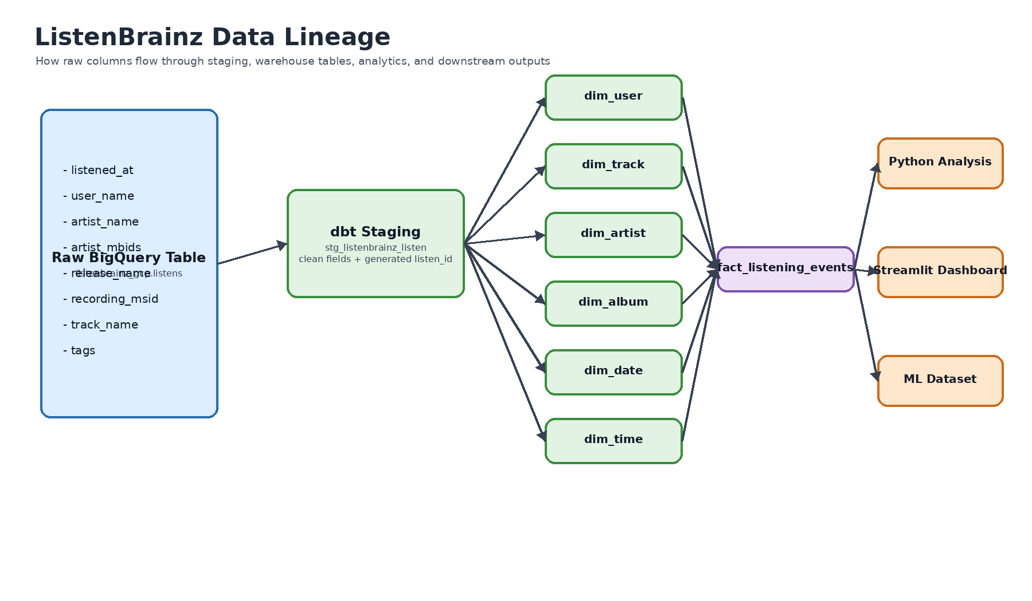
Figure 2. Data lineage from raw table to star schema and outputs.
Raw Column | Transformation | Warehouse Output
listened_at | Extract date and time parts | dim_date, dim_time, fact_listening_events.listened_at
user_name | Deduplicate users | dim_user
track_name, recording_msid, recording_mbid | Deduplicate tracks | dim_track
artist_name, artist_mbids | Deduplicate artists | dim_artist
release_name | Represent album/release information | dim_album.release_name
staging fields | Join to dimension keys | fact_listening_events

6. Star Schema Design
A star schema was chosen because the project is analytical. The central fact table stores measurable listening events, while dimensions store descriptive attributes. This makes aggregation and filtering efficient for reporting queries.
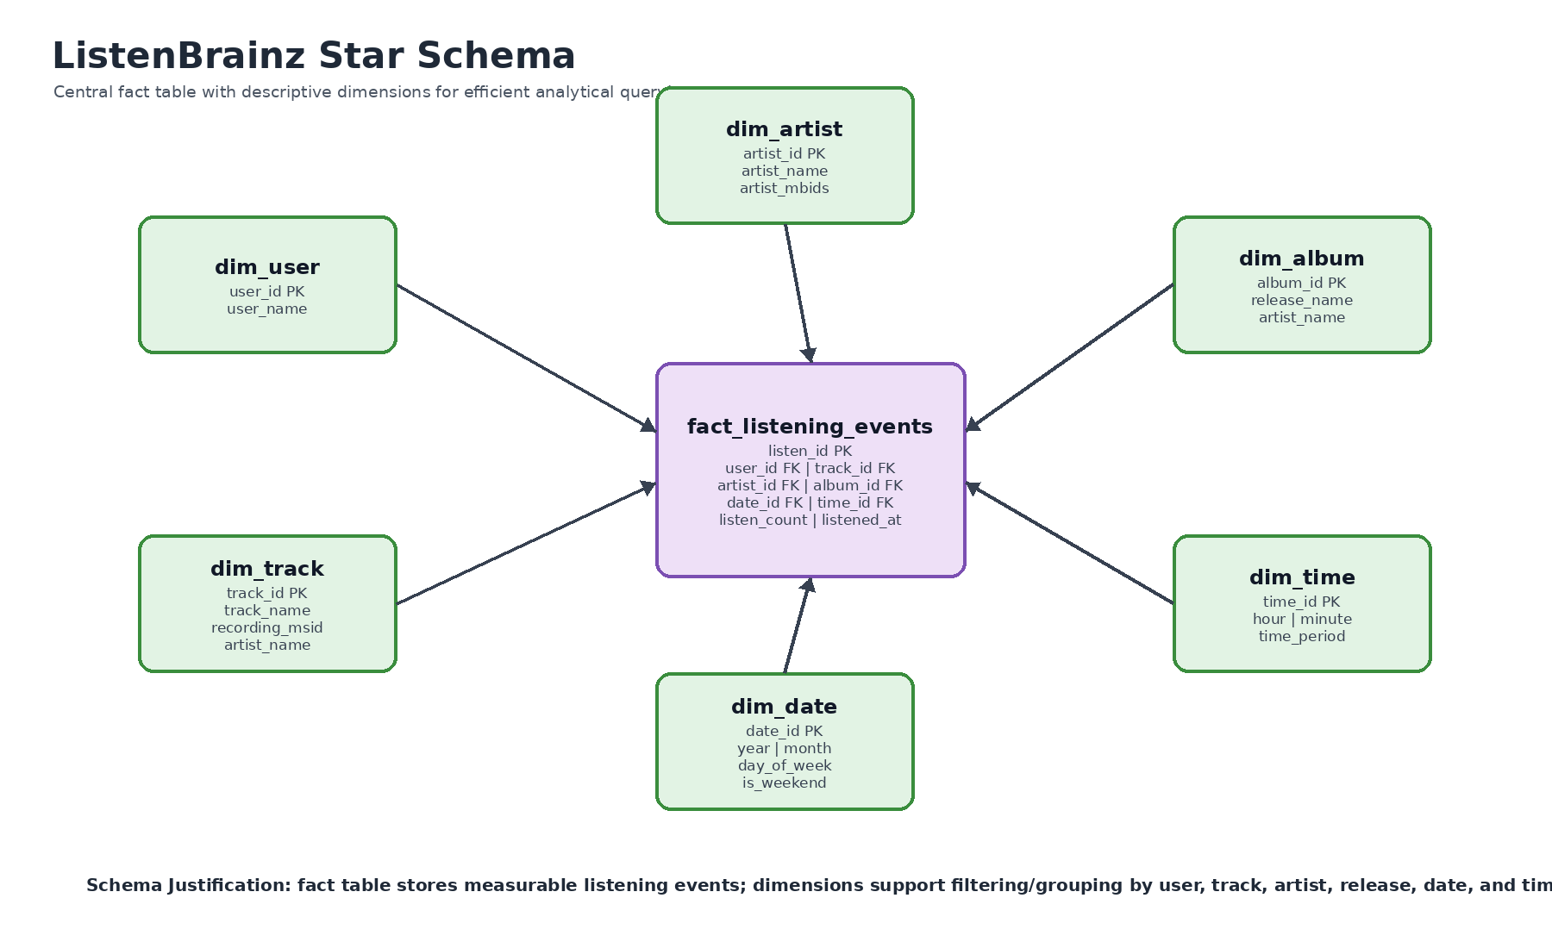
Figure 3. Star schema entity relationship design.
Table | Description
fact_listening_events | Central table with one row per listening event and foreign keys to all dimensions.
dim_user | Unique users/listeners.
dim_track | Unique tracks and recording identifiers.
dim_artist | Unique artists and artist identifiers.
dim_album | Release-level metadata using release_name.
dim_date | Calendar attributes such as year, month, weekday, and weekend flag.
dim_time | Time attributes such as hour, minute, and time period.

7. Schema Design Justification
The star schema supports efficient querying because the fact table can be aggregated by different business dimensions without repeatedly scanning raw fields. For example, top artists use fact_listening_events joined to dim_artist, while monthly trends use the same fact table joined to dim_date. This reusable structure reduces duplicated SQL logic and improves consistency across notebooks, dashboards, and ML feature creation.
Query Requirement | How the Schema Supports It
Top artists | Aggregate listen_count or event rows by dim_artist.artist_name.
Popular songs | Aggregate by dim_track.track_name and artist_name.
Time-of-day analysis | Group events by dim_time.time_period or hour.
Monthly trend | Group events by dim_date.year and dim_date.month.
Active users | Aggregate events by dim_user.user_name.
Trending releases | Aggregate events by dim_album.release_name and artist_name.

8. Tool Selection and Justification
Tool | Purpose | Reason for Selection
Google BigQuery | Cloud data warehouse | Serverless, scalable, and well suited for analytical SQL workloads.
dbt | Transformation and modeling | Modular SQL, version control, tests, documentation, and lineage.
Python / pandas | Analysis and validation | Flexible for exploratory analysis, CSV exports, charts, and ML preparation.
Great Expectations-style checks | Data quality validation | Validates required fields, uniqueness, blank values, and timestamp logic.
Dagster | Pipeline orchestration | Asset graph, scheduling, monitoring, and orchestration of dbt/Python tasks.
Streamlit | Dashboard | Fast way to build interactive web analytics using Python.
Google Cloud Run | Dashboard deployment | Serverless hosting of the containerized Streamlit app.
GitHub | Version control | Supports collaboration, history tracking, and deployment workflow.

9. Data Quality Testing
Data quality checks are applied at both dbt and Python levels. dbt tests validate model-level constraints, while Python checks validate business rules and export results for reporting.
Check | Expected Result | Purpose
listen_id not null | 0 invalid rows | Ensures every event has a generated ID.
listen_id unique | 0 duplicates | Prevents double-counting listening events.
user_name, artist_name, track_name not null | 0 invalid rows | Required for user, artist, and track analysis.
recording_msid not null | 0 invalid rows | Required for track uniqueness.
artist_name and track_name not blank | 0 invalid rows | Prevents poor-quality reporting labels.
listened_at not in future | 0 invalid rows | Prevents invalid future listening events.
foreign key relationships | All fact rows map to dimensions | Ensures star schema integrity.

10. Dagster Orchestration
Dagster is used to orchestrate the workflow as assets. The Dagster asset graph allows the team to understand dependencies, rerun failed stages, monitor outputs, and schedule regular pipeline runs.
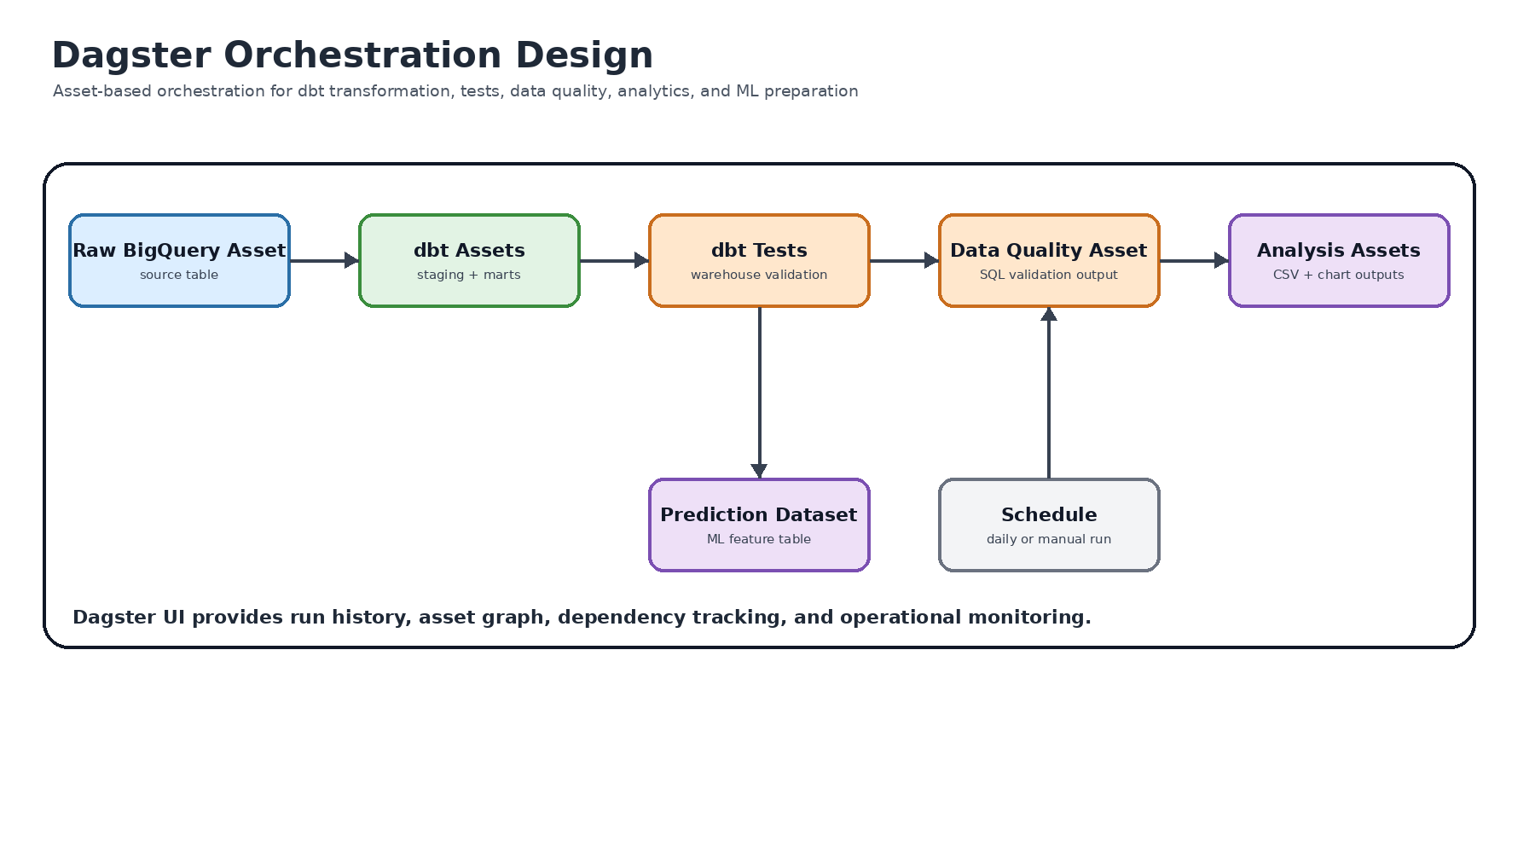
Figure 4. Dagster orchestration design for dbt, quality, analysis, and ML assets.
Dagster Asset | Responsibility
dbt assets | Run dbt staging, dimension, and fact models.
dbt tests | Validate uniqueness, not-null, and relationship tests.
data quality asset | Run BigQuery SQL validation checks and save CSV output.
business analysis asset | Generate top artists, top songs, time-of-day, monthly trend, users, and releases outputs.
prediction dataset asset | Create ML-ready dataset from star schema joins.

11. Streamlit Dashboard and Cloud Run Deployment
The dashboard is implemented using Streamlit and deployed on Google Cloud Run. It queries the BigQuery star schema and displays the six business-question outputs in dashboard tabs. Cloud Run provides a serverless URL for users to access the app without running notebooks locally.
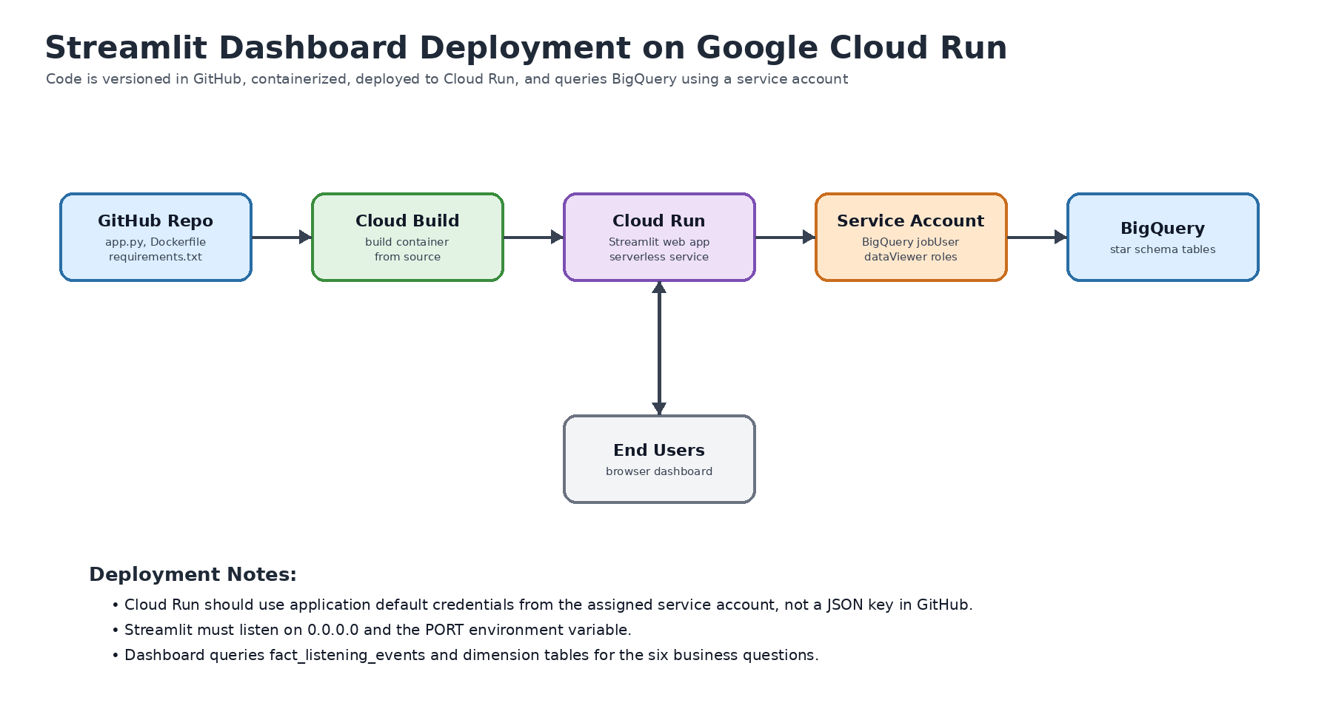
Figure 5. Streamlit dashboard deployment architecture on Google Cloud Run.

12. Analysis Findings and Visual Outputs
The Python analysis notebook and Streamlit dashboard produce tables and charts for the main business questions. The monthly trend chart is limited to the latest 24 months to keep the output readable and useful for executive presentation.
Analysis Output | Chart Type | Business Value
Top artists | Horizontal bar chart | Identifies most popular artists.
Top songs | Horizontal bar chart | Shows most listened tracks.
Time of day | Bar chart | Shows peak listening periods.
Monthly trend | Line chart | Shows listening growth or decline over time.
Top users | Horizontal bar chart | Identifies most active listeners.
Top releases | Horizontal bar chart | Shows trending albums/releases.

13. Risks and Mitigations
Risk | Impact | Mitigation
Missing or duplicate data | Inaccurate insights | Use dbt tests and Python data quality checks.
Schema changes | Dashboard or SQL errors | Maintain schema documentation and test queries before deployment.
BigQuery cost | Higher cloud spend | Use aggregated queries, limits, caching, and scheduled outputs.
Cloud Run deployment issue | Dashboard unavailable | Use logs, versioned revisions, and rollback.
ML model limitations | Weak recommendations | Use more history, better features, and ranking metrics in future work.

14. Conclusion
The ListenBrainz solution demonstrates a complete data engineering workflow. Raw listening data is transformed using dbt into a star schema in BigQuery, validated through data quality checks, analyzed using Python, orchestrated with Dagster, and presented through a Streamlit dashboard deployed on Cloud Run. The star schema supports efficient analytical queries and provides a strong foundation for future music recommendation and repeat-listen prediction models.

15. Optional Enhancements

15.1 Machine Learning Enhancement
A future enhancement is a repeat-listen prediction model. The model uses star schema outputs to create features such as user activity, track popularity, artist popularity, listening hour, time period, and weekend flag. Logistic Regression can be used as a baseline, while Random Forest can capture non-linear patterns. A future recommendation system could use collaborative filtering or matrix factorization.
ML Component | Description
Target variable | repeated_listen: 1 if a user listened to a track more than once, otherwise 0.
Baseline model | Logistic Regression.
Improved model | Random Forest Classifier.
Future model | Collaborative filtering for personalized recommendations.
Feature sources | fact_listening_events, dim_user, dim_track, dim_artist, dim_date, dim_time.

15.2 Kafka and Spark Streaming Incorporation
As an optional future enhancement, the ListenBrainz pipeline can incorporate Kafka and Spark Structured Streaming to support near real-time processing of high-volume music listening events. Music listening activity can happen at any time of the day, and popular songs can generate large volumes of play events within short time windows. A streaming layer would allow the system to monitor listening trends, top songs, and unusual spikes with lower latency than a purely batch-based pipeline.
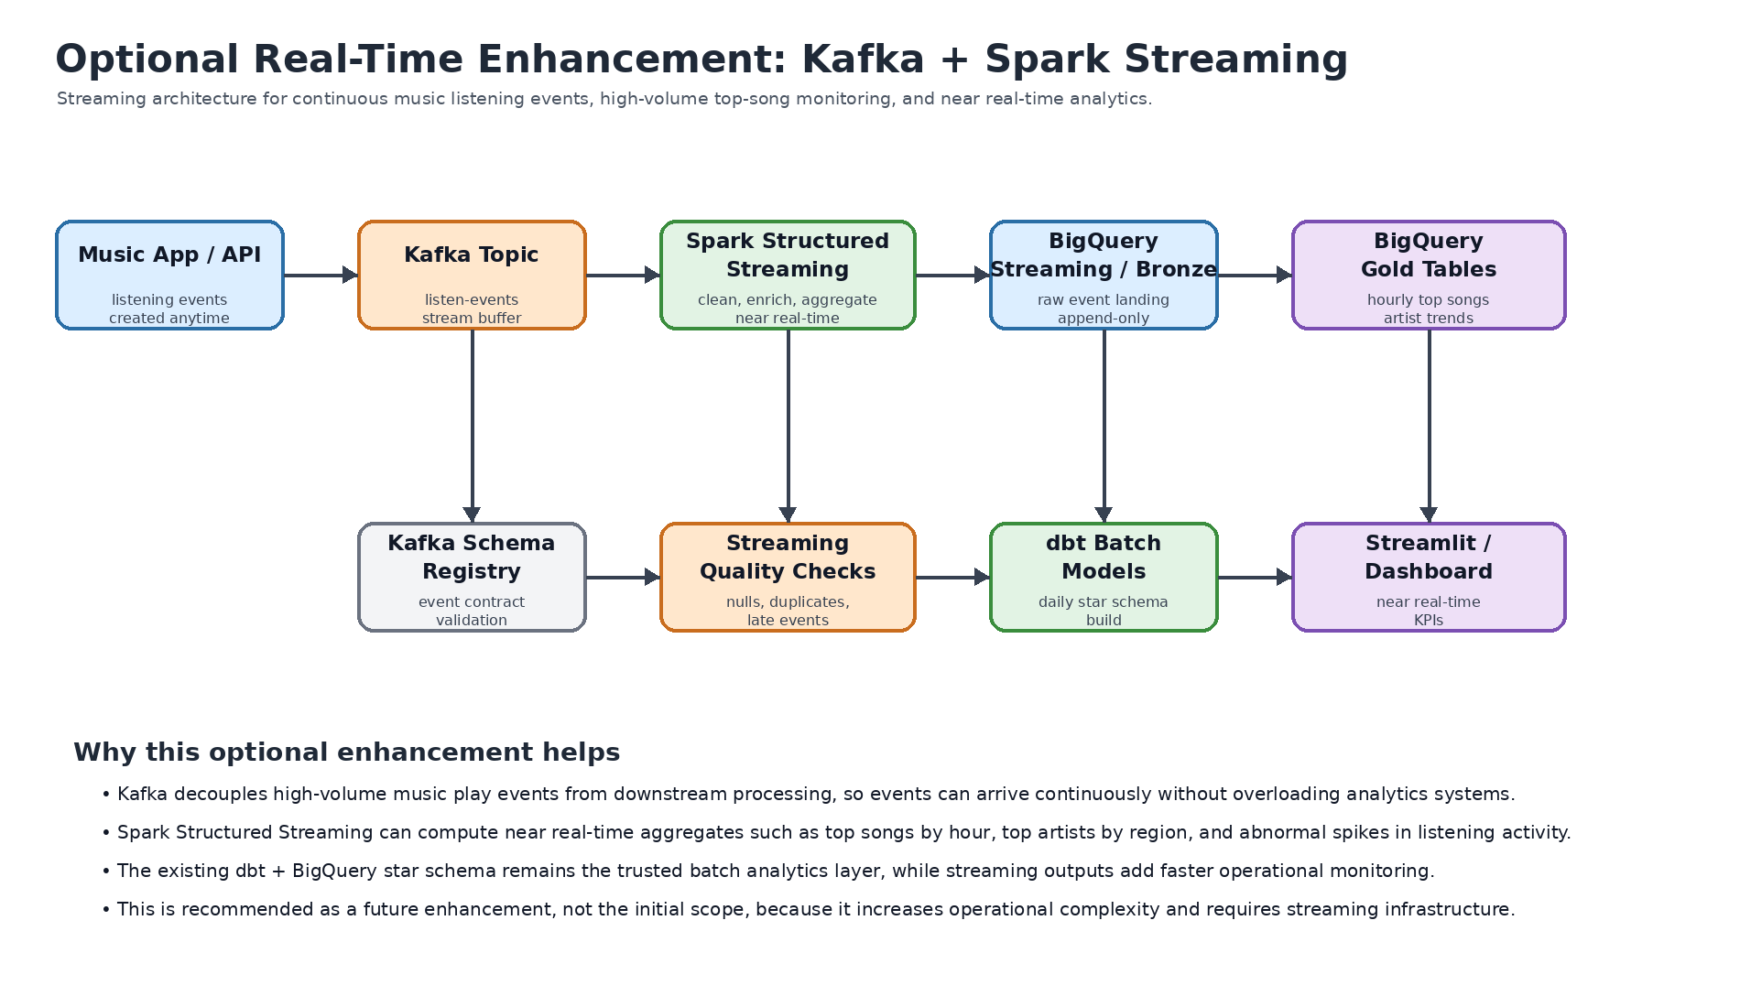
Figure 6. Optional Kafka and Spark Streaming enhancement for near real-time ListenBrainz analytics.

15.2.1 Streaming Architecture Overview
Component | Role in Streaming Enhancement | Reason for Use
Kafka producer | Receives listening events from music apps, APIs, or ingestion services. | Provides a continuous event ingestion layer for real-time music play events.
Kafka topic: listen-events | Stores listening events temporarily and decouples producers from consumers. | Handles high event volume and allows multiple downstream consumers to process the same event stream.
Spark Structured Streaming | Reads events from Kafka, cleans records, handles duplicates, enriches metadata, and creates rolling aggregates. | Supports scalable stream processing and windowed analytics such as top songs per hour.
BigQuery bronze table | Stores raw or minimally processed streaming events. | Preserves event history and supports replay/debugging.
BigQuery gold streaming tables | Stores pre-aggregated metrics such as top songs, top artists, and hourly listening counts. | Improves dashboard performance for near real-time reporting.
dbt batch models | Continues to build the trusted star schema for official reporting. | Maintains the existing governed analytics layer while streaming provides faster operational metrics.
Streamlit dashboard | Displays current listening trends and top-song metrics. | Provides stakeholders with near real-time visibility.

15.2.2 Streaming Use Cases
Use Case | Example Metric | Business Value
Near real-time top songs | Top 10 songs in the last 15 minutes, 1 hour, or 24 hours. | Helps identify trending songs quickly.
Peak listening detection | Listening volume by minute or hour. | Supports capacity planning and event monitoring.
Artist trend monitoring | Fast-rising artists by rolling time window. | Supports marketing and recommendation opportunities.
Anomaly detection | Unexpected spikes or drops in event volume. | Helps detect data pipeline issues or sudden popularity changes.
Personalization features | Recent user listening behavior. | Supports future real-time recommendations.

15.2.3 Batch vs Streaming Design Justification
Area | Current Batch Design | Streaming Enhancement
Latency | Best for daily or scheduled reporting. | Best for near real-time trend monitoring.
Complexity | Lower operational complexity using BigQuery and dbt. | Higher complexity due to Kafka, Spark jobs, checkpoints, and streaming operations.
Cost | Controlled by scheduled queries and dbt runs. | Potentially higher due to always-on stream processing resources.
Reliability | Easier to test and rerun. | Requires event replay strategy, checkpointing, and late-event handling.
Best fit | Official analytics, reporting, dashboard summaries, and ML datasets. | Real-time top songs, live monitoring, and operational alerts.

15.2.4 Recommendation
Kafka and Spark Streaming are recommended as an optional enhancement rather than the first implementation phase. The current BigQuery + dbt star schema is appropriate for reliable batch analytics and executive reporting. A streaming layer should be added when the business requires live trend monitoring, high-volume event processing, or real-time recommendation features. This phased approach reduces initial delivery risk while keeping the architecture scalable for future real-time use cases.

