**How Compilers Work**

Structured in multiple phases. First there is an input program, then at the end is an output program.

**First, Tokenize**: Program is fed into a Tokenizer/Lexer where the code is broken down into tokens

**Second, Parsing**: Tokens are passed into a Parser and the program is then represented into an Abstract Syntax Tree (AST).

**Third, Typechecked**: The AST is passed into the Typechecker which annotates the AST.

**Fourth, Code Generated**: The annotated AST is passed into a Code Generator and outputs the program.

**Typechecker**

**Tokenizer/Lexer**

Input Program

Annotated AST

Tokens

Output Program

AST

**Typechecker**

**Parser**

**Tokenizer/Lexer**

An input program is taken in and broken down into tokens. **Tokens** are sections of a program divided up.

Example:

if(1 < 2) return 7;

else return 3;

Tokens would be: if_token, else_token, (_token, )_token, <_token, number_token(1), number_token(2), number_token(3), number_token(7), return_token, semi-colon_token

**Types of Tokens**:

**Identifier**: Sequence of characters that makes up what keywords can’t. Something like #include would be seen as an identifier since keywords are always words. *The variables name would be the identifier.*

**Operator**: The mathematical operators

**Constants**: The fixed values we assign to the values in the source code

**Keywords**: The combination of characters that has a very specific meaning. Like int, string, in my case Var. *What is typed to tell the program what type of variable it is*

**Literals**: String characters

**Punctuators**: All punctuation characters

**Analyzing Tokens in C**

Each starting state is when something is entered in and is scanning for anything and everything. Each state is its own scenario.

**First** Whatever is entered in, you must have a DFA for each

* **Keyword**: Check the combination of letters to see if a keyword is produced
* **Identifier**: Check all letters. The first input must be a letter, the rest following can be letters or numbers.
* **Integer**: Start with seeing if there is an operation followed by a number, then followed by as many numbers as needed. To take care of multi-digit numbers, there will be a lambda that goes back to the previous state to enter in more integers. I feel like a loop would be a better idea. We also can skip the beginning operation if it redundant.

**Now we need to combine these into a DFA, starting from an NFA.**

Notice how from S->3, it doesn’t include i. This is because if ‘i’ is the first thing to be entered, it is checked to see if it is a keyword, or an identifier. If it is a keyword, we will expect ‘i’ to be followed by ‘f’.

If it is not a keyword, it will be an identifier because it will be followed by another letter or number.

And if there is no ‘i’ at all, there’s no reason to do extra work, so we have that extra path just to check what will be followed by a certain letter that has potential.

With the integer portion, we can declare a number to be positive or negative right away or skip to a direct number. If we want, we can bend it a bit so that any number of operation inputs flow in.

**Parser**

A parser is what groups tokens together and represents the program as a data structure rather than a program, code, or bytes. The main output of the parser is an **Abstract Syntax Tree (AST)** which is an original representation of the program represented in a tree structure. *Think of the context-free grammar as the parsing tree*

Example:

if(1 < 2) return 7;

else return 3;

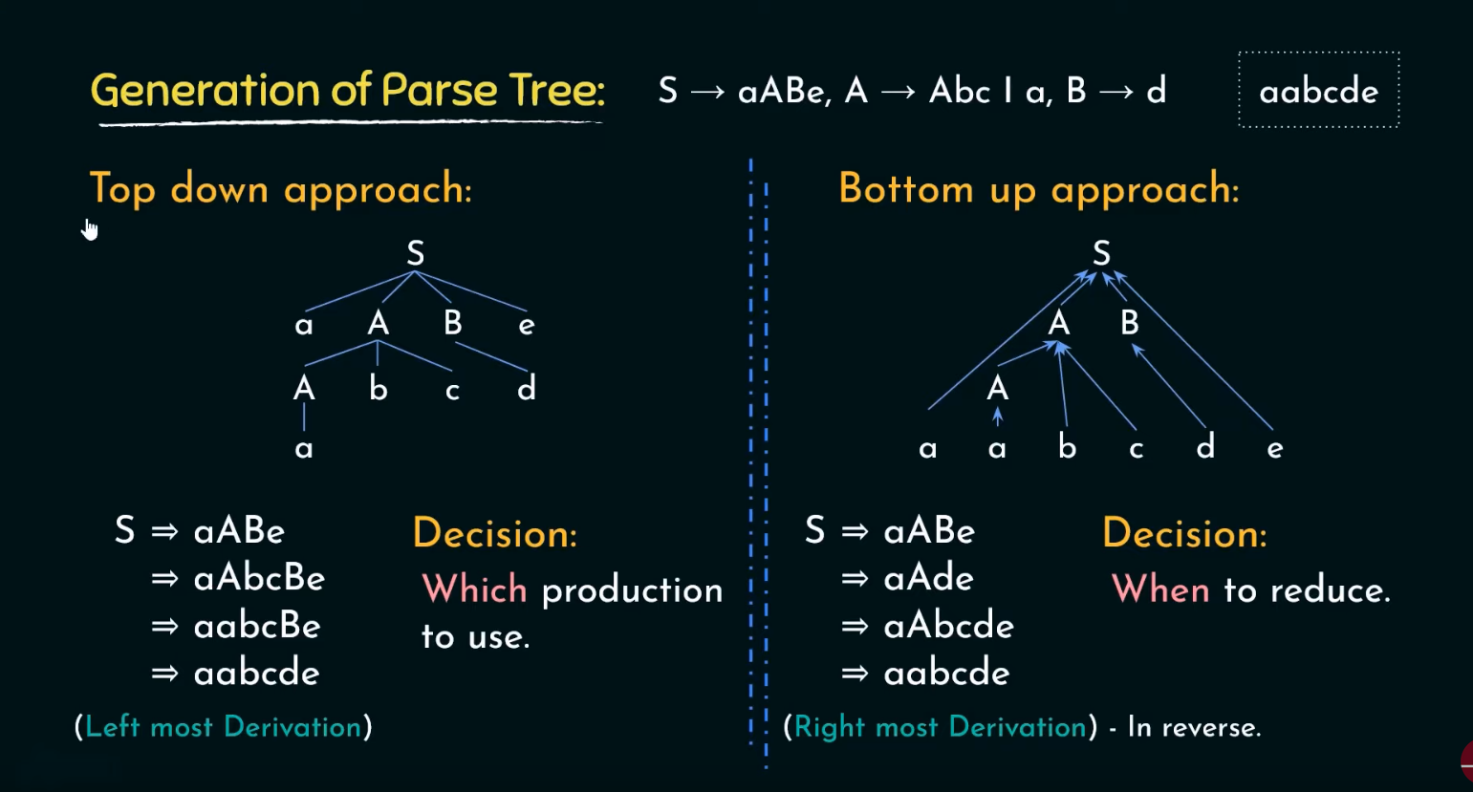

Something funny about parsers is there a **Recursive Descent Parser**, but I saw in [this video](https://www.youtube.com/watch?v=GWYhtksrmhE&t=75s) that NASA basically forbids the use of recursion.

What is at the top-right is a Letter that can be re-written into whatever its pointing at

**NOTE**: variable look_ahead keeps its passed value the entire time. It starts with the first input. look_ahead = getchar() is getting the next character in the input and assigning it to look_ahead.

How this recursive definition works is you start with E, which then does its comparison functions with match(char c) and then runs E`()

When E`() runs, it looks for its queue to run, in this case +. Then it checks to see if the syntax that it wants to be re-written to. Once it finds the ‘+’, is basically double and triple looks ahead to make sure the syntax is completely correct.

Once both checks are made, the variable “look_ahead” retains its value. It is basically a static variable

**Typechecker**

It looks at all the types involved and checks if each type is used correctly. If they are not, a compile error is returned, and the program terminates. The AST is then annotated and passed along.

Example: int i = 2; //Type int is paired with an int. Types are properly paired

int s = “dog”; //Type int is paired with a string. Types not a proper pair

string s = “dog”;

int i = 10;

if(s < i) return s + i;

// The comparison between variables s and i are not correctly used

Since this code’s syntax is correct, it will get through the Tokenizer/Lexer

and parser. This is why we need a Typerchecker.

**Code Generator**

This is where the actual code to low-level language translation is done. This is what returns the output program. What separates a good compiler from a great compiler is the code generator, so a good code generator is very important. The design and breakup of the code generator is strictly language and architecture dependent.

**Exercise**: **Building a Context-Free Grammar Binary Compiler**

This compiler inputs a string of 1’s and 0’s, combines them into the number variable, then goes through an expression to get the final “compiled” result.

Each line is referred to as a **Production**. Everything inside a production is referred to as **Productions**. and whenever a ‘’ is present around a variable, it means this specific quoted expression or input strictly needs to happen

digit ::= ‘1’ **|** ‘0’ // Input variable

number ::= digit **|** digit & number // Recursive Variable

expression ::= number **|** expression ‘+’ expression // Recursive Statement

Input:

1

10

10 + 1

Output:

1:

digit = 1, number = digit, expression = 1

10:

digit = 1, number = 1, expression = 1. Then digit = 0, number = 10, expression = 10

10 + 1:

digit = 1, number = digit, expression = 1, Then digit = 0, number = 10, expression = 10, first expression = 10. Recursive call is made, digit = 1, number = digit, next expression = 1. Since there are two expressions inputted, the recursion stops and does “expression + expression” which in this case = 11 as our “compiled” output.

**Language Design Example**

**Simplistic Very Basic Language Design Layout**:

* Has Integers and Booleans
* Variable can be declared and initialized and assigned
* Performs standard arithmetic and logical operations
* Able to loop

**Grammar Syntax Components For this Simplistic Very Basic Language**:

var ::= Variable name

num ::= Integer

type ::= ‘int’ **|** ‘bool’

variable_decloration ::= ‘(‘ ‘vardec’ type var expression ‘)’

expression ::= num **|** ‘true’ **|** ‘false’ **|** var **|** ‘(‘ operator expression expression ‘)’

loop ::= ‘while’ ‘(‘ expression statement ‘)’ ‘END_LOOP’

assign ::= ‘(‘ ‘=’ var expression ‘)’

statement ::= variable_decloration **|** loop **|** assignment

operator ::= ‘+’ **|** ‘-‘ **|** ‘&&’ **|** ‘||’ **|** ‘<’

program ::= statement*

{*NOTE: * means you can have as many of these as needed, Nogas Class*}

~**Using this as if it were code**~

(vardec int i 7) // int i = 7

(vardec bool b true) // bool b = true

(vardec int j (+ 15 22) ) // int j = 15 + 22

(vardec bool c (&& true false) ) // bool c = true && false

while( < i j) // while(i < j){ i += j}

( i = (+ i j) )

END_LOOP

{NOTE: Having code in this format compared to the C/C++/Java format is good for us because it will make the parsing stage a lot easier}

**Tokens**:

* IdentifierToken(String) // Holds identifier type, and string used for operators
* NumberToken(int) // Holds the integer
* IntToken // For the string ‘int’
* BoolToken // For the string ‘bool’
* LeftParenthesesToken // For the char (
* RightParenthesesToken // For the char )

[NOTE – These simple character tokens are needed cause the start and ending of anything inside parentheses is an important operation and detection]

* VardecToken // For the string ‘vardec’
* TrueToken // For the string ‘true’
* FalseToken // For the string ‘false’
* WhileToken // Looks for a loop
* *END_LOOPToken // Maybe needed maybe not, for string*
* EqualsToken // Looks for the equals operator
* PlusToken // Looks for the addition operator
* MinusToken // Looks for the Minus operator
* LogicalAndToken // Looks for the && operator
* LogicalOrToken // Looks for the || operator
* LogicalLessThanToken // Looks for the < operator

**Parsing’s**:

[Note, each specific parsing is a class. But for simplicity is broken down into categories]

* **Interface Type**
  + IntType
  + BoolType
* **Interface Statement** 
  + vardecStatment
  + LoopStatment
  + AssignmentStatment
* **Interface Expression** 
  + NumberExpression
  + BoolExpression
  + VariableExpression
  + BinaryOperatorExpression //For the expression production where there’s ‘expression expression’
* **Interface Operator** 
  + PlusOperator
  + MinusOperator
  + AndOperator
  + OrOperator
  + LessThanOperator
* **Interface AST**
  + IntType
  + BoolType
  + vardecStatment
  + LoopStatment
* **Class Program**

**Typechecks**:

* Varcec puts a Variable in a scope with a type
  + Needs to remember the variable and type
  + Needs to ensure the expression of the type
* Num should be an int
* Bool should be true or false
* Var is whatever the type of the variable is
* While expression is a Boolean
* Assignments
  + Var should be in scope
  + Vars type should match the expression type
* Expression1 + Expression2, Expression1 – Expression2, Expression1 < Expression2
  + int, expression1: int, expression2: int
* Expression1 && Expression2, Expression1 || Expression2
  + Bool, expression1: bool, expression2: bool: bool
* Program
  + All statements are correctly types

**Code Generation**: Need to watch the video

**Start**:

**Target Language**: Pick a language to have our code compile into

**Meta Language**: Which language the compiler is written in

**Object Language**: What Language we are defining (Our Language)

**Go to 54:15 in** [**Lecture 1's Video**](https://mycsun.app.box.com/s/h77o6g57vmct7c8cm2o5de9iehvzro5z/file/1131029573979) **to start implementing this as an actual compiler. The rest of the lectures are implementing this in code with each compiler Phase.**

[**Tokenizing**](https://mycsun.app.box.com/s/h77o6g57vmct7c8cm2o5de9iehvzro5z/file/1131044882559)

[**Parsing**](https://mycsun.app.box.com/s/h77o6g57vmct7c8cm2o5de9iehvzro5z/file/1131045425225)

[**Typechecking**](https://mycsun.app.box.com/s/h77o6g57vmct7c8cm2o5de9iehvzro5z/file/1131032697911)

[**Code Generator**](https://mycsun.app.box.com/s/h77o6g57vmct7c8cm2o5de9iehvzro5z/file/1131043171563)