<https://code.google.com/archive/p/dotsvn/>

<http://www.csharpopensource.com/dotsvn/>

<https://code.google.com/archive/p/dotsvn/downloads>

**dotsvn**

Free Open-Source .Net port of Subversion

**DotSVN**

The objective of **DotSVN** is to re-implement [Subversion](http://subversion.tigris.org/) version-control-system completely in .NET.

**Goals of the project**

DotSVN will be 100% compatible with the Subversion backend. This will facilitate side-by-side deployment of Subversion and DotSVN which in turn will help in leveraging the ecosystem of existing tools like [TortoiseSVN](http://tortoisesvn.tigris.org/), [RapidSVN](http://rapidsvn.tigris.org/) etc. For instance, this can support scenarios like DotSVN being deployed with read-only access to a live Subversion repository, while TortoiseSVN is used to manipulate the repository. DotSVN will implement a layered architecture similar to Subversion, thereby enabling developers to create solutions suitable for each layer.

Being a .NET library, DotSVN can leverage many of the platform capabilities of Windows like Authentication and Permissions. Also, DotSVN will run natively on IIS which will enable DotSVN to be deployed on Windows Hosting sites that support ASP.NET. Additionally, DotSVN can expose Subversion through other endpoints like web-services. Other .NET applications like content management systems can use such endpoints to implement a versioned storage backend. Another advantage of having a .NET port is that the code-base will be exposed to a broader audience who can contribute extensions to this project.

**Influence of SVNKit**

[SVNKit](http://svnkit.com/) is a pure Java Subversion client library and is very similar in philosophy to DotSVN, and as such this code-base is heavily influenced by the design (and code) of SVNKit.

**Relation to nTrac**

This project started as part of [nTrac](http://code.google.com/p/ntrac/) project which required a .Net interface to Subversion.

**Current State of the project**

Current version of DotSVN implements the repository access layer using 'file://' protocol to access a local FSFS repository. With this version, it is possible to implement applications similar to [WebSVN](http://websvn.tigris.org/) or [bsSvnBrowser](http://bssvnbrowser.bountysource.com/) that can read the contents of an SVN repository, display the history of files in the repository etc.

**Milestones**

The next milestone of the project is to implement the repository access based on WebDAV protocol so that applications can access the repository using 'http://' or 'https://' protocols.

Subsequently, DotSVN will be extended to implement a Working Copy Management library which will enable check-in, check-out of files.

**News**

* [27-Aug-2007] The first incremental version of DotSVN is released. In this version, the basic functionality of 'file access' works.

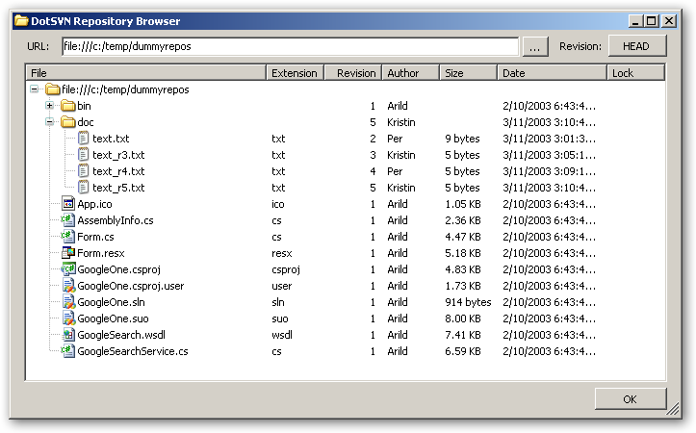

* [08-Sep-2007] Added ability to get files from the repository.