2151299_苏家铭_hw3

苏家铭

Table of Contents

This is an [R Markdown](http://rmarkdown.rstudio.com) Notebook. When you execute code within the notebook, the results appear beneath the code.

Try executing this chunk by clicking the *Run* button within the chunk or by placing your cursor inside it and pressing *Ctrl+Shift+Enter*.

# 导入数据  
music_data <- read.csv("music_data.csv")  
  
# 查看数据结构和基本统计信息  
str(music_data)

## 'data.frame': 150 obs. of 3 variables:  
## $ ID : int 1 2 3 4 5 6 7 8 9 10 ...  
## $ condition : chr "no_music" "no_music" "no_music" "no_music" ...  
## $ productivity: num 188 196 194 190 157 ...

summary(music_data)

## ID condition productivity   
## Min. : 1.00 Length:150 Min. :104.7   
## 1st Qu.: 38.25 Class :character 1st Qu.:161.0   
## Median : 75.50 Mode :character Median :185.0   
## Mean : 75.50 Mean :184.9   
## 3rd Qu.:112.75 3rd Qu.:205.0   
## Max. :150.00 Max. :285.3

# 查看分组信息  
no_music <- music_data[music_data$condition == "no_music",][["productivity"]]  
music_no_choice <- music_data[music_data$condition == "music_no_choice", ][["productivity"]]  
music_choice <- music_data[music_data$condition == "music_choice", ][["productivity"]]  
print("no_music:")

## [1] "no_music:"

summary(no_music)

## Min. 1st Qu. Median Mean 3rd Qu. Max.   
## 110.7 143.1 171.7 174.5 196.7 276.6

print("music_no_choice")

## [1] "music_no_choice"

summary(music_no_choice)

## Min. 1st Qu. Median Mean 3rd Qu. Max.   
## 104.7 152.4 179.0 177.1 201.0 252.8

print("music_choice")

## [1] "music_choice"

summary(music_choice)

## Min. 1st Qu. Median Mean 3rd Qu. Max.   
## 130.9 180.4 195.0 203.0 230.8 285.3

# 分组绘制直方图  
hist(music_choice, freq = F, breaks = 4, main = "music_choice",col="lightyellow")

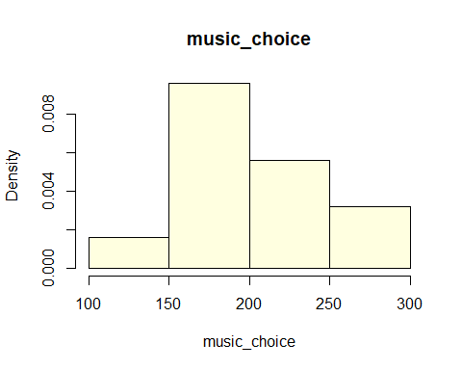

hist(music_no_choice, freq = F, breaks = 4, main = "music_no_choice",col="lightyellow")

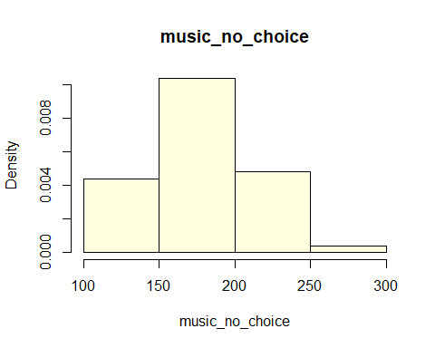

hist(no_music, freq = F, breaks = 4, main = "no_music",col="lightyellow")

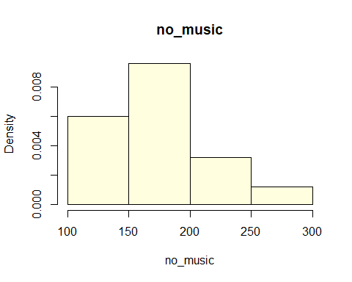

# 进行方差分析  
anova_result <- aov(productivity ~ condition, data = music_data)  
  
# 查看方差分析结果  
summary(anova_result)

## Df Sum Sq Mean Sq F value Pr(>F)   
## condition 2 24734 12367 9.291 0.000159 ***  
## Residuals 147 195661 1331   
## ---  
## Signif. codes: 0 '***' 0.001 '**' 0.01 '*' 0.05 '.' 0.1 ' ' 1

# 组别之间的差异： 通过 p 值（Pr(>F)），我们拒绝了零假设，即至少一个组别的均值与其他组别不同。因此，我们有理由相信，不同的音乐条件（condition）对生产力产生了显著影响。  
  
# F 统计量： F 统计量（9.291）表示组间均值方差与组内均值方差的比例。由于 p 值非常小，我们可以得出结论，在组别之间存在显著差异。

# 进行 Tukey HSD 测试  
tukey_result <- TukeyHSD(anova_result)  
  
# 查看比较结果  
print(tukey_result)

## Tukey multiple comparisons of means  
## 95% family-wise confidence level  
##   
## Fit: aov(formula = productivity ~ condition, data = music_data)  
##   
## $condition  
## diff lwr upr p adj  
## music_no_choice-music_choice -25.820579 -43.09679 -8.544367 0.0015539  
## no_music-music_choice -28.466400 -45.74261 -11.190188 0.0004246  
## no_music-music_no_choice -2.645821 -19.92203 14.630391 0.9301260

# music_no_choice vs. music_choice:  
  
#差异 (diff): -25.82  
# 置信区间 (95% family-wise confidence level): [-43.10, -8.54]  
#调整过的 p 值 (p adj): 0.00155  
#结论：music_no_choice 组的平均生产力明显低于 music_choice 组，差异具有统计学显著性。  
  
#no_music vs. music_choice:  
  
#差异 (diff): -28.47  
#置信区间: [-45.74, -11.19]  
#调整过的 p 值: 0.00042  
#结论：no_music 组的平均生产力明显低于 music_choice 组，差异具有统计学显著性。  
  
#no_music vs. music_no_choice:  
  
#差异 (diff): -2.65  
#置信区间: [-19.92, 14.63]  
#调整过的 p 值: 0.93013  
#结论：no_music 组和 music_no_choice 组之间的平均生产力差异不具有统计学显著性。  
  
#结论和建议：  
  
#在音乐条件方面，music_choice 组表现出最高的生产力，明显高于其他两组。  
#music_no_choice 组的生产力也明显高于 no_music 组，两者之间差异显著。  
#no_music 组和 music_no_choice 组之间的生产力差异不显著。  
#这些结论有助于理解不同音乐条件对员工生产力的影响。建议在提高生产力的同时，也考虑员工对音乐的个人选择，因为提供音乐选择的条件可能会更有利于工作效率。

Add a new chunk by clicking the *Insert Chunk* button on the toolbar or by pressing *Ctrl+Alt+I*.

When you save the notebook, an HTML file containing the code and output will be saved alongside it (click the *Preview* button or press *Ctrl+Shift+K* to preview the HTML file).

The preview shows you a rendered HTML copy of the contents of the editor. Consequently, unlike *Knit*, *Preview* does not run any R code chunks. Instead, the output of the chunk when it was last run in the editor is displayed.