Active Thermography for Inspection, Monitoring and Control:
From Technology Development to Commercialization

Hoon SOHN¹, Hyunjin KIM¹, Ikgeun Jeon¹, Soonkyu Hwang², Chisung Kim¹
¹ Department of Civil and Environmental Engineering, KAIST (Korea Advanced Institute of Science and Technology), Daejeon, 34141, South Korea
² Yield Enhancement Team, Global Infra Technology, Samsung Electronics, Asan, 31489,

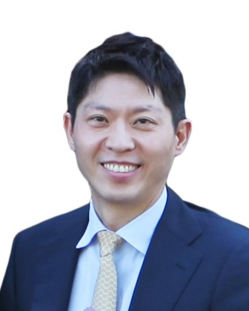
In this presentation, an active thermography system is developed for automated, noncontact, and nondestructive inspection, monitoring and control of various engineering structures. The developed system uses a laser beam or halogen lamp to heat up the target structure, and the corresponding electromagnetic radiation is measured using an infrared camera. Several real-world applications of the developed active thermography system is showcased in the presentation. First, the coating thickness and surface defects, such as corrosion, delamination, checking and chalking, of painted steel structures are visualized, classified and quantified using the active thermography system and machine learning. The active thermography system is also integrated with a drone or unmanned vehicle for automated inspection of bridges, pipelines, and ships. Other applications include online monitoring and process control during metal 3D printing and in-line inspection of electronic car batteries.

Biography
Hoon Sohn is Professor at KAIST (Korea Advanced Institute of Science and Technology), and the Director of 3D Printing Nondestructive Testing Center sponsored by the National Research Foundation of Korea. Over last twenty-five years, his research interest has been in the areas of structural health monitoring, nondestructive testing, sensing technologies and data analytics. He has published over 200 refereed journal articles, over 390 conference proceedings, and 11 book & book chapters. He is holding 44 domestic and 16 international patents, and his developed technologies are licensed and commercialized by private companies. He is currently SPIE Fellow, Member of National Academy of Engineering of Korea (NAEK), and Member of Korean Academy of Science and Technology (KAST).

