char a = '^';

char b = '#';

char c = '\*';

char d = '|';

System.out.format("%10c%n", a);

System.out.format("%9c%c%c%n",b,c,b );

System.out.format("%8c%c%c%c%c%n", b,c,b,c,b);

System.out.format("%7c%c%c%c%c%c%c%n", b,c,b,c,b,c,b);

System.out.format("%6c%c%c%c%c%c%c%c%c%n", b,c,b,c,b,c,b,c,b,c);

System.out.format("%10c%n", d);

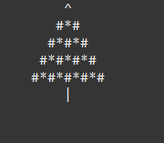

Realizat de: Laura Calina Scutelnic

Clasa a 9-a „A“