Query 1. EMPLOYEES DISTRIBUTION BY Department.
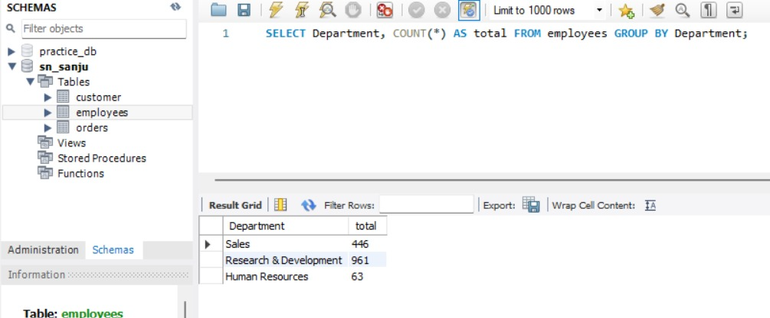

Query 2. Overall Attrition Count – 16% Employees Left.
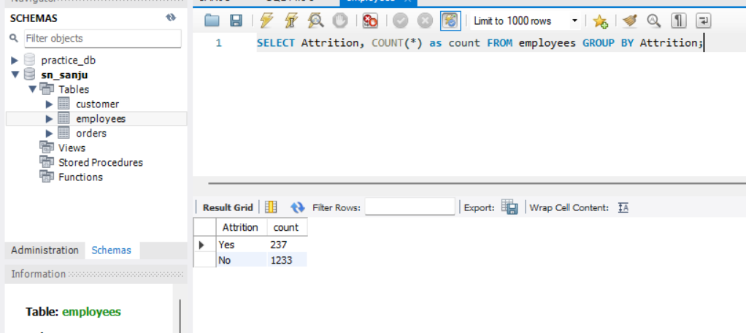

Query 3. AVERAGE Monthly Income By JobRole – Manager Highest Paid.
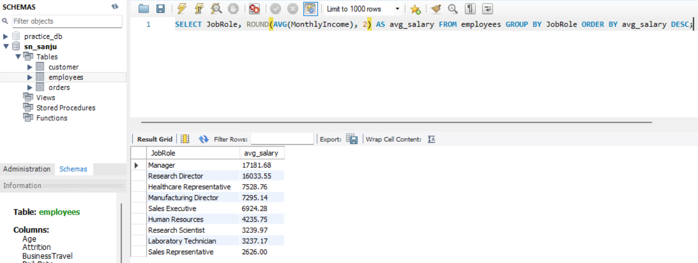

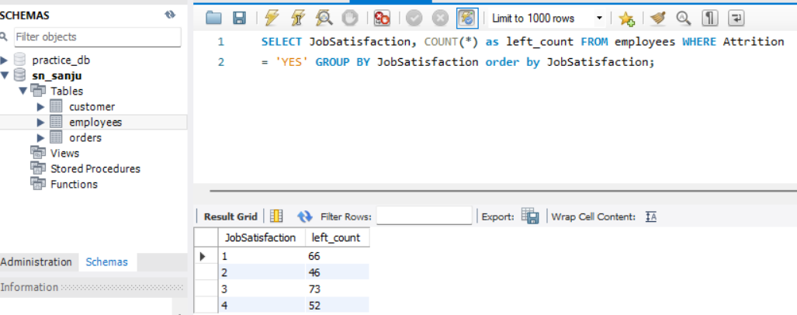
Query 4. Job Satisfaction Impact – Low Satisfaction = High Attrition.

Query 5. OverTime Impact – Employees Working Overtime Leave More.
