Titanic Survival

## Import Packages

library('dplyr') # data manipulation

##   
## Attaching package: 'dplyr'

## The following objects are masked from 'package:stats':  
##   
## filter, lag

## The following objects are masked from 'package:base':  
##   
## intersect, setdiff, setequal, union

library('ggplot2')

## Load in datasets

# load train.csv  
train <- read.csv('~/Downloads/train.csv', stringsAsFactors = F)  
# load test.csv  
test <- read.csv('~/Downloads/test.csv', stringsAsFactors = F)  
# combine them as a whole  
test$Survived <- NA  
full <- rbind(train,test)

## Show & Check the full data

head(full)

## PassengerId Survived Pclass  
## 1 1 0 3  
## 2 2 1 1  
## 3 3 1 3  
## 4 4 1 1  
## 5 5 0 3  
## 6 6 0 3  
## Name Sex Age SibSp  
## 1 Braund, Mr. Owen Harris male 22 1  
## 2 Cumings, Mrs. John Bradley (Florence Briggs Thayer) female 38 1  
## 3 Heikkinen, Miss. Laina female 26 0  
## 4 Futrelle, Mrs. Jacques Heath (Lily May Peel) female 35 1  
## 5 Allen, Mr. William Henry male 35 0  
## 6 Moran, Mr. James male NA 0  
## Parch Ticket Fare Cabin Embarked  
## 1 0 A/5 21171 7.2500 S  
## 2 0 PC 17599 71.2833 C85 C  
## 3 0 STON/O2. 3101282 7.9250 S  
## 4 0 113803 53.1000 C123 S  
## 5 0 373450 8.0500 S  
## 6 0 330877 8.4583 Q

## Data Cleaning

# Dump out Name Column  
full$Name <- NA  
# Process Age Column  
age <- full$Age  
n = length(age)  
# replace missing value with a random sample from raw data  
set.seed(123)  
for(i in 1:n){  
 if(is.na(age[i])){  
 age[i] = sample(na.omit(full$Age),1)  
 }  
}  
# Process Cabin Column  
cabin <- full$Cabin  
n = length(cabin)  
for(i in 1:n){  
 if(is.na(cabin[i])){  
 cabin[i] = 0  
 } else{  
 s = strsplit(cabin[i]," ")  
 cabin[i] = length(s[[1]])  
 }  
}   
# Check fare missing values   
full$PassengerId[is.na(full$Fare)]

## [1] 1044

#full[1044,]  
# Fill in fare missing values  
full$Fare[1044] <- median(full[full$Pclass == '3' & full$Embarked == 'S', ]$Fare, na.rm = TRUE)  
# Process Embarked Column  
embarked <- full$Embarked  
n = length(embarked)  
for(i in 1:n){  
 if(is.na(embarked[i])){  
 embarked[i] = "S"  
 }  
}

Exploratory Analysis & Data Processing

# Survival vs Age  
d <- data.frame(Age = age[0:891], Survived = train$Survived)  
ggplot(d, aes(Age,fill = factor(Survived))) +  
 geom_histogram()

## `stat_bin()` using `bins = 30`. Pick better value with `binwidth`.

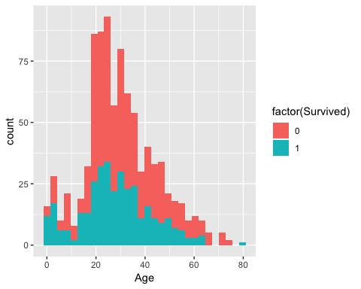

# create bar chart to show relationship between survival rate and age intervals  
cuts <- cut(d$Age,hist(d$Age,10,plot = F)$breaks)  
rate <- tapply(d$Survived,cuts,mean)  
d2 <- data.frame(age = names(rate),rate)  
barplot(d2$rate, xlab = "age",ylab = "survival rate")

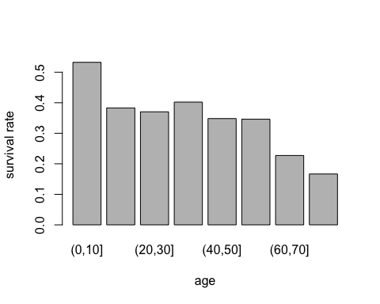

# create histgram to show effect of Sex on survival  
ggplot(train, aes(Sex,fill = factor(Survived))) +  
 geom_histogram(stat = "count")

## Warning: Ignoring unknown parameters: binwidth, bins, pad

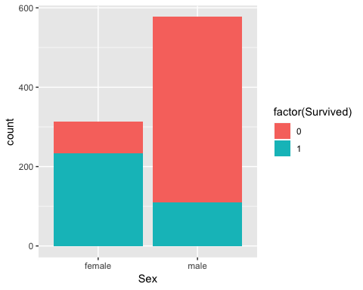

# Pclass v.s. Survival  
ggplot(train, aes(Pclass,fill = factor(Survived))) +  
 geom_histogram(stat = "count")

## Warning: Ignoring unknown parameters: binwidth, bins, pad

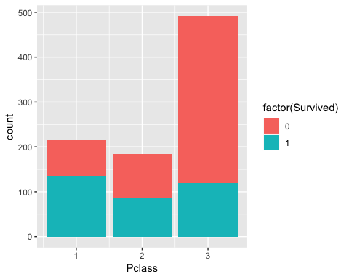

# Family Size v.s. Survival  
ggplot(train, aes(Parch,fill = factor(Survived))) +  
 geom_histogram(stat = "count")

## Warning: Ignoring unknown parameters: binwidth, bins, pad

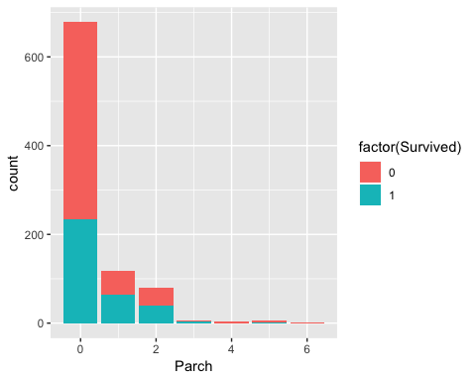

# Having siblings/spouse v.s. Survival  
ggplot(train, aes(SibSp,fill = factor(Survived))) +  
 geom_histogram(stat = "count")

## Warning: Ignoring unknown parameters: binwidth, bins, pad

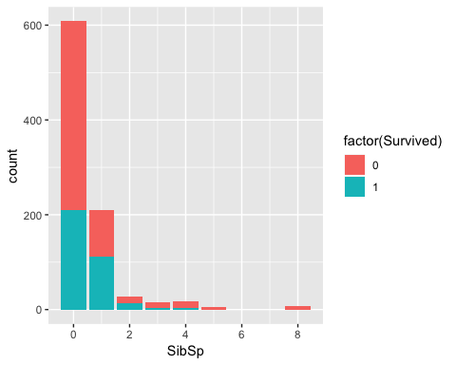

# Combine SibSp and Parch   
family <- full$SibSp + full$Parch  
d <- data.frame(family = family[1:891],Survived = train$Survived)  
ggplot(d, aes(family,fill = factor(Survived))) +  
 geom_histogram(stat = "count")

## Warning: Ignoring unknown parameters: binwidth, bins, pad

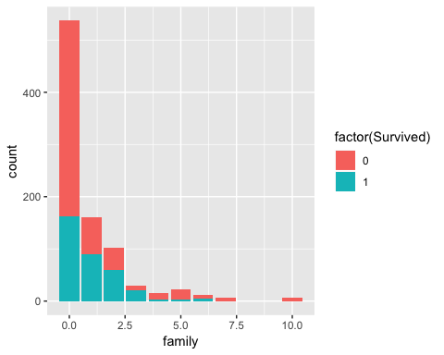

# Fare vs Survival  
ggplot(train, aes(Fare,fill = factor(Survived))) +  
 geom_histogram()

## `stat_bin()` using `bins = 30`. Pick better value with `binwidth`.

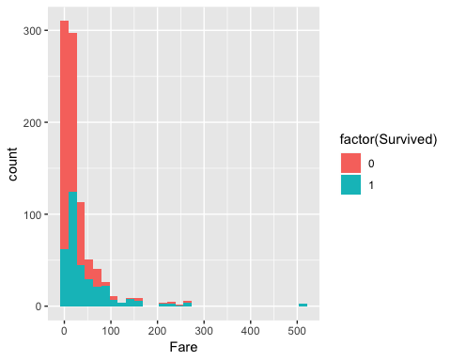

#Fare vs Survival  
cuts <- cut(train$Fare,hist(train$Fare,10,plot = F)$breaks)  
rate <- tapply(train$Survived,cuts,mean)  
d <- data.frame(fare = names(rate),rate)  
barplot(d$rate, xlab = "fare",ylab = "survival rate")

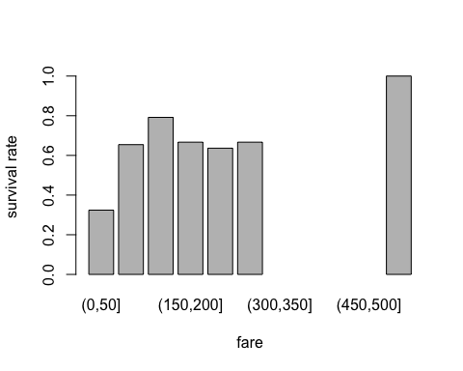

# Embarked v.s. Survival  
d <- data.frame(Embarked = embarked[1:891], Survived = train$Survived)  
ggplot(d, aes(Embarked,fill = factor(Survived))) +  
 geom_histogram(stat = "count")

## Warning: Ignoring unknown parameters: binwidth, bins, pad

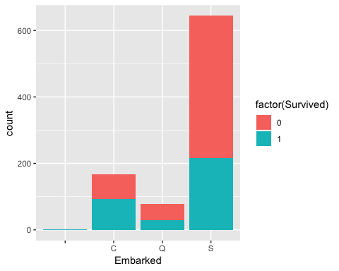 ## Feature Engineering

f.survived = train$Survived  
# Train-test Split  
f.age = age[1:891]   
t.age = age[892:1309]   
f.fare = full$Fare[1:891]  
t.fare = full$Fare[892:1309]  
f.cabin = cabin[1:891]  
t.cabin = cabin[892:1309]  
family <- full$SibSp + full$Parch  
f.family = family[1:891]  
t.family = family[892:1309]  
f.pclass = train$Pclass  
t.pclass = test$Pclass  
f.sex = train$Sex  
t.sex = test$Sex  
f.embarked = embarked[1:891]  
t.embarked = embarked[892:1309]

## Modeling

## [1] 0.8002245

# decision tree  
library(rpart)  
fit_dt <- rpart(factor(survived) ~ age + fare + sex + embarked + family   
 + cabin + pclass,data = data)  
# Prediction with Decision Tree  
dt.fitted = predict(fit_dt)  
pred1 = rep(NA,891)  
for(i in 1:891){  
 if(dt.fitted[i,1] >= dt.fitted[i,2] ){  
 pred1[i] = 0  
 } else{  
 pred1[i] = 1  
 }  
}  
# Check Accuracy  
mean(pred1 == train$Survived)

## [1] 0.8316498

# Plot Decision Tree  
library(rpart.plot)  
rpart.plot(fit_dt, extra = 106)

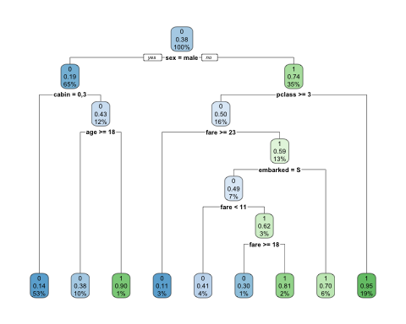

# Random Forest  
library('randomForest')

## randomForest 4.6-12

## Type rfNews() to see new features/changes/bug fixes.

##   
## Attaching package: 'randomForest'

## The following object is masked from 'package:ggplot2':  
##   
## margin

## The following object is masked from 'package:dplyr':  
##   
## combine

set.seed(123)  
fit_rf <- randomForest(factor(survived) ~ age + fare + sex + embarked + family   
 + cabin + pclass,data = data)  
# Prediction with Random Forest  
rf.fitted = predict(fit_rf)  
pred2 = rep(NA,891)  
for(i in 1:891){  
 pred2[i] = as.integer(rf.fitted[[i]]) - 1  
}  
# Check Accuracy  
mean(pred2 == train$Survived)

## [1] 0.8125701

# svm  
library(e1071)  
fit_svm <- svm(factor(survived) ~ age + fare + sex + embarked + family   
 + cabin + pclass,data = data)  
# Prediction with svm  
svm.fitted = predict(fit_svm)  
pred3 = rep(NA,891)  
for(i in 1:891){  
 pred3[i] = as.integer(svm.fitted[[i]]) - 1  
}  
# Check Accuracy  
mean(pred3 == train$Survived)

## [1] 0.8249158

## Prediction with decision tree model

# Dataframe for training  
test_data <- data.frame(age = t.age, fare = t.fare, sex = t.sex, embarked = t.embarked,  
 family = t.family, cabin = t.cabin, pclass = t.pclass)  
# make prediction  
dt_predict = predict(fit_dt,newdata = test_data )  
dt_predict1 = rep(NA,418)  
for(i in 1:418){  
 if(dt.fitted[i,1] >= dt.fitted[i,2] ){  
 dt_predict1[i] = 0  
 } else{  
 dt_predict1[i] = 1  
 }  
}  
table(dt_predict1)

## dt_predict1  
## 0 1   
## 294 124