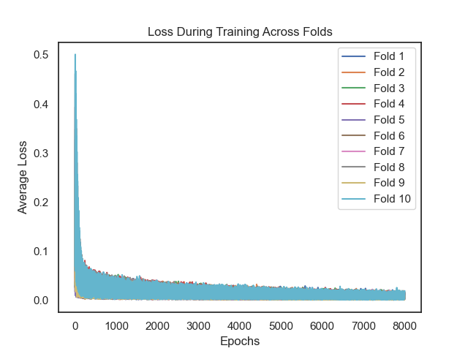

|  |  |  |
| --- | --- | --- |
|  | SBP | DBP |
| MAE | 0.03958393101476961 | 0.03453847058117389 |
| MSE | 0.002090512415820797 | 0.0019779039918072557 |
| RMSE | 0.04572212173358534 | 0.04447363254566975 |
| R² | 0.950275332868224 | 0.9481396832119174 |
| MAPE | 0.15328491794670115 | 0.09999567281599873 |

SBP MAE: 0.03958393101476961

DBP MAE: 0.03453847058117389

SBP MSE: 0.002090512415820797

DBP MSE: 0.0019779039918072557

SBP RMSE: 0.04572212173358534

DBP RMSE: 0.04447363254566975

SBP R²: 0.950275332868224

DBP R²: 0.9481396832119174

SBP MAPE: 0.15328491794670115

DBP MAPE: 0.09999567281599873