Ball Mill
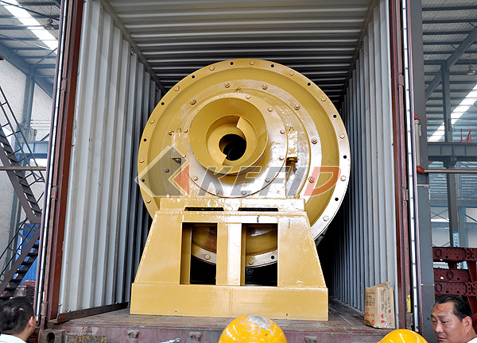
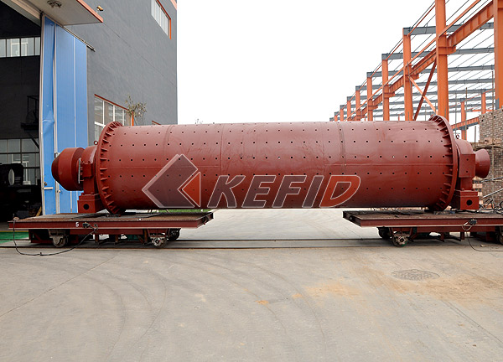
Ball mill is the key grinding equipment and is suitable for all kinds of mines and other materials after being crushed. It is widely used in producing industries such as cement, calcium silicate concrete, new type building materials, and chemical fertilizer, ore dressing for black and non-ferrous metals, glass and ceramics for both dry and wet grinding methods.
The ball mainly includes the inlet part, outlet part, revolved part ,drying part(reducer, drive gear, engine , control panel). The main body of the grinding chamber adopts the welded frame and the liner is replaced. The revolved gear adopts the welded technique, and there are abrasion liners, which have good performance. The ball mill has a stable operation and reliable performance.
Main Features:
Ball mill is made up of feeding part, discharging part, gyre part, transmission part, (decelerator, small transmission gear, generator, electrical control) and so on.
The hollow axis adopts the cast steel and the lining can replace, the rotating big gear processes in the way of casting rolling gear. The barrel body is wearable well and bears wearable scaleboard. This machine run steadily and works reliably.
Technical Parameter:
Mm to inch conversion: 25.4millimeters=1 inch
Mm to mesh conversion: 25.4mm=1in.
The humidity and hardness of raw materail will affect the fineness and capacity.
Model | Speed of bucket (r/min) | Weight of ball (t) | Size of feed opening (mm) | size of outputting feed (mm) | Production (t/h) | Power (kW) | Weight (t)
Ф900×1800 | 38 | 1.5 | ≤20 | 0.075-0.89 | 0.65-2 | 18.5 | 3.6
Ф900×3000 | 38 | 2.7 | ≤20 | 0.075-0.89 | 1.1-3.5 | 22 | 4.6
Ф1200×2400 | 32 | 3.8 | ≤25 | 0.075-0.6 | 1.5-4.8 | 45 | 12.5
Ф1200×3000 | 32 | 5 | ≤25 | 0.075-0.4 | 1.6-5 | 45 | 12.8
Ф1200×4500 | 32 | 7 | ≤25 | 0.075-0.4 | 1.6-5.8 | 55 | 13.8
Ф1500×3000 | 27 | 8 | ≤25 | 0.075-0.4 | 2-5 | 90 | 17
Ф1500×4500 | 27 | 14 | ≤25 | 0.075-0.4 | 3-6 | 110 | 21
Ф1500×5700 | 27 | 15 | ≤25 | 0.075-0.4 | 3.5-6 | 132 | 24.7
Ф1830×3000 | 24 | 11 | ≤25 | 0.075-0.4 | 4-10 | 180 | 28
Ф1830×6400 | 24 | 23 | ≤25 | 0.075-0.4 | 6.5-15 | 210 | 34
Ф1830×7000 | 24 | 25 | ≤25 | 0.075-0.4 | 7.5-17 | 245 | 36
Ф2200×5500 | 21 | 30 | ≤25 | 0.075-0.4 | 10-22 | 370 | 48.5
Ф2200×6500 | 21 | 30 | ≤25 | 0.075-0.4 | 14-26 | 280 | 52.8
Ф2200×7500 | 21 | 33 | ≤25 | 0.075-0.4 | 16-29 | 380 | 56
Φ2200×9500 | 21 | 38 | ≤25 | 0.074-0.4 | 18-35 | 475 | 62

Note: Any change of Ball Mill technical data shall not be advised additionally.

