Belt Conveyor
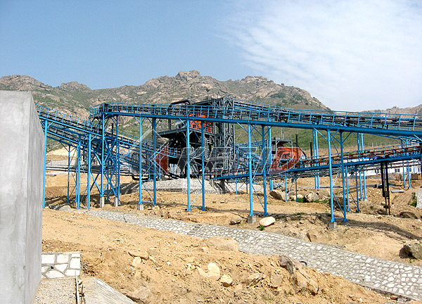
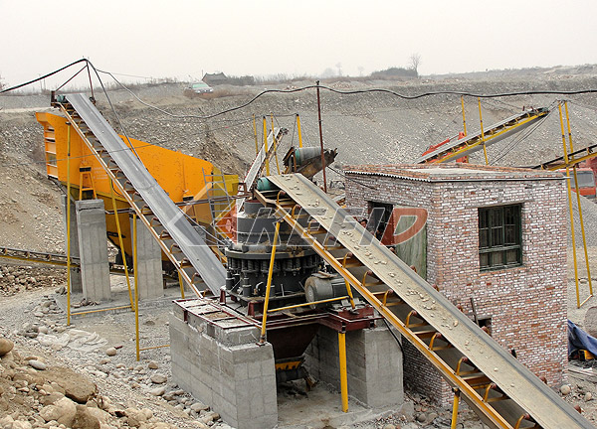
Belt conveyor is one kind of transferring equipment widely used in chemical, coal ore, metallurgy, mining, foundry, construction, building material, electric power, light industry, food, transportation, production line, the concrete dam building site of hydropower station, port and the other production departments. With reference of the transportation requirement, the transfer system can be one independently or multi-conveyors or combined with other transfer equipments, the belt conveyor can be installed horizontally or aslope to meet the needs of different transfer lines. The belt conveyor can be operated in the circumstance temperature from -20℃ to +40℃. The material transferred by the belt conveyor should be lower than 50℃, the density of various of granular and powder material should be between 0.5 and 2.5t/ m³, and the belt can transfer the whole set goods. The length of the belt we manufacture can be changed according to the customer’s requirement. At present, the widely used type of the belt contains TD75, DT, and QD80, the belt conveyor designed and manufactured by our company mainly meet the mining equipment in different circumstance, combined with different crushing , grinding and sieve devices so as to realize the continuity and the automation of the production and improve the productivity and reduce labor intensity.
Main Features:
The belt conveyor moves according to the abrasion and transmission principle and has the advantages of large transportation amount, long transportation distance, smooth delivery, no relative motion between material and the belt, low noise, simple structure, easy to maintain, low energy consumption and standardization of the parts.
Technical Parameter:
Belt Width(mm) | Belt Length (m) / Power (kW) |  |  | Belt Speed (m/s) | Capacity (t/h)
500 | ≤12/3 | 12-20/4-5.5 | 20-30/5.5-7.5 | 1.3-1.6 | 45-100
650 | ≤12/4 | 12-20/5.5 | 20-30/7.5-11 | 1.3-1.6 | 70-120
800 | ≤10/4 | 10-15/5.5 | 15-30/7.5-15 | 1.3-1.6 | 120-180
1000 | ≤10/5.5 | 10-20/7.5-11 | 20-40/11-22 | 1.3-2.0 | 160-250
1200 | ≤10/7.5 | 10-20/11 | 20-40/15-30 | 1.3-2.0 | 200-400
Note: Any change of Belt Conveyer technical data shall not be advised additionally.

