CS Cone Crusher
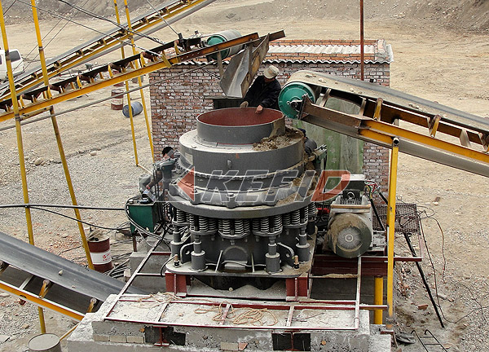
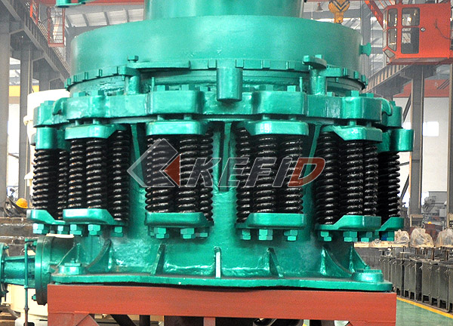
According to customers’ requirement, Kefid CS Cone Crusher is a high efficiency spring cone crusher absorbing advanced technology at home and abroad. It’s based on the lamination crushing theory with the features of high-frequency pendulum, optimized cavity and reasonable stroke.
Main Features:

1. High-performance
Combining optimal designing of chamber type with applying reasonable speed and stroke, to make this kind of machine does more work with the same dynamic cone diameter. Therefore, this machine is of high-performance and manufacturing capacity compared with other cone crusher of the same type.
Use laminated crushing principle, to make more cubic shape materials and less needle-like materials.
2. Good products size composition
the crusher applies for laminated crushing principle to make cubic shapes of final products stand for larger proportion. Acicular and flake shape products decrease and size fraction much more well-proportioned.
3. Good stability
if there is metal or other non-broken material come to the chamber, metal going through protection device will release it and then reset automatically. The protection device has fixed discharge opening returning point and the original discharge opening can returning back immediately after the metal goes through the crushing chamber.
4. Convenient Cleaning-up
If the crusher stops under loading condition, hydraulic cleaning system can clean up the crushing chamber quickly so that decrease the downtime.
5. High reliability.
Adopting main shaft with big diameter，heavy main frame and separate automatic Control System of thin oil lubrication system, so that it guarantees robustness and reliable operation of the crusher.
6. Easy maintenance and operation
all parts can be disassembled from top and the upper side, so that fixed cone and dynamic cone can be disassembled easily.
Under high shock and vibration environment, bronze Bearing can keep excellent bearing capacity and it is much more economic and easy for maintenance.
7. Low production costs
Due for big capacity, high reliability and easy maintenance, the production costs has been reduced greatly.
8. Widespread use
the specialty of CS Series High-efficiency Spring Cone Crusher is maximizing the performance to apply to all kinds of crushing process: from special coarse crushing to fine crushing; from fixed crushing plant to mobile crushing plant.
CS Series High-efficiency Spring Cone Crusher has different types of crushing chamber for choosing according to crushing process.
9. Separate Lubrication
Technical Parameter:

Model | Dia. mm (inch) | Cavity | Feed Opening |  | Outlet Setting (mm) | Shaft Speed (r/min) | Power (kw) | Capacity (t/h) | Weight (t) | Dimension (mm)
Model | Dia. mm (inch) | Cavity | Closing Side (mm) | Open Side (mm)
CSB75 | 900 (3') | Fine | 83 | 102 | 9-22 | 580 | 75 | 45-91 | 15 | 2821×1880×2164
CSB75 | 900 (3') | Coarse | 159 | 175 | 13-38 | 580 | 75 | 59-163 | 15 | 2821×1880×2164
CSB160 | 1295 (4 1/4') | Fine | 109 | 137 | 13-31 | 485 | 185 | 109-181 | 27 | 2800×2342×2668
CSB160 | 1295 (4 1/4') | Medium | 188 | 210 | 16-38 | 485 | 185 | 132-253 | 27 | 2800×2342×2668
CSB160 | 1295 (4 1/4') | Coarse | 216 | 241 | 19-51 | 485 | 185 | 172-349 | 27 | 2800×2342×2668
CSB240 | 1650 (5 1/2') | Fine | 188 | 209 | 16-38 | 485 | 240 | 181-327 | 55 | 3911×2870×3771
CSB240 | 1650 (5 1/2') | Medium | 213 | 241 | 22-51 | 485 | 240 | 258-417 | 55 | 3911×2870×3771
CSB240 | 1650 (5 1/2') | Coarse | 241 | 268 | 25-64 | 485 | 240 | 299-635 | 55 | 3911×2870×3771
CSB315 | 2134 (7') | Fine | 253 | 278 | 19-38 | 435 | 315 | 381-726 | 110 | 4613×3251×4732
CSB315 | 2134 (7') | Medium | 303 | 334 | 25-51 | 435 | 315 | 608-998 | 110 | 4613×3251×4732
CSB315 | 2134 (7') | Coarse | 334 | 369 | 31-64 | 435 | 315 | 789-1270 | 110 | 4613×3251×4732
Short Head
Model | Dia. mm (inch) | Cavity | Feed Opening |  | Outlet Setting (mm) | Shaft Speed (r/min) | Power (kw) | Capacity (t/hour) | Weight (t) | Dimension (mm)
Model | Dia. mm (inch) | Cavity | Closing Side (mm) | Open Side (mm)
CSD75 | 914 (3') | Fine | 13 | 41 | 3-13 | 580 | 75 | 27-90 | 15 | 2821×1880×2410
CSD75 | 914 (3') | Coarse | 33 | 60 | 3-16 | 580 | 75 | 27-100 | 15 | 2821×1880×2410
CSD160 | 1295 (4 1/4') | Fine | 29 | 64 | 3-16 | 485 | 160 | 36-163 | 27 | 2800×2342×2668
CSD160 | 1295 (4 1/4') | Medium | 54 | 89 | 6-16 | 485 | 160 | 82-163 | 27 | 2800×2342×2668
CSD160 | 1295 (4 1/4') | Coarse | 70 | 105 | 10-25 | 485 | 160 | 109-227 | 27 | 2800×2342×2668
CSD240 | 1676 (5 1/2') | Fine | 35 | 70 | 5-13 | 485 | 240 | 90-209 | 55 | 3917×2870×3771
CSD240 | 1676 (5 1/2') | Medium | 54 | 89 | 6-19 | 485 | 240 | 136-281 | 55 | 3917×2870×3771
CSD240 | 1676 (5 1/2') | Coarse | 98 | 133 | 10-25 | 485 | 240 | 190-336 | 55 | 3917×2870×3771
CSD315 | 2134 (7') | Fine | 51 | 105 | 5-16 | 435 | 315 | 190-408 | 110 | 4130×3251×4454
CSD315 | 2134 (7') | Medium | 95 | 133 | 10-19 | 435 | 315 | 354-508 | 110 | 4130×3251×4454
CSD315 | 2134 (7') | Coarse | 127 | 178 | 13-25 | 435 | 315 | 454-599 | 110 | 4130×3251×4454
Note: Any change of CS Cone Crusher technical data shall not be advised additionally.

