Deep rotor VSI crusher
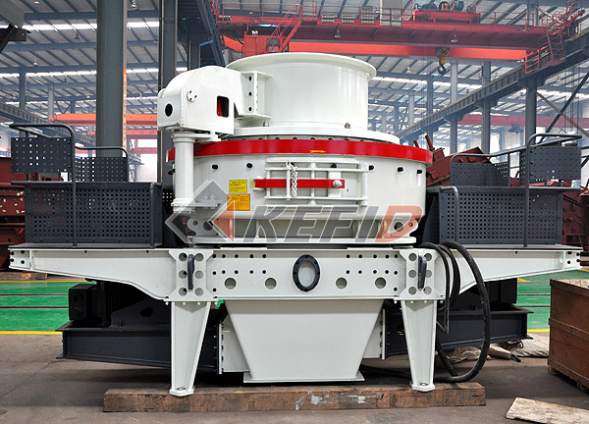
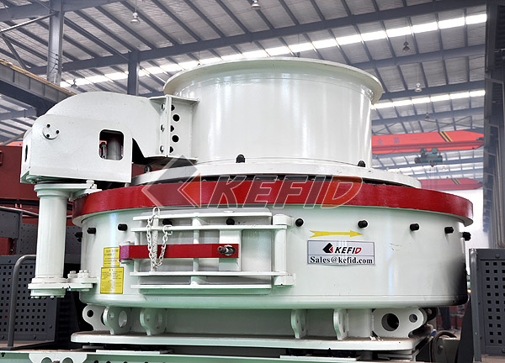
Deep rotor VSI crusher is the latest launching high efficiency equipment on the basis of fully study by the crusher expert of Kefid of production characteristics traditional VSI crusher. It is the core equipment in machine-made sand industry for it contains the three crushing models. The rotor of deep rotor VSI crusher has been specially optimized design, which makes the capacity increased by about 30%. Around guard adopts innovative design to improve the service life of over 48%. Increase vice hammer to prevent from damaging the side plate after the main hammer wear and tear. The most key wear resistant material uses wear resistant and high temperature resistant material in American important area. Japanese hydraulic opening cover device is originally imported. The cover is moved easily and inspection of inner part is easy.

Deep rotor VSI crusher is widely used in various metallic and nonmetallic ores, cement, corhart, abrasive material, glass, construction material, machine-made sand, metallurgy, etc. It is suitable for medium and fine crushing of different hardness of varied ore and rock, such as iron ore, nonferrous ore, diamond, bauxite, quartz sand, corundum, perlite, basalt and other aggregate material’ medium and fine crushing.
Main Features:
1. Its capacity increases 30% by optimized deep chamber.
2. Operating ratio can be increased 48% by changed side plate direction.
3. The operating cost reduces 30% by combined type worn hammer.
4. Using high temperature resistant and wear resistant material.
5. Bearing is famous international brand that imported from Japan ,Sweden and America.
6. Perfect graded final products with excellent shape.
7. High exchange rate to utilize any application and material.
8. Spread dish with double purposes can make two feeding ways change easily.
9. Special seal structure under main shaft guarantee no oil leak without seal.
10. VSI5X series sand making machine can be used for stationary crushing plant and can be mounted on mobile crushing plant.
Technical Parameter:
Mm to inch conversion: 25.4millimeters=1 inch 1.
Main technical parameters:

model |  | DR-7615 | DR-8522 | DR-9532 | DR-1145
Throughput capacity (t/h) | Center and Ring feeding | 150~280 | 240~380 | 350~540 | 500~640
Throughput capacity (t/h) | Center feeding | 70~140 | 120~200 | 180~280 | 250~360
Max. Feed Size (mm) | Soft material | <35 | <40 | <45 | <50
Max. Feed Size (mm) | Hard material | <30 | <35 | <40 | <45
Rotation speed (r/min) |  | 1700~1900 | 1500~1700 | 1300~1510 | 1100~1310
Power of double motor (KW) |  | 110~150 | 180~220 | 260~320 | 400~440
Overall dimension L x W x H (mm) |  | 4100×2330×2300 | 4140×2500×2700 | 4560×2600×2900 | 5100×2790×3320
Weight (t) |  | 8.6 | 11.8 | 17.5 | 27.5
Power source |  | 380v，50Hz
Thin oil lubrication station | Power for double oil pump | 2 x 0.31 KW
Thin oil lubrication station | Safety | To make sure the supply of oil with double oil pump, working without oil, temperature when water cools, start the motor by heating it in winter.
Thin oil lubrication station | Power for oil box heater | 2 KW
Thin oil lubrication station | Overall dimension  L x W x H (mm) | 820 x 520 x 1270

Note: Capacity depends on crushing limestone, material size, moisture and features also affect capacity.
2. Lubricating system parameter:

Oil box volume (L) | 240
Rated pressure (MPa) | 0.63
Flow capacity (L/min) | 8
Power (KW) | 0.31
Cooling water consumption (m3/h) | ≥1.2
Electrical heating voltage (V) | 220
Medium | Bearing oil 32—46#

Note: Any change of Deep Rotor VSI Crusher technical data shall not be advised additionally.

