European Hammer Mill
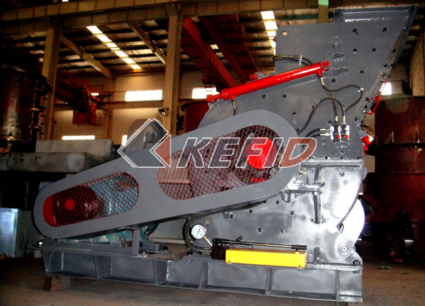
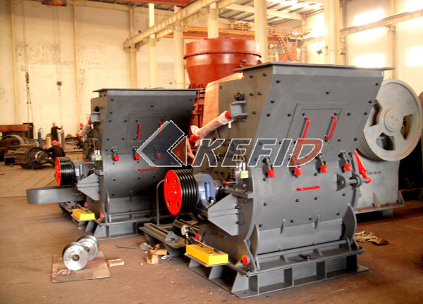
European Hammer Mills are widely used in metallurgy, mining, chemical, cement, coal gangue, construction, sand, refractory material, ceramic and other industry, engaged in breaking and crushing the material in the operation. European Hammer Mill is mainly suitable for crushing various soft and hard ore. Whose compression strength is not higher than 320MPa. European Hammer Mill is mainly made up of frame, rotor, hammers, grizzly bar and other components.
Main Features:
1. big crushing ratio and large capacity;
2. Low consumption and even granule;
3 .Simple design and compact structure;
4. Modest investment and easy management.
Technical Parameter:
Model | EHM4008-75 | EHM4012-90 | EHM4015-132
Diameter of the rotor (mm) | 750 | 900 | 1150
Length of the rotor(mm) | 800 | 1200 | 1500
Rotation speed of the rotor (r/min) | 800-1000 | 800-1000 | 700-1000
Input size(mm) | <70 | <90 | <100
Output size(mm) | 0-3 | 0-3 | 0-3
Capacity (t/h) | 35-50 | 50-70 | 70-100
Motor power(Kw) | 55-75 | 75-90 | 110-132
No. of the hammers(piece) | 18 | 16 | 32
Dimension(L*W*H/mm) | 2310*1665*1610 | 2840*2100*2020 | 3720*2650*2540

