HC Cone Crusher
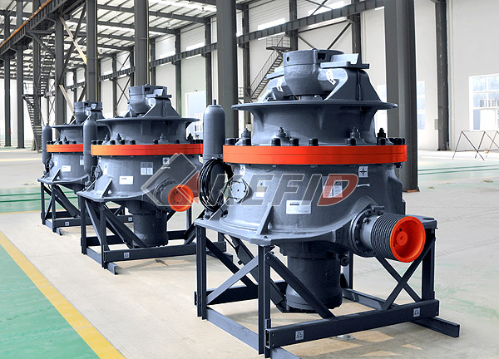
HC Series single cylinder hydraulic cone crusher is the international advanced cone crusher. It adopts crushing, hydraulic, computer control technology, advanced manufacturing technology, and other latest researching results. It is widely used in the work of medium-size crushing, fine crushing and super fine crushing that can meet the toughest working conditions and has the characteristics of meeting the requirements of different types and hardness stones.

HC series cone crusher adopts alloy steel frame body, alloy forged spindle, spiral face gear transmission, having the structural features of small size, light weight, large power and durability. Self-storage operating system, fast assembly and disassembly liner, curve crushing cavity designs make it has large processing capacity, lower operation cost and failure rate.
Main Features:
1.Top and bottom body are alloy steel, which make the body more durable and robust through computer FEM finite element analysis design. Adopts alloy forged mainshaft, and can bear overweight crushing force.
2.The main axis, eccentric, eccentric bushing combined together. By rotating the eccentric can easily set multiple eccentricities, which can meet requirement of different minerals and mining.
3.Spiral bevel gear surface transmission makes it torque, efficiency.
According to the parietal broken principle and laminated material wear characteristic, the curve crushing chamber can ensure the large production, high quality, and low wear and tear cost of the crusher.
4.Lubrication system and hydraulic system adopt modular design, and they run independently. They chain with the host, enabling the protection of the oil temperature, flow, pressure, power, and abnormal power supply.
5.Self-operation system can achieve overload protection, over-iron protection and automatic compensation of liner wear during crushing operations. Feeding through crowded warehouse can maximize the effect of the crusher.
6.Technical Parameter of HC Cone Crusher.
Technical Parameter:

Model | Main shaft speed(rpm) | Eccentric distance(mm) | Motor power(kw) | Weight(kg)
HC100S | 360 | 16-25 | 90 | 7100
HC200S | 340 | 16-30 | 150 | 13200
HC300S | 285 | 20-36 | 220 | 19500
HC100 | 395 | 13-28 | 90 | 5400
HC200 | 360 | 16-36 | 150 | 9400
HC300 | 320 | 16-36 | 250 | 14500
HC400 | 290 | 18-50 | 315 | 24200

Model | Chamber  Type | Max.feeding  size(mm) | Capacityt/h:Capacity,Metric tons per hour
Model | Chamber  Type | Max.feeding  size(mm) | CSS
Model | Chamber  Type | Max.feeding  size(mm) | 16 | 19 | 22 | 25 | 29 | 32 | 35 | 38 | 41 | 44 | 48 | 51 | 54
HC100S | EC | 240 |  | 80 | 90 | 120 | 160 | 175 | 150 | 130
HC100S | C | 200 | 68 | 75 | 102 | 133 | 117 | 102
HC200S | EC | 360 |  |  | 122 | 131 | 180 | 243 | 258 | 325 | 343 | 360 | 320 | 269 | 225
HC200S | C | 300 |  | 104 | 142 | 152 | 209 | 267 | 284 | 299 | 316 | 277 | 189
 |  |  | 25 | 29 | 32 | 35 | 38 | 41 | 44 | 48 | 51 | 54 | 57 | 60 | 64
HC300S | EC | 450 |  | 248 | 264 | 350 | 371 | 468 | 493 | 630 | 550 | 479
HC300S | C | 400 | 215 | 295 | 314 | 400 | 423 | 536 | 470 | 418 | 350
 |  |  | 4 | 5 | 6 | 8 | 10 | 13 | 16 | 19 | 22 | 25 | 29 | 32 | 35
HC100 | EC | 130 |  |  |  |  | 48 | 89 | 97 | 104 | 110 | 118 | 127 | 134 | 103
HC100 | C | 90 |  |  |  |  | 56 | 93 | 101 | 108 | 116 | 124 | 110 | 74
HC100 | M | 64 |  |  |  | 46 | 78 | 84 | 80 | 62
HC100 | MF | 48 |  |  | 38 | 70 | 74 | 71 | 56
HC100 | F | 38 | 35 | 51 | 52 | 56 | 60 | 50 | 40
EF available |  |  | 6 | 8 | 10 | 13 | 16 | 19 | 22 | 25 | 29 | 32 | 35 | 38 | 41
HC200 | EC | 190 |  |  |  | 113 | 157 | 169 | 179 | 191 | 207 | 218 | 230 | 218 | 174
HC200 | C | 145 |  |  |  | 138 | 149 | 160 | 170 | 182 | 196 | 207 | 197 | 156 | 120
HC200 | MC | 115 |  |  | 60 | 147 | 158 | 170 | 182 | 193 | 168 | 152 | 123
HC200 | M | 90 |  |  | 88 | 138 | 149 | 160 | 170 | 161 | 137 | 109
HC200 | MF | 65 |  | 64 | 111 | 121 | 130 | 132 | 120 | 97
HC200 | F | 50 | 82 | 87 | 92 | 101 | 108 | 110 | 100 | 81
EF available |  |  | 10 | 13 | 16 | 19 | 22 | 25 | 29 | 32 | 35 | 38 | 41 | 44 | 48
HC300 | EC | 210 |  |  | 210 | 290 | 309 | 329 | 355 | 374 | 395 | 415 | 434 | 403 | 320
HC300 | C | 170 |  | 106 | 229 | 307 | 327 | 348 | 377 | 397 | 378 | 352 | 276 | 240
HC300 | MC | 140 |  | 128 | 275 | 296 | 316 | 336 | 363 | 344 | 322 | 254 | 221
HC300 | M | 105 |  | 196 | 292 | 313 | 334 | 356 | 314 | 295 | 233 | 204
HC300 | MF | 80 | 120 | 238 | 257 | 276 | 295 | 314 | 277 | 260 | 206
HC300 | F | 65 | 185 | 201 | 216 | 232 | 248 | 263 | 233 | 218 | 172
EF available |  |  | 13 | 16 | 19 | 22 | 25 | 29 | 32 | 35 | 38 | 41 | 44 | 48 | 51
HC400 | EC | 300 |  | 186 | 355 | 458 | 487 | 526 | 574 | 605 | 635 | 665 | 695 | 663 | 536
HC400 | C | 210 |  | 200 | 385 | 504 | 535 | 579 | 611 | 643 | 675 | 643 | 538 | 426 | 371
HC400 | MC | 170 |  | 266 | 447 | 478 | 508 | 549 | 580 | 610 | 524 | 488 | 382 | 303
HC400 | M | 130 |  | 310 | 462 | 494 | 525 | 567 | 527 | 504 | 423 | 389
HC400 | MF | 100 | 202 | 387 | 416 | 444 | 472 | 510 | 473 | 408 | 381
HC400 | F | 75 | 319 | 344 | 370 | 395 | 420 | 454 | 421 | 363 | 339
HC400 | EF | 55 | 295 | 318 | 313 | 304
EF = Extra fine
F = Fine
MF = Medium fine
MC= Medium coarse
M = Medium
C = Coarse
EC = Extra coarse
The capacity is based on granite, the density of aggregate is 1.6t/m3.
The technical data is only for reference, it is not considered as our guarantee. Please consult Kefid Machinery for more information.

Note: Any change of Cone Crusher technical data shall not be advised additionally.

