HP Cone Crusher
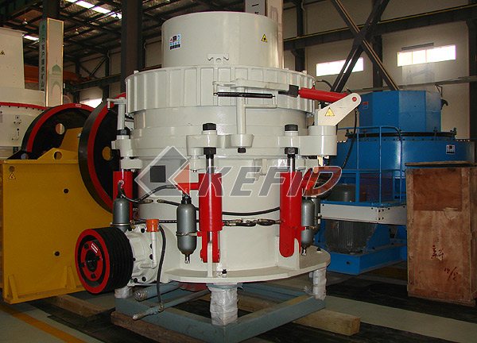
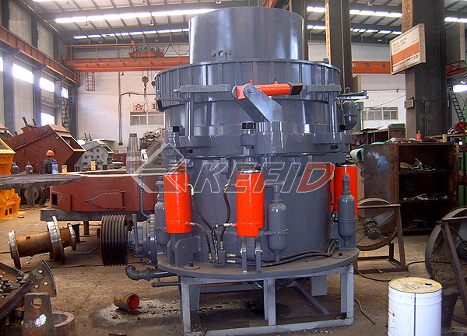
HP series hydraulic cone crusher is a world-level cone crusher developed from the latest technology of Germany. The crusher is widely used in metal and nonmetal mines, cement, sand and metallurgical industries.
HP series hydraulic cone crusher not only improves the production capacity and crushing efficiency, but also widens the applying area, the hardness of materials range from limestone to basalt. It has a second-to-none crushing performance in the work of medium-size crushing, fine crushing and super fine crushing. The crusher is the improved type of spring cone crusher and can be used to replace ordinary hydraulic cone crusher in the line of mining and construction. It is the ideal equipment for large stone crushing factory and mining industry.
Main Features:
1. High-efficiency: The machine uses optimized structure such as, fixed axis, small spherical bearing, which make the efficiency is 5%-15% higher than the efficiency of traditional cone crusher.
2. Large capacity: The perfect combination of broken stroke, broken speed and crushing chamber makes the capacity is 35%-65% larger than the capacity of traditional cone crusher under the same broken cone size.
3. High quality stone: The machine uses special laminated crushing principle resulting in the crushing effect of particles, so that the proportion of cube in the output clearly increased, the flake stone needless reduced and the grain size more uniform.
4. More smoothly operation: When iron and other hard objects that cannot be broken into the machine, the over iron protection equipment will released the objects and then reset immediately.
5. Multi-split hydraulic lubrication control system can ensure the double protection of the bush and overload protection.
Technical Parameter:
Mm to inch conversion: 25.4millimeters=1 inch

Type | Cavity (coarse/fine) | Min. discharge size (mm) | Feed size (mm) | Capacity (t/h) | Power (kW) | Weight (t) | movable cone diameter (mm)
HP-160 | C | 13 | 150 | 120-240 | 160 | 13 | 950
HP-160 | F | 6 | 76 | 55-180 | 160 | 13 | 950
HP-220 | C | 13 | 225 | 150-430 | 220 | 18 | 1160
HP-220 | F | 6 | 86 | 90-260 | 220 | 18 | 1160
HP-315 | C | 13 | 290 | 190-610 | 315 | 26 | 1400
HP-315 | F | 6 | 100 | 108-320 | 315 | 26 | 1400
HP-400 | C | 13 | 320 | 230-700 | 400 | 33 | 1500

Note: Any change of Cone Crusher technical data shall not be advised additionally.

