High Pressure Mill
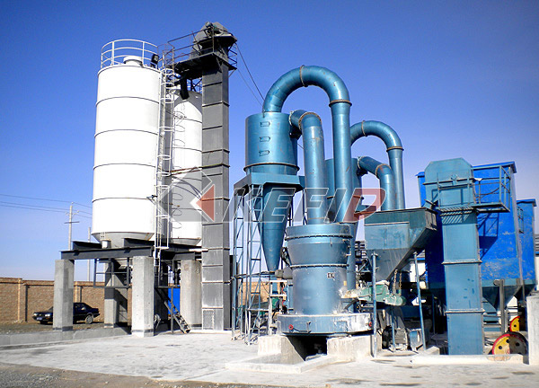
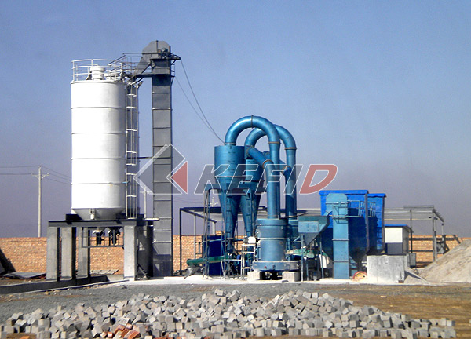
High press mill can be used to grind the non-inflammable and non-explosive material with the Moh’s hardness below 9.3 and moisture below 6%, such as the quartz, feldspar, calcite, limestone, talc, marble, granite, dolomite, bauxite, iron stone, barite, bentonite, coal gangue and coal. The fineness of the final size can be adjusted from 0.613mm to 0.033mm.
Main Features:
1. Compared with other mills, its capacity increases by 10%-20% under the same power condition, and compression force of rollers to material improve 800-1200kgf under the force of high-pressure spring.
2. Size of final product can be 0.613mm (30mesh) –0.033mm (425mesh). Some can reach the fineness of 0.013mm (1000 mesh).
3. High Pressure Suspension Mill meets the requirement of national dust-dump standard.
4. The separator can be adjusted very easily.
5. The multi-class seals are adopted to keep the grinding equipment tightly closed.
Technical Parameter:
Mm to inch conversion: 25.4millimeters=1 inch
Mm to mesh conversion: 25.4mm=1in.
The humidity and hardness of raw materail will affect the fineness and capacity.

Model | HGM60 | HGM80 | HGM100
Roller number | 15 | 21 | 27
Diameter (mm) | Φ600 | Φ800 | Φ1000
Ring number | 2 | 2 | 2
Main unit speed(mm) | 235 | 235 | 235
Max. feeding size(mm) | 10 | 10 | 10
Final size (mesh) | 325-2500 | 325-2500 | 325-2500
Capacity (kg/h) | 350-2500 | 600-4000 | 900-6000
Overall dimension (m) | 10×2×5.5 | 12.4×2.5×5.8 | 14.5×3.8×6.3

Note: Any change of Three-Rings & Medium-Speed Micro Powder Mill technical data shall not be advised additionally.

