Hydraulic impact crusher
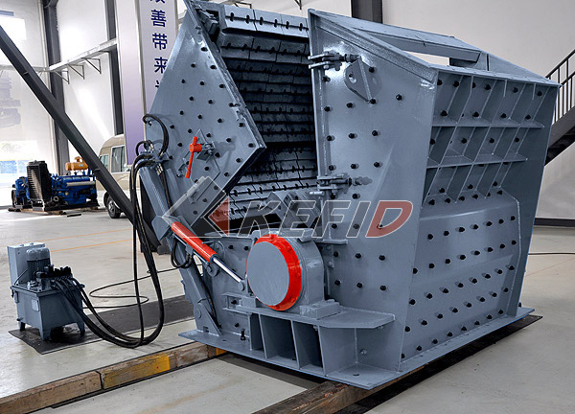
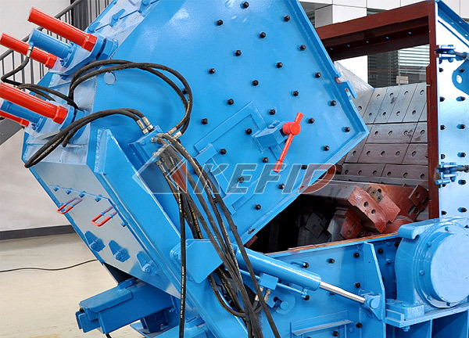
Kefid Hydraulic impact crusher is widely used in construction material, highway and railway, cement, mining and chemical fields etc. It is designed to crush soft and medium hard rock. The size range of feed material (maximum compression strength 300Mpa, the moisture should be below 8-10%) can be up to 700mm. Hydraulic impact crusher improves the adjusting device making operation more convenient. The three– cavity makes excellent capability in fine crushing and super fine crushing line.
Main Features:

1. Bearing adopts the integrated cast-steel structure, which ensures the perfect match with crusher frame. Meanwhile, it greatly increases the radial intensity of bearing seat.
2. Unique fixing device of blow bar brings higher reliability.
3. Reformative adjusting device decrease the time of machine stop and overhaul.
4. Self-own open-top device can quickly finish the replacement of wearing parts.
5. Larger bearing specification and higher carrying capacity.
6. Rotor analysis ensures stableness and reliability.
Technical Parameter:

P model | Spec. | Feeding  size (mm) | Max. feeding  size (mm) | Capacity (t/h) | Power (kW) | Weight (t)
PFS1210 | Ф1150X960 | 1100X1030 | 400 | 90-160 | 90-110 | 17.0
PFS1214 | Ф1150X1400 | 1100X1430 | 500 | 130-200 | 132-160 | 22.0
PFS1315 | Ф1300X1500 | 1200X1530 | 600 | 180-320 | 160-200 | 29.0
PFS1318 | Ф1300X1800 | 1200X1830 | 700 | 240-400 | 200-250 | 34.0

If there is change of the above specification, it subjects to the newest products' specifications.
Note: Any change of Hydraulic Impact Crusher technical data shall not be advised additionally.

