Impact Crusher
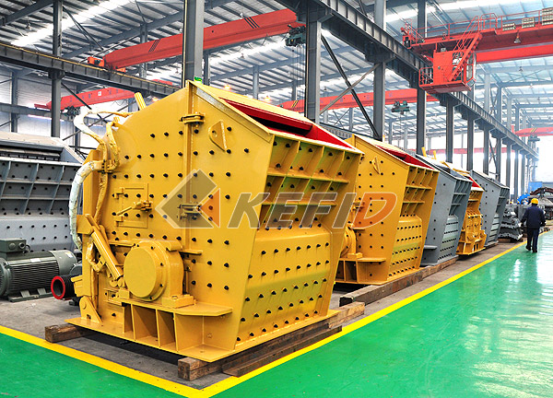
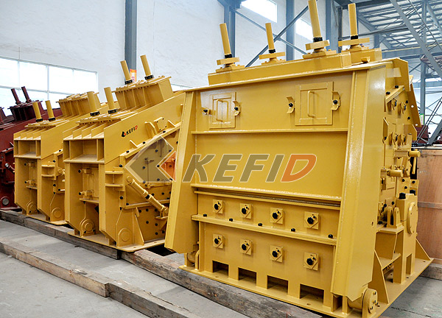
By absorbing advanced technology in the world and combining experience in sand and gravel mining industry, Kefid PF Series Impact Crusher uses the latest manufacturing technology and unique structure design; the final sizes share the advantages of cubic shapes, no tension and no cracks. It’s suitable to crush various coarse, medium and small materials (granite, limestone, concrete, etc.) with the feeding size less than 500mm, compressive strength less than 350MPa, which has been widely used in ore crushing, railway, highway, energy, cement, chemicals, construction and other industries, it can crush various ores and rocks, such as: limestone, cooked material, slag, coke and coal. The discharge opening can be adjusted under various specifications.

Compared with hammer crusher, PF series impact crusher offers larger crushing ratio and more fully utilizes the high-speed impact energy of the rotor, which is the best choice in stone and gravel crushing line. However, as crusher boards are easy to wear, there is a limitation to crush hard materials, PF series impact crusher is usually used for coarse and fine crushing of medium-hardness materials, such as limestone, coal, calcium carbide, quartz, dolomite, sulfide iron ore, gypsum and chemical raw materials.

The ideal feed size of PF impact crusher is 100-500mm, the maximum sizes shall not exceed the specification. According to the requirement, users can adjust final particle sizes via the space between the hammer head and impacting plate.
Main Features:

1.Larger input size, higher crushing cavity can process harder material with less powder in final products;
2. Easy adjustment of space between the impact plate and hammer, effective control of the final sizes with good cubic shapes;
3. Compact structure, good rigidity, the rotor offers larger inertia;
4. High chrome hammer offers larger impacting force with less abrasion on easy-wearing parts;
5. New type rotor increases impacting force;
6. Full breaking function, higher crushing ratio and productivity with lower energy consumption.
7. By using simple structure of expansion connection, it’s easy to get maintenance.
Technical Parameter:

Mm to inch conversion: 25.4millimeters=1 inch
Model | Size of rotor (mm) | Feed opening (mm) | Max. feed size (mm) | Capacity (t/h) | Power of Motor (kW) | Weight (t)
PF1010 | Φ1000×1050 | 400×1080 | 350 | 50-80 | 75 | 12.5
PF1210 | Φ1250×1050 | 400×1080 | 350 | 70-130 | 110 | 16.5
PF1214 | Φ1250×1400 | 400×1430 | 350 | 90-180 | 132 | 19
PF1315 | Φ1320×1500 | 860×1520 | 500 | 120-250 | 200 | 24
PF1320 | Φ1320×2000 | 860×2030 | 500 | 160-350 | 260 | 27

Note: Any change of Impact Crusher technical data shall not be advised additionally.

