JC Series Jaw Crushers
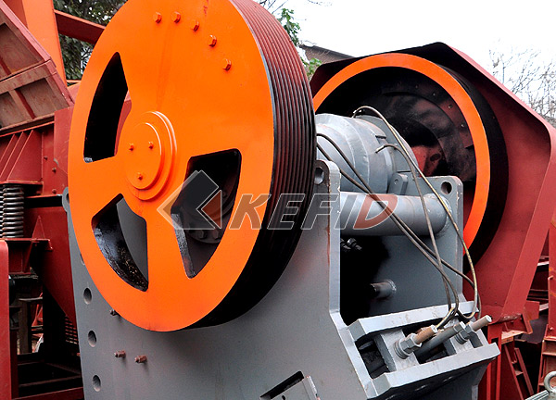
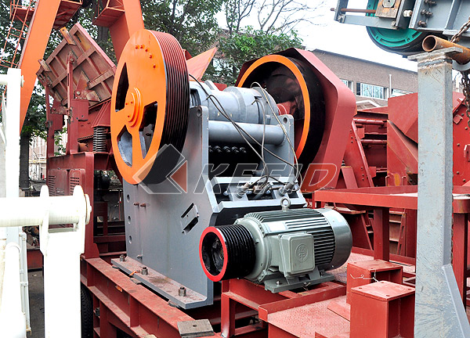

JC series Jaw Crushers are widely used in mine, building materials, chemical industry, metallurgy, whose compressive strength is below 320Mpa. JC series Jaw Crusher can be divided into coarse crusher and fine crusher with world-wide advanced crushing technology and producing standard and the JC series Jaw Crusher can crush the material with high hardness and strong abrasive efficiently.
Main Features:

1. World-level manufacturing technology is adopted, and highest-level raw material is used.
2. More advanced movable jaw assembly lengthens life of crusher.
Movable jaw assembly is made from cast piece with high-quality, is driven by two large flying wheels which are made from cast steel. Moreover, heavy eccentric shaft is processed by forged mold. These entire make the JC series jaw crusher extremely reliable.
3. Integral cast steel structure is adopted for bearing seat. Integral cast steel bearing matches well with the crusher frame, at the same time, radial strength of the bearing seat is highly strengthened.
4. Finite element analysis technology is adopted to make the crusher much stronger.
5. Crusher chamber adopts "V" structure which could make actual feed width comply with the nominal one.
6. Adjustment of the discharge part is more convenient.
The adjustment methods: gasket adjustment, hydraulic assistant adjustment, wedge block and wedge hydraulic adjustment.
7. Bearing with larger model and higher load are used.
All JC jaw crusher is equipped with larger bearing compared with same model of normal jaw crusher. Its higher load capacity and effective oil seal will lengthen the life of bearing.
8. A newly designed tooth-shape side plate, makes the available area of jaw plate longer, and enhances the capacity.
Technical Parameter:
Mm to inch conversion: 25.4millimeters=1 inch
Model |  | JC760×1100 | JC840×1100 | JC1100×1200 | JC180×1300 | JC250×1000 | JC250×1300 | JC400×600
Opening Size  (mm) |  | 760×1100 | 840×1100 | 1100×1200 | 180×1300 | 250×1000 | 250×1300 | 400×600
Max. Feed  Size (mm) |  | 620 | 720 | 930 | 150 | 220 | 220 | 350
Discharge  Opening Range  (mm) |  | 75-200 | 100-225 | 150-275 | 10-30 | 20-40 | 70-100 | 35-85
Shaft Speed  (r/min) |  | 270 | 240 | 210 | 320 | 330 | 290 | 250
Capacity (t/h) |  | 150-350 | 200-500 | 300-650 | 12-35 | 15-50 | 26-85 | 15-70
Motor | Power  (kw) | 110-132 | 132-160 | 185-200 | 30-37 | 30-37 | 37-45 | 37-45
Motor | Speed  (r/min) | 985 | 985 | 740 | 980 | 980 | 980 | 980
Dimension  (mm)(L×W×H) |  | 2600×2500  ×2200 | 3300×2320  ×3120 | 4140×2660  ×3560 | 1320×2150  ×1175 | 1400×1850  ×1310 | 1450×2150  ×1175 | 1920×1460  ×1840
Weight (kg) |  | 24000 | 32000 | 59200 | 6000 | 5600 | 6800 | 7000
Note: Any change of JC Series Jaw Crusher technical data shall not be advised additionally.

