JC Series Jaw Crushers
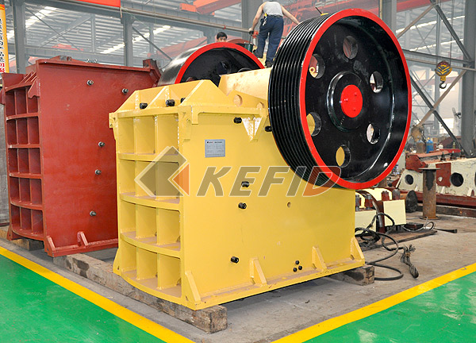
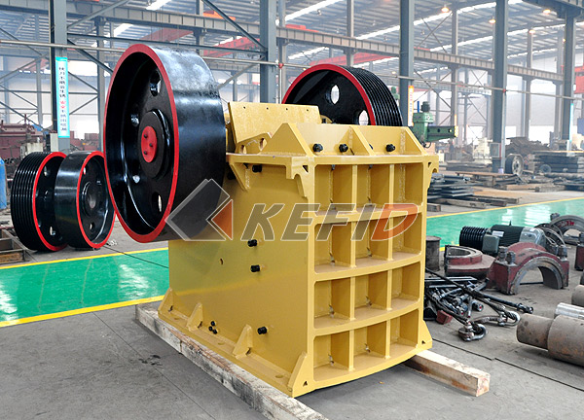

Our company has reached world-wide advanced standard in the design and produce large model jaw crusher as the domestic leading manufacturer of crushing and screening plant. Jaw Crusher is mainly used in medium size crushing of rocks and bulk material, whose compressive strength is below 320Mpa. Jaw Crusher as the first choice of primary crushing, can be divided into coarse crusher and fine crusher, feeding size is 125mm~750mm. It is widely used in mine, metallurgy, the building, road and railroad construction, hydraulic construction, chemical industry, fire-proofing material and ceramics.
Main Features:

- Deep crushing chamber without dead zone, which increase the feeding capacity and production capacity.
- High crushing ratio, uniform final product size.
- Stable and convenient gasket discharge adjusting device makes the adjusting range wide and flexible.
- Safe and reliable lubrication system, easy replacement of spare parts.
- Simple structure, reliable operation with low operation costs.
- Energy saving: single equipment saves energy of 15%-30%, system saves energy a times more.
- The range of discharging opening is big and it can match with different customers’ requirements.
- Low noise and little dust.
Simple structure, easy maintenance; stable performance, low operation costs; high crushing ratio.
Technical Parameter:

Mm to inch conversion: 25.4millimeters=1 inch
Model | Max. Feeding Size (mm) | Discharge Size (mm) | Capacity (t/h) | Motor Power (kW) | Overall Dimensions (mm) | Weight (t)
PE400×600 | 350 | 40-100 | 15-60 | 30 | 1700×1732×1653 | 6.5
PE500×750 | 425 | 50-100 | 50-100 | 55 | 2035×1921×2000 | 10.3
PE600×900 | 480 | 65-160 | 60-168 | 75 | 2290×2206×2370 | 16.5
PE750×1060 | 630 | 80-140 | 100-250 | 110 | 2620×2302×3110 | 29
PE900×1200 | 750 | 95-165 | 160-380 | 110 | 3789×2826×3025 | 54.5
PE1000×1200 | 850 | 195-265 | 315-550 | 110 | 3335×3182×3025 | 57
PE1200×1500 | 1020 | 150-300 | 400-800 | 160-220 | 4200×3750×3820 | 100.9

Note: Any change of Jaw Crusher technical data shall not be advised additionally.

