MTW Series Trapezoid Mill
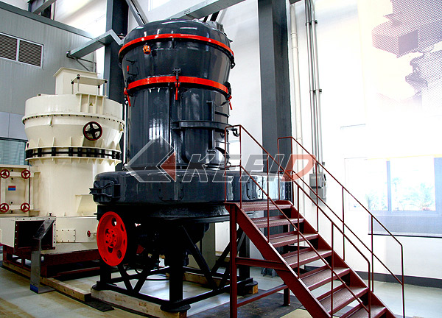
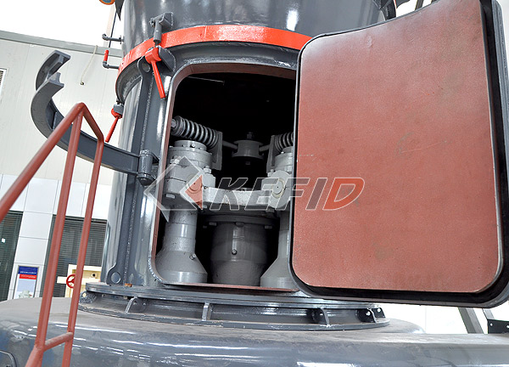
MTW series European technology trapezium grinding mill is newly promoted with advanced technology in the world and its own knowledge patents. This type grinding mill adopts integral-drive bevel gear, inner automatic thin-oil lubrication system, arc air channel and several latest patent technology.
The MTW series trapezium grinding mill is mainly used in the industries metallurgy, construction, chemical, mining and other industry. It can grind quartz, feldspar, calcite, talcum, barite, fluorite, rare earth, marble, ceramics, bauxite, manganese, iron, copper, rock phosphate, iron oxide red, zircon sand, slag, slag , cement clinker, activated carbon, dolomite, granite, garnet, iron oxide yellow, fertilizer, compound fertilizer, fly ash, bituminous coal, coke, lignite, Ling U.S. sand, chromium oxide green, gold, red mud, clay, Kaolin, coke, coal gangue, porcelain clay, kyanite, fluorspar, bentonite, medical stone rhyolite, diabase, leaf wax rock, shale, purple rock, Diego rock, basalt, gypsum, graphite, silicon carbide , insulation materials,and many other types of non-flammable non-explosive ores, which hardness are below 9 grade, and with moisture less than 6%.
Main Features:
1.Integral-drive bevel gear: an additional reducer is needed for a traditional mill, and drive the main draft through sleeve pipe, which is difficult in installing, has loud noise and low efficiency. The MTW series European trapezium mill is integral-drive bevel gear, which is more compact in structure, convenient and prompt to install and adjust, and helpful for improving efficiency.
2.Inner thin oil lubrication system: lubrication pattern of traditional mills is grease lubrication, which has more resistance, high temperature, short life span; the MTW series European trapezium mill adopts inner oil pump, no additional oil pump or lubrication plant is needed, and lubrication can be implemented to the main draft and cone gear draft.
3.Arc air channel: mill air channel of traditional mills are of straight type. This structure has disadvantages of resistance caused by air flow impacting air channel plat, energy loss caused by mutual impact of air molecules, votex flow cause stuck of air channel. Air channel of the MTW series European trapezium mill adopts the curved surface channel, in which, air flow is able to enter smoothly with little resistance; the inner outlet is helpful for scatter of materials and can reduce material stuck.
4.Blade on the curved surface is changeable: blade of traditional mill is wearable, and blade is a wholesome one, which should be changed totally and is material wasting and will prolong stop time. Blade of the MTW series European trapezium mill is of high abrasive alloy material, long life span; which changing, only blade is necessary to be changed, which can greatly improve material utilizing ratio. Besides, with traditional flat blade, materials are piped to one layer, which is possible to damage center of roller ring of the roller, while curved blade is able to guide materials to a vertical surface and powder can be milled in up-middle-down part of the roller and mills evenly, which is able to increase working area and capacity.
5.Separated cyclone dust collector: separated structure is adopted between the inner barrel and mixed air powder, which is able to improve efficiency and accuracy of powder selection.
6.Wind inlet scroll casing: for traditional mill, inner side of the inner observing door protrudes, which is not on the same surface with the wind inlet scroll casting. Thus, there will be eddy effect, and energy consumption of the whole system will increase a lot, while those of the MTW series are on the same surface, which is able to avoid eddy effect.
Technical Parameter:

Model Specification Name | MTW110 | MTW138 | MTW175
Quantity of roller (PCS) | 4 | 4 | 6
Inner diameter of ring (mm) | Ф1100 | Ф1380 | Ф1750
Rotary speed of main frame(r/min) | 120 | 96 | 75
Max. Feeding size(mm) | < 30 | < 35 | < 40
Output size (mm) | 1.6～0.045 The fineness is 0.038 | 1.6～0.045 The fineness is 0.038 | 1.6～0.045 The fineness is 0.038
capacity (t/h) | 3.5～10 | 6.5～15 | 11～25
Overall dimension (mm) | 8910×6950×9010 | 9860×8340×10227 | 13500×11500×9500
Total weight (t) | 18 | 28.5 | 46

Remarks: Capacity is based on grinding limestone, 80% passing-through. If the technical data and overall dimension is changed, it is subjected to the operation manual which is together with delivered goods.
Note: Any change of European Trapezium Grinding Mill technical data shall not be advised additionally.

