Mobile Cone Crusher
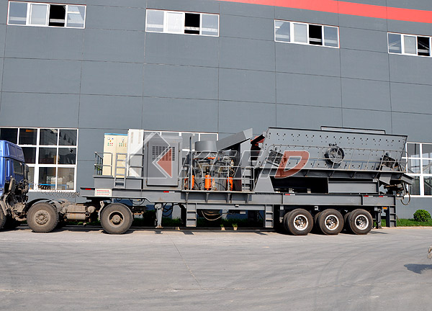
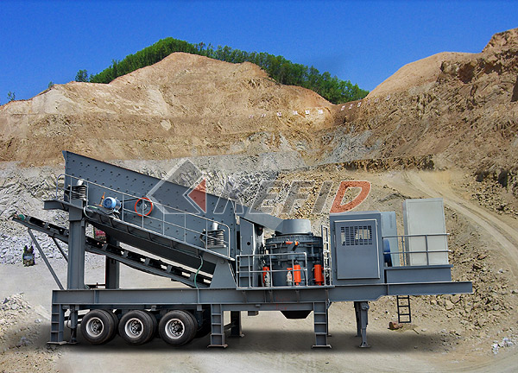

The new launched mobile cone crusher plant by KEFID is an up-to –minute rock crushing equipments, which is widely used in construction waste disposal and crush, highway, railway construction, hydroelectric plants and other large projects.
Mobile cone crusher plant is mainly used in fine crushing area. According to different stone and different purpose of products, mobile cone crusher can replace impact crusher in aggregates production circuit to produce sand, stone products harder and finer. Configuration of the cone crusher can be adjusted according to actual needs, adopting different crushing chamber type or expanding the scope and areas of cone crusher.
Mobile cone crushing plant mainly consists of high efficient cone crusher, high performance screener, belt conveyor, motor and electric control box etc.
Integrated installation and coordinated work of the whole unit fully display the advantages of convenience and flexibility.
Mobile cone crushing plant can be manufactured according to customers’ requirements, in strict accordance with the actual situation. It is of high capacity, high efficiency, medium and fine crushing and strong adaptability etc.
Main Features:
YSY series stone crushing station is designed by different crushing principle and crushing effects of cone crusher and impact crusher.
There is large difference between input requirement and the output size. At the side of easy operating, it has the common advantage of YGE series mobile crushing station and YSF series mobile crushing station.
1. The integrating installation of the equipments makes strong coordination. Reasonable and compact spatial distribution saves much time for site construction. It improves the flexibility and avoids lots of infrastructure construction. In this method, invest cost is saved largely.
2. Bottom head of the truck-mounted coarse mobile crushing station is high. Width of the truck is smaller than the operating semi trailer. The turning radius is small and it is easy for road driving and more convenient for driving in the hash hilly environment. It saves much time from start working.
3. Cone crusher acts the function of fine crusher; also it can produce fine grained final products of stones and sands. It will save the cost of
materials transporting. At the same time, the lengthened unit can directly send the crushed 120products to the bin of the truck and the transporting cost is reduced.
4. Cone crusher adopts static pressure principle. The shake will be softer after the second time obstruct. It is easy for installing.
5. The crushing efficiency will be high of bed of materials of cone crusher. It works stable and can save much time to a large extent.
6. The single unit can work separately; also it can be equipped with other unit flexibly to work together. The sideways hopper produces flexible equipments combination for transporting the materials. The diesel motor in the line of integration unit can provide electricity not only to the line itself but also to the equipments combination of the whole system.
7. The technical is mature. It is easy for maintenance. A clear division of labor of the equipments is convenient for maintenance.

Technical Parameter:

Model  Technical data | Y3S154Y55 | Y3S184Y75 | Y3S186Y160 | Y3S216Y220
Transportation Length (mm) | 12000 | 12000 | 13500 | 13500
Transportation Width (mm) | 2550 | 2800 | 2800 | 3000
Transportation Height (mm) | 3900 | 3900 | 4200 | 4200
Maximum Length (mm) | 13700 | 13700 | 15200 | 15200
Maximum Width (mm) | 2800 | 3150 | 3150 | 3500
Maximum Height (mm) | 5700 | 5700 | 6400 | 6400
Weight (T) | 34 | 39 | 54 | 53
Tire Configuration | Dualaxial | Dualaxial | Triaxial | Triaxial
Cone crusher | PYB900 | CS75 | CS160 | HPC-220
The maximum Feeding size (mm) | 115 | 102 | C-150 F-76 | C-225 F-86
Discharge opening size (mm) | 15-50 | 9-38 | C13 F6> | C13 F6
Capacity (T/h) | 50-90 | 45-165 | C120-240、F55-180 | C150-430、F90-260
Belt conveyor | B650X7M | B650X7M | B800X8M | B1000X8M
Vibrating Screen | 3YZS1548 | 3YZS1848 | 3YZS1860 | 3YZS2160

