Mobile Impact Crusher
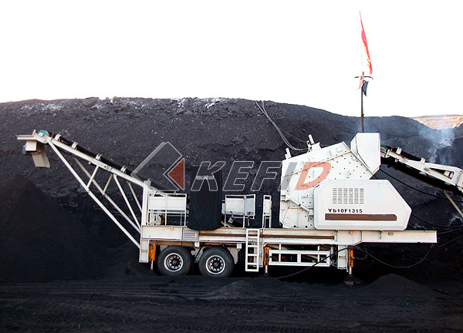

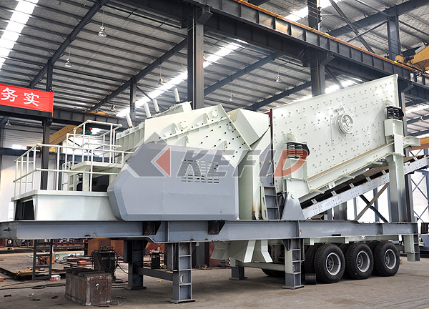

The PF Series mobile impact crusher is a star product of KEFID ,which is equipped by the unit configuration, uses the latest manufacturing technology, adopts the high-quality chrome blow bar and wear-resisting counterattack linings, and has great crushing ratio, Because of its own advantage of good particle shape, it is widely used in various fields, say, metallurgy, chemical, construction material, hydroelectric fields to process materials that need to be moved frequently especially in processing the liquid stones for highway, railway, and hydroelectric subjects. Customers can equip different configuration according to different processing materials, scale and requirements. The mobile impact crusher plant is especially convenient for operation in a small working site, to process and crush the construction waste.
Main features:
Flexibility:
Bottom head of the truck-mounted impact crusher mobile crushing station is high. Width of the truck is smaller than the operating semi trailer. The turning radius is small and it is easy for road driving and more convenient for driving in the hash hilly environment. It saves much time from start working.
It is more convenient for the vehicle to enter the exact processing area. It provides for the whole crushing flow with more flexible space and reasonable layout.
Cost reduced:
The crushing station can drive to the selected working site directly and no need transport. Also the lengthened unit can directly send the materials being crushed to the conveyor belt and the transport cost is reduced.
More flexible technical plan can be provided to satisfy customers' various requirements on mobile crushing and mobile screening according to the material type and products request. The working process and transportation of final material will be more effective and cost can be reduced at most.
Immediacy and efficiency:
Integrated truck mounted impact crusher mobile crushing station includes primary crushing station and secondary crushing and sieving station. Each crushing station is separate working unit and can undertake different duties. Belt conveyor takes charge of transporting materials between conveyors, and sends materials to stacking.
Strong adjustability and flexible combination:
Truck mounted mobile crushing station provides to customers with simple, low-cost equipments combination with special characteristic. As to coarse crushing, fine crushing and screening system, the single unit can work separately; also it can be equipped with other unit flexibly to work together. The sideways hopper produces flexible equipments combination for transporting the materials. The diesel motor in the line of integration unit can provide electricity not only to the line itself but also to the equipments combination of the whole system.
Stable performance and easy maintenance:
The truck mounted mobile crushing station equipped with PE series, PF series, HP series, and PV series crushers. It has the features of high efficiency, multifunction, good quality of crushers, reasonable structure, and brilliant crushing capability. It can furthest satisfy the crushing and screening requirement of coarse, medium-coarse, fine materials. It sets good reputation for all the customers.
Technical Parameter:

Model | Y3S154F1010 | Y3S184F1210 | Y3S186F1214 | Y3S216F1315
Transportation Length (mm) | 11000 | 11600 | 12800 | 13500
Transportation Width (mm) | 2450 | 2800 | 2800 | 3000
Transportation Height (mm) | 3900 | 4400 | 4400 | 4500
Maximum Length (mm) | 12700 | 13500 | 15500 | 16200
Maximum width (mm) | 2800 | 3150 | 3150 | 3500
Maximum Height (mm) | 5700 | 6000 | 6400 | 6700
Weight (T) | 34 | 40 | 45 | 56
Tire Configuration | Dualaxial | Dualaxial | Triaxial | Triaxial
Impact crusher | PF-1010 | PF-1210 | PF-1214 | PF-1315
Feed opening size | 400*1080 | 400*1080 | 400*1430 | 860*1520
The maximum Feeding size (mm) | 350 | 350 | 350 | 500
Capacity (T/h) | 50-250 | 70-300 | 90-400 | 120-450
Belt conveyor | B650X7M | B650X7M | B800X8M | B800X8M
Vibrating Screen | 3YZS1548 | 3YZS1848 | 3YZS1860 | 3YZS2160

Note: Any change of Mobile Impact Crusher Crushing Plant technical data shall not be advised additionally.

