Mobile Jaw Crusher
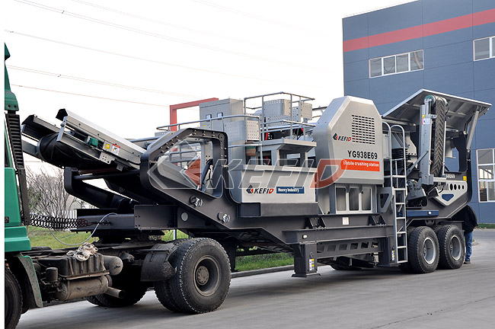
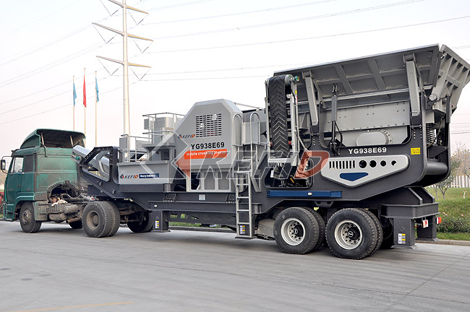

Mobile jaw crusher plant is the newest rock crushing equipment, mainly used in metallurgy, chemical industry ,building materials, hydroelectric power and material processing that often requires removal working, especially for highways, railways, hydroelectric subjects. The users can adopt a variety of configurations according to different type of raw materials, different requirements for scale and final product materials. Jaw crusher station has greatly expanded the concept of coarse crushing areas.
Main features:
1 High-performance crusher, great crushing ratio, and powerful crushing pioneer.
2 Truck-mounted motor and integrated control box.
3. Work with the integrated machines of jaw crusher, cone crusher, vertical impact crusher, feeders and vibrating screens.
4. With vehicle installation of sieve under the belt, vibrating screener and crusher.
5. Support of vehicle installation and settlement of equipments are prompt and convenient.
6. Steering traction axis will be helpful for high way transportation and getting close to the working site.
Technical Parameter:

Model Technical data | YG830E46 | YG938E57 | YG938E69 | YG114E710 | YG134E912
Transportation Length (mm)  (If there is an diesel generator) | 8600 | 9800 | 11000 | 13000 | 14000
 | 10000 | 11600 | 12000 | 14000 | 15500
Transportation Width (mm) | 2450 | 2450 | 2450 | 2450 | 3000
Transporation Height (mm) | 3800 | 3500 | 3600 | 4500 | 4800
Maximum Length (mm) | 12000 | 13300 | 13200 | 15000 | 17000
Maximum Width (mm) | 2800 | 2900 | 2900 | 2900 | 3100
Maximum Height (mm) | 3800 | 4100 | 4600 | 5800 | 5800
Weight (T) | 26 | 32 | 41 | 55 | 81
Tire Configuration | Uniaxial | Dualaxial | Triaxial | Triaxial | Quadrqxial
Jaw crusher | PE400×600 | PE500×750 | PE600×900 | PE750×1060 | PE900×1200
The maximum Feeding size (mm) | 350 | 425 | 480 | 630 | 750
Discharge opening size(mm) | 40-100 | 50-100 | 65-160 | 80-140 | 95-165
Capacity (T/h) | 15-60 | 50-100 | 60-130 | 100-250 | 160-380
Vibrating Feeder | GZD850×3000 | GZD960×3800 | GZD960×3800 | GZD1100×4200 | GZD1300×4900
Belt conveyor | B650×7M | B650×7.5M | B800×8M | B1000×9M | B1200×11M

Note:
1. The above model is elementary mobile crushing plant;
2. We can produce the Mobile Jaw Crusher according to customers' requirement.

