Mobile VSI Crusher
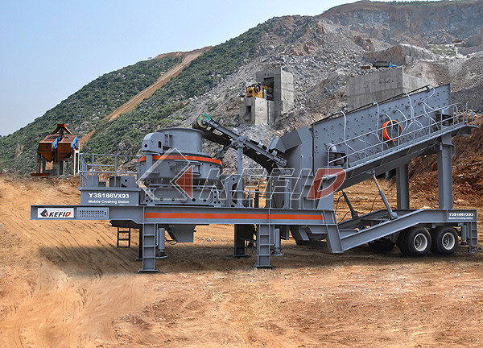
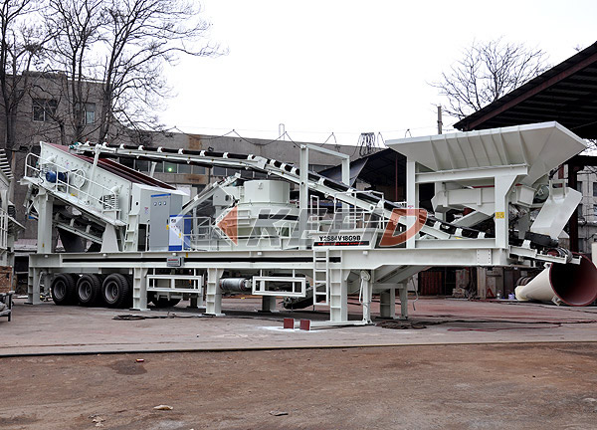

The Mobile VSI Crusher is widely used on highway & bridge construction, urban architecture, metallurgy, energy and so on, carrying crushing and screening work.
The advantages of the plant are high capacity, high efficiency, high adaptability and economical and it can do the work of integral crushing & screening and belt conveyor self-loaded and is suitable for fine crushing, shape adjusting.
Technical Parameter:
Model  Technical data | Y3S154VSI71 | Y3S184VSI81 | Y3S186VSI92 | Y3S216VSI14
Transportation Length (mm) | 11000 | 11300 | 13500 | 14000
Transportation Width (mm) | 2450 | 2800 | 2800 | 3000
Transportation Height (mm) | 4000 | 4200 | 4200 | 4400
Maximum Length (mm) | 13000 | 13300 | 14500 | 15000
Maximum Width (mm) | 2800 | 3150 | 3150 | 3500
Maximum Height (mm) | 5700 | 6000 | 6400 | 6700
Weight (T) | 32 | 36 | 48 | 61
Tire Configuration | Dualaxial | Dualaxial | Dualaxial | Triaxial
Vertical Shaft Impact crusher | VSI-7611 | VSI-8518 | VSI-9526 | VSI-1140
The maximum Feeding size (mm) | 34 | 38 | 43 | 59
Capacity (T/h) | 60-180 | 100-260 | 150-380 | 225-520
Belt conveyor under vibraitng screen | B650X7M | B800X7M | B800X8M | B1000X8M
Self-loaded belt conveyor | B800X3M | B800X3M | B1000X3M | B1200X3M
Vbrating screen | 3YZS1548 | 3YZS1848 | 3YZS1860 | 3YZS2160
Note:
1. The above model is elementary mobile crushing plant;
2. We can produce the crushing & screening plant according to customers' requirement.

