P series VSI crusher
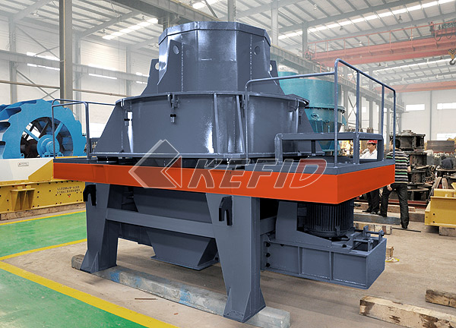
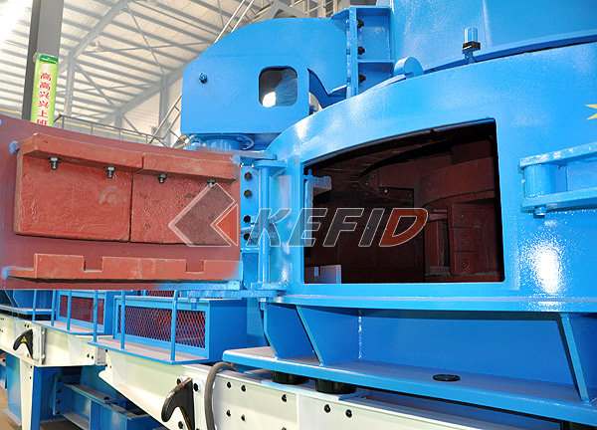
P series VSI crusher, also know as sand making machine, is an equipment with high production capacity and low consumption newly developed by R&D department of Kefid on basis of many years experience in mining equipments design and by introducing sand making machine principle of Barmac vertical shaft impact crusher. The new crusher can be used in fine crushing of various ores, especially for fine crushing and intermediate crushing of abrasive material, quartz sand, emery, refractory material, cement, copper ore, gold ore, furnace slag, river stones, concrete aggregate, asphalt aggregate, etc. Meanwhile, the crusher has become a good substitution of hammer crusher, double roller crusher, roller crusher and other traditional equipments and become a leading equipment of sand making industry due to it’s brilliant performance in producing more and costing less.
Main Features:
1.Simple and reasonable design, low operation cost.
2.Designed for fine crushing and coarse grinding, low in power consumption, high in production capacity and crushing ratio.
3.Small volume, less wear in impeller lining, simple in operation, easy in installation and maitenance.
4.Moisture can impact little influence, moisture can be about 8%.
5.Can be used for shaping, products are of cubic shape with big packing density and less pollution of iron content.
6.Has better performance in crushing medium hard and special hard material.
7.Some wearing parts are made of specially hard wear-resistant material with small volume, small weight, and are easy to change.
8.Working noise is below 75db and there is less dust pollution.
Technical Parameter:

Mm to inch conversion: 25.4millimeters=1 inch

Model | Rotate speed of  impeller (r/min) | Max feed  size (mm) | Power (kW) | Weight (including  motor) (t) | Capacity (t/h) | Overall dimensions (mm)
P-600 | 2000-2600 | 30 | 2×30 | 5.6 | 10-30 | 2800×1550×2030
P-750 | 1600-2100 | 35 | 2×45 | 7.5 | 30-50 | 3300×1800×2440
P-900 | 1300-1700 | 40 | 2×55 | 12 | 50-80 | 3750×2120×2660
P-1050 | 1100-1450 | 45 | 2×110 | 16 | 70-120 | 4480×2450×2906
P-1250 | 950-1200 | 45 | 2×132 | 22 | 80-150 | 4563×2650×3176
P-1350 | 800-1200 | 50 | 2×160 | 26 | 120-200 | 5340×2940×3650

Note: Any change of P series VSI crusher technical data shall not be advised additionally.

