Primary Impact Crusher
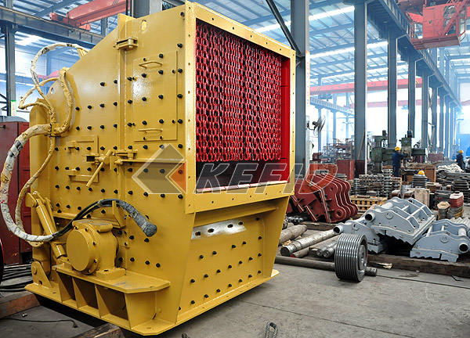
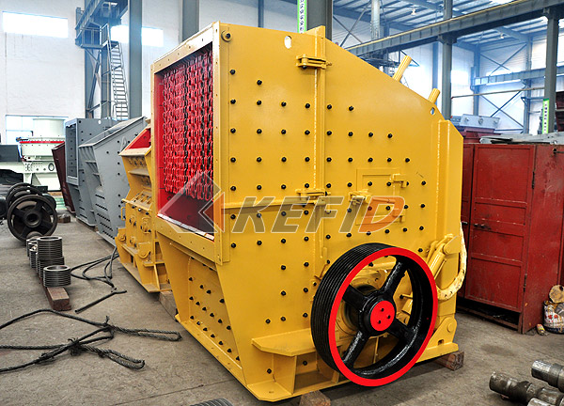
By using international advanced technology, Kefid PFP series primary impact crusher offers excellent quality and efficiency. Rotor, as the heart of the impact crusher, makes great contribution when working, so it needs strict quality control. We developed stronger rotor to produce heavier moving inertia. Hard wear resistant material and the best cavity design make sure the excellent performance of the crusher, which is suitable to crush various hard and medium-hard materials to coarse to fine sizes. The PFP series impact crushers are mainly used in metallurgy, mining, cement, chemicals, refractory, ceramics and other industrial sectors, and have been widely used in the highway construction, water conservancy projects, building stone and other fields.
Main Features:
1. Using world-class manufacturing process and good-quality raw material.
2. Heavy-duty design and rigorous tests to ensure the quality of the rotor.
3. Using integrated steel bearing structure.
4. The unique fixtures make the hammer more reliable.
5. Improved adjustment device reduces stop and maintenance time.
6. Choosing larger-size bearing with higher carrying capacity.
7. Analysis of the rotor ensures stability and reliability.
Technical Parameter:
Mm to inch conversion: 25.4millimeters=1 inch
Model |  | JC760×1100 | JC840×1100 | JC1100×1200 | JC180×1300 | JC250×1000 | JC250×1300 | JC400×600
Opening Size  (mm) |  | 760×1100 | 840×1100 | 1100×1200 | 180×1300 | 250×1000 | 250×1300 | 400×600
Max. Feed  Size (mm) |  | 620 | 720 | 930 | 150 | 220 | 220 | 350
Discharge  Opening Range  (mm) |  | 75-200 | 100-225 | 150-275 | 10-30 | 20-40 | 70-100 | 35-85
Shaft Speed  (r/min) |  | 270 | 240 | 210 | 320 | 330 | 290 | 250
Capacity (t/h) |  | 150-350 | 200-500 | 300-650 | 12-35 | 15-50 | 26-85 | 15-70
Motor | Power  (kw) | 110-132 | 132-160 | 185-200 | 30-37 | 30-37 | 37-45 | 37-45
Motor | Speed  (r/min) | 985 | 985 | 740 | 980 | 980 | 980 | 980
Dimension  (mm)(L×W×H) |  | 2600×2500  ×2200 | 3300×2320  ×3120 | 4140×2660  ×3560 | 1320×2150  ×1175 | 1400×1850  ×1310 | 1450×2150  ×1175 | 1920×1460  ×1840
Weight (kg) |  | 24000 | 32000 | 59200 | 6000 | 5600 | 6800 | 7000
Note: Any change of JC Series Jaw Crusher technical data shall not be advised additionally.

