Raymond Mill
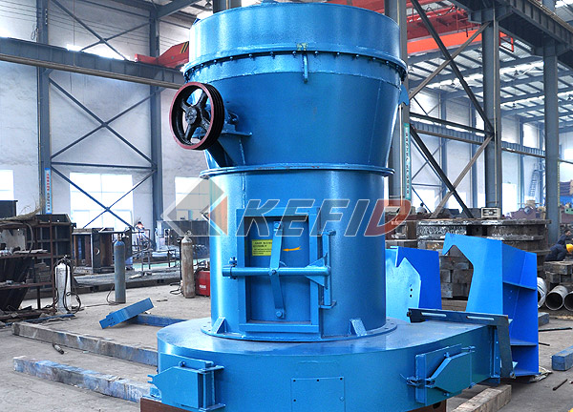
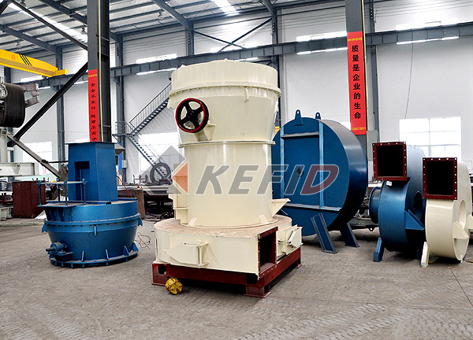
Raymond Mill, named after its inventor, is the first generation of medium speed pendulum miller which uses American technology. Firstly, raw material is crushed by jaw crusher to the size required, and then the crushed materials are elevated into a hopper from which the material is transported through the electro-magnetic vibrating feeder, evenly and continuously into the grinding chamber for powder-processing. The rollers oscillate outward to press the ring because of the centrifugal force and the shovel scoops up the materials, send to the middle between ring and roller to accomplish the grind.
After this, the ground stuff is carried by the air from the blower into the separator for screening. The fine powers are blow into the cyclone collector and are poured out through the output-powder valve as the final products and the rough stuff after the screening will be recycled back into the grinding chamber for regrinding. The set’s airflow system is closely sealed up and circulated under condition of negative and positive pressure.
Raymond is widely used in metallurgy, building materials, chemicals, mining and so on as grinding materials processing, suitable for processing the following Mohs hardness of 6-7 and humidity below 6% of all non-explosive minerals, such as gypsum, talc, calcite, limestone, marble, feldspar, barite, dolomite, granite, kaolin, bentonite, stone, bauxite, iron oxide red, iron ore, finished fineness 615 microns to 44 microns (0.615 mm -0.044 mm) between the machine and the fan through the analysis of joint action to meet the requirements of different users, it is ideal for grinding industry, especially for small and medium enterprises.
Main Features:
1. The whole plant is a vertical structure of strong systematic characteristic, so it occupies small area. From crushing of raw material to grinding and packing is an independent production system.
2. Compared with other milling plants, its passing ratio achieves 99%, this is what other mill can not reach.
3. Driving system of main frame adopts airtight gearing and pulley, drives smoothly and operates reliably.
4. Main parts of the whole plant are made from cast and steel of high quality. The techniques is so subtly that insures the durability of whole plant.
5. The electric control system is centralized controlled, so the automaticity is high, no people are needed in the operating room.
6. Little dust pollution, low noise.
7. The use of electromagnetic vibrating feeder to the material uniform, easy to adjust, small size, light weight, fuel-efficient power-saving and easy maintenance.
Technical Parameter:
Mm to inch conversion: 25.4millimeters=1 inch
Mm to mesh conversion: 25.4mm=1in.
The humidity and hardness of raw materail will affect the fineness and capacity.

Model |  |  | 3R2115 | 3R2615 | 3R2715 | 3R3016 | 4R3216
Roller | Number |  | 3 | 3 | 3 | 3 | 4
Roller | Diameter (mm) |  | 210 | 260 | 270 | 300 | 320
Roller | Height (mm) |  | 150 | 150 | 150 | 160 | 160
Ring | Inside diameter (mm) |  | 630 | 780 | 830 | 880 | 970
Ring | Height (mm) |  | 150 | 150 | 150 | 160 | 160
Maximum feed size (mm) |  |  | 15 | 15-20 | 15-20 | 15-20 | 20-25
Output size (mm) |  |  | 0.044-0.165 | 0.044-0.165 | 0.044-0.165 | 0.044-0.165 | 0.044-0.165
Power of main frame (kW) |  |  | 15 | 18.5 | 22 | 30 | 37
Fineness of final product (mm) | 0.165 | capacity (t/h) | 1.2-1.8 | 1.8-2.5 | 2.3-2.8 | 2.6-3.2 | 3.2-4.5
Fineness of final product (mm) | 0.075 | capacity (t/h) | 0.6-1.2 | 1.2-1.8 | 1.8-2.3 | 1.9-2.6 | 2.4-3.1
Fineness of final product (mm) | 0.044 | capacity (t/h) | 0.6-1.0 | 0.8-1.2 | 0.9-1.7 | 1-1.9 | 1.8-2.5

Note: We hold the ringts to modify the design and specification of our products, any modification shall not be advised additionally.

