Sand Making Plant
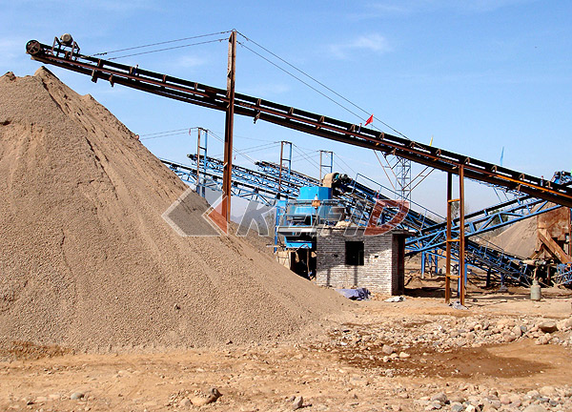
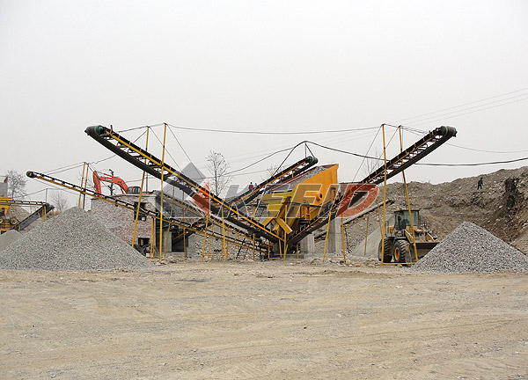
Kefid is specializing in all series sand making equipments and will offer you comprehensive technological support. The production line on basis of years R&D of Kefid is generally composed of vibration feeder, jaw crusher, vertical shaft impact crusher(sand making machine), vibration screen, sand washing plants, belt conveyor, switch box, etc, which enables a production capacity of 50-500TPH has established its leading position in this industry and can be widely used in sand making of hard limestone, granite, basalt,river stone,stone chips, all variety of rocks and ore tailings,which are to be used in hydroelectric construction, building material, highways, urban constructions.
Main Features:
The sand making line is reasonable in equipments configuration of different crushing stages, adding rigorous and crossed space distribution, enables less occupation of land and good investment returns. Meanwhile, advanced electric control system guarantees a smooth operation of the whole process, which is high in automatization standard, adjustable in fineness, low in operation cost, high in sand making, low in power consupmption, low level in pollution, easy in maitenance, stable in operation, easy in operation and high in total performance.

Below are classical design for manufactured sand production:

1.Vibrating feeder + jaw crusher + cone crusher + impact crusher VSI5X + vibrating screen

High crushing ratio of cone crusher and small crushed size ensures feed size and crushing efficiency of VSI impact crusher. VSI5X impact crusher is the third generation of manufactured sand equipment and has many important approvements on vital working parts,like spindly impact plates which has a much longer life time. Advanced hydraulic set used makes maintenance easier and it is suitable for large scale manufactured sand production line of high automation degree.

This manufactured sand production line has a long life time for spare parts,long consecutive working time and easy maintenance. All this increases the overall economic benifites greatly.

2.Vibrating feeder + primary jaw crusher + secondary jaw crusher + impact crusher VSI5X + vibrating screen

In this design secondary jaw crusher is used to replace cone crusher. It can decrease the once and for all cost of investment and is suitable for medium and small size manufactured sand production line.

The complete sand production line has a long life time for spare parts,long consecutive working time and easy maintenance. It has a low once and for all investment cost and good overall economic benifites

3.Vibrating feeder + jaw crusher + cone crusher + VSI series impact crusher + vibrating screen

In this design VSI impact crusher is used to replace VSI5X impact crusher which is used in the first design. VSI impact crusher has a lower investment cost compared with VSI5X impact crusher, it also has hydraulic set and is easy to maintain and change spare parts.

4.Vibrating feeder + primary jaw crusher + secondary jaw crusher + PCL series impact crusher + vibrating screen

This is the most economic design. The disadvantage is that PCL impact crusher has no hydraulic system,its maintenance and usage is also relatively complicated. Outstanding advantage of this design is that it has a much lower one and for all investment cost.

