Screw sand washing machine
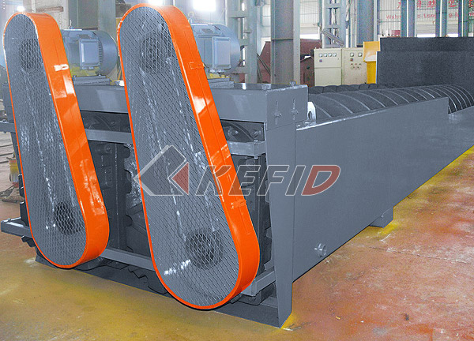
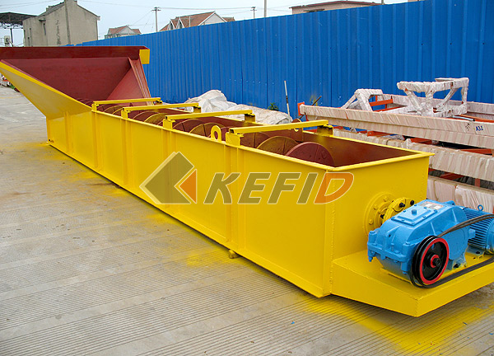
Screw sand washing machine is mainly used for sand processing, electric pole factory, building work site and concrete dam, various sands classifying and dewatering.
This sand washer adopts inclination of 15°, under the water tub, three weir plates form the sediment pool, the screw head is immersed in this pool, the screw is driven by electric motor through reducer rotating continuously, the fresh water is feeding from porous plate at bottom of sediment pool, this machine have three functions of washing, dewatering, classifying.
Working Principle
Washing: The sand is feeding into the sediment pool from the feeding box, acting by rotating screw blade, the sand is turning and rolling and grinding each other to eliminate impurity and water-air layer around sand to facilitate de-water. The fresh eater rising current from the porous plate carry foreign matter to water surface and overflow the weir plate, to finish washing processing
De-watering: The sand with bigger density is sunken down to tub bottom, the screw blade push this sand upwards, when passing through upper tub of proper length above water level, the water is draining into sediment pool from another drainage ditch, the de-watered sand is out from the discharging opening.
Classifying: Material classifying is realized by overflowing the non-needed fines, the controlling method is adjusting height of overflowing weir and adjusting speed of screw.
Technical Parameter:
Models | LSX-920 | 2LSX-920 | LSX-1120 | 2LSX-1120
Diameter of screw (mm) | 920 | 920 | 1120 | 1120
Length of tub (mm) | 7585 | 7585 | 9750 | 9750
Feed Size (mm) | ≤10 | ≤10 | ≤10 | ≤10
Capacity (t/h) | 100 | 200 | 175 | 350
Speed of screw (r/min) | 21 | 21 | 17 | 17
Electric Motor Power(kW) | 11 | 2x11 | 18.5 | 2x18.5
Water Consumption (t/h) | 10-80 | 20-160 | 20-150 | 40-300
Dimension (mm)(L×B×H) | 8420×2180×3960 | 8420×3970×3960 | 10770×3950×4860 | 10770×5260×4860
Weight (t) | 6.2 | 11.5 | 10.9 | 17.8
Note: Any change of Screw Sand Washing Machine technical data shall not be advised additionally.

