Spring Cone Crusher
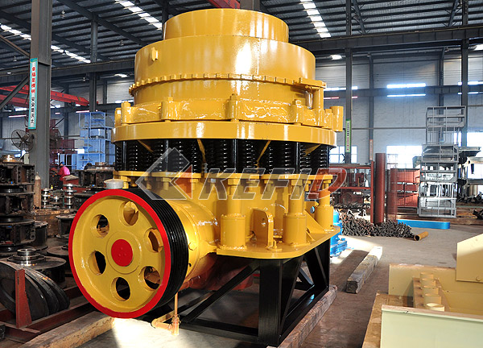
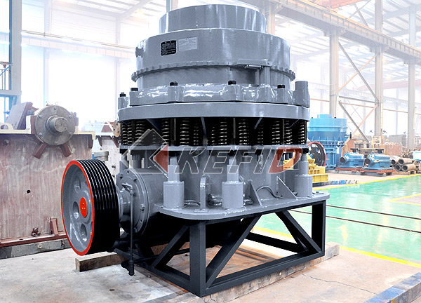
Kefid Spring Cone crusher is suitable to crush various kinds of ores and rocks of medium or above medium hardness. Compare with jaw crusher, cone crusher is of stable structure, high efficiency, easy adjustment, economic operation, etc. The spring safety system of crusher acts as an overloading protection system that allows metal to pass through the crushing chamber so as not to damage the cone crusher. The safety system uses dry oil and water as two kinds of sealed formation to make plaster powder and engine oil separate to make sure reliable performance. The type of crushing chamber depends upon size of feeding and fineness of crushed product. The standard type is applied to medium crushing, the medium type is applied to medium or fine crushing and the short head type is applied to fine crushing.
Kefid Cone crusher crushes materials by the working surface between the movable cone and fixed cone. So it is more advanced and efficiency efficient than jaw crusher. The movable cone is supported by spherical bearing and fixed on a hanging erect shaft which is set in the eccentric sleeve, and the sleeve is set on the stopping and pushing bearing. The movable cone and erect shaft are driven by the eccentric shaft sleeve together. The eccentric shaft sleeve is driven by horizontal shaft and fabricated gear, and the wheel of the conveyor belt is driven by motor through v-belts. The lower part of vertical shaft is installed in the eccentric sleeve. When the eccentric sleeve rotates, there is a conical surface lined out by the shaft. When the movable cone comes near the fixed cone, rocks are grinded into pieces, when the movable cone leaves, grinded materials is discharged from the discharge hole. The fixed cone can be ascended or descended by adjusting setting to adjust the width of discharge hole, consequently the output size is determined adjusted.
Main Features:
Spring cone crusher is one of the first cone crusher. It is an advanced high-power, large crushing ratio, high productivity hydraulic crusher. The machine is developed on the basis of the digestion and absorption of the various types of international advanced technology in 80 countries. The design of the machine is clearly different from the traditional cone crusher, and it put the main advantages of various types of cone crusher together. It is suitable for fine crushing and super fine crushing of hard rock, ore, slag, refractories, etc. Cone crusher can be widely used in metallurgy, construction industry, road building, chemical industry, and the phosphate industry. It is suitable for crushing hard and mid-hard ore and rock, such as iron ore, copper ore, limestone, quartz, granite, basalt, diabase, etc.
Technical Parameter:
Mm to inch conversion: 25.4millimeters=1 inch
Type |  | Max. input (mm) | Adjusting range  of output (mm) | Capacity (t/h) | Motor power  (kW) | weight (t) | Overall dimensions  (L×W×H)(mm)
PYB | 900 | 115 | 15-50 | 50-90 | 55 | 10.2 | 3050×1640×2350
PYZ | 900 | 60 | 5-20 | 20-65 | 55 | 10.2 | 3050×1640×2350
PYD | 900 | 40 | 3-13 | 15-50 | 55 | 10.3 | 3050×1640×2350
PYB | 1200 | 145 | 20-50 | 110-200 | 110 | 24.7 | 4152×2300×2980
PYZ | 1200 | 100 | 8-26 | 50-150 | 110 | 25 | 4152×2300×2980
PYD | 1200 | 50 | 3-15 | 18-105 | 110 | 25.6 | 4152×2300×2980
PYB | 1750 | 215 | 25-60 | 280-480 | 160 | 50.3 | 4870×3800×4192
PYZ | 1750 | 185 | 10-30 | 115-320 | 160 | 50.3 | 4870×3800×4192
PYD | 1750 | 85 | 5-15 | 75-230 | 160 | 50.4 | 4870×3800×4192
PYB | 2200 | 300 | 30-60 | 590-1000 | 260-280 | 80 | 7705×3430×4852
PYZ | 2200 | 230 | 10-30 | 200-580 | 260-280 | 80 | 7705×3430×4852
PYD | 2200 | 100 | 5-15 | 120-340 | 260-280 | 81.4 | 7705×3430×4852
Note: Any change of Spring Cone Crusher technical data shall not be advised additionally.

