Stone Crushing Plant
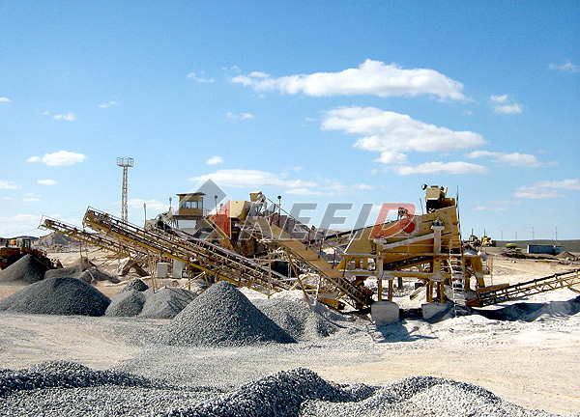
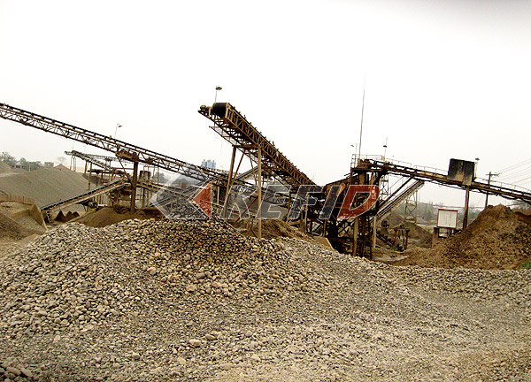
Stone production line of Kefid is mainly composed of vibration feeder, jaw crusher, impact crusher, cone crusher, vibration screen, cable box, dust collector and so on with production capacity of 50-500 tons per hour and can be designed according to clients’ special requirements by using equipments of different models. The production line performs well in crushing of medium hard rocks such as limestone, shale, granite and so on, which are to be used in hydroelectric construction, building material, highway, urban construction and many other similar industries.
Main Features:
Stone production line of Kefid is of high automatization standard, with adjustable mateiral discharge size, high crushing ratio, high production capacity, even final product, good grain shape, which suits project construction of bridges and highways of different scales. Meanwhile, stone production and screen line designed by Kefid also has the characteristics of high investment returns and small land occupation due to its reasonable configuration of equipments at different crushing stages, which is generally recommended according to material specifications, production capacity and material usage. Finally, before, during and after sales service provided by Kefid will offer you scientic design according to your working site aiming at offering you reasonable and economical production line.
Here are some useful stone production line plans:

1. Vibrating feeder + jaw crusher + Multi-cylinder Hydraulic Cone crusher+ reshaping machine (VSI sand making machine) + vibraing screen

Main charaicteristic of this plan is that it adopts advanced multi-cylinder hydraulic cone crusher. This makes fine products take a bigger proportion. 80% of the finals can be smaller than the size of discharge opening. It will obviously increase processing capacity and decrease general energy cost. Add reshaping equipment to the secondary crusher can assure the quality and shape of the final products on one hand; on the other, some sands can be chose for other usage.

The efficiency of the whole line is very high. Working life of easy-worn parts is long. Continuous operating time of the equipment is longer, and it is easy maintenance. Its general economic profits are higher than the traditional plan.

2. Vibrating feeder + Jaw crusher + CS cone crusher + Reshaping machine (VSI sand making machine) + vibrating screen

This plan adopts high efficiency CS cone crusher and it makes fine products take a bigger proportion. It reduces secondary crushing and gets much more final products. Add reshaping equipment to the secondary crusher can assure the quality and shape of the final products on one hand; on the other, some sands can be chose for other usage.

Working life of easy-worn parts of the whole production line is long. It has the feature of easy maintenance, less investment at one time, smaller operating cost and higher general economic profits.

3. Vibrating feeder + Jaw Crusher + HP singlecylinder cone crusher + vibrating screen

This plan is mainly suitable for processing hard material, like granite. Since the secondary crusher is hydraulic equipment, it has the feature of easy maintenance, less investment at one time, simple flow process, easy to operate. It is widely used in the industry which produces mixed materials or there is lower requirement to shape of the materials. This line has the features of combining with few types of equipments, easy maintenance, and indiscrete structure. It is suitable for any scale of investment due to smaller floor space requirement.

4. Vibrating feeder + Jaw crusher + CS cone crusher + vibrating screen

This plan is suitable for processing hard materials, like granite. Comparing with the same scale plans, the obvious feature of this plan is smaller investment at one time, simple flow process, easy operating and maintenance. The easy-worn parts using is fewer. Its economic profits are higher while maufacturing cost is lower.

5. Vibrating feeder + Jaw crusher + Impact crusher + vibrating screen

This plan is mainly suitable for processing soft materials, like limestone. Comparing with the same scale plans, the obvious feature of this plan is smaller investment at one time, simple flow process, easy operating and maintenance. This line can produce good final products with nice shape materials. It is widely used as a traditional economic plan.

