T130X Super-fine Grinding Mill
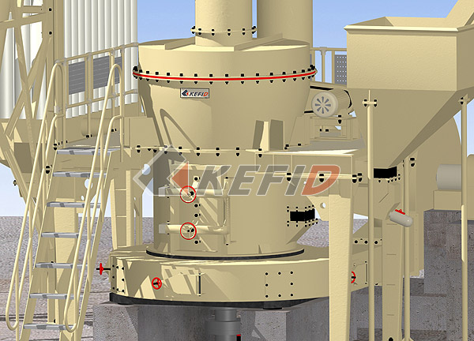
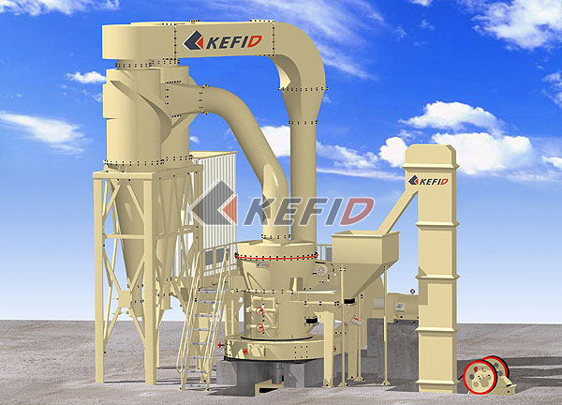
T130X reinforced ultrafine mill is mainly used in metallurgy, building materials, chemicals, mining of minerals such as grinding materials processing, it can ground feldspar, calcite, talc, barite, fluorite earth, rare marble, ceramic , bauxite, manganese ore, iron ore, copper ore, phosphate rock, red iron oxide, slag, clinker, activated carbon, dolomite, granite, yellow iron oxide, soybean meal, chemical fertilizers, compound fertilizers fly ash, bituminous coal, coke, lignite, sand, magnesite, gold, red clay, clay, kaolin, coke, coal gangue, porcelain clay, kyanite, fluorspar, bentonite, rhyolite stone, muddy green rock, rock, leaf wax , shale rock, stone dwelling, gypsum, graphite, insulation materials, processing of all minerals with moisture below 6%, non-flammable or explosive.
Main Features:
T130X reinforced ultrafine mill is a new facility designed by SBM expert based on statistical analysis and a large number of suggestions from users and based on the innovative design of the super pressure trapezoidal mill. This model has superseded and optimized in the structural characteristics of trapezoidal MTM mill, and it also formed its own unique characteristics:
1. The body connected to the base of all soft contact without rigid contact
This avoid body vibration to analyzer, improved the accuracy of the analysis.
2. The base made of high strength ductile cast iron
Ductile cast iron has the performance of damping force of molten steel, and good impact resistance.
3. Use of Germany Flender reducer
It fully exploited the technical advantages of professional manufacturer to improve the stability of the machine.
Reducer and motor is driven by the triangle belt for transmission for overload protection.
4. The coupling of the elastic sleeve is used in the main unit and the gearbox, which avoided the phenomenon of easily breaking nylon pin, thus improving the reliability of equipment.
5. Analyzer machine applies high-density blade
The classifier uses high-density blade that can increase the fineness of powders and the production capacity. Practice shows that in the case of velocity remained unchanged, the density of the leaves can increase the fineness of the finished products. In other words, in the case of the same finesse, high-density blade is driven by a lower rate than that of low density, thus reducing air resistance and increasing production.
Adopting a new structure of the blade wheel prevented the escape of the coarse powders.
6. Analyzer with a frequency control
It adopts the variable voltage and variable frequency to save more energy than the electromagnetic ones, and with the characteristics of accurate control, flexible process control, and high degree of automation.
7. Use of dust bypass collector
The dust bypass collector has an insulation cavity to reduce dusty gas escape from the lower vents. Compare with other dust collector, the bypass dust collector are high-efficiency and less pressure loss, particularly for collecting dust particles that is difficult to collect by the general collectors.
8. Equipment layout of the equal resistance design The equal resistance arrangement to avoid using of two different dust collector outputs power, improved dust collector’s performance, reduced internal circulation, and increased production of the mill.
9. Two collector discharge ports and dust collector are of a straight line arrangement to facilitate the materials centralized collection, which is labor saving and easy packing.
10. Establishing maintenance platform to make the mill maintenance more convenient and secure.
Technical Parameter:
1. Parameters of machine body
Name | Unite | Specifications and technical parameters
Quantity of roller | pcs | 4
Diameter of roller×height | mm | Ф410×210
Diameter of grinding ring×height | mm | Ф1300×210
Rotating speed of machine body | Rev/min | 103
Max feeding size | mm | <30
Grain size of powder | mm | 0.074—0.038
Production capacity | t/h | 4－13
Total weight of machine body | t | 18
2. System power
Name | Item | Unite | Specifications, technical data
Main motor | Model |  | Y280S-4
Main motor | Power | Kw | 75
Main motor | Rotational speed | Rev/min | 1480
Motor of classifier | Model |  | Y160L-4
Motor of classifier | Power | Kw | 15
Motor of classifier | Rotational speed | Rev/min | 1460(frequency control)
Motor of elevator | Model |  | Y100L2-4
Motor of elevator | Power | Rev/min | 3
Motor of elevator | Rotational speed | Rev/min | 1430
Motor of draught fan | Model |  | Y280M-4
Motor of draught fan | Power | Kw | 90
Motor of draught fan | Rotational speed | Rev/min | 1480
Motor of jaw crusher | Jaw crusher model |  | PE 250×400
Motor of jaw crusher | Motor model |  | Y180L-6
Motor of jaw crusher | Motor power | Kw | 15
Motor of jaw crusher | Motor rotational speed | Rev/min | 970
Vibration feeder | Model |  | GZ3F
Vibration feeder | power | W | 200

